List Activities

List Activities

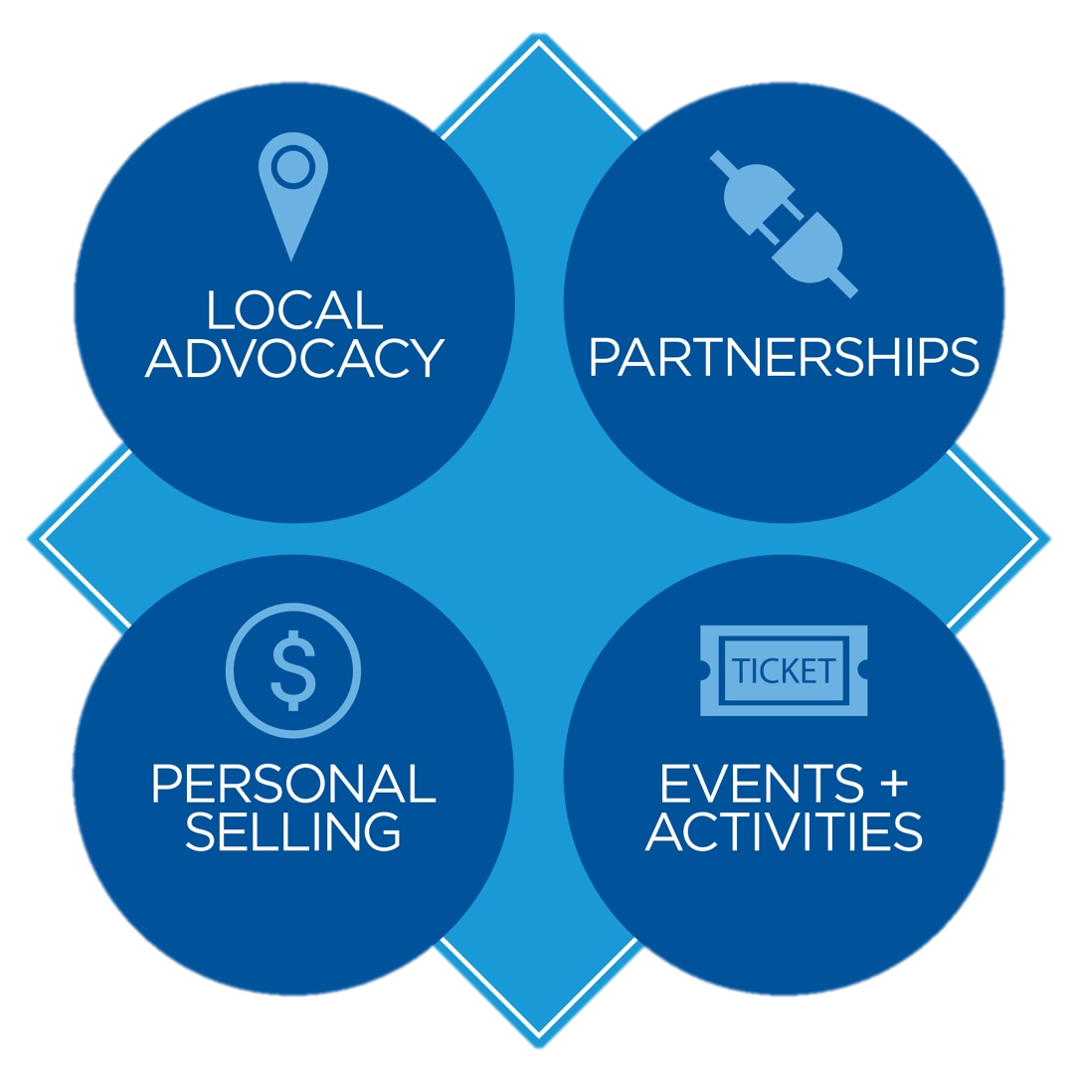

List Activities

List Activities