Moses was looking after the flock of Jethro, his father-in-law, priest of Midian. He led his flock to the far side of the wilderness and came to Horeb, the mountain of God. There the angel of Yahweh appeared to him in the shape of a flame of fire, coming from the middle of a bush. Moses looked; there was the bush blazing but it was not being burnt up. 'I must go and look at this strange sight,' Moses said 'and see why the bush is not burnt.' Now Yahweh saw him go forward to look, and God called to him from the middle of the bush. 'Moses, Moses!' he said. 'Here I am' he answered. 'Come no nearer' he said. 'Take off your shoes, for the place on which you stand is holy ground. I am the God of your father,' he said 'the God of Abraham, the God of Isaac and the God of Jacob.' At this Moses covered his face, afraid to look at God.

Exodus 3:1-6 (JB)

Marc Chagall (1887-1985)
Moses and the Burning Bush from The Story of the Exodus (1966)
Lithograph

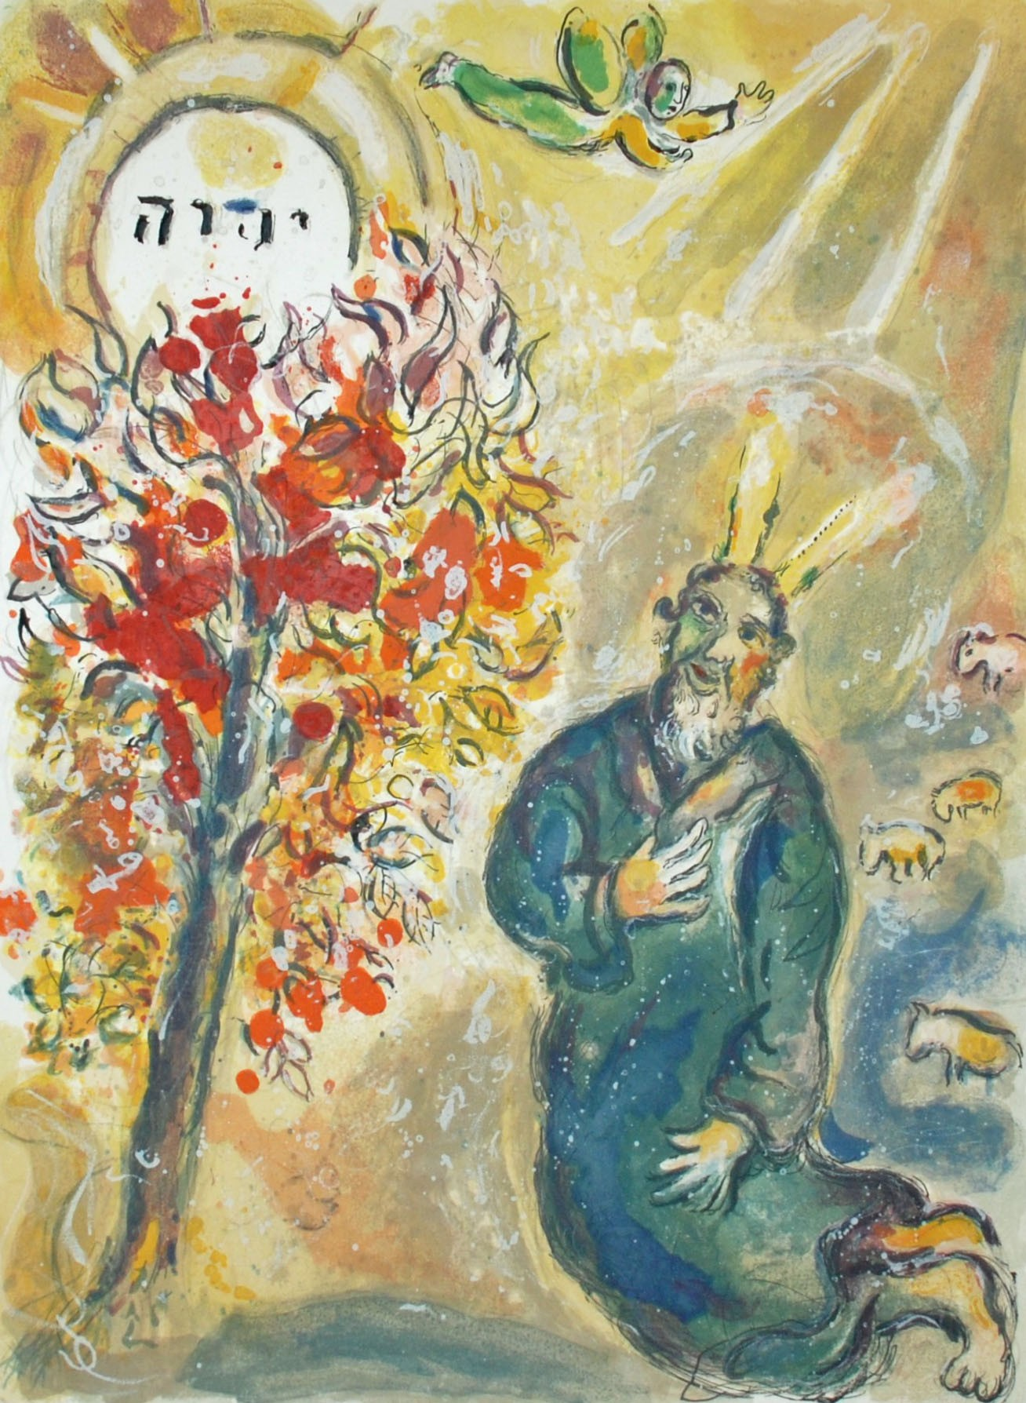
On the way he came to the Samaritan town called Sychar, near the land that Jacob gave to his son Joseph. Jacob's well is there and Jesus, tired by the journey, sat straight down by the well. It was about the sixth hour. When a Samaritan woman came to draw water, Jesus said to her, 'Give me a drink'. His disciples had gone into the town to buy food. The Samaritan woman said to him, 'What? You are a Jew and you ask me, a Samaritan, for a drink?' - Jews, in fact, do not associate with Samaritans. Jesus replied: 'If you only knew what God is offering and who it is that is saying to you: Give me a drink, you would have been the one to ask, and he would have given you living water'. 'You have no bucket, sir,' she answered 'and the well is deep: how could you get this living water? Are you a greater man than our father Jacob who gave us this well and drank from it himself with his sons and his cattle?' Jesus replied: 'Whoever drinks this water will get thirsty again; but anyone who drinks the water that I shall give will never be thirsty again: the water that I shall give will turn into a spring inside him, welling up to eternal life'. 'Sir,' said the woman 'give me some of that water, so that I may never get thirsty and never have to come here again to draw water.'

John 4:5-15 (JB)

He Qi (b.1951)
The Woman at the Well
