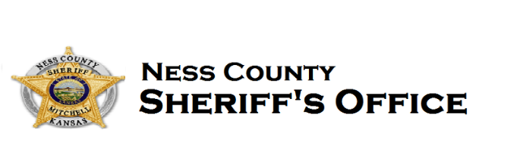
221 W. Main
Ness City, KS 67560
Phone: 785-798-36111
Sheriff Brandon J Mitchell bmitchell@nesscoso.org
We are currently recruiting for a professional and reliable Communications/Corrections Officer to act as our agencies first point of contact for emergency and non-emergency calls. In this position, you will be tasked with maintaining call logs, monitoring routes, transferring messages, and directing field units. To excel in this position, all candidates should be able to multi-task in stressful conditions with little supervision. In addition to being an excellent communicator, the ideal candidate will also demonstrate superb organizational and interpersonal skills. Some benefits available are paid holidays, KPERS retirement, and health insurance.

Minimum Qualifications:
Applicant must be at least 18 years of age and a United States citizen who has never been convicted of a felony or misdemeanor involving moral turpitude. Applicant must demonstrate honesty and integrity by successfully completing pre-employment background investigation and drug testing. Must have a valid Kansas Driver’s license or be able to obtain one prior to employment. Applicant will also be required to pass a medical physical.

Responsibilities:
- Answer emergency and non-emergency calls and document important information.
- Operate and manage a multi-line telephone console system.
- Respond to queries related to calls to service.
- Use the radio, phone or computer to direct Emergency units to the appropriate sites.
- Responsible for the control, observation and direct supervision of inmate populations to ensure the maintenance of security, operational rules, procedures and guidelines.
- Maintain and update call logs, call records and other important documentation.
- Preparing daily meals and medications for inmates

OBTAINING APPLICATION
Applications will be accepted until filled. Applications can be obtained by emailing Sheriff Brandon Mitchell (bmitchell@nesscoso.org), calling the Ness County Sheriffs Office at (785)798-3611 or by meeting in person at 221 W Main St, Ness City, Ness County, Kansas 67560.

