Pilgrimage People

Retreat for Priests
Buckfast Abbey
6th – 10th February 2023

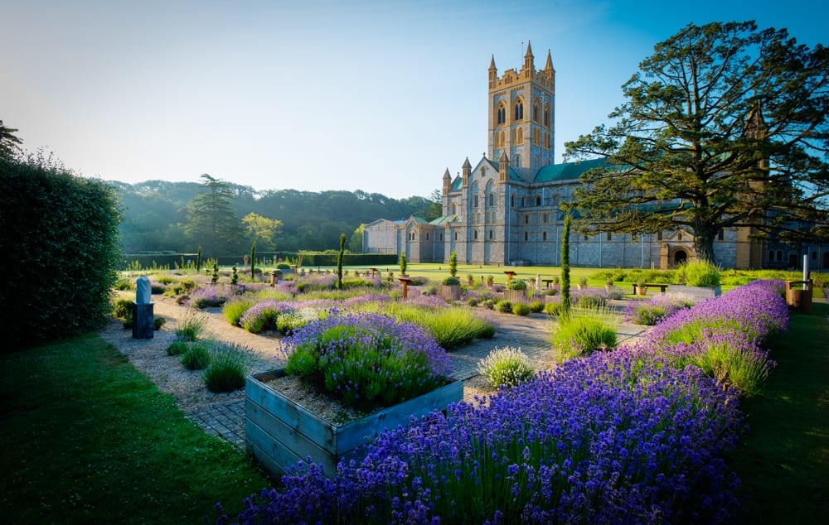

At a time of momentous change in the church and in society, how do priests encourage others and encourage themselves? Join us in the beautiful surroundings of Buckfast Abbey for this opportunity to relax, rest and refresh. Fr Paul Maddison will lead our few days together looking at St Paul’s second letter to the Corinthians when he realises that in order to be strong, we need to be content with our weakness.

Staying in the excellent accommodation of Northgate House within the grounds of Buckfast Abbey, Devon, the retreat will run from the afternoon of Monday, 6th February to Friday, 10th February. Single en suite rooms and all meals included. A conference will be held each morning and afternoon, daily Mass will be celebrated and the opportunity to join the community for daily office. £590pp.

Places are limited. To reserve your place contact us on 0800 612 3423 or email info@pilgrimagepeople.org.

Find time for prayer and silence, be encouraged and enriched.

