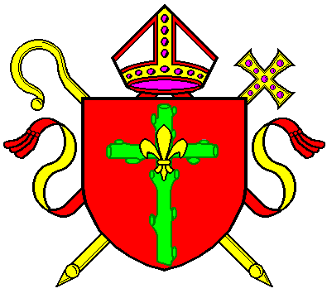

Safeguarding at

Our parish and community is a place of welcome, where each person is respected and loved, and in which everyone receives and shares their unique gifts and where we support and protect each other. We must take particular care of those who may be vulnerable because of age, illness or disability or who may be vulnerable because of current or past life experiences.

Everyone in the Church has a responsibility to safeguard and promote the wellbeing of those who worship in our Church or who join us for any activity facilitated by Church members.

If you are concerned about a child, vulnerable adult or a person in distress then you may want to speak to your Safeguarding Representative,………………………………………………………….by calling them on………………………………….. or Rachael Campion, Safeguarding Coordinator for the Diocese on 0115 953 9849.

