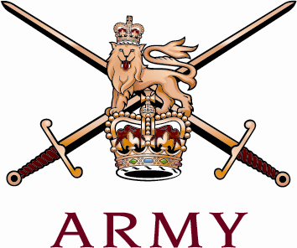 | The Royal Regiment of Scotland  Regimental Headquarters  The Royal Regiment of Scotland  The Castle  EDINBURGH  EH1 2YT | 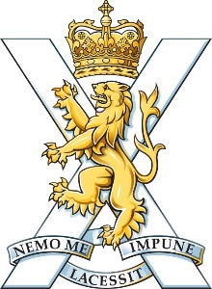

To all SCOTS Soldiers 30th November 2021

The royal regiment of scotland STRATEGY: ‘scots in 2025 and beyond’

1. Introduction.

15 years on from Formation, The Royal Regiment of Scotland has much to be proud of. We have played a significant part in the Army's demanding campaigns in Iraq and Afghanistan, with all Battalions serving with great distinction, including providing the last three Battalions to serve in Kabul to the end of the mission. Elsewhere, we continue to be at the forefront of the Army's activity at home and abroad, and our performance on successive collective training events has sealed our reputation as the Field Army's foremost fighting troops. We are known the world over.

Of course, we are not really a new Regiment; we bear the glittering histories of our antecedent Regiments, going back to 1633. Everything we do builds on these traditions of proud service and sacrifice of our numerous ancestors. The regimental system has always evolved and changed to adapt to circumstances and the age, and we are no different. All that pride and tradition now comes together under the Royal Regiment of Scotland, and it is under this banner that we continue to take forward our service to the Crown and country, and write the next chapters of our glorious history.

Field Marshal Sir Claude Auchinleck once said "A regiment is not just a pack of soldiers; a regiment is a living being". Our people, serving and retired, are what makes the Regiment, and the job of the Regiment is to train, command and look after our people, to ensure we can do our duty to the highest standard. This new strategy is designed to do just that; it sets an ambitious vision for the Regiment, and details how we will achieve it across a number of key areas. It is comprehensive and deliberately challenging. It will require all of us in our Regiment to support it. In doing so, we will achieve success and be the standard for others to follow. I therefore commend it to you and ask that we all do our utmost to support the strategy and make it a reality. Doing so will ensure that we live up to the proud heritage of those who went before; look after our people now in the best way possible and fit ourselves for the inevitable challenges that lie ahead.

2. “Advance, The Royal Regiment of Scotland.” The Royal Regiment of Scotland formed on 28 March 2006. Plenty has happened in the world and in Defence since then. This strategy enables us to adapt proactively to the new environment and sets the Regiment up to strengthen and grow into the future.

The Integrated Review and Defence Command Paper in 2021 directed that Defence shift to ‘operate’, prioritise continuous activity over contingency, and reduce the Army’s strength to just over 70,000. The Army is implementing this direction through the ‘Future Soldier’ programme. The Regiment is embracing the Army’s transformation and is forward leaning in playing our role in it, so that we can seize every possible opportunity in the process. These are external drivers for change; but there are compelling factors internal to the Regiment, too, which this strategy addresses and thereby takes the Regiment confidently forward.

The Army’s emphasis on accountable leadership and the desire to serve our people even better than ever before indicates a demand for a deliberate approach to mentoring and personal development. A revised approach to mentoring and personal development will also support a restructured Army where more and more young officers and NCOs will be required to work independently in austere environments. We are encouraging more women to join our Regiment across all ranks. We will also, once and for all, counter what appears to be our continued struggle to ‘attract’. We will be respected for our performance and behaviour in camp as we are feared and held in awe on operations and when training. We will do better to ‘retain’ and will do more to bind in the support of our growing veteran community.

Finally, perhaps of greatest importance. The Royal Regiment of Scotland still faces challenges with its identity. The people of Scotland and the wider United Kingdom are not crystal clear who we are. We must take care not to confuse our proud history with clarity on who we are today.

This strategy:

- Identifies our Regimental endstate as part of a unifying vision.

- Focusses on our people as our principal planning factor.

- Seeks to strengthen our internal and external identity.

- Acknowledges our requirement to appeal to a wide audience, not just Scotland and Scots but all potential SCOTS soldiers, male and female, from across the UK and the Commonwealth; we will tailor communications to reach beyond young people and families to gatekeepers and the wider community.

- Revises our governance to improve coherence, support activity, and continuous improvement, including Strategy implementation. All enabled by improved holding to account.

- Restructures the existing Lines of Operation to direct the continuation of the essential activities (heritage and finance) and prioritisation of the areas that require renewed focus.

- Will be enacted as a collective effort, enacted by all members of the Regiment.

The Strategy will also seek to empower the network to augment capacity of both RHQ and Battalions in its implementation.
3. Our audiences. Whilst conducting our day-to-day business as a Regiment, we will focus on the following four audiences with priority given to the current generation.

- The next generation. These are young men and women in Scotland and throughout the United Kingdom and Commonwealth who could be SCOTS soldiers. Be they yet to consider joining the Army, ACF/CCF cadets, or already in training, we wish to ‘attract’ them.

- The current generation. These are our officers, soldiers, and civilians now serving within the regular Army, the Army Reserve, or cadets, who we want to ‘retain’.

- Former generations. These are our veterans, whose service it is a privilege and enduring duty to ‘honour’.

- Our support community. These are parents, partners/spouses, teachers, politicians, youth leaders, Lords Lieutenant, Civic leaders, emergency service personnel, and all those who have a bearing on the Army, or support our soldiers. The ‘support’ of whom is invaluable to our Regiment.

Section 1: The Regimental Vision:
4. Vision. We will be known for how we look after our own: as we join, serve, live and ultimately continue as part of our veteran community. The answer to all we do as a Regiment in the future is guided by our vision and it is based on a simple idea: we win with our people. When we are in doubt about what course of action to take, whether in a fireteam, section, platoon, company or battalion, or family home, the answer is simple: be the standard for others to follow.

In all that we do, from in-barracks activity, to training courses, to engagement overseas and delivering on operations, we are to be considered the standard of quality by the Infantry and the Army. Being the standard means constant and active leadership. Being the standard means continually learning and improving. Being the standard involves everyone, at every level within the Regiment, whether at Regimental Duty or on an external posting. In order to accomplish this, our Regiment must serve its people with a clear and renewed focus – that is why the Regiment exists.

This Regimental strategy sets out the end-state and a series of lines of development, with actions and targets (the ways). The end-state is others recognise us as the standard: the Infantry emulates, the Army admires, our audiences revere, our allies respect and our adversaries fear –
– no worse enemy and no better friend. The Lines of Operation represent the paths and areas to focus on to ensure The Royal Regiment of Scotland is considered the place to serve in the Infantry – the LoO are the ways by which we will make progress towards the end-state. This is to be a continuous effort by all of us to ensure that the Infantry and the Army further recognises our quality, our performances and, most importantly, our renowned open, friendly and humble manner as we work towards this vision.

All we do every day, and what we represent as a Regiment, must be guided by our collective vision for 2025, that the Royal Regiment of Scotland will be the standard for others to follow.

Section 2: How will we achieve our desired endstate? – The Ways

5. The three foundations. Identity, Communications and Governance are the foundations for a golden thread which runs through and binds together every element of the Regiment’s strategy. We will consider them in everything we do and they will act as guiding principles as we progress each Line of Operation.

a. Consolidate Regimental Identity (priority foundation). A clear identity is the cornerstone of our Regimental Strategy. It is central to the Regiment’s future and we all have a responsibility to ensure its success. We know we must not lose sight of how great our fundamental identity is. No other Regiment in the British Army is as easily recognisable nor as rich in heritage. This will endure, embedded as part of our history and reputation, but will not be central to how we move forward. Now is the time to focus on the future of the Regiment. We will strengthen our connection to Scotland while attracting soldiers from across the whole of the United Kingdom and the Commonwealth. We will project our unique, inclusive, tough, canny and proud character.

The guiding principle throughout will be Regiment first, embracing a collective identity and all the opportunities that offers. This will be represented by greater uniformity, specifically in our titles, appearance and behaviour.

b. Ensure all-pervading communications. Regimental Headquarters will be properly empowered and resourced to enable the Regiment to speak with one voice to multiple audiences, whilst preserving space for Battalions to establish proportionate links across Scotland’s proud Army heritage. This will include better explanation and use of extant practices, and clearer direction on the responsibilities of the whole Regiment to support this effort. As the future of the Regiment becomes clearer, the Regimental Council will outsource Branding, PR and Marketing. All the Regiment’s communications (internal and external), and anyone involved in disseminating them, will adhere to a single set of communications objectives, which are in line with the Army’s Engagement and Communication objectives.
- Support the Army’s contribution to MOD and cross-Whitehall engagement and communications in support of the Nation and Regions.

- Showcase the Regiment as the recognised standard across the board: join well, live well, serve well, leave well, engage well.

- Foster pride in serving in the Regiment – celebrate our combined history, secure our future.

- Demonstrate the opportunities available to our soldiers.
- Celebrate individual and collective successes.
- Visibly engage within our communities (where we live, where we work and where we come from), highlighting the impact the Regiment has there through its soldiers and veterans.

- Support the SCOTS association to create a continued sense of belonging to the Regiment by our veterans.

- Keep our people (our soldiers, families, supporters, and veterans) informed.
- Avoid being drawn into inappropriate discussions over political decisions and discussions regarding independence.

c. Apply active governance. The Colonel of the Regiment will ‘command’ the Regiment with support from his Deputy Colonels. They will maximise the benefits of a direct line and engagement with Commanding Officers and Regimental Sergeant Majors. The Colonel of the Regiment will ‘manage’ the Regiment’s business using Regimental and General staff officers to deliver the activities set out in the Lines of Operation. Regimental Headquarters will support these leadership functions and harness the power of the community ‘at E’ to augment capacity where required. Key to good governance will be our ability to hold ourselves to account for which our activities will be measured and success judged against a new target dashboard.

6. Lines of Operation. With one vision, three foundations, and four audiences in place, our Lines of Operation bring focus to the activities we will conduct to drive the Regiment forward. They are focussed on our people. The five new Lines of Operation (LoO) are: Join Well, Live Well, Serve Well, Leave Well, Engage Well. Two existing LoO complete the set: Heritage and Finance. We will make progress across all LoO through a collective Regimental effort. Each LoO will be driven forward by teams comprising members of the Regiment at E and in Battalions where capacity allows. With RHQ, LoO leads will identify the means required to deliver their activities, including workforce support:

Current (pre-2021 Integrated Review) |  | Future (post-2021 Integrated Review)
1 | Soldier Recruiting | Join Well | 1
2 | Officer Recruiting
3 | Welfare | Live Well | 2
4 | Sport and AT
5 | Professional Competence | Serve Well | 3
6 | Towards an Integrated Army
7 | Regt Association | Leave Well | 4
8 | Engagement and Comms | Engage Well | 5
9 | Heritage | Heritage | 6
10 | Finance | Finance | 7

Our Vision, Audiences, Foundations, and Lines of Operation interact constantly.

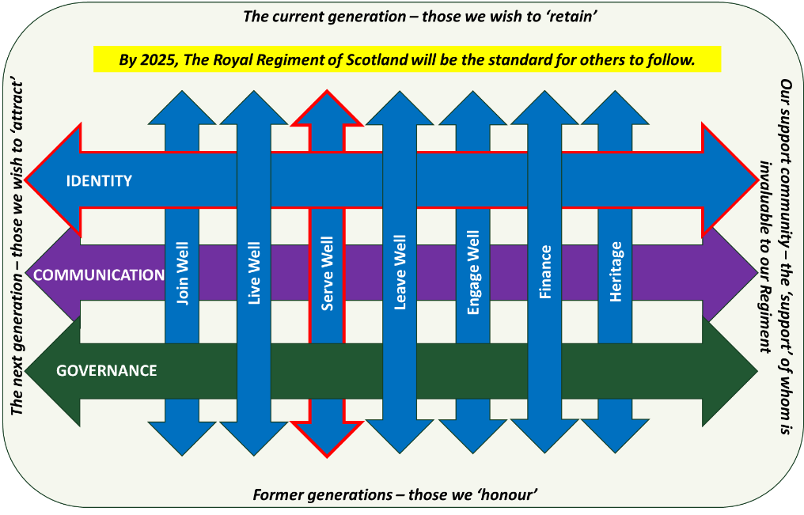

Line of Operation 1: JOIN WELL

Outcome. The Regiment will secure the right quality of people in ever sufficient numbers to ensure a strong Regiment; a Regiment whose position in the Army’s ORBAT is unquestionable.

Guiding principles:
- Focus on our people as our principal planning factor;
- Consolidate Regimental Identity;
- Ensure all-pervading communications;
- Apply active Governance.

Objectives. To achieve this, the Regiment will attract, nurture, and embed into the Regiment new or re-joiners from the moment they first express an interest in becoming a soldier in the SCOTS or re-joining. Our overarching objectives are:
- Connect with potential recruits before they step into the recruiting pipeline with a focus on Cadets (ATTRACT);
- Attract people to join; dispel reservations in those who may have been directed to join (ATTRACT);
- Train and maintain communications with those who have expressed an interest or have made a commitment (TRAIN and NURTURE);
- Optimise our induction process (EMBED).

Line of Operation 2: LIVE WELL

Outcome. The Regiment will enhance the mental health and physical well-being of our people. The Regiment’s standard for looking after and caring for its people is, and is recognised as, second to none.

Guiding principles:
- Focus on our people as our principal planning factor;
- Consolidate Regimental Identity;
- Ensure all-pervading communications;
- Apply active Governance.

Objectives. To achieve this, the Regiment will place as much importance on our people’s health and well-being as we do on them delivering their core professional outputs, recognising the direct correlation how problems in the former impact the latter. While Battalions have the lead for much of our population, RHQ will support them with a substantive regimental wrap around business as usual activity. That wrap will extend to those at E. The overarching objectives are:

- Promote the Army’s focus in this area to ensure our Battalions are supported to implement the best programmes in full.
- Protect the mental health of our people – the serving community and the Veteran community;
- Have a culture of healthy living and high physical performance, demonstrated through our approach to sport and adventure training;
- An individual’s lived experience, encompassing his/her personal support network, is valued and enhanced.

Line of Operation 3: SERVE WELL (Priority LoO)

Outcome. We will ensure that every member of the Royal Regiment of Scotland is enabled to have a fulfilling career and that the Royal Regiment of Scotland is an organisation renowned throughout the Army for the advancement of professional standards.

Guiding principles:
- Focus on our people as our principal planning factor;
- Consolidate Regimental Identity;
- Ensure all-pervading communications;
- Apply active Governance.

Objectives. To achieve this, we will enable and support the professional development of every soldier and officer and will recognise and reward individual commitment and success in achieving their own personal and professional development. Our overarching objectives are to:

- Better communicate what the Regiment will do for its members, and what it expects of them.
- Better recognise and reward achievement, communicating how we invest in and celebrate our people.
- Better inform members of the Regiment of opportunities available to them.
- Enhance the professional development of all members of the Regiment.
- Enhance the preparation of all members of the Regiment for key promotion courses.
- Standardising the processes delivering, and levels of investment in, professional development across the Battalions and for those serving away from the Regiment.
- Ensure that the achievements of members of the Regiment are better communicated, providing sources of inspiration and suitable role models for members, or potential members, of the Regiment to follow.

Line of Operation 4: LEAVE WELL

Outcome. The Regiment will ensure that all SCOTS are professionally prepared for a change of career and working environment, knowing they will remain valued, and will be provided with a lifetime of support by the Regiment.

Guiding principles:
- Focus on our people as our principal planning factor;
- Consolidate Regimental Identity;
- Ensure all-pervading communications;
- Apply active Governance.

Objectives. The overarching objectives are:
- SCOTS soldiers prepare for their next career whilst serving (interdependency with LoO 3)
- Data is captured in an accurate and timely way by units and RHQ.
- Effective lines of communication with leavers are established and maintained.
- A Regimental Association is developed which is capable of offering a lifetime of support to our veterans; supported by the Regiment and is capable of supporting the Regiment and is willing to do so.

Line of Operation 3: SERVE WELL (Priority LoO)

Outcome. We will ensure that every member of the Royal Regiment of Scotland is enabled to have a fulfilling career and that the Royal Regiment of Scotland is an organisation renowned throughout the Army for the advancement of professional standards.

Guiding principles:
- Focus on our people as our principal planning factor;
- Consolidate Regimental Identity;
- Ensure all-pervading communications;
- Apply active Governance.

Objectives. To achieve this, we will enable and support the professional development of every soldier and officer and will recognise and reward individual commitment and success in achieving their own personal and professional development. Our overarching objectives are to:

- Better communicate what the Regiment will do for its members, and what it expects of them.
- Better recognise and reward achievement, communicating how we invest in and celebrate our people.
- Better inform members of the Regiment of opportunities available to them.
- Enhance the professional development of all members of the Regiment.
- Enhance the preparation of all members of the Regiment for key promotion courses.
- Standardising the processes delivering, and levels of investment in, professional development across the Battalions and for those serving away from the Regiment.
- Ensure that the achievements of members of the Regiment are better communicated, providing sources of inspiration and suitable role models for members, or potential members, of the Regiment to follow.

Line of Operation 5: ENGAGE WELL

Outcome. By 2025, the Regiment will be visibly engaged within our communities, contributing to the Regiment’s current and future health, and supporting the Army’s institutional engagement ends.

Guiding principles:
- Focus on our people as our principal planning factor;
- Consolidate Regimental Identity;
- Ensure all-pervading communications;
- Apply active Governance.

Objectives. The Regiment’s engagement will achieve two macro objectives:
- The SCOTS is considered a positive contributor to our communities.
- Communities and key stakeholders support and advocate the Regiment.

Lieutenant General NRM Borton DSO MBE
Colonel of the Regiment

Enclosures:

1, Strategy Campaign Plan.
2. Regimental Engagement Plan.

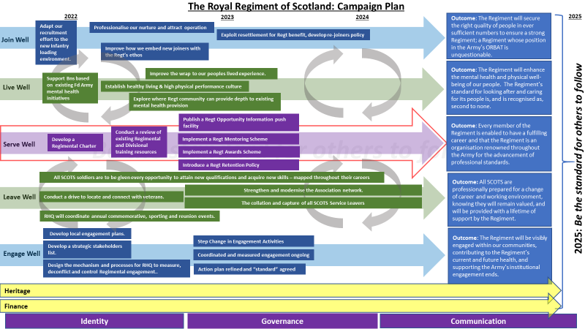

The Regimental Engagement Plan

1. Audiences and Outcomes. The Regiment’s reputational outcomes are below and align to the Army’s ends.

Priority | Regimental Audience | Sub-audience | Army Reputational Ends | Desired Outcome
1 | The Regiment – those we wish to RETAIN | Those serving at RD | The best – serve with us | - Our soldiers are proud to be in the Regiment  - They recognise and demonstrate that the SCOTS is the standard for others to follow
 |  | Those serving at E
2 | The future of the Regiment – those we wish to ATTRACT | Those at Ph1/Ph2 | The best – serve with us | - The SCOTS is the first choice for people to join  - Recognised as the standard for looking after its people and personal development  - Understand the breadth of opportunities available in the Regt
 |  | Potential Officers – UOTC, RMAS
 |  | Cadets
3 | The Regiment’s wider family – those whose SUPPORT we need | The Army, Defence and Government | Government – values us  Adversaries – fear us  Allies – respect us | - Recognise and advocate the Regiment’s usefulness  - Recognise the Regiment as the standard for others to follow
 |  | Commentators and influencers, opinion leaders, academics |  | - Understand and communicate the Regiment’s successes
 |  | Our families and local communities | Society – is proud of us | - Support the Regt and our people, recognising and advocating the positive impact the Regiment has
 |  | Segments 1-6
4 | The Regiment’s legacy – those we need to HONOUR | Our veterans | The best – serve with us  Society – is proud of us | - Our proud to have served in the SCOTS  - Advocate the Regiment as the standard for looking after its veterans
 |  | Our antecedents |  | - Continue to support the SCOTS and our people  - Feel that antecedent legacy and successes are secure

2. Sub-Audiences and Stakeholder Action Plan.

Regimental Audience | Sub-audience | Army Reputational Ends | Stakeholders | Responsibility | The Standard
The future of the Regiment – those we wish to ATTRACT | Those at Ph1/Ph2 | The best – serve with us | Depot/Academy Staff (gatekeepers), potential recruits and officers | RHQ, supported by Dep Cols and Bns | Bn attendance at all formal Regtl events; COs to visit ITC/RMAS/UOTCs once a year; visit all SCOTS ACFs annually.
 | Potential Officers – UOTC, RMAS
 | Cadets
The Regiment’s wider family – those whose SUPPORT we need | The Army, Defence and Government | Government – values us | The Royal Family – Regtl and Bn Royal Colonels | CoR, supported by Dep Cols and COs | Royal Colonels to visit Bns once every two years
 |  |  | Defence and Army Executive Board Members | CoR, supported by Dep Cols and COs | 2 x Board Members to visit the Regt per year (inc CGS every other year)
 |  |  | Fd Army (CFA, GOCs, Bde Comds) | CoR (2* and above), Deputy Colonels at 1* and below | 3 x visits a year to SCOTS Bns at 2-3* level.
 |  |  | HQ Infantry | RHQ, supported by COs
 | Commentators and influencers, opinion leaders, academics |  | Lord Lieutenants | CoR, supported by Dep Cols and COs | Lord Lieutenants hosted once a year by each Bn and RHQ
 |  |  | Mayors and Local Govt | COs, supported by Dep Cols | Hosted annually (cocktail party or otherwise)
 |  |  | Retired senior officers and senior soldiers | Dep Cols, supported by COs | Annual brief, invitation to Regtl event
 |  |  | Regional politicians | COs, supported by RHQ for Bde and Army deconfliction | 7 MPs/MSPs hosted per year
 | Our families and local communities | Society – is proud of us | Local schools, charities, sports clubs and businesses | RHQ, supported by COs | Each Bn to visit one school per term, raise money for local charities annually, have at least one local sporting fixture and engage with local businesses
 | Segments 1-6
The Regiment’s legacy – those we need to HONOUR | Our veterans | The best – serve with us  Society – is proud of us | Former soldiers and officers | RHQ, supported by COs | Virtual brief annually, regional veteran social events
 | Our antecedents |  | Antecedent Home Headquarters | COs, supported by Dep Cols | Attendance at key memorial and annual events/dinners

