Microsoft and Enjin Launch Minecraft-Compatible NFTs to Celebrate International Day of Women and Girls in Science
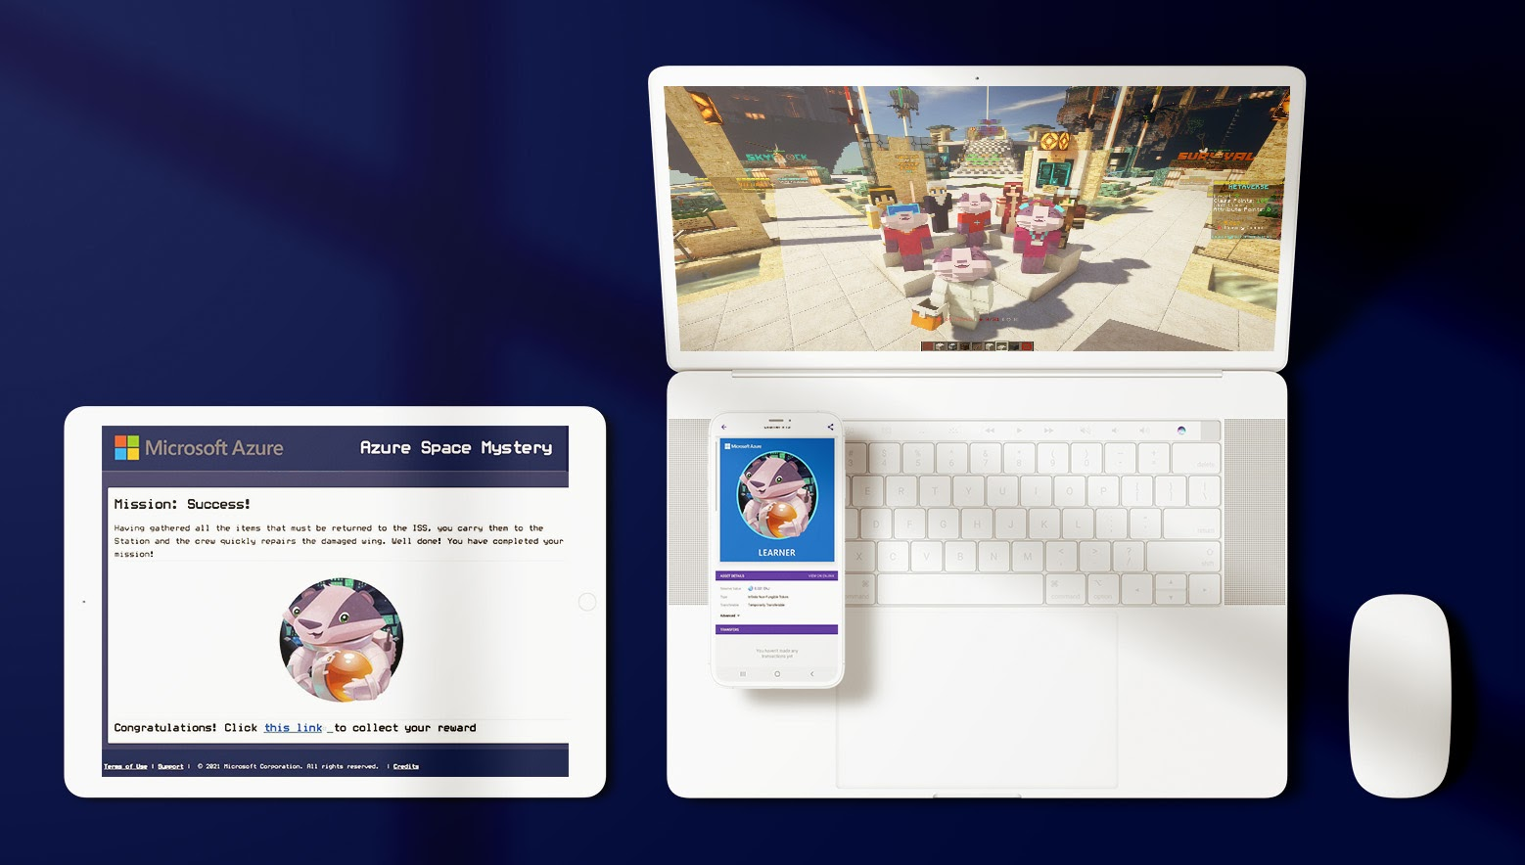
11 February 2021, SINGAPORE — Microsoft and Enjin are celebrating the International Day of Women and Girls in Science by launching customizable Non-Fungible Tokens (NFTs) compatible with the popular and beloved game Minecraft.
The NFTs can be earned through the Azure Space Mystery, an educational, interactive space exploration game that utilizes the Microsoft Learn platform and aims to champion women in science and technology.
During the Azure Space Mystery game, players will embark on a journey to save the International Space Station, while learning from and celebrating prominent European female scientists, including Caroline Herschel, Mary Somerville, Hypatia and Raymonde de Laroche.
“Education is key to empowering the next generation of innovators. Enjin is proud to work alongside Microsoft to generate innovative opportunities for merging virtual worlds, bringing digital communities closer together and celebrating powerful women in science and tech,” said Bryana Kortendick, VP of Operations & Communications at Enjin.
Those who complete the game will receive an Enjin Beam QR code that, when scanned, delivers a limited-edition Learner Badger NFT to the user’s wallet. While the Learner NFTs have infinite supply, the tokens received during this event will feature custom art that will never be available again.
The Learner NFTs have been integrated into Minecraft, enabling its holders to gain access to a sequel quest in the MyMetaverse Minecraft Network. This cross-game functionality is made possible by Enjin’s “EnjinCraft” plugin, which has just been upgraded to allow any Minecraft server to integrate and support NFTs.
Microsoft’s Azure Heroes companions can be summoned in the Minecraft sequel, joining users on their next quest. Completing the quest will enable players to unlock more unique collectibles in Minecraft, including “XX & XY Certified Equal,” a tokenized certificate that encourages equality of the chromosomes and all genders.
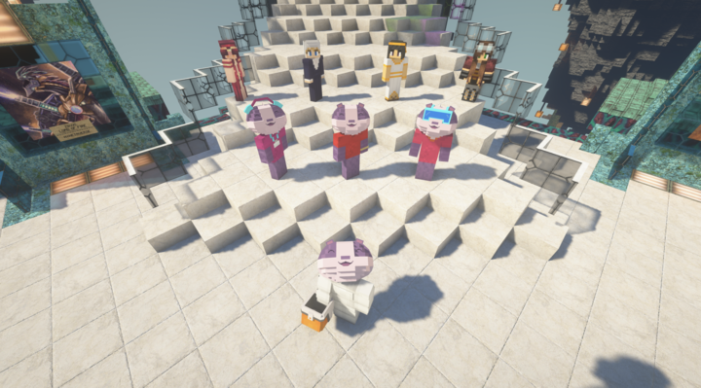
Enjin and Microsoft’s ongoing partnership via the Azure Heroes program leverages Enjin’s blockchain ecosystem to distribute exclusive NFTs as rewards to the Microsoft Azure developer community and raise awareness about NFT technology for enterprises.
“Enjin’s platform powers innovative projects across the gaming and wider blockchain ecosystem. Our collaboration has allowed Microsoft Azure to integrate cutting-edge technology with educational tools and recognize the contributions of our developer communities around the world,” said Sherry List, Azure Developer Engagement Lead at Microsoft.
By collaborating with global leading technology and gaming companies like Microsoft, Enjin is leveraging the power of its blockchain adoption ecosystem to create simple, user-friendly bridges between centralized and decentralized gaming technologies.
NFTs have gained much in popularity and use in 2021, with a collection of NBA-themed digital artworks works recently attracting more than $31.8 million in sales.
The Azure Space Mystery challenge is free to join and can be accessed via Microsoft’s website from 11 February through 11 March 2021.
<ENDS>
About Enjin
In 2009, Enjin launched the Enjin Network, a gaming community platform with over 20 million users. In 2017, following a successful ICO, Enjin began building a suite of blockchain products that enable anyone to easily create, manage, trade, distribute, and integrate blockchain assets. Comprising the Enjin Platform, Marketplace Explorer, Wallet, Beam, and other tools and services, Enjin’s tools enable game developers and enterprises to utilize tokenized digital assets as part of their acquisition, retention, engagement, and monetization strategies. The Enjin ecosystem is fueled by Enjin Coin (ENJ), a cryptocurrency used to back the value of blockchain assets. For more information, visit https://enjin.io.
About Microsoft Azure Heroes
Launched in 2019 by Microsoft, Azure Heroes is a blockchain-based rewards program that recognizes inclusive behavior and meaningful acts of impact in the technical community. By offering digital collectible NFT badges, the program rewards members of the Azure developer community with verifiably scarce, publicly-visible rewards. Community members are recognized across a number of unique categories, such as mentorship, green development, technical contributions, and inclusive leadership. For more information, visit https://aka.ms/azure.heroes.
Media Contacts:
Dylan Tucker
E: dylan@yapglobal.com
Telegram: @dylantucker
Bryana Kortendick
Enjin VP of Communications
bryana@enjin.io

