Enjin’s Blockchain Goes Carbon-Negative as It Joins the Crypto Climate Accord

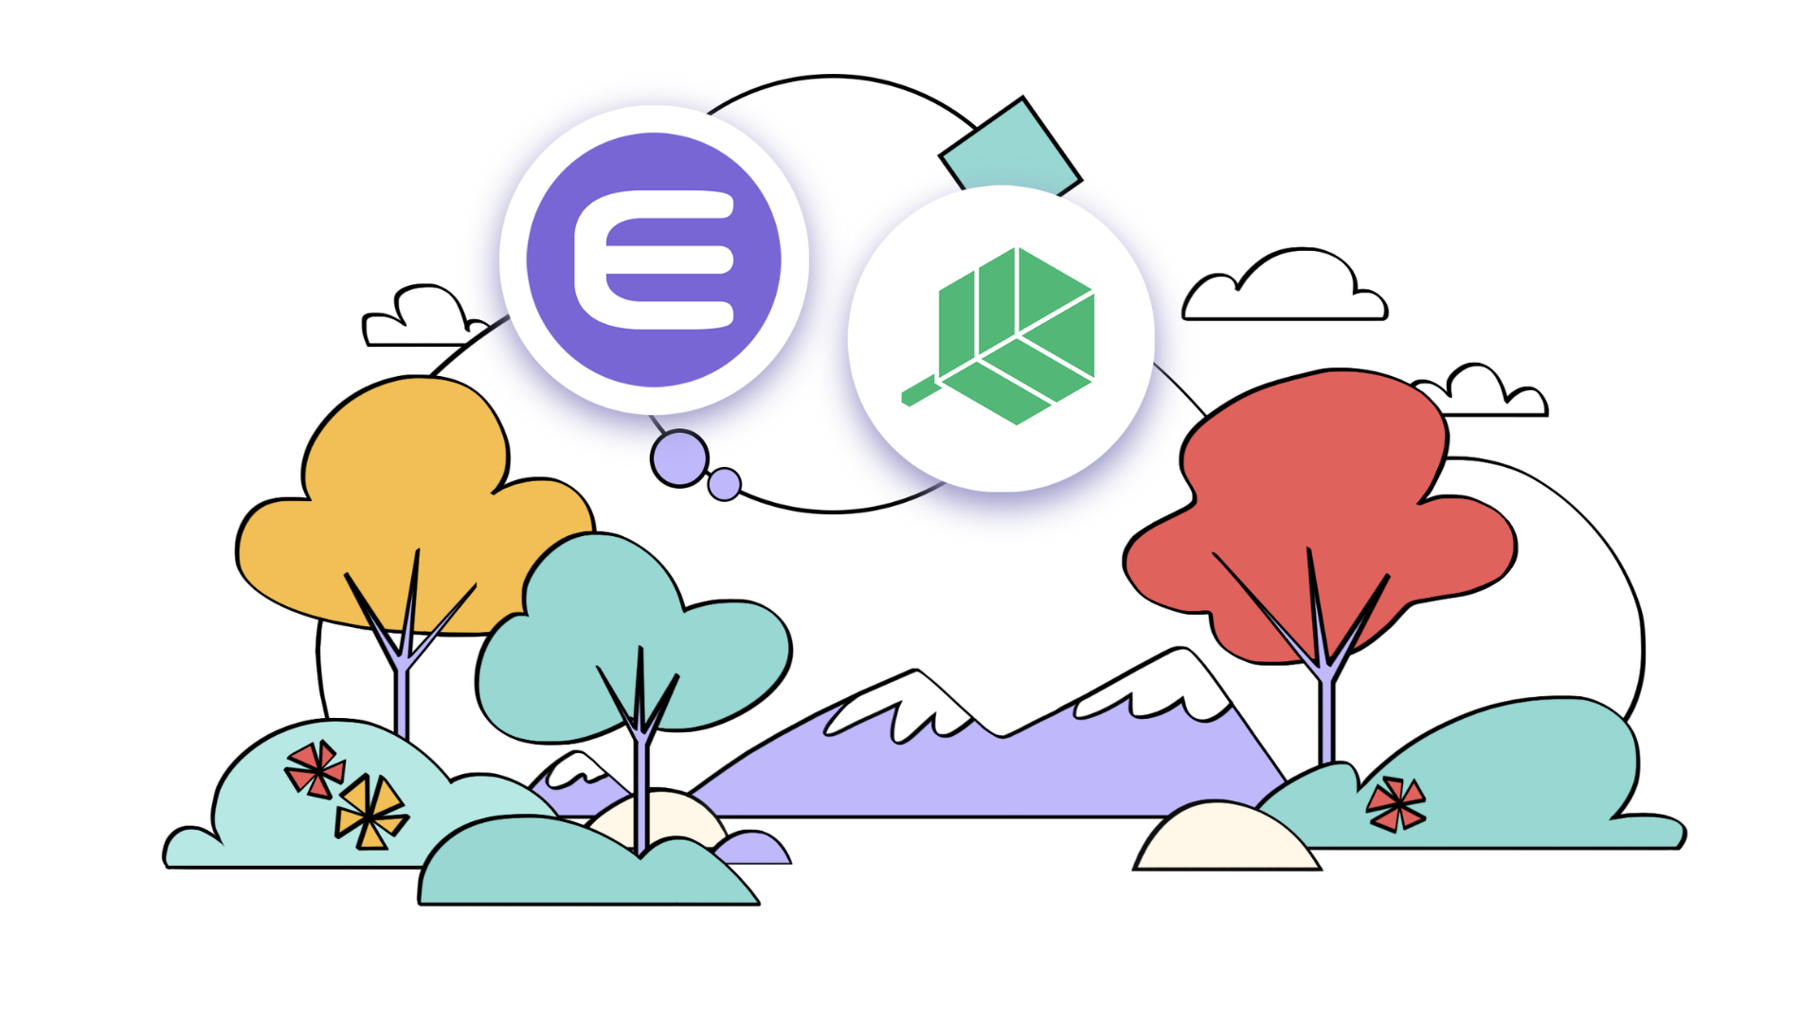
Singapore /June 24, 2021/ - Enjin, the leading non-fungible token (NFT) ecosystem provider and creator of the ERC-1155 token standard, has joined the Crypto Climate Accord, an initiative focused on decarbonizing the cryptocurrency industry. In support of the Accord’s mission, Enjin has also announced that its JumpNet blockchain is now carbon negative.

JumpNet already uses less energy than the average U.S. household and 99.99% less electricity than Ethereum. By acquiring carbon offset credits through Beyond Neutral, Enjin has now made JumpNet carbon negative, offsetting a higher amount of carbon than it produces.

“We are happy to see Enjin join this fast-growing community of companies that want to build solutions to decarbonize the crypto sector,“ said Doug Miller, Global Markets Lead at Energy Web. “The race is on for someone like Enjin to lead the way with delivering proof of green NFTs while promoting standard energy and carbon industry practices.”

Blockchain has faced heightened scrutiny among media, politicians, and celebrities due to its environmental impact. JumpNet provides a direct response to this criticism, offering an eco-friendly, free solution for creators, developers, and brands to utilize NFTs.

Home to NFTs from leading companies like Microsoft, Binance, CoinMarketCap, and Korea’s largest social gaming app GameTakTalk, JumpNet has already been used to create over 1.6 million blockchain assets without any gas fees. Most recently, leading tech discovery platform Product Hunt used the network to give away 25,000 carbon-negative video NFTs for free to its community. In comparison, hosting a similar NFT marketing campaign on Ethereum would’ve cost hundreds of thousands of dollars in gas fees.

“It’s crucial to consider our planet first, even while innovating. The creation of new forms of technology should never come at the cost of destroying our environment,” said Enjin CEO Maxim Blagov. “Carbon neutrality for JumpNet is an important step toward our vision of a sustainable NFT ecosystem for Enjin and our partners.”

Earlier this year, Enjin announced its intention to take JumpNet and its upcoming Polkadot parachain, Efinity, carbon neutral by 2030. JumpNet has achieved this goal nine years ahead of schedule, and Enjin will work with Parity Technologies to fast track the development of a sustainable Efinity parachain.

On July 8, Enjin will join fellow Crypto Climate Accord signatory Gryphon Digital Mining in an event hosted by the United Nations Interregional Crime and Justice Research Institute (UNICRI). The panel will discuss the importance of creating sustainable blockchain solutions to address inequality, discrimination, and unemployment across developing countries.

ABOUT ENJIN
Enjin is the leading ecosystem of blockchain software products that make it simple for anyone to develop, trade, monetize, incentivize, and market with blockchain. The Enjin Platform powers the creation of unique digital assets and marketplaces that underpin the next generation of the digital economy. The Enjin ecosystem powers many of the world’s pioneering blockchain games, applications, and projects created by talented developers and forward-thinking companies. For more information, visit enjin.io.

ABOUT THE CRYPTO CLIMATE ACCORD
Launched by Energy Web, the Alliance for Innovative Regulation, and RMI, the Crypto Climate Accord is a private sector-led initiative committed to making the cryptocurrency industry 100% renewable. The Accord brings together the crypto and fintech industry to build a sustainable future for global finance with support from the United Nations Framework Convention on Climate Change (UNFCCC) Climate Champions. For more information, visit cryptoclimate.org.

