Dvision Network Adopts Enjin to Launch Metaverse Across Five Blockchains
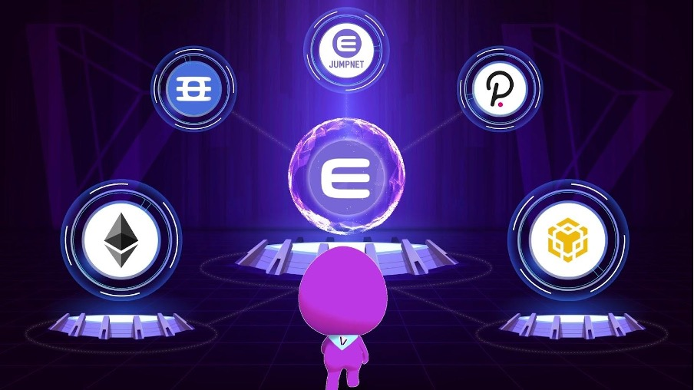

SEOUL, 28 July 2021 — Dvision Network, a South Korea-based blockchain metaverse built on Ethereum and Binance Smart Chain, has joined the Enjin ecosystem. Expanding into a multichain platform, Dvision aims to become the first Metaverse to run on five blockchains, with plans to integrate Efinity, Polkadot, and Enjin’s carbon-negative JumpNet network.

Dvision will use Enjin’s platform and API to mint non-fungible tokens (NFTs) for avatars, real estate, and decor, and integrate them into its metaverse character and world creators. This will allow users to design unique avatar NFTs through Dvision’s character creator, then mint them on their preferred blockchain. Users will then be able to use Enjin’s network of bridges to move their NFTs seamlessly across the different blockchains.

[Optional - Embed Video https://youtu.be/qm9Jtd11-OE]

Users will also be able to acquire real estate NFTs that allow them to create their own worlds within the Dvision metaverse. They will be able to mint furniture and decorations through Dvision’s cross-chain minting platforms that can be placed inside the properties.
“We fully recognize the necessity for improving the usability of NFTs,” said Jung Hyun Eom, CEO of Dvision Network. “With Ethereum-based NFTs, the creation and possession of the items has come at a major cost for players, who have had to pay huge amounts of money for simple in-game transactions. With the help of Enjin, we will allow users to create NFTs for free, and let the market decide the price, without the burdensome gas fees.”

Dvision will also host a multi-chain marketplace where NFT creators and collectors can mint and trade their unique NFT creations on their blockchain of choice, further encouraging interoperability of the blockchain ecosystem.

Users interested in exploring Dvision Network can do so during the upcoming Luniverse Partners Day event on July 29-30. Following this event, the team plans to open the cross-chain metaverse publicly in Q3 2021.

About Enjin
Enjin is the all-in-one platform for developing scalable, interoperable blockchain ecosystems, making it simple for anyone to adopt NFTs. NFTs are central to the Enjin ecosystem, which offers a comprehensive product stack for creating, integrating, trading, and distributing NFTs on a scalable and almost-zero fee platform. Enjin’s products see wide application in blockchain games, applications, enterprise programs, and innovative marketing campaigns. For more information, visit https://enjin.io.

About Dvision Network
Dvision Network provides web-based real-time streaming 3D VR metaverse service so that users can easily experience metaverse contents such as fairs and games. On the Division platform, anyone can easily create NFT items without any development-related expertise. Division’s NFT trading system enables monetization by directly connecting creators and consumers without intermediaries. This serves to connect the virtual world to reality. All these products are powered by the Dvision Network utility token DVI, which is listed on several exchanges, including Uniswap, Bittrex, Indodax, Bithumb, Coinone, and PancakeSwap.

