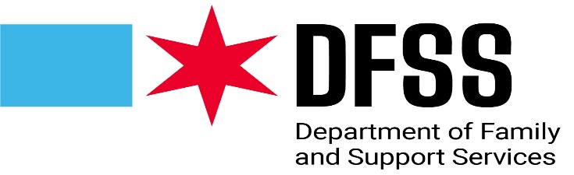

Delegate Agency Parent Committee/Policy Committee Tracking Form
DUE TO DFSS Annually on November 30th

Please provide DFSS with the following information as it relates to the orientation and establishment of your parent and policy committees.

Delegate Agency Name
Name/Title of Person Completing Form
Contact Number
Email Address
How often does your center Parent Committee(s) meet?
How often does your Delegate Agency Policy Committee meet?
For multiple site reporting, indicate: Page _____of _______

(For multiple sites, please indicate site and date of parent orientation)

Name of  Delegate Agency Site | Date of Parent Committee Orientation | Date of 1st Parent Committee Meeting

Policy Committee Established

Date of First Policy Committee Meeting

