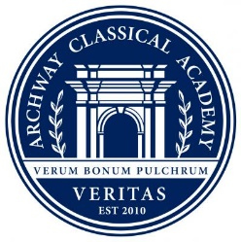

Latin Instructor Job Description

Purpose of the Role
To teach Latin and to nurture a joy and love of Latin. Your role will depend partly on your skills, experience and preferences and we would like you to be willing and able to teach Latin across the age range.

Curriculum: 4th & 5th grades: provided by University of Dallas, Classical Languages. It is the expectation that 4th & 5th grade students receive Latin instruction two times/week. As this is a new curriculum for Archway Veritas, for the 2021 – 2022 school year 4th & 5th grade students will receive the same Latin instruction, meaning the weekly lesson planning will be used for both grade levels.

Curriculum: 6th grade: Linqua Latina/taught daily

Core Duties
1. To implement the Latin syllabus in line with the University of Dallas’ Latin scope and sequence.
2. To manage the development plan for the learning of Latin in the school.
4. To teach Latin to 4th – 6th grade students, ensuring that the students have the skills and knowledge to provide a good foundation for Latin whilst also developing a love for and enjoyment of the language and classical civilization.

5. To monitor and assess the progress of the students taught to ensure that their potential is being recognized and developed and issues are identified and addressed.

6. To keep staff and parents informed of the progress of students through the School’s assessment and reporting systems.

Additional duties
If a part-time position, there are no other additional duties. If full-time, all faculty members are asked to have either a morning or afternoon duty monitoring students.

Key Skills, Experience and Qualities
● A university/college graduate
● At least Latin ‘B’ level
● An enthusiasm for working with children and an appreciation of time spent in their company
● The ability to develop good relationships with students of varying backgrounds, interests, and personalities
● Confidence and sensitivity in dealing with parents
● Teamworking skills
● Interests and hobbies that can be shared with children

Responds to: The Headmaster(s)

Remuneration
The School has its own salary scale. The salary for this role will depend on the skills and experience of the successful candidate.

