**Email signatures**

Suggested text for email signatures:  
  
**Option 1**

We are proud to promote and support the [Mindful Business Charter](https://mindfulbusinesscharter.com/)



**Option 2**

We are proud signatories of the [Mindful Business Charter](https://mindfulbusinesscharter.com/)



**To change a signature in Outlook, follow these steps:**

Select and copy the text above

Open a new blank email

Click on Signature, then Signatures

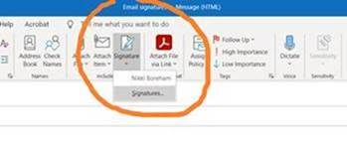  
Paste in the text and edit your details accordingly

Click ok

**Social Media**

A selection of images can be designed to accompany wording, for example:

As a company, we have signed up to the Mindful Business Charter which provides a practical framework that encourages us to be more thoughtful about the impact we have on each other. It allows us to talk openly and honestly with others, by providing a common language built on four pillars.

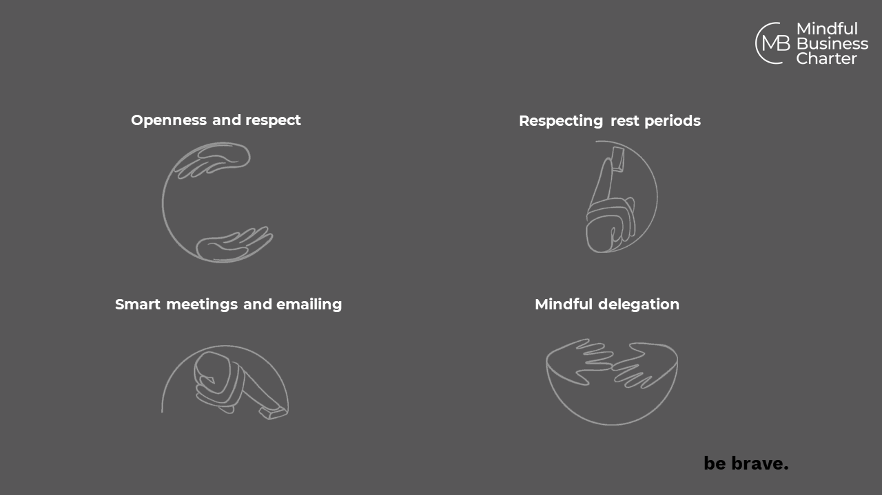

The members area of the website contains a range of MBC logos which you are free to use.

**Website**

Bespoke wording for each website, but all to include the link to the MBC should anyone wish to find out more.