INTERNAL EMAIL ETIQUETTE
GUIDELINES
As part of (COMPANY)’s commitment to the Mindful Business Charter, ensuring the health and wellbeing of our employees is of fundamental importance to us. There are many things that we as a firm can do to promote this and one particular area relates to our use of email.
Please note that these guidelines are intended for use with respect to internal emails.
The firm is committed to the Mindful Business Charter (MBC), the main principles of which are based on communication, respect, and consideration. We can all promote and support these principles and embed a more efficient way of working, through smarter, more considered use of email.
These guidelines are not intended to be strictly applied rules, rather they are aimed at encouraging a more thoughtful, considered and ultimately efficient and effective use of emails which respects everyone’s time, wellbeing, and individual way of working.
In light of this, we ask that all employees take a NANO second before issuing emails. The aim is that, where possible, we avoid situations where our use of emails may unnecessarily cause stress or anxiety to our colleagues.
Take a NANO second to consider some key areas before sending an email:
- Necessary?
For example, is it necessary that the recipient see this email now, particularly when now might be over the weekend / late in the evening?
- Attendees?
For example, is it necessary to include all the recipients? Do they all need to ‘attend’ to the email?
- Notice?
For example, am I giving adequate notice to recipients of the actions required and have I communicated a clear deadline for any urgent email?
- Objective?
What is the objective of this email, have I considered the best way to achieve this, noting the guidelines of our Email Etiquette policy and have I clearly communicated this objective to the recipient?
- Non-Urgent Emails
Take a NANO second to consider the impact of sending non-urgent emails outside of standard working hours. There are of course certain situations where emails are urgent and, by their very nature, require immediate action outside of the usual working day and item 2 below includes some suggestions on how to deal with urgent emails.
However, in the case of non-urgent emails it is recommended to consider the impact on the intended recipient, particularly with respect to the timing of sending. In this case, a good question to ask is “Does the recipient need to see this now”. This is perhaps most relevant in cases where the recipient might incorrectly interpret the email as requiring immediate action late in an evening, or over a weekend.
In many circumstances, whilst the recipient might not need to see an email immediately, it may nevertheless be convenient or necessary for the sender to prepare the email for sending in advance. For example, they may have a full diary the next day or be in meetings or at court.
In this case, a useful function on Outlook, is the option to ‘delay delivery’, which will simply store your email in the outbox to be issued at the time and date that you have set. The body of the email should ideally also state the deadline for the response and seek active confirmation from the recipient that the proposed deadline is achievable and if not, for them to suggest an alternative that is achievable.
Please note that you must be logged into Outlook at the intended time of sending for delay delivery emails to be activated. If not, they will be sent the next time you log into Outlook. See screen shots below on how to use the ‘delay delivery’ option.
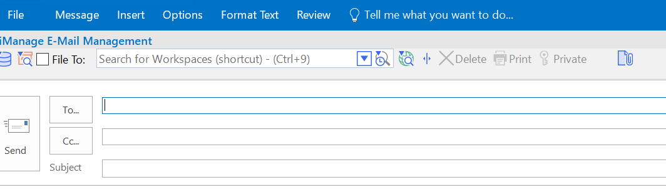
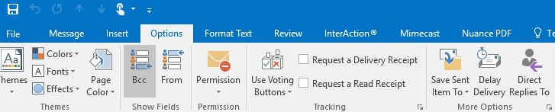
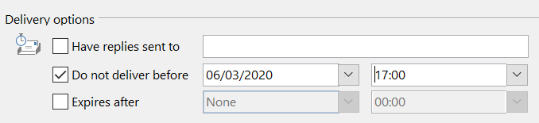
- Urgent Emails
Take a NANO second to consider whether an email is in fact urgent and, if it is, how best to communicate this to the recipient.
By way of guidance, urgent emails are those requiring immediate action or response within a small timeframe. Urgent emails should be marked ‘Urgent’ in the subject line so that the recipient can immediately identify that the email is urgent.
The body of the email should state the deadline for the response and seek active confirmation from the recipient that the proposed deadline is achievable and if not, for them to suggest an alternative that is achievable.
It is also strongly recommended best practice that any urgent email or matter requiring prompt action is followed up with a call to the recipient to confirm understanding of the action and deadline required.
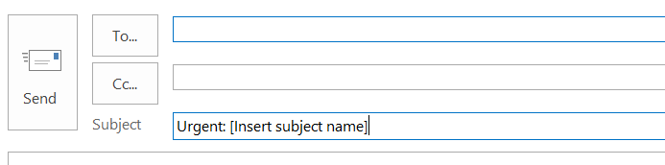
It is also advisable to use the ‘priority flags’ when issuing an urgent communication via email.
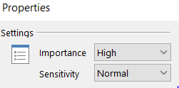
- Internal out of office
In order to effectively implement the guidelines suggested in 1 and 2 above, it is also recommended to consider the use of the internal out of office function on Outlook. This allows an out of office automated response to be sent only to Matheson contacts. This can be very useful if you are for example, in board meetings or attending court for a large portion of the day and unlikely to be able to monitor or respond to emails. It also allows for urgent emails to be redirected, where possible or appropriate.
- Using ‘cc’ on email
Please take a NANO second and consider whether it is necessary to ‘Cc’ an individual on an email before you hit send. This is recommended from a practical standpoint, to help reduce overloaded inboxes but also to mitigate the possibility of an individual incorrectly interpreting an email as requiring action.
The ‘Cc’ function is often used for “fyi” purposes which is useful way of ensuring team members are kept up to date on various work streams. However, it should generally be assumed that anyone who is Cc’d on an email is not expected to respond.
If a response or action is required of a recipient, that individual should be included in the “To” line and this should also be clear from the body of the email.
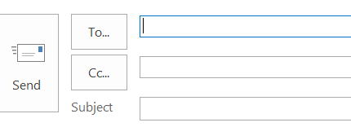
- Using ‘Reply All’ on email
If you are one of many Cc’d on an email, it is assumed, as outlined in point 4 above that you are not expected to respond. If however you would like to respond to the sender, then take a NANO second to consider whether or not it is necessary to include all recipients on your response.
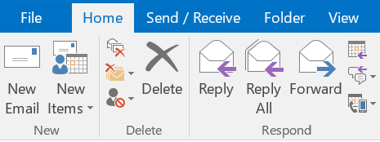
- Applying full transparency on use of emails
In the interests of transparency, take a NANO second to consider whether it is really necessary to use the ‘Bcc’ function on any internal emails. A good question to ask is, would you use the Bcc function if the recipient was aware of the individual blind copied and the purpose for doing this.
Bcc can be extremely useful in arranging for filing of emails and diary management. However, if you have doubts about the recipient’s potential reaction to the use of Bcc in any circumstance it is worth taking a NANO second to consider this further.
Similarly, forwarding emails is often extremely useful for sharing relevant information with other team members. In the interests of transparency and collegiality, take a NANO second to consider how the sender would interpret any forwarding of their email, or copying the sender for their information too.
For the avoidance of doubt, forwarded emails should never be altered or amended in any way.
Summary
The primarily aim of the MBC and these guidelines, is to help to reduce stress levels by enabling our colleagues to manage daily demands and workloads better. It also promotes a more positive work-life blend for everyone at Matheson.
If you have any queries in relation these guidelines or suggestions for their improvement, please feel free to contact Lorraine Roche or Phil Lovegrove in the first instance.

