Priority Service Plan Renewal

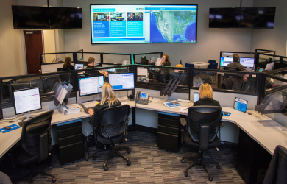

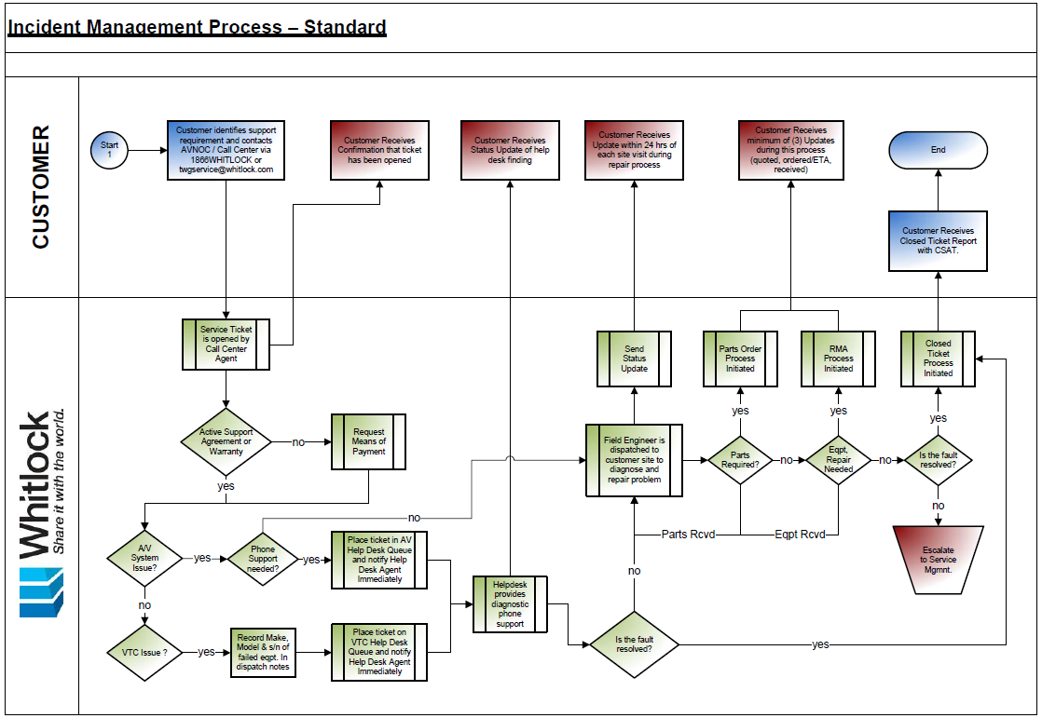



Texas Division of Emergency Management

Statewide Operations Center AV

Prepared For:

TDEM SOC AV

**Submitted to:**

Michael Ouimet

TDEM

Michael.ouimet@tdem.texas.gov

(512)921-9671

**Technical Point of Contact:**

Blair Ferrier

TDEM

[Blair.ferrier@tdem.texas.gov](mailto:Blair.ferrier@tdem.texas.gov)

(512)547-7115

**Submitted by:**

Craig Orris Taylor

Key Account Manager

taylorc@whitlock.com

DIR Contract Number DIR-TSO-3875



**Date Revised: 06.12.2020**

**Contents**

**Warranty Statement & Priority Service Plan** 3

Standard Workmanship Warranty 3

Manufacturer’s Warranty 3

Priority Service Plan 3

Comparison Chart 4

Managed Service Hours (Optional) 5

Annual Premium 5

Agreement Period 6

Service Engagement Procedure 6

Service Hours 6

Critical Spares & Other Recommendations 7

Value-Added Services 8

Appendix A – Covered Equipment List 9

Attachment 1 – Critical Spares List 9

Attachment 2 –Preventive Maintenance Procedures (General) 10

## **Warranty Statement & Priority Service Plan**

### Standard Workmanship Warranty

Whitlock warrants that our installation services will be free of defects in workmanship for a period of 12 months following first beneficial use of the equipment. Travel expenses to and from the site are not included as part of this warranty. Any equipment or software is subject solely to limited warranties offered by the manufacturer of such equipment or software, if any. In most cases, the manufacturer does not provide for system fault isolation and other on-site services such as removal and replacement of equipment, etc. To bridge this gap, and to ensure the system is properly maintained during the warranty period, Whitlock includes a Priority Service Plan with every project.

### Manufacturer’s Warranty

Typically, a manufacturer’s warranty covers parts and labor to repair the equipment, but the equipment must be returned to the manufacturer’s facility or their authorized service center (ASC) for warranty repair. System diagnostics, removal, replacement and post repair testing along with shipping cost to ship the unit the ASC are typically not included with equipment warranties.

### Priority Service Plan

The Whitlock Priority Service Plan (PSP) has been specifically designed to provide comprehensive on-site technical support for integrated audiovisual and video teleconference systems to ensure they are properly maintained throughout the life of the system. All A/V Systems and rooms located at the TDEM-SOC on 5805 N. Lamar, Austin Texas and integrated by Whitlock are covered under this Statement of Work (SOW). Services include:

* An assigned Field Engineer trained on your system with trained back-ups on standby
* Access to our AVNOC (866-WHITLOCK) or  [Service@whitlock.com](mailto:%20Service@whitlock.com) for dispatch, parts procurement and service tracking
* Semi-annual preventive maintenance checks and services performed by factory trained Field Engineers
* No charge for labor for equipment repairs performed on-site and at Whitlock depot facilities
* Guaranteed 2 hour phone response and 24 hour (NBD) emergency on-site response
* Service and support is provided during normal working hours (M-F 8:00AM – 5:00PM)
* Standard ground shipping is included for in-warranty repairs
* No charge for installation of firmware and software up-grades on system components
* Unlimited phone support
* Cost plus 15% on parts and out-of-warranty equipment repairs

1. Consultation on system upgrades
2. Detailed inventories of covered equipment

*\* General purpose computer and network hardware is assumed to be directly supported by the customer’s IT organization and is excluded from this service plan unless specifically stated otherwise.*

### Comparison Chart

The chart below provides a quick comparison of coverage between workmanship warranty, manufacturer’s equipment warranty and the Whitlock Priority Service plan.

|  |  |  |  |
| --- | --- | --- | --- |
| **Coverage** | **Typical Manufacturer Warranty** | **The Whitlock Standard Workmanship Warranty** | **Whitlock Priority  Service Plan** |
| Repair/Replacement of defective parts during warranty period | X | X | X |
| Factory and/or Whitlock shop labor to repair defective parts under warranty | X | X | X |
| Travel time and expenses to troubleshoot covered defective parts under warranty |  |  | X |
| Travel time and expenses to troubleshoot defective parts out of warranty and/or owner furnished |  |  | X |
| On-site labor to disconnect and box up defective parts |  |  | X |
| On-site labor to troubleshoot defective parts purchased through Whitlock under warranty |  |  | X |
| On-site labor to diagnose system malfunctions, remove and replace failed components and restore system functionality |  |  | X |
| Standard shipping of defective parts to manufacturer |  |  | X |
| Standard return shipping of defective parts back to customer | X | X | X |
| Regular Scheduled Preventive Maintenance Checks & Services for improved system reliability |  |  | X |
| Escalated guaranteed Emergency on-site response times |  |  | X |
| Additional end-user training and consultation |  |  | X |
| Loaners of comparable equipment during extended repairs (limited to available stock) |  |  | X |
| Unlimited phone support and consultation |  | X | X |
| Cost plus pricing on out-of-warranty repairs, parts & consumables, such as lamps, CRT's, PDP's, Optics, LCD panels, etc. |  |  | X |
| Trained Whitlock Service Technician and Backup |  |  | X |
| Detailed inventories and repair logs on covered equipment |  |  | X |

### Managed Service Hours (Optional)

Managed Service Hours (MSH) are prepaid service hours that may be added to the Priority Service Plan to be used for scheduled ad hoc technical support outside normal preventive maintenance visits and break-fix service calls. Some examples include: technical support for special events, recurring executive meetings, back-up support for on-site staff, user training, etc.

* Managed Service Hours are only available as an added service under the Whitlock Priority Service Plan.
* Rate: Managed Services Hours may be purchased at a base rate of $100/hr in blocks of ten (10) hours for services during normal working hours. Support for after-hours events shall be charged a 1.5X base rate.
* Usage: Managed Service Hours are intended to provide operational and technical support for scheduled events employing systems covered under our Priority Service Plan.
* Scheduling: We request that you always schedule Managed Service Hours usage a minimum of one (1) week in advance.
* Unused Managed Service Hours may not be carried over from one contract period to another.

### Annual Premium

The Annual premium to provide Whitlock Priority Support for the AV Systems and rooms at the TDEM SOC located at 5805 N. Lamar, Austin TX 78752, is as follows. Note: This Priority Service Plan covers preventive maintenance services and on-site support not typically covered under a basic workmanship warranty or the equipment manufacturer’s warranty. Please see accompanying system proposal for a list of covered equipment. All AV Systems and rooms integrated by Whitlock are covered under this Statement of Work (SOW). A sample “Covered Equipment List” is included in Appendix A.

|  |  |  |  |
| --- | --- | --- | --- |
| Agreement Period | Whitlock PriorityService Plan List Price | DIR % Discount off List | Total Premium Due |
| Year 5 (9/1/20 – 8/31/21), also known as 4th Renewal Term | $14,400 | 3% | $13,968.00 |
|  |  |  |  |

***1****Year 5 of Whitlock PSP is quoted under terms of current State of Texas DIR Contract Number DIR-TSO-3875. Annual premium has been stabilized for these renewal periods.*

*The pricing in this proposal is based on invoicing the premium in advance. All pricing reflects a discount for payment via check, ACH, or wire transfer and does not include sales taxes or other similar taxes as applicable.*

### Agreement Period

The agreement period will begin upon successful completion of the project as defined in the Warranty paragraph above.

### Service Engagement Procedure

Upon completion of the system integration, please follow the steps below to engage our Managed Services team for any warranty or service issues that may arise.

1. Call 1-866-Whitlock (1-866-944-8562) or,
2. Email your service request to [service@whitlock.com](mailto:service@whitlock.com)
3. Please identify yourself, the street address of the service location and room requiring support.
4. Please state the nature of the problem with as much detail as possible and the room availability.
5. If the problem is video teleconference related, please be prepared to provide our service coordinator the serial number of the video teleconference component requiring support
6. Routine Preventive Maintenance Checks & Services will be proactively scheduled in advance. Whitlock Field Engineers clean, inspect, align and adjust all systems and components to optimize performance and system reliability. See Attachment 2 for general preventive maintenance procedures.

### Service Hours

Services under this agreement shall be provided during normal working hours M-F 8:00AM – 5:00PM. After hours support shall be provided at a discounted hourly rate of $140/hr.

### Critical Spares & Other Recommendations

**Consumables**: Spare lamps and filters should always be maintained on-site for use as needed to minimize downtime in the event of failure.

**Video Conference Equipment**: We highly recommend you maintain your video teleconference equipment under the manufacturer’s extended warranty program at all times. These programs typically guarantee next business day (NBD) advance replacement equipment, critical software upgrades and helpdesk services. Without these programs in place, out-of-warranty repair to VTC hardware could take up to six (6) weeks to facilitate. As a platinum level service provider to all VTC manufactures we are authorized to facilitate the warranty program under our Partner “Core Services” program.

**Critical Spares**: If your operational requirements indicate a low tolerance for down time, pre-purchasing critical spares and stocking them on-site is the key to rapid field service of your systems. While our Field Engineers are well versed at quickly diagnosing problems and fashioning a work-around or installing temporary components to restore system functionality during off-site repair periods, catastrophic failure of a critical component can lead to unplanned downtime. Purchasing spares can be expensive and is not for everyone. However, if your system is “mission critical”, provisioning spares is an essential part of a well thought out service plan. If included, Critical Spares shall be identified in Attachment 1.

**Contingency Funds**: We do not typically recommend prepaying for extended warranty coverage on AV equipment. First, most manufacturers do not offer extended warranty on their equipment and when they do it typically runs 10-12% of the replacement cost. Purchasing an extended warranty is akin to purchasing an insurance policy on the equipment. At the end of the year, if the component does not fail, you have thrown good money away. Our standard Priority Service Plan provides for cost+ pricing on out-of-warranty repairs and replacement components. The idea is simple: Include a line item on your service agreement PO to be used for parts and out-of-warranty repairs as needed. At the end of the year, the remaining funds are yours to keep. This money can then be used to fund the purchase critical spares, upgrade obsolete components, or be applied toward to on-going support of your system the following year.

### Value-Added Services

On-going technical support is not the only thing Whitlock Priority Support brings to your organization. Centralized Service Coordination and Configuration Management are a couple key value-added services you receive with Whitlock Support.

**Centralized Service Coordination:**

Whitlock operates a multi-region, nationwide Support Services organization. Enterprise-level customers with multiple locations throughout the North America may utilize our National Service Center (NSC) for centralized dispatching and service coordination. Our coordinators can connect you with our VTC & AV Helpdesk for phone support, order parts, process RMA’s or dispatch a field service engineer to your site as needed.. Service may be requested on-line, emailed or called in. Centralized services include:

* Service Ticket Origination and Tracking
* Dispatch
* Parts procurement
* RMA Processing for equipment repairs
* Service History Database Management
* Asset Management – Critical Spares and Loaner Sharing between sites
* Customer Satisfaction Polling
* Contract Billing

**Configuration Management:**

* **Hardware Support** - Whitlock takes care to provide coordinated and consistent support to our customers where similar or standardized system design practices are in place. Where standards are not in place we encourage and help our customers to create and implement system standards. When products are discontinued and support for obsolete components become an issue, we will recommend and help specify and implement a phased upgrade plan as applicable.
* **Software Support** – Firmware and software upgrades are a way of life today. Under the terms of our service agreement we will coordinate the implementation of all available upgrades on a routine basis (typically at scheduled preventive maintenance visits). If a software or firmware upgrade is deemed critical to improved system operation, field engineers will be immediately dispatched to all sites to perform the upgrade. Note: In some cases, a software or firmware upgrade could have an adverse effect on system interoperability. For this reason, it is typical that only “critical” or operationally beneficial upgrades are normally implemented.
* **Control System Support** – Whitlock employs fully certified programmers in both AMX and Crestron systems. In addition, our Field Engineers are also trained and experienced at making routine control system modifications as needed when components are replaced during routine maintenance. It is understood that any such modifications will be made under strict control and direction of the owner’s governing technical organization.

### Appendix A – Covered Equipment List

All A/V Systems and rooms located at the TDEM-SOC at 5805 North Lamar, Austin, Texas and integrated by Whitlock are covered under the terms of this agreement. A basic equipment inventory will be conducted during scheduled preventive maintenance visits and break fix service calls during the agreement period. That inventory will be added to this agreement upon completion. Double-Click on the icon to view the “Sample” Covered Equipment List.

Service Location:

|  |
| --- |
| **Texas TDEM SOC**  **5805 North Lamar**  **Austin TX 78752** |

### Attachment 1 – Critical Spares List

If applicable, this attachment will contain a list of spare equipment and service parts intended for use in maintaining the covered equipment & systems identified in Appendix A.

|  |  |  |  |  |
| --- | --- | --- | --- | --- |
| Qty | MFR | Model # | Description | Location |
|  |  |  | To be determined with the Customer |  |
|  |  |  |  |  |
|  |  |  |  |  |

### Attachment 2 –Preventive Maintenance Procedures (General)

General Instructions to Field Service personnel regarding Preventive Maintenance Checks and Services to integrated AV & VTC Systems are as follows:

1. Perform a detailed inspection and testing of selected system components- technical review for component failure
2. Perform mock presentation test using full audio & video system capabilities
3. Successfully complete an audio and video point-to-point and bridge call as applicable to the customer’s operation
4. Perform a complete operational checkout of the system functions via user control interface
5. Adjust audio levels and EQ as required to optimize response for voice and program sound reinforcement
6. Upgrade equipment firmware as needed
7. Reload system software, if required to restore functions or update code changes as required
8. Open and clean all filtering systems: Professional cleaning of record / playback heads, screens, projector lenses, CD and DVD lenses and other critical surfaces, as needed
9. Lubricate all moving parts as recommended by manufacturers
10. Perform geometry and color balance adjustments on projection equipment as required for optimum image quality
11. Perform detailed inventory of system components with model numbers and serial numbers on initial preventive maintenance visit. Include any spare equipment available
12. Verify inventory present on subsequent preventive maintenance visits and report missing or damaged hardware on PM Report
13. Dust and clean surfaces of all rack and podium equipment
14. Document lamp runtime and general condition of projection equipment using Projector Status Cards
15. Identify and repair any faulty wiring or connections in the system and correct other operating conditions that are not within industry standards
16. Complete PM Check Sheet and issue report to customer. Include recommendations for any additional services and upgrades and note all outstanding service issues with follow-up action required.
17. Open service tickets on any outstanding issues

**Double-click to view**

