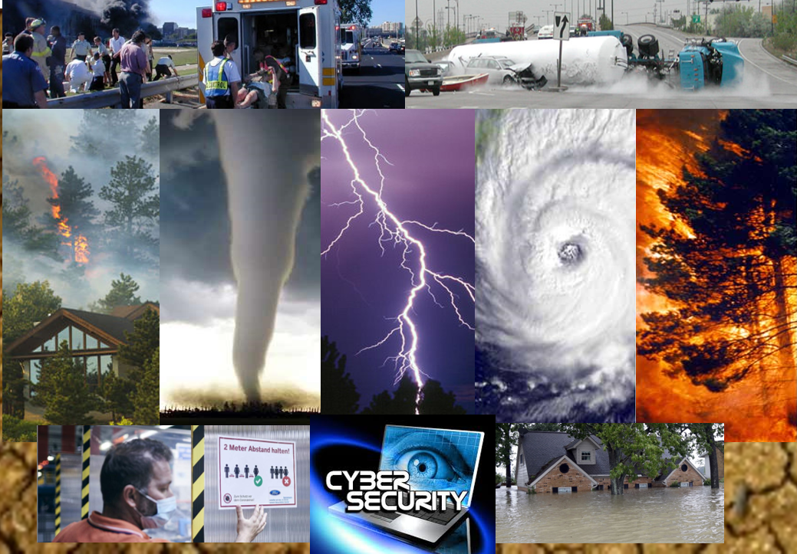

All Hazards [Seminar/Workshop]

After-Action Summary Report
[Date]

The After-Action Summary Report aligns objectives with preparedness doctrine to include the National Preparedness Goal and related frameworks and EMPG guidance.

Instructions: Delete these instructions once report is completed.
This Summary Report may be used to request a seminar or workshop EMPG credit.
Please follow the 2020 EMPG guidance:

A seminar or workshop maybe credited to the jurisdiction as a discussion-based exercise. The After-Action Summary Report should include documentation that a minimum of two (2) core capabilities for seminars and three (3) for workshops.

EMPG funded jurisdictions should consult current FY grant guidance and direct questions to the Finance and/or Exercise Unit.

Fill in your jurisdictional information in all areas shaded in gray.
Delete items that do not apply.

Exercise Overview

Exercise Name
Date(s)
Type
(Seminar or Workshop)
Scope
(local, regional, state, multi-jurisdictional)
Mission Area(s)
(Prevention, Protection, Response, Recovery, Mitigation)
Core Capabilities  (check all that apply, minimum 2 for Seminars and 3 for Workshops) |  |  | ﻿﻿Access Control and Identity Verification
 |  |  | Community Resilience
 |  |  | Critical Transportation
 |  |  | Cybersecurity
 |  |  | Economic Recovery
 |  |  | Environmental Response/Health and Safety
 |  |  | Fatality Management Services
 |  |  | Fire Management and Suppression
 |  |  | Forensics and Attribution
 |  |  | Health and Social Services
 |  |  | Housing
 |  |  | Infrastructure Systems
 |  |  | Intelligence and Information Sharing
 |  |  | Interdiction and Disruption
 |  |  | Logistics and Supply Chain Management
 |  |  | Long-Term Vulnerability Reduction
 |  |  | Mass Care Services
 |  |  | Mass Search and Rescue Operations
 |  |  | Natural and Cultural Resources
 |  |  | On-scene Security, Protection, and Law Enforcement
 |  |  | Operational Communications
 |  |  | Operational Coordination
 |  |  | Physical Protective Measures
 |  |  | Planning
 |  |  | Public Health, Healthcare, and Emergency Medical Services
 |  |  | Public Information and Warning
 |  |  | Risk and Disaster Resilience Assessment
 |  |  | Risk Management for Protection Programs and Activities
 |  |  | ﻿Screening, Search, and Detection
 |  |  | Situational Assessment
 |  |  | Supply Chain Integrity and Security
 |  |  | Threat and Hazard Identification
 |  |  | Other (Add your own)
Objectives
(Add your objectives)
Threat or Hazard
Scenario
Major Strengths
Point of Contact |  | Name:  Title:  Phone:  Email:

Exercise Discussion Summary

Instructions: Delete this shaded area after report is completed.
All FEMA core capabilities are listed below but only select ones applicable to your exercise. Delete the rest.
Enter your observations or discussion highlights associated with each core capability in the space provided.

Core Capability
﻿Access Control and Identity Verification
Mission Area: Protection
Description: Apply and support necessary physical, technological, and cyber-measures to control admittance to critical locations and systems.

Observations:

Core Capability
﻿Community Resilience
Mission Area: Mitigation
Description: Enable the recognition, understanding, communication of, and planning for risk and empower individuals and communities to make informed risk management decisions necessary to adapt to, withstand, and quickly recover from future incidents.

Observations:

Core Capability
﻿Critical Transportation
Mission Area: Response
Description: Provide transportation (including infrastructure access and accessible transportation services) for response priority objectives, including the evacuation of people and animals, and the delivery of vital response personnel, equipment, and services into the affected areas.

Observations:

Core Capability
﻿Cybersecurity
Mission Area: Protection
Description: Protect (and if needed, restore) electronic communications systems, information, and services from damage, unauthorized use, and exploitation.

Observations:

Core Capability
﻿﻿Economic Recovery
Mission Area: Recovery
Description: Return economic and business activities (including food and agriculture) to a healthy state and develop new business and employment opportunities that result in an economically viable community.

Observations:

Core Capability
﻿Environmental Response/Health and Safety
Mission Area: Response
Description: Conduct appropriate measures to ensure the protection of the health and safety of the public and workers, as well as the environment, from all-hazards in support of responder operations and the affected communities.

Observations:

Core Capability
﻿﻿Fatality Management Services
Mission Area: Response
Description: Provide fatality management services, including decedent remains recovery and victim identification, working with local, state, tribal, territorial, insular area, and federal authorities to provide mortuary processes, temporary storage or permanent internment solutions, sharing information with mass care services for the purpose of reunifying family members and caregivers with missing persons/remains, and providing counseling to the bereaved.

Observations:

Core Capability
﻿Fire Management and Suppression
Mission Area: Response
Description: Provide structural, wildland, and specialized firefighting capabilities to manage and suppress fires of all types, kinds, and complexities while protecting the lives, property, and the environment in the affected area.

Observations:

Core Capability
﻿Forensics and Attribution
Mission Area: Prevention
Description: Conduct forensic analysis and attribute terrorist acts (including the means and methods of terrorism) to their source, to include forensic analysis as well as attribution for an attack and for the preparation for an attack in an effort to prevent initial or follow-on acts and/or swiftly develop counter-options.

Observations:

Core Capability
﻿﻿Health and Social Services
Mission Area: Recovery
Description: Restore and improve health and social services capabilities and networks to promote the resilience, independence, health (including behavioral health), and well-being of the whole community.

Observations:

Core Capability
﻿Housing
Mission Area: Recovery
Description: Implement housing solutions that effectively support the needs of the whole community and contribute to its sustainability and resilience.

Observations:

Core Capability
﻿Infrastructure Systems
Mission Area: Response, Recovery
Description: Stabilize critical infrastructure functions, minimize health and safety threats, and efficiently restore and revitalize systems and services to support a viable, resilient community.

Observations:

Core Capability
﻿Intelligence and Information Sharing
Mission Areas: Prevention, Protection
Description: Provide timely, accurate, and actionable information resulting from the planning, direction, collection, exploitation, processing, analysis, production, dissemination, evaluation, and feedback of available information concerning physical and cyber-threats to the United States, its people, property, or interests; the development, proliferation, or use of WMDs; or any other matter bearing on U.S. national or homeland security by local, state, tribal, territorial, federal, and other stakeholders. Information sharing is the ability to exchange intelligence, information, data, or knowledge among government or private sector entities, as appropriate.

Observations:

Core Capability
﻿Interdiction and Disruption
Mission Areas: Prevention, Protection
Description: Delay, divert, intercept, halt, apprehend, or secure threats and/or hazards.

Observations:

Core Capability
﻿﻿Logistics and Supply Chain Management
Mission Area: Response
Description: Deliver essential commodities, equipment, and services in support of impacted communities and survivors, to include emergency power and fuel support, as well as the coordination of access to community staples. Synchronize logistics capabilities and enable the restoration of impacted supply chains.

Observations:

Core Capability
﻿Long-Term Vulnerability Reduction
Mission Area: Mitigation
Description: Build and sustain resilient systems, communities, and critical infrastructure and key resources lifelines so as to reduce their vulnerability to natural, technological, and human-caused threats and hazards by lessening the likelihood, severity, and duration of the adverse consequences.

Observations:

Core Capability
﻿Mass Care Services
Mission Area: Response
Description: Provide life-sustaining and human services to the affected population, to include hydration, feeding, sheltering, temporary housing, evacuee support, reunification, and distribution of emergency supplies.

Observations:

Core Capability
﻿Mass Search and Rescue Operations
Mission Area: Response
Description: Deliver traditional and atypical search and rescue capabilities, including personnel, services, animals, and assets to survivors in need, with the goal of saving the greatest number of endangered lives in the shortest time possible.

Observations:

Core Capability
﻿Natural and Cultural Resources
Mission Area: Recovery
Description: Protect natural and cultural resources and historic properties through appropriate planning, mitigation, response, and recovery actions to preserve, conserve, rehabilitate, and restore them consistent with post-disaster community priorities and best practices and in compliance with applicable environmental and historic preservation laws and executive orders.

Observations:

Core Capability
﻿﻿On-scene Security, Protection, and Law Enforcement
Mission Area: Response
Description: Ensure a safe and secure environment through law enforcement and related security and protection operations for people and communities located within affected areas and also for response personnel engaged in lifesaving and life-sustaining operations.

Observations:

Core Capability
﻿﻿Operational Communications
Mission Area: Response
Description: Ensure the capacity for timely communications in support of security, situational awareness, and operations by any and all means available, among and between affected communities in the impact area and all response forces.

Observations:

Core Capability
﻿﻿Operational Coordination
Mission Areas: All
Description: Establish and maintain a unified and coordinated operational structure and process that appropriately integrates all critical stakeholders and supports the execution of core capabilities.

Observations:

Core Capability
﻿Physical Protective Measures
Mission Area: Protection
Description: Implement and maintain risk-informed countermeasures, and policies protecting people, borders, structures, materials, products, and systems associated with key operational activities and critical infrastructure sectors.

Observations:

Core Capability
﻿Planning
Mission Areas: All
Description: Conduct a systematic process engaging the whole community as appropriate in the development of executable strategic, operational, and/or tactical-level approaches to meet defined objectives.

Observations:

Core Capability
﻿﻿﻿Public Health, Healthcare, and Emergency Medical Services
Mission Area: Response
Description: Provide lifesaving medical treatment via Emergency Medical Services and related operations and avoid additional disease and injury by providing targeted public health, medical, and behavioral health support, and products to all affected populations.

Observations:

Core Capability
﻿﻿Public Information and Warning
Mission Areas: All
Description: Deliver coordinated, prompt, reliable, and actionable information to the whole community through the use of clear, consistent, accessible, and culturally and linguistically appropriate methods to effectively relay information regarding any threat or hazard, as well as the actions being taken and the assistance being made available, as appropriate.

Observations:

Core Capability
﻿Risk and Disaster Resilience Assessment
Mission Area: Mitigation
Description: Assess risk and disaster resilience so that decision makers, responders, and community members can take informed action to reduce their entity's risk and increase
Observations:

Core Capability
﻿﻿Risk Management for Protection Programs and Activities
Mission Area: Protection
Description: Identify, assess, and prioritize risks to inform Protection activities, countermeasures, and investments.

Observations:

Core Capability
﻿﻿Screening, Search, and Detection
Mission Areas: Prevention, Protection
Description: Identify, discover, or locate threats and/or hazards through active and passive surveillance and search procedures. This may include the use of systematic examinations and assessments, bio surveillance, sensor technologies, or physical investigation and intelligence.

Observations:

Core Capability
﻿﻿Situational Assessment
Mission Area: Response
Description: Provide all decision makers with decision-relevant information regarding the nature and extent of the hazard, any cascading effects, and the status of the response.

Observations:

Core Capability
﻿﻿Supply Chain Integrity and Security
Mission Area: Protection
Description: Strengthen the security and resilience of the supply chain.

Observations:

Core Capability
﻿Threat and Hazard Identification
Mission Area: Mitigation
Description: Identify the threats and hazards that occur in the geographic area; determine the frequency and magnitude; and incorporate this into analysis and planning processes so as to clearly understand the needs of a community or entity.

Observations:

Conclusion

Instructions: Delete this area after report is completed.
Summarize the outcomes of the exercise.

Participant List

Local, State, Federal Organizations

