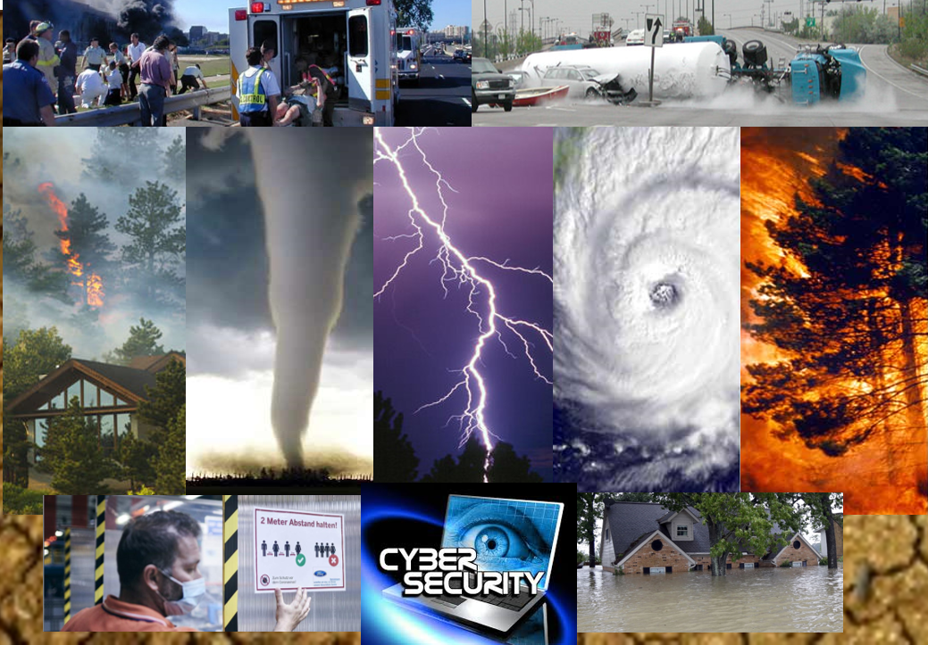

All Hazards
Real-World Response

Real-World Incident After-Action Report/Improvement Plan
[Date]

The After-Action Report/Improvement Plan (AAR/IP) aligns objectives with preparedness doctrine to include the National Preparedness Goal and related frameworks and EMPG guidance.

Instructions: Delete these instructions once AAR/IP is completed.
This After-Action Report and Improvement Plan (AAR/IP) template is designed to document your jurisdictions response to a real-world incident.

If you are receiving EMPG funding you may use it to request a full-scale or triennial full-scale EMPG credit. Please follow the current FY EMPG guidance:

An actual, Real-World Incident response maybe credited to the jurisdiction as an operational exercise credit. In addition to the full-scale exercise requirements, for triennial credit, the AAR/IP should document a minimum of three (3) of the four (4) following conditions.

1. The jurisdiction’s community leadership* and/or chief elected official or a designated representative, identified in the jurisdiction’s emergency management plan participated;

2. At a minimum, four (4) Core Capabilities were evaluated (addressing at least one (1) of the Priority Core Capabilities, indicated by the red *);

3. A declaration of local disaster was issued; and

4. The emergency response involved resources from outside the jurisdiction.

Fill in your jurisdictional information in all areas shaded in gray.
Delete items that do not apply.

* Community Leadership includes: Fire chiefs, police chiefs, sheriffs, emergency managers,
city managers, judges, mayors, public health officials, schools principals, and others in
a leadership roles, either elected or not.

Incident Overview

Real-World Incident Name
Response Dates
Date of Jurisdiction’s
Emergency Declaration
Type |  | Real-World Incident
Jurisdiction |  | City/County:
Scope
(local, regional, state, multi-jurisdictional)
Mission Area(s) (Prevention, Protection, Response, Recovery, Mitigation)
Core Capabilities  (check a minimum of four Core Capabilities) |  |  | ﻿﻿Access Control and Identity Verification
 |  |  | Community Resilience
 |  |  | Critical Transportation
 |  |  | Cybersecurity
 |  |  | Economic Recovery
 |  |  | Environmental Response/Health and Safety
 |  |  | Fatality Management Services
 |  |  | Fire Management and Suppression
 |  |  | Forensics and Attribution
 |  |  | Health and Social Services
 |  |  | Housing
 |  |  | Infrastructure Systems
 |  |  | Intelligence and Information Sharing
 |  |  | Interdiction and Disruption
 |  |  | Logistics and Supply Chain Management
 |  |  | Long-Term Vulnerability Reduction
 |  |  | Mass Care Services
 |  |  | Mass Search and Rescue Operations
 |  |  | Natural and Cultural Resources
 |  |  | On-scene Security, Protection, and Law Enforcement
 |  |  | Operational Communications
 |  |  | Operational Coordination
 |  |  | Physical Protective Measures
 |  |  | Planning
 |  |  | Public Health, Healthcare, and Emergency Medical Services
 |  |  | Public Information and Warning
 |  |  | Risk and Disaster Resilience Assessment
 |  |  | Risk Management for Protection Programs and Activities
 |  |  | ﻿Screening, Search, and Detection
 |  |  | Situational Assessment
 |  |  | Supply Chain Integrity and Security
 |  |  | Threat and Hazard Identification
 |  |  | Other (Add your own)
Objectives |  | - Add your objectives
Threat or Hazard
Scenario
Jurisdiction’s Chief Elected Official  (Or community leader) |  | Name:  Title:  Phone:  Email:
Point of Contact |  | Name:  Title:  Phone:  Email:

Incident Summary

Instructions: Delete these instructions once AAR/IP is completed.
Enter your local story here. In a few paragraphs explain what happened, describe the response efforts and those involved. How was the incident resolved? Give credit and say thank you for special support rendered. Highlight turning point and cascading effects. Did something unexpected happen? Where there lessons learned and if so, how will you carry them forward.

Analysis of Core Capabilities
Aligning response objectives and core capabilities provides a standard for evaluation to support preparedness reporting and trend analysis. Table 1 includes the response objectives, aligned core capabilities, and performance ratings for each core capability as observed during the response and determined by the evaluation team.

Response  Objective | Core Capability | Performed without Challenges (P) | Performed with Some Challenges (S) | Performed with Major Challenges (M) | Unable to be Performed (U)
Ratings Definitions:
- Performed without Challenges (P): The targets and critical tasks associated with the core capability were completed in a manner that achieved the objective(s) and did not negatively impact the performance of other activities. Performance of this activity did not contribute to additional health and/or safety risks for the public or for emergency workers, and it was conducted in accordance with applicable plans, policies, procedures, regulations, and laws.
- Performed with Some Challenges (S): The targets and critical tasks associated with the core capability were completed in a manner that achieved the objective(s) and did not negatively impact the performance of other activities. Performance of this activity did not contribute to additional health and/or safety risks for the public or for emergency workers, and it was conducted in accordance with applicable plans, policies, procedures, regulations, and laws. However, opportunities to enhance effectiveness and/or efficiency were identified.
- Performed with Major Challenges (M): The targets and critical tasks associated with the core capability were completed in a manner that achieved the objective(s), but some or all of the following were observed: demonstrated performance had a negative impact on the performance of other activities; contributed to additional health and/or safety risks for the public or for emergency workers; and/or was not conducted in accordance with applicable plans, policies, procedures, regulations, and laws.
- Unable to be Performed (U): The targets and critical tasks associated with the core capability were not performed in a manner that achieved the objective(s).

Table 1. Summary of Core Capability Performance

The following sections provide an overview of the performance related to each response objective and associated core capability, highlighting strengths and areas for improvement.

Instructions: Delete these instructions once AAR/IP is completed.
All FEMA core capabilities are listed below. The ones with the red * are FY-20 priorities.
- Select only the ones appropriate and applicable to your incidence response. Delete the rest.
- Enter your Objective associated with the core capability in the space provided.
- List the strengths.
- In the Areas for Improvement, enter your observations and make a recommendation for the improvement.
- Enter the recommendation into the Improvement Plan in Appendix A.

Core Capability
﻿Access Control and Identity Verification
Mission Area: Protection
Description: Apply and support necessary physical, technological, and cyber-measures to control admittance to critical locations and systems.

Objective:

Strengths

Areas for Improvement
Observations:

Recommendation:

Core Capability
﻿Community Resilience*
Mission Area: Mitigation
Description: Enable the recognition, understanding, communication of, and planning for risk and empower individuals and communities to make informed risk management decisions necessary to adapt to, withstand, and quickly recover from future incidents.

Objective:

Strengths

Areas for Improvement
Observations:

Recommendation:

Core Capability
﻿Critical Transportation
Mission Area: Response
Description: Provide transportation (including infrastructure access and accessible transportation services) for response priority objectives, including the evacuation of people and animals, and the delivery of vital response personnel, equipment, and services into the affected areas.

Objective:

Strengths

Areas for Improvement
Observations:

Recommendation:

Core Capability
﻿Cybersecurity*
Mission Area: Protection
Description: Protect (and if needed, restore) electronic communications systems, information, and services from damage, unauthorized use, and exploitation.

Objective:

Strengths

Areas for Improvement
Observations:

Recommendation:

Core Capability
﻿﻿Economic Recovery*
Mission Area: Recovery
Description: Return economic and business activities (including food and agriculture) to a healthy state and develop new business and employment opportunities that result in an economically viable community.

Objective:

Strengths

Areas for Improvement
Observations:

Recommendation:

Core Capability
﻿Environmental Response/Health and Safety
Mission Area: Response
Description: Conduct appropriate measures to ensure the protection of the health and safety of the public and workers, as well as the environment, from all-hazards in support of responder operations and the affected communities.

Objective:

Strengths

Areas for Improvement
Observations:

Recommendation:

Core Capability
﻿﻿Fatality Management Services
Mission Area: Response
Description: Provide fatality management services, including decedent remains recovery and victim identification, working with local, state, tribal, territorial, insular area, and federal authorities to provide mortuary processes, temporary storage or permanent internment solutions, sharing information with mass care services for the purpose of reunifying family members and caregivers with missing persons/remains, and providing counseling to the bereaved.

Objective:

Strengths

Areas for Improvement
Observations:

Recommendation:

Core Capability
﻿Fire Management and Suppression
Mission Area: Response
Description: Provide structural, wildland, and specialized firefighting capabilities to manage and suppress fires of all types, kinds, and complexities while protecting the lives, property, and the environment in the affected area.

Objective:

Strengths

Areas for Improvement
Observations:

Recommendation:

Core Capability
﻿Forensics and Attribution
Mission Area: Prevention
Description: Conduct forensic analysis and attribute terrorist acts (including the means and methods of terrorism) to their source, to include forensic analysis as well as attribution for an attack and for the preparation for an attack in an effort to prevent initial or follow-on acts and/or swiftly develop counter-options.

Objective:

Strengths

Areas for Improvement
Observations:

Recommendation:

Core Capability
﻿﻿Health and Social Services
Mission Area: Recovery
Description: Restore and improve health and social services capabilities and networks to promote the resilience, independence, health (including behavioral health), and well-being of the whole community.

Objective:

Strengths

Areas for Improvement
Observations:

Recommendation:

Core Capability
﻿Housing*
Mission Area: Recovery
Description: Implement housing solutions that effectively support the needs of the whole community and contribute to its sustainability and resilience.

Objective:

Strengths

Areas for Improvement
Observations:

Recommendation:

Core Capability
﻿Infrastructure Systems*
Mission Area: Response, Recovery
Description: Stabilize critical infrastructure functions, minimize health and safety threats, and efficiently restore and revitalize systems and services to support a viable, resilient community.

Objective:

Strengths

Areas for Improvement
Observations:

Recommendation:

Core Capability
﻿Intelligence and Information Sharing
Mission Areas: Prevention, Protection
Description: Provide timely, accurate, and actionable information resulting from the planning, direction, collection, exploitation, processing, analysis, production, dissemination, evaluation, and feedback of available information concerning physical and cyber-threats to the United States, its people, property, or interests; the development, proliferation, or use of WMDs; or any other matter bearing on U.S. national or homeland security by local, state, tribal, territorial, federal, and other stakeholders. Information sharing is the ability to exchange intelligence, information, data, or knowledge among government or private sector entities, as appropriate.

Objective:

Strengths

Areas for Improvement
Observations:

Recommendation:

Core Capability
﻿Interdiction and Disruption
Mission Areas: Prevention, Protection
Description: Delay, divert, intercept, halt, apprehend, or secure threats and/or hazards.

Objective:

Strengths

Areas for Improvement
Observations:

Recommendation:

Core Capability
﻿﻿Logistics and Supply Chain Management*
Mission Area: Response
Description: Deliver essential commodities, equipment, and services in support of impacted communities and survivors, to include emergency power and fuel support, as well as the coordination of access to community staples. Synchronize logistics capabilities and enable the restoration of impacted supply chains.

Objective:

Strengths

Areas for Improvement
Observations:

Recommendation:

Core Capability
﻿Long-Term Vulnerability Reduction*
Mission Area: Mitigation
Description: Build and sustain resilient systems, communities, and critical infrastructure and key resources lifelines so as to reduce their vulnerability to natural, technological, and human-caused threats and hazards by lessening the likelihood, severity, and duration of the adverse consequences.

Objective:

Strengths

Areas for Improvement
Observations:

Recommendation:

Core Capability
﻿Mass Care Services
Mission Area: Response
Description: Provide life-sustaining and human services to the affected population, to include hydration, feeding, sheltering, temporary housing, evacuee support, reunification, and distribution of emergency supplies.

Objective:

Strengths

Areas for Improvement
Observations:

Recommendation:

Core Capability
﻿Mass Search and Rescue Operations
Mission Area: Response
Description: Deliver traditional and atypical search and rescue capabilities, including personnel, services, animals, and assets to survivors in need, with the goal of saving the greatest number of endangered lives in the shortest time possible.

Objective:

Strengths

Areas for Improvement
Observations:

Recommendation:

Core Capability
﻿Natural and Cultural Resources
Mission Area: Recovery
Description: Protect natural and cultural resources and historic properties through appropriate planning, mitigation, response, and recovery actions to preserve, conserve, rehabilitate, and restore them consistent with post-disaster community priorities and best practices and in compliance with applicable environmental and historic preservation laws and executive orders.

Objective:

Strengths

Areas for Improvement
Observations:

Recommendation:

Core Capability
﻿﻿On-scene Security, Protection, and Law Enforcement
Mission Area: Response
Description: Ensure a safe and secure environment through law enforcement and related security and protection operations for people and communities located within affected areas and also for response personnel engaged in lifesaving and life-sustaining operations.

Objective:

Strengths

Areas for Improvement
Observations:

Recommendation:

Core Capability
﻿﻿Operational Communications*
Mission Area: Response
Description: Ensure the capacity for timely communications in support of security, situational awareness, and operations by any and all means available, among and between affected communities in the impact area and all response forces.

Objective:

Strengths

Areas for Improvement
Observations:

Recommendation:

Core Capability
﻿﻿Operational Coordination*
Mission Areas: All
Description: Establish and maintain a unified and coordinated operational structure and process that appropriately integrates all critical stakeholders and supports the execution of core capabilities.

Objective:

Strengths

Areas for Improvement
Observations:

Recommendation:

Core Capability
﻿Physical Protective Measures*
Mission Area: Protection
Description: Implement and maintain risk-informed countermeasures, and policies protecting people, borders, structures, materials, products, and systems associated with key operational activities and critical infrastructure sectors.

Objective:

Strengths

Areas for Improvement
Observations:

Recommendation:

Core Capability
﻿Planning*
Mission Areas: All
Description: Conduct a systematic process engaging the whole community as appropriate in the development of executable strategic, operational, and/or tactical-level approaches to meet defined objectives.

Objective:

Strengths

Areas for Improvement
Observations:

Recommendation:

Core Capability
﻿﻿﻿Public Health, Healthcare, and Emergency Medical Services
Mission Area: Response
Description: Provide lifesaving medical treatment via Emergency Medical Services and related operations and avoid additional disease and injury by providing targeted public health, medical, and behavioral health support, and products to all affected populations.

Objective:

Strengths

Areas for Improvement
Observations:

Recommendation:

Core Capability
﻿﻿Public Information and Warning*
Mission Areas: All
Description: Deliver coordinated, prompt, reliable, and actionable information to the whole community through the use of clear, consistent, accessible, and culturally and linguistically appropriate methods to effectively relay information regarding any threat or hazard, as well as the actions being taken and the assistance being made available, as appropriate.

Objective:

Strengths

Areas for Improvement
Observations:

Recommendation:

Core Capability
﻿Risk and Disaster Resilience Assessment*
Mission Area: Mitigation
Description: Assess risk and disaster resilience so that decision makers, responders, and community members can take informed action to reduce their entity's risk and increase their resilience.

Objective:

Strengths

Areas for Improvement
Observations:

Recommendation:

Core Capability
﻿﻿Risk Management for Protection Programs and Activities*
Mission Area: Protection
Description: Identify, assess, and prioritize risks to inform Protection activities, countermeasures, and investments.

Objective:

Strengths

Areas for Improvement
Observations:

Recommendation:

Core Capability
﻿﻿Screening, Search, and Detection
Mission Areas: Prevention, Protection
Description: Identify, discover, or locate threats and/or hazards through active and passive surveillance and search procedures. This may include the use of systematic examinations and assessments, bio surveillance, sensor technologies, or physical investigation and intelligence.

Objective:

Strengths

Areas for Improvement
Observations:

Recommendation:

Core Capability
﻿﻿Situational Assessment*
Mission Area: Response
Description: Provide all decision makers with decision-relevant information regarding the nature and extent of the hazard, any cascading effects, and the status of the response.

Objective:

Strengths

Areas for Improvement
Observations:

Recommendation:

Core Capability
﻿﻿Supply Chain Integrity and Security*
Mission Area: Protection
Description: Strengthen the security and resilience of the supply chain.

Objective:

Strengths

Areas for Improvement
Observations:

Recommendation:

Core Capability
﻿Threat and Hazard Identification*
Mission Area: Mitigation
Description: Identify the threats and hazards that occur in the geographic area; determine the frequency and magnitude; and incorporate this into analysis and planning processes so as to clearly understand the needs of a community or entity.

Objective:

Strengths

Areas for Improvement
Observations:

Recommendation:

Conclusion

Instructions: Delete these instructions once AAR/IP is completed.
Summarize and/or conclude your incident description. How did problems get resolved and how will it improve your planning going forward? Which planning documents will be updated? Say thank you and give credit for outstanding support. Look forward.

Resources from Outside the Jurisdiction

Resource | Place of Origin

Real-World Response
After-Action Report/ Improvement Plan (AAR/IP)

Appendix A: Improvement Plan

Core Capability | Issue/Area for Improvement | Corrective Action | Primary Responsible Organization | Start Date | Completion Date

After-Action Report/ Improvement Plan (AAR/IP)
Real-World Response

Appendix B: Response Agencies

Local, State, Federal Organizations

