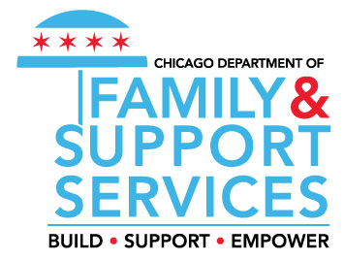
Chicago Early Learning Enrollment Eligibility Monitoring Elements/Form
Agency & Site Name |  |  |  |  |  |  |  | Program Year |  |  |  |  |  | Date of File Review
Site Address: |  |  |  |  |  |  |  | Monitor Name
Program Option(s) |  |  | _____ Head Start |  | _____ Early Head Start |  |  |  | _____ Early Head Start- Child Care Partnership |  |  | _____ Preschool for All |  |  |  |  | _____ Prevention Initiative
(1) |  | (2) |  | (3) |  | (4) | (5) |  |  | (6) | (7) |  | (8) |  | (9) | (10)
Child’s Name  (Last, First) |  | Enrollment Date |  | (Enrollment)  HS, EHS, EHSCCP Application |  | HSEV | Proof of Income |  |  | Proof of Age | Proof of Residency for PFA/PI |  | Emergency Contacts |  | Health Hx  Signed Consent Forms | Monitor’s  Notes
PFA_PI
Student Information Sheet
ERSEA Elements for Monitoring
- The agency has a written policy that describes their process for verifying program eligibility.
- The policy includes steps that will be taken for staff who may violate the determining eligibility policy.
- The agency has a written process for verifying income eligibility and maintaining documentation of verification on site.
- The agency has a current recruitment plan that includes strategies that reflect the program’s understanding of the needs and characters of the community’s eligible children and their families (review recruitment plan and ask how the strategies reflect information gathered from the agency’s community needs assessment).
- The program has a recruitment strategy for enrolling eligible children with disabilities; categorially eligible children and other vulnerable populations.
- The program has a selection and enrollment criteria policy and process.
- The agency/site has challenges maintaining full enrollment monthly.
- The agency/site has a plan for meeting and maintaining full enrollment; the agency/site is fully enrolled.
- The agency has a plan to address chronic absenteeism and has a system in place to follow-up on children who have not arrived at school within the hour of the regular program schedule.
- The agency has a transition plan that is implemented for children who transition from Early Head Start into Head Start and from Head Start into kindergarten.
- The agency has a suspension and expulsion policy.

