Monday, March 27th
6:30 – 8:00 p.m.

“So, You Want to Vote”
“So, You Want to Vote” will review the basic eligibility guidelines for voters, the types of accommodations voters with disabilities may be eligible for, and what kind of assistance family members and/or caretakers may provide voters.
Presented by:
Molly Broadway, MSW
Molly works with Disability Rights Texas as the Training and Technical Support Specialist for Voting Rights. This role allows her to travel across the state to provide voting rights training for community members and election officials, as well as provide no-cost accessibility inspections of polling sites.
RSVP by clicking the Zoom link to register:
https://us06web.zoom.us/meeting/register/tZUqdu-rrz8oG9LoqVspD4SX7D3WOjFuo1Dz

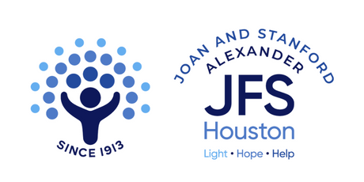
https://www.jfshouston.org/services/disability-services

