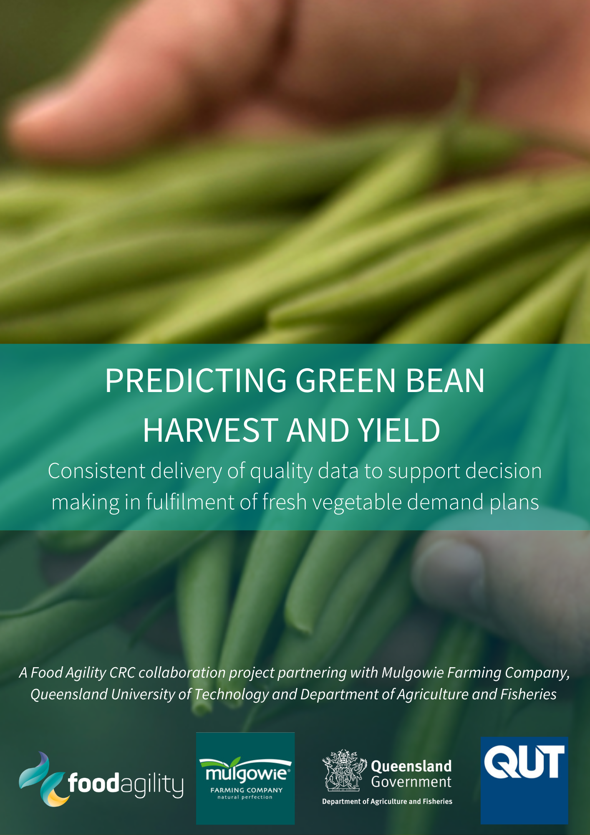
PREDICTING GREEN BEAN HARVEST AND YIELD

“Improving the accuracy of predicting green bean growth rate, maturity and harvest date in multiple plantings and locations within Australia.”
Mulgowie Farming Company (Mulgowie) is one of Australia’s largest vegetable producers. The Mulgowie teamwork in a dynamic growing, packaging, and marketing system with the additional complexity of several farming locations across the eastern seaboard of Australia. Mulgowie Farming Company supply green beans in fresh loose, bagged, and semi-processed formats to Australian supermarkets, market agents and foodservice daily, as well as targeted export markets.

Mulgowie’s agronomists and the wider supply chain team must make fast crop management decisions every day to match supply volume with green bean customer demand to retain customer confidence, plan promotions and ensure quality. Daily weather variability throughout all seasons and locations is the main cause of fluctuations in planned supply. Mulgowie’s customers demand quality product delivered on-time.

This CRC collaboration project aimed to develop and evaluate a commercial (in-house) green bean crop maturity model that could track and predict the maturity of sequentially planted green bean crops using historical Mulgowie crop development and yield records. These records (from multiple production sites) were analysed by Queensland University of Technology (QUT) data specialists. The historical data was combined with, and enhanced by, published green bean crop physiology data and field observation studies by Mulgowie, QUT and Department of Agriculture and Fisheries (DAF) project staff.

Green bean crop development phases were measured under local growing conditions and the crop maturity changes and associated weather (temperature) drivers were recorded and used to devise and refine a green bean crop growth model. Detailed crop physiology research, local observations and commercial crop data were combined in a complex growth model (Grena-Bena) to enhance commercial cropping and sales decision making.

PROJECT MANAGEMENT
- The Mulgowie Farming Company team engaged effectively with researchers, data analysts, agronomists, and information technology staff from QUT and DAF, with guidance and support from Food Agility staff, to turn commercial green bean production planting and harvest records into a prototype on-line digital production and market supply decision tool (Grena-Bena). This commercially focused collaboration with specialist researchers set out to empower and refine on-farm production related decision making. This combination of specialist researcher knowledge and data analysis skills to address a well-defined commercial problem is a great cross-industry example of the power and value of a well-run CRC project.
- Mulgowie’s agronomy team have an extensive multi-year dataset of planting and harvest dates over their production locations and seasons. Based on this data QUT staff have created a dedicated Green Bean modelling tool for Mulgowie. DAF and QUT staff have utilised published “ideal” crop growth parameters, in-field crop measurements and Australian Bureau of Meteorology location specific weather records and forecasts to digitise, automate, and enhance the existing Mulgowie green bean database into a flexible, easy access, planning tool.
- Commercial green bean planting and harvest data from multiple production locations, underpinned by on-site observations of green bean growth and development measurements, was combined with scientifically documented green bean physiology knowledge to develop a variety and location specific commercial green bean harvest date and yield model.
- The model uses location specific weather conditions and Mulgowie agronomists crop observation data to predict crop growth, yield, and maturity. This on-line crop development data is available in real time to all members of the Mulgowie agronomy team.
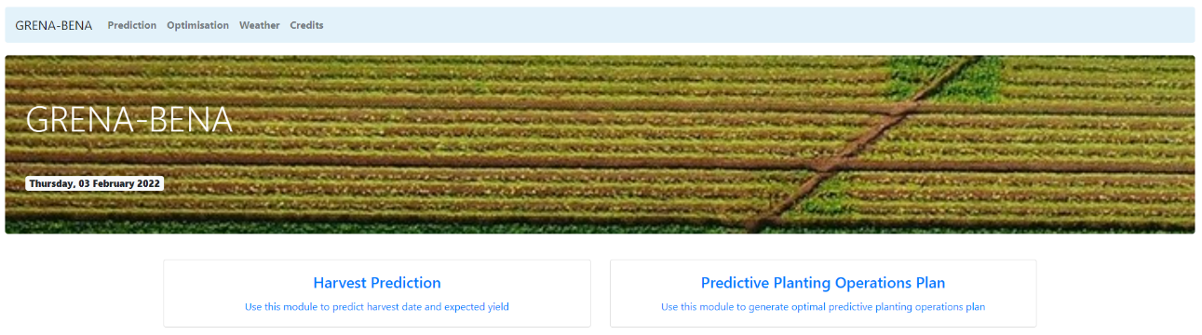
- The data rich, fully integrated and automated crop location specific production and growth model will evolve as more crop data is entered, enhancing crop and business management by improving forecast accuracy. Mulgowie agronomists’ data entry time will be greatly reduced, and computer processing power will streamline and enhance decision making from paddock, to packing shed and most importantly with customers. A standardised and systemised crop growth assessment system minimises variation and importantly removes “guess work” at every decision stage along the production chain.
Figure 1: The Grena-Bena tool allows harvest prediction or develops an entire operation plan for all farm location.

MULGOWIE MANAGEMENT COMMENT

“The dedicated Grena-Bena prediction tool will support everyone involved at Mulgowie with our mission, to consistently deliver quality fresh green beans. Our goal is to continue as the trusted, reliable supplier of choice for green beans in Australia. The tools developed within this project will support our farm, agronomy and wider supply chain team members to make good decisions, quickly and effectively, based on the best available data.”

Shane Quinn – National Sales Manager, Mulgowie Farming Company
Throughout the next 12 months the focus will be on testing and further enhancing the capability and accuracy of the Grena-Bena model. The tool will be “live” in the Mulgowie green bean production system and used frequently by agronomists at all production locations. This will allow ongoing assessment of the tool’s accuracy by agronomists. Incremental improvement and refinement of the new Grena-Bena tool will be the focus of the next 12 months of “in-field” work. QUT statisticians and technical staff will be intimately involved in this process, supporting Mulgowie to embrace and adopt the crop forecast tool, while being available to tweak, modify and enhance the underlying computer code.
The Grena-Bena crop growth tool enhances, standardises, and systemises the existing crop development and yield forecasting tasks of all Mulgowie in-field agronomists at all production locations. This “single green bean crop tracking portal” enhances regular crop assessment tasks – saving time, makes the task easier and provides an immediate accurate overview of every planting.
Importantly this new centralised on-line green bean crop forecasting and planning system will now be immediately visible to the entire Mulgowie agronomy and crop production team.
Through this program/research, the project team has demonstrated how a vast and complex green bean crop growth database can be analysed and then combined with published crop development and physiology data, weather records and location specific forecasts to better predict crop growth, maturity, and yield.
This collaboration between Mulgowie, QUT and DAF demonstrates to industry the power of a focused, hand-picked, multi-disciplinary team to address and resolve a commercial business problem/need identified by Mulgowie. This project work team demonstrates to the Australian agricultural industry the power of collaborative research and skill-based problem solving to make their businesses more financially viable, sustainable and resilient over time.

BACKGROUND
Accurately predicting green bean harvest date and yield for every week of the year is essential to business sustainability, reputation and customer confidence.
Mulgowie Farming Company is an Australian owned and operated business with a team of 400 staff and contract partners, involved in the management and operations for some 10,000 acres of fertile farming land throughout Australia. Mulgowie’s reach strategically spans across the east coast of Australia from Far North Queensland to Gippsland, Victoria. Their farms are located at Mulgowie in the Lockyer Valley, Southeast Queensland; Glen Innes in New South Wales; Bowen and Home Hill in North Queensland and Gippsland in Victoria.

Mulgowie are the largest farmer of fresh green beans in the country, planting, harvesting, packing, and delivering fresh and prepacked quality product to Australian retailers every week of the year. Farming in multiple locations and states is a key strategy to ensure quality green beans are available throughout the year. Mulgowie’s dedicated end-to-end supply chain team work together closely to ensure they have enough harvested product available each day to meet both fresh and bagged green bean sales commitments.

Agronomists, farm teams and dedicated growers at each farming location are responsible for production and in-field quality control – this is the beginning of a long and complex supply focused, crop management decision chain.

Once planted the real work begins, watering, fertilising, weeding, and tending to the crop’s needs to maximise yield. Agronomists, farm teams, and growers monitor all crops weekly to ensure they are growing properly and adjust agronomic inputs as needed to keep each planting on-track.
Improving green bean supply forecasting accuracy is a vital step in business sustainability and profitability, and the new on-line Grena-Bena predicted harvest date and yield tool allows instant up-dated crop information. Weather variability that impacts potential yield and harvest date will immediately be visible to the agronomy team crop management. This will enhance communication and oversight throughout the entire production line allowing sales staff to minimise any supply disruption impacts and maximise sales. Improved knowledge and supply forecasting should drive efficiency gains from planting all the way through to the retail shelf.

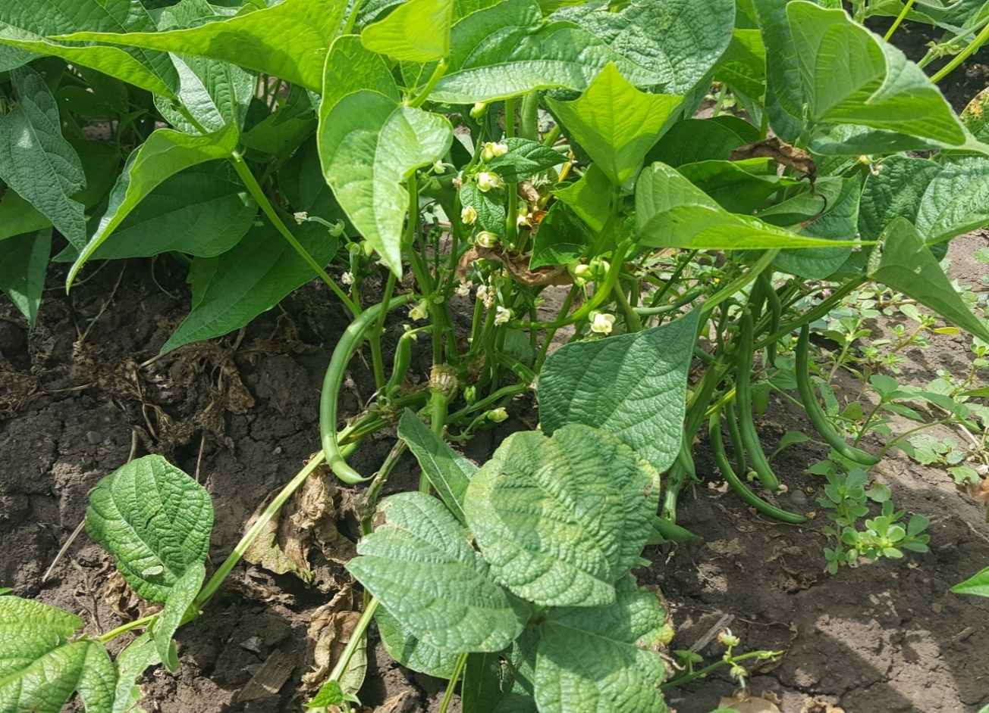

Figure 2 Green bean plant with flowers and maturing pods

The Grena-Bena prediction tool incorporates multiple interactive models and production variables
Planting date + variety + location + local weather predicted harvest date
Planting date | Variety & location | Local weather data | Predicted harvest date
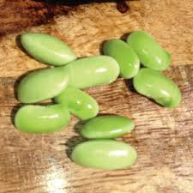 | 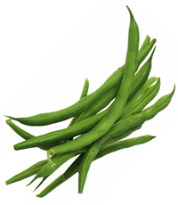  Figure 3 Grena-Bena considers all production variables | 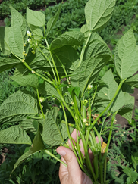 | 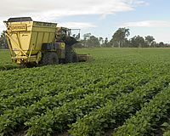

RESULTS

Grena-Bena – analysing data for improved decisions

The Grena-Bena predictive tool incorporates and uses multiple interconnected data models:

- Data collection and cleaning. Data fusion, specifically, linking weather data and commercial planting data.
- Statistical modelling to provide predictive capability for harvest date and yield.
- Production planning algorithm to automate and optimise the development of annual production plans based on sales targets.
- Deployment of the predictive and planning methodologies in the form of a user-friendly web application.

The Grena-Bena predictive tool is powered by multiple models

There are 5 predictive models applied to each growing region, consisting of the south-east QLD/northern NSW sites and the north QLD sites. Each of the 5 models are used in sequence to make the relevant predictions, following the process below:

- Estimated petal fall without reference to weather variables.
- Estimated vegetative period using weather variables (including weather that refers to vegetative period using the model in step 1).
- Estimated harvest date without reference to weather variables.
- Estimated total growing period (including weather that refers to vegetative period using the model in step 2, and total growing period from step 3)
- Estimated yield (including weather that refers to vegetative period using the model in step 2, and total growing period from step 4)

Grena-Bena Mulgowie computational production planning

The Grena-Bena predictive models are integrated into the production planning module of the planning tool. Based on an annual projected sales plan, Grena-Bena will computationally generate a plan for planting, harvesting and processing, to align with the sales plan, aiming for efficiency whilst mitigating against risk factors. The underlying production planning algorithm accounts for production and packaging constraints such as crop rotation, and capacity of the supply chain (blocks, harvesters, and production plants).

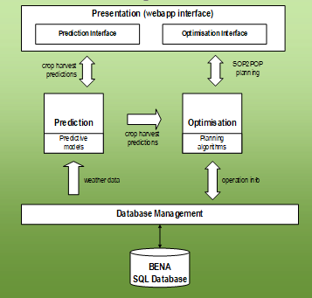
Figure 4 Overarching design schematic of the Grena-Bena tool

KEY RESULTS
- Analysis of predictive model performance so far shows competitive level of accuracy with current practices, with avenues for further improvement through the hypercare period. Current practice for pre-harvest human crop yield assessments will continue to be important and will further enhance predictive model accuracy and development.

- The production planning algorithm demonstrates good capability to match production to sales targets within the constraints of the current Mulgowie system. The research team will continue to support Mulgowie in adoption and refinement of the technologies developed in this project.
- The infrastructure, methods and processes developed in this project provide a valuable platform and example for ongoing improvement and development of underlying models and algorithms in the crop growing and broader agricultural sector

NEXT STEPS (HYPERCARE PERIOD)

The project team has successfully analysed Mulgowie Farming Company’s extensive green bean production database. World-wide published green bean growth studies were reviewed to ascertain critical growth temperatures and this information was combined with local in-field crop development measurements. This data and knowledge were combined to develop a prototype green bean maturity and yield model as well as a business wide, multi-crop/multi-location/season/rotation/crop growth and workflow model. These two models will be tested by Mulgowie agronomists and managers over the next 12 months. This will allow commercial model testing/validation/adjustment and refinement “hand in hand” with key Mulgowie staff – maximising commercial adoption opportunities and outcomes.

Both prototype models will help to inform Mulgowie’s existing supply chain and commercial plans. This means crop information and crop development updates and their subsequent business planning impacts are immediately available to the Mulgowie Supply Chain team. The next 12 months will see this data-feed and its integration tested, refined, tweaked, problem solved, tested and used in a cyclic fashion to ensure the Mulgowie team become familiar with and gain confidence in using, assessing, and implementing outcomes.
QUT digital and technical staff will be on hand to help with business integration, support, refine and fix any software issues. This hyper-care period will allow technical staff at both QUT and Mulgowie to gain a deeper understanding of model integration issues and may well lead to significant “insight” and process improvements.

The project team will remain active throughout the next 12 months to maximise adoption of the customised crop/business information tools developed by the project team. The entire team will continue to meet formally on a regular basis while project technical (model development) staff will be available to assist Mulgowie as needed, as outlined in the project documentation.

This ongoing work will focus on model integration and commercial adoption highlighting the power and impact of quickly and easily turning new business data into timely decisions to maximise productivity, management oversight and sales team foresight.

This multi-disciplinary work demonstrates to industry the power of collaboration and skill-based problem solving. The project has highlighted the potential of commercially focused work to enhance business management through utilising existing business records and knowledge to fine-tune daily decisions and make a business more efficient, financially resilient, and environmentally sustainable over time.

CONCLUSIONS

This commercial question was “can we improve our crop yield and maturity forecasting across sites while making the job easier for our agronomists and giving the sales team instant access to a more accurate forecast of product availability”?
Existing cropping and yield records, combined with specific science based green bean knowledge and computer programming skills were harnessed to devise, design and build a bespoke production scheduling and development tool. This initiative assists and enhances all aspects of the Mulgowie production operations across all Australian production and packing sites.
This project successfully developed a complex crop growth, scheduling, maturity, and yield assessment tool which will be commercially tested and refined over the next 12 months.
The collaborative nature and commercially focused and implemented outputs from this research work demonstrates the potential for problem solving research work across other agricultural sectors and within individual business and business groups.

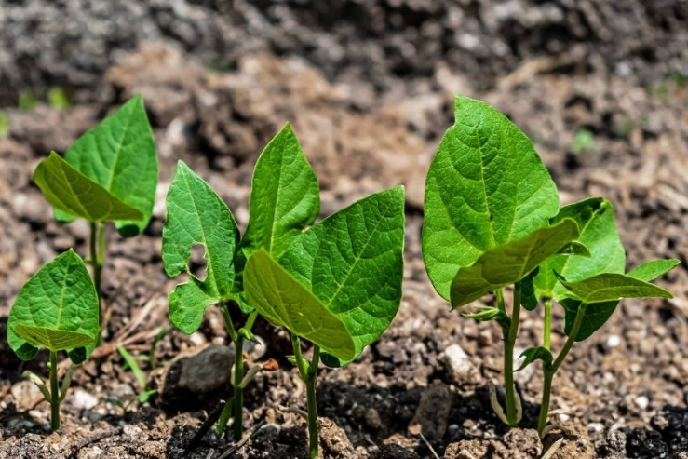

Figure 5 Bean - me up Scotty

