Dear Neighbour

You may not be aware but your dog is currently causing a nuisance in the Neighbourhood by barking excessively
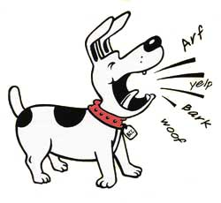
I have discussed this problem with the Council and have been advised that as a first step I express my concern to you, to allow you the opportunity to rectify the situation without recording an official complaint against you on Council’s file.

On the back of this letter is some information that may be of assistance to you in resolving the problem.

Your co-operation at this stage is all that is needed to avoid this matter progressing any further

Your Neighbour

Some simple tips for reducing barking

• Make sure that you do not reward your dog for barking too much.

• Don’t let the dog inside or give it attention when it barks. Instead, give the dog attention when it is quiet.

• If the dog is barking at people or noises on the other side of a fence, move the dog to another part of the yard, or put up a barrier to keep the dog away from that area.

• If the dog barks at regular disturbances such as children walking to school or rubbish trucks, keep the dog inside or in an enclosed area at these times.

• If the dog races along a path or fence barking at passing distractions, put barriers or obstacles in the dog’s way to slow it down.

• Ensure that the dog has adequate exercise and obedience training.

• Make sure that the dog has food, water and shelter from the weather.

• If the dog is barking through gaps and cracks in the fence, fill them in.

• If the dog is barking at people it can see passing by, try blocking the dog’s view.

• An anti-barking collar may be useful for some, but not all, barking dogs.

• Contact East Gippsland Shire Council’s Community Laws officers on 5153 9500 for further information.

• Teach the dog to stop barking on command. When the dog is barking give a firm command such as ‘cease’ and call the dog to you. Praise the dog when it stops barking. If the dog will not listen to you, it will need obedience training.

Remember, dogs bark for many reasons. If these simple tips do not help you, seek further advice.

Barking is one of the dog’s main ways of communicating, however It is not normal for a dog to bark at every noise, passer-by, nor to bark for long periods of time.
Myth

