Chicago Crime Trends, 2019- 2022

Prepared by Jack Sevil - Research Analyst
January 21, 2022
centerforjusticeresearch.org

Chicago Crime Trends, 2019-2022

The current sample (N) comprised data relevant to 60-Zip Codes within Chicago, Illinois, United States of America. From the 60-Zip Codes, N = 42 neighborhoods were derived which constituted the current sample (Johnson, 2021). These 42-neighborhoods were then aggregated into two groups: 1) Focus Neighborhoods (N = 11); and 2) Non-Focus Neighborhoods (N = 31). This was done to allow calculation of inferential statistics with the data, given some neighborhoods comprised n = 1 observations. Nonetheless, Focus Neighborhoods included: 1) Auburn Gresham; 2) Austin; 3) Edgewater; 4) Englewood; 5) North Lawndale; 6) Rogers Park/Howard Area; 7) Roseland; 8) South Shore; 9) Uptown; 10) West Englewood; and 11) Woodlawn. Additionally, Non-Focus Neighborhoods included: 1) Amour Square; 2) Ashburn; 3) Avalon Park; 4) Beverly; 5) Brunside; 6) Chatham; 7) Chicago Lawn; 8) Douglas; 9) East Garfield Park; 10) East Side; 11) Englewood; 12) Garfield Ridge; 13) Grand Boulevard; 14) Greater Grand Crossing; 15) Hegewisch; 16) Humboldt Park; 17) Hyde Park; 18) Kenwood; 19) Morgan Park; 20) Oakland; 21) Pullman; 22) Riverdale; 23) South Chicago; 24) South Deering; 25) South Lawndale; 26) Washington Heights; 27) Washington Park; 28) West Garfield Park; 29) West Lawn; 30) West Pullman; and 31) West Town.
Englewood was a neighborhood observed within both neighborhood groups by label, but each Englewood neighborhood was comprised of different Zip Codes. Moreover, for each neighborhood, social and health outcome data were aggregated, comprising six-variables. These aggregated variables, and respective means (M) and standard deviations (SD) were: 1) Estimates of Property Crime per-100,000 Population (M = 3,924.30, SD = 1,659.06) (areavibes, 2022); 2) Estimates of Violent Crime per-100,000 Population (M = 1,545.50, SD = 839.12) (areavibes, 2022); 3) 80% Black Community Areas (M = 0.92, SD = 0.04) (City of Chicago, 2021); 4) Percentage of Positive Corona Virus 2019 (COVID-19) Results (M = 4.84%, SD = 1.20%) (Johnson, 2021); and 5) Percentage of COVID-19 Vaccinations (M = 6.82%, SD = 9%) (Johnson, 2021); 3) COVID-19 Deaths (M = 153.11, SD = 71.33) (Johnson, 2021).
Figure 1 provides a visual representation of mean Estimates of Property Crime per-100,000 Population for Focus Neighborhoods compared to the Non-Focus Neighborhoods. Herein property crimes are demonstrated as lower within Focus Neighborhoods per-capita.

Figure 1
Estimates of Property Crime per-100,000 Population for Focus Neighborhoods compared to Non-Focus Neighborhoods
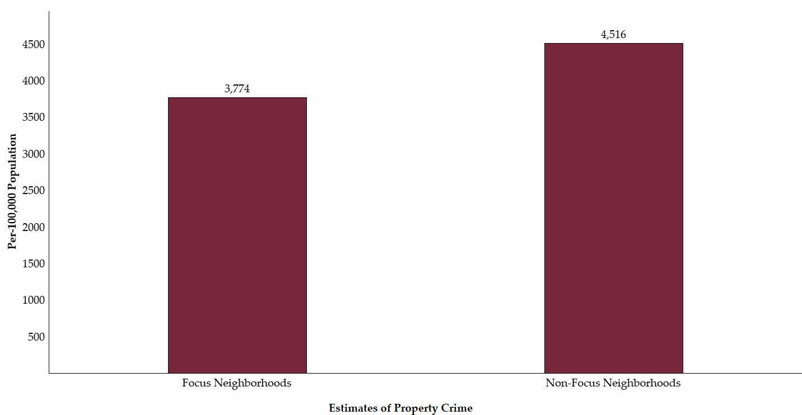 Figure 2 provides a visual representation of mean Estimates of Violent Crime per-100,000 Population for both Focus Neighborhoods and Non-Focus Neighborhoods. Like property crime, violent crimes occur less per-capita within Focus Neighborhoods. Specifically, per-100,000 population, estimated violent crimes occur approximately 400-times less within Focus Neighborhoods when compared to Non-Focus Neighborhoods.

Figure 2
Estimates of Violent Crime per-100,000 Population for Focus Neighborhoods compared to Non-Focus Neighborhoods
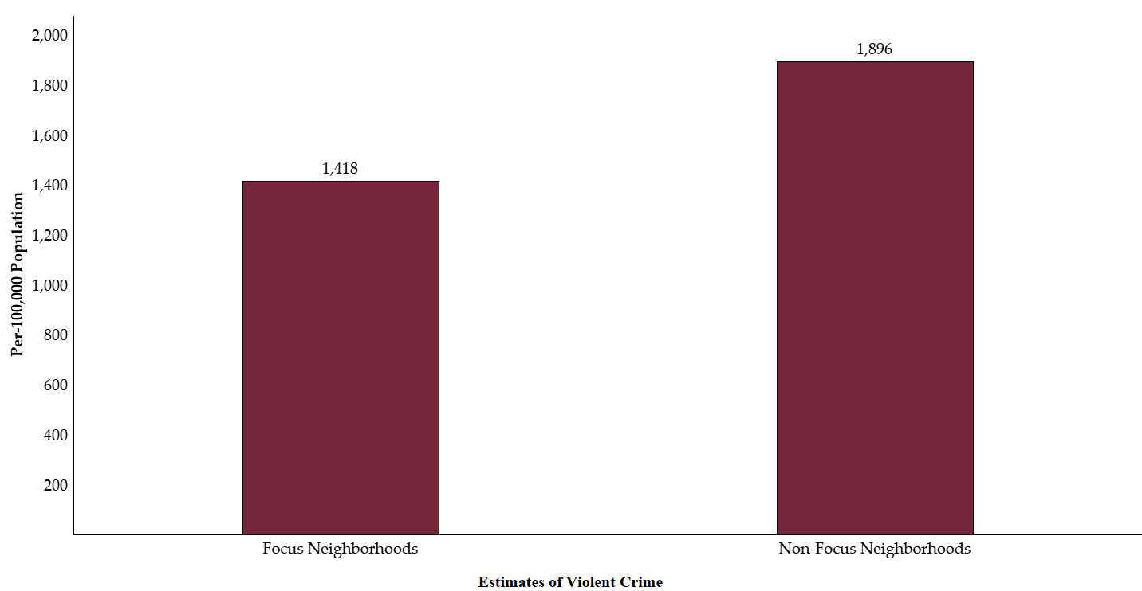 Additionally, Table 1 demonstrates descriptive statistics for property crimes per-100,000 population and violent crime per-100,000 population by the two neighborhood groupings - Focus Neighborhoods and Non-Focus Neighborhoods. The averages therein generally suggest lower crime within Focus Neighborhoods. Though, standard deviations for both property and violent crime demonstrate individual Focus Neighborhoods varied more than those within Non-Focus Neighborhoods.

Table 1
Mean (M) and Standard Deviation (SD) Descriptive Statistics by Focus Neighborhoods and Non-Focus Neighborhoods
Variable | Focus Neighborhoods |  | Non-Focus Neighborhood
 | M | SD | M | SD
Estimates of Property Crime per-100,000 Population | 3,733.64 | 1,688.81 | 4,516.13 | 1,473.62
Estimates of Violent Crime per-100,000 Population | 1,417.91 | 842.39 | 1,896.38 | 745.78
Within Figure 3, differences between individual neighborhoods within Focus Neighborhoods and Non-Focus Neighborhoods for Estimates of Property Crime per-100,000 Population are visually represented. Herein disparities between individual neighborhoods are demonstrated. Specifically, all neighborhoods have leastways twice the estimated violent crime per-capital as Edgewater, Uptown, and Rogers Park/Howard Area.
Figure 3
Mean Estimates of Property Crime per-100,000 Population by Individual Neighborhoods within the Experimental Neighborhoods Group
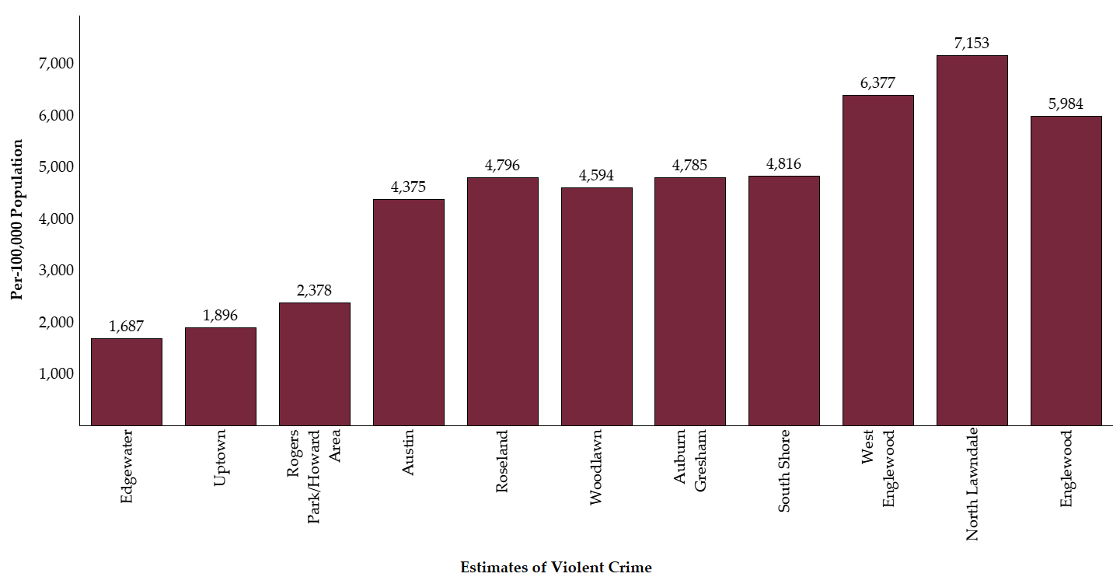
Regarding property crimes, Table 2.0 demonstrates Estimates of Property Crime per-100,000 Population by individual neighborhoods within the Focus Neighborhoods group. Herein property crimes averaged between 1,687 for Edgewater to 7,153 for North Lawndale. Moreover, given the small sample size for each neighborhood, deviations from the mean are non-existent or equal zero. This is also common for individual neighborhoods within Non-Focus Neighborhoods.

Table 2.0

Frequencies, Mean (M), and Standard Deviation (SD) of Estimates of Property Crime per-100,000 Population by Individual Neighborhoods within the Focus Neighborhoods Group
Variable | n | M | SD
Auburn Gresham | 1 | 4,785 | -
Austin | 2 | 4,375 | 0
Edgewater | 1 | 1,687 | -
Englewood | 1 | 5,984 | -
North Lawndale | 1 | 7,153 | -
Rogers Park/Howard Area | 1 | 2,378 | -
Roseland | 1 | 4,796 | -
South Shore | 4 | 4,816 | 0
Uptown | 1 | 1,896 | -
West Englewood | 1 | 6,377 | -
Woodlawn | 2 | 4,594 | 0
Total | 16 | 4,516.13 | 1,473.62
Further, Table 2.1 demonstrates descriptive statistics for Estimates of Property Crime per-100,000 Population by individual neighborhoods within the Non-Focus Neighborhood group. Herein averages of individual neighborhoods did not differ greatly from those within Focus Neighborhoods, but the overall average was lower for Non-Focus Neighborhoods. Also, individual neighborhoods comprising the Non-Focus Neighborhoods averaged between 1,487 for Beverly and 8,974 for West Garfield Park estimated property crimes per-100,000 population.

Table 2.1

Frequencies, Mean (M), and Standard Deviation (SD) of Estimates of Property Crime per-100,000 Population by Individual Neighborhoods within the Non-Focus Neighborhoods Group
Variable | N | M | SD
Amour Square | 1 | 2,325 | -
Ashburn | 2 | 1,654 | 0
Avalon Park | 3 | 3,674 | 0
Beverly | 2 | 1,487 | 0
Brunside | 1 | 4,453 | -
Chatham | 3 | 5,218 | 0
Chicago Lawn | 2 | 3,022 | 0
Douglas | 1 | 3,960 | -
East Garfield Park | 1 | 6,696 | -
East Side | 1 | 1,596 | -
Englewood | 1 | 5,984 | -
Garfield Ridge | 1 | 1,757 | -
Grand Boulevard | 2 | 4,407 | 0
Greater Grand Crossing | 1 | 5,519 | -
Hegewisch | 2 | 2,222 | 0
Humboldt Park | 1 | 4,346 | -
Hyde Park | 1 | 2,234 | -
Kenwood | 1 | 2,979 | -
Morgan Park | 1 | 2,688 | -
Oakland | 1 | 3,939 | -
Pullman | 2 | 5,068 | 0
Riverdale | 1 | 4,462 | -
South Chicago | 2 | 4,251 | 0
South Deering | 1 | 3,542 | -
South Lawndale | 1 | 1,866 | -
Washington Heights | 1 | 3,295 | -
Washington Park | 2 | 6,222 | 0
West Garfield Park | 1 | 8,974 | -
West Lawn | 2 | 1,493 | 0
West Pullman | 1 | 3,951 | -
West Town | 1 | 3,386 | -
Total | 44 | 3,733.64 | 1,688.81
Additionally, Figure 4 demonstrates mean Estimates of Violent Crime per-100,000 Population for individual neighborhoods within Focus Neighborhoods. This provides a visual representation of disparities which were measured by property crimes also occurring within the Focus Neighborhoods group regarding violent crime. That is, Edgewater, Uptown, and Rogers Park/Howard Area again all have leastways half the violent crime per-capita as other individual neighborhoods.
Figure 4
Mean Estimates of Violent Crime per-100,000 Population by Individual Neighborhoods within the Experimental Neighborhoods Group
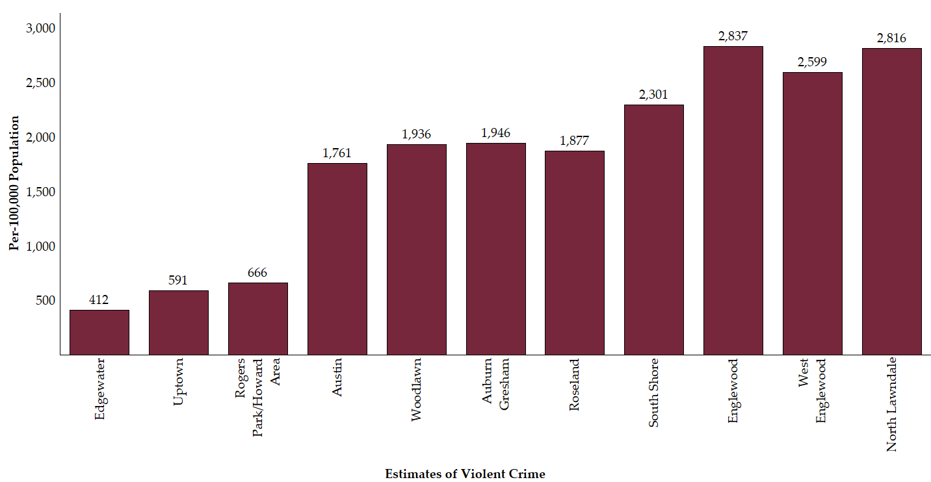
Within Table 2.2, average Estimates of Violent Crime per-100,000 Population ranged from 412 for Edgewater to 2,837 for Englewood. Interesting, Edgewater also had the lowest average property crimes per-capita of individual neighborhoods within the Focus Neighborhoods group. Moreover, North Lawndale, West Englewood, and Englewood were the top-three neighborhoods for both property crimes and violent crimes within the Focus Neighborhoods group. As such, property crimes and violent crimes seemingly follow similar trends within the current data, but with property crimes occurring more often per-capita.

Table 2.2

Frequencies, Mean (M), and Standard Deviation (SD) of Estimates of Violent Crime per-100,000 Population by Individual Neighborhoods within the Focus Neighborhoods Group
Variable | N | M | SD
Auburn Gresham | 1 | 1,946 | -
Austin | 2 | 1,761 | 0
Edgewater | 1 | 412 | -
Englewood | 1 | 2,837 | -
North Lawndale | 1 | 2,816 | -
Rogers Park/Howard Area | 1 | 666 | -
Roseland | 1 | 1,877 | -
South Shore | 4 | 2,301 | 0
Uptown | 1 | 591 | -
West Englewood | 1 | 2,599 | -
Woodlawn | 2 | 1,936 | 0
Total | 16 | 1,896.38 | 745.78
Within Table 2.3, Estimates of Violent Crime per-100,000 Population for individual neighborhoods within the Non-Focus Neighborhoods group are presented. Herein, average Estimates of Violent Crime per-100,000 Population ranged from 245 for Beverly to 2,837 for Englewood. Englewood is the only neighborhood recorded with Zip Codes within both neighborhood groupings. Moreover, within both groups Englewood had the highest recorded Estimates of Violent Crime per-100,000 Population amongst individual neighborhoods. Additionally, Beverly had the lowest rates of property crime and violent crime per-capita for both Focus Neighborhoods and Non-Focus Neighborhoods. Regarding Non-Focus Neighborhoods, Beverly had estimated rates of 245 violent crimes per-100,000 persons.
Table 2.3

Frequencies, Mean (M), and Standard Deviation (SD) of Estimates of Violent Crime per-100,000 Population by Individual Neighborhoods within the Non-Focus Neighborhoods Group
Variable | N | M | SD
Amour Square | 1 | 873 | -
Ashburn | 2 | 501 | 0
Avalon Park | 3 | 1,481 | 0
Beverly | 2 | 245 | 0
Brunside | 1 | 1,955 | -
Chatham | 3 | 1,965 | 0
Chicago Lawn | 2 | 1,150 | 0
Douglas | 1 | 1,506 | -
East Garfield Park | 1 | 2,886 | -
East Side | 1 | 553 | -
Englewood | 1 | 2,837 | -
Garfield Ridge | 1 | 422 | -
Grand Boulevard | 2 | 1,761 | 0
Greater Grand Crossing | 1 | 2,679 | -
Hegewisch | 2 | 702 | 0
Humboldt Park | 1 | 1,559 | -
Hyde Park | 1 | 520 | -
Kenwood | 1 | 1,004 | -
Morgan Park | 1 | 794 | -
Oakland | 1 | 1,271 | -
Pullman | 2 | 1,269 | 0
Riverdale | 1 | 2,450 | -
South Chicago | 2 | 1,900 | 0
South Deering | 1 | 1,222 | -
South Lawndale | 1 | 662 | -
Washington Heights | 1 | 1,167 | -
Washington Park | 2 | 3,084 | 0
West Garfield Park | 1 | 3,371 | -
West Lawn | 2 | 399 | 0
West Pullman | 1 | 1613 | -
West Town | 1 | 684 | -
Total | 44 | 1,417.91 | 842.39
Lastly, Figure 5 provides a visual representation of how many 80% Black Community Areas are within Focus Neighborhoods compared to Non-Focus Neighborhoods. This demonstrates both Focus Neighborhoods and Non-Focus Neighborhoods had generally the same frequency of 80% Black Community Areas, with an average of less than one 80% Black Community Area per-neighborhood.
Figure 5
Frequency of 80% Black Community Areas within Focus Neighborhoods compared to Non-Focus Neighborhoods
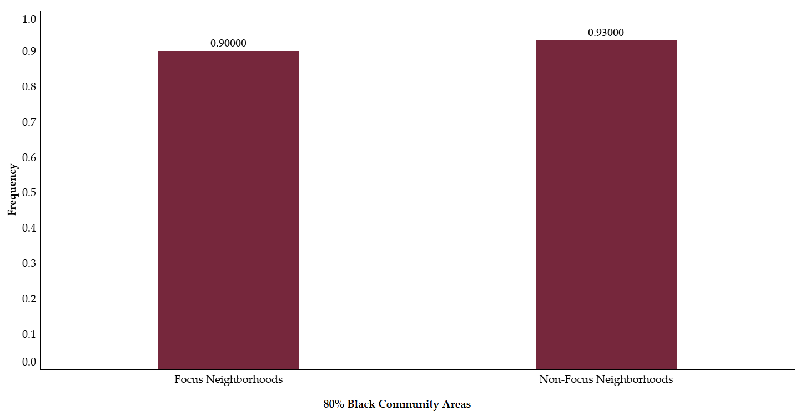 Similar statistics are demonstrated within Table 2.4 pertinent to 80% Black Community Areas within Focus Neighborhoods. Table 2.4 also includes standard deviations, which are again not calculatable or zero because of the sample size for each neighborhood. Nonetheless, within each individual neighborhood, the frequency of 80% Black Community Areas remains consistent – ranging from 0.81 for Austin to 0.96 for Auburn Gresham and Roseland.

Table 2.4

Frequencies, Mean (M), and Standard Deviation (SD) of 80% Black Community Areas by Individual Neighborhoods within the Focus Neighborhoods Group
Variable | n | M | SD
Auburn Gresham | 1 | 0.96 | -
Austin | 2 | 0.81 | 0
Edgewater | 1 | 0.92 | -
Englewood | 1 | 0.95 | -
North Lawndale | 1 | 0.87 | -
Rogers Park/Howard Area | 1 | 0.92 | -
Roseland | 1 | 0.96 | -
South Shore | 4 | 0.94 | 0
Uptown | 1 | 0.92 | -
West Englewood | 1 | 0.91 | -
Woodlawn | 2 | 0.83 | 0
Total | 16 | 0.90 | 0.06
Frequencies of 80% Black Community Areas remains consistent within individual neighborhoods within Non-Focus Neighborhoods, as demonstrated within Table 2.5. Still, the overall frequency of 80% Black Community Areas for each neighborhood within Non-Focus Neighborhoods are higher than individual neighborhoods within Focus Neighborhoods. Specifically, the frequency of 80% Black Community Areas within individual neighborhoods comprising Non-Focus Neighborhoods ranged from 0.83 for Pullman to 0.98 for Brunside. Moreover, the average frequency of 80% Black Community Areas within Non-Focus Neighborhoods (M = 0.93) is higher than Non-Focus Neighborhoods (M = 0.90).

Table 2.5

Frequencies, Mean (M), and Standard Deviation (SD) o80% Black Community Areas by Individual Neighborhoods within the Non-Focus Neighborhoods Group
Variable | n | M | SD
Amour Square | 1 | 0.92 | -
Ashburn | 2 | 0.92 | 0
Avalon Park | 3 | 0.97 | 0
Beverly | 2 | 0.92 | 0
Brunside | 1 | 0.98 | -
Chatham | 3 | 0.96 | 0
Chicago Lawn | 2 | 0.92 | 0
Douglas | 1 | 0.92 | -
East Garfield Park | 1 | 0.89 | -
East Side | 1 | 0.92 | -
Englewood | 1 | 0.95 | -
Garfield Ridge | 1 | 0.92 | -
Grand Boulevard | 2 | 0.92 | 0
Greater Grand Crossing | 1 | 0.96 | -
Hegewisch | 2 | 0.92 | 0
Humboldt Park | 1 | 0.92 | -
Hyde Park | 1 | 0.92 | -
Kenwood | 1 | 0.92 | -
Morgan Park | 1 | 0.92 | -
Oakland | 1 | 0.90 | -
Pullman | 2 | 0.83 | 0
Riverdale | 1 | 0.93 | -
South Chicago | 2 | 0.92 | 0
South Deering | 1 | 0.92 | -
South Lawndale | 1 | 0.92 | -
Washington Heights | 1 | 0.96 | -
Washington Park | 2 | 0.94 | 0
West Garfield Park | 1 | 0.94 | -
West Lawn | 2 | 0.92 | 0
West Pullman | 1 | 0.93 | -
West Town | 1 | 0.92 | -
Total | 44 | 0.93 | 0.03
To compare the mean differences in health outcome and social outcome variables for Focus Neighborhoods to those of Non-Focus Neighborhoods, Independent Samples t-tests were conducted. This is because differences are observable between Focus Neighborhoods and Non-Focus Neighborhood; however, it is unsure if these differences are representative of actual phenomena occurring within Chicago, Illinois. An independent samples t-tests calculates if mean differences exist between groups within the sample, and estimate if those differences are likely to exist beyond the current sample. Specifically, the following Independent Samples t-tests compared Focus Neighborhoods means to Non-Focus Neighborhoods means by the following variables: 1) Estimates of Property Crime per-100,000 Population; 2) Estimates of Violent Crime per-100,000 Population; 3) 80% Black Community Areas; 4) Percentage of Positive COVID-19 Results; 5) Percentage of COVID-19 Vaccinations; and 6) COVID-19 Deaths. Prior to each Independent Samples t-tests, assumptions testing was conducted. Independent samples t-tests assume the frequency of scores by each variable follow a Gaussian distribution, or are normally distributed. Visual inspection of frequency histograms revealed each variable was normally distributed, and thereafter appropriate for Independent Samples t-tests.
Firstly, the Independent Samples t-test comparing Focus Neighborhoods Estimates of Property Crime per-100,000 Persons to those of Non-Focus Neighborhoods was significant, with Focus Neighborhoods (M = 3,733.64, SD = 1,688.81) estimated instances of property crimes 782.49 (CI = -782.49, -782.48) lower than those of Non-Focus Neighborhoods (M = 4,516.13, SD = 1,473.62), t(58) = -3.65, probability (p) = <.01, two-tailed, Cohens’ d (d) = -.47. This means 782.49-less property crimes per-100,000 persons are estimated to occur within Focus Neighborhoods when compared to Non-Focus Neighborhoods. Moreover, this finding was significant. As such, it is likely these estimated crime rates occurred within Chicago, Illinois, and not just within data aggregated for the current report.
Secondly, the Independent Samples t-test comparing Focus Neighborhoods Estimates of Violent Crime per-100,000 Persons to those of Non-Focus Neighborhoods was significant, with Focus Neighborhood (M = 1,417.91, SD = 842.39) estimated instances of violent crimes 478.47 (CI = -478.47, -478.-478.46) lower than those of Non-Focus Neighborhoods (M = 1,896.38, SD = 745.78), t(58) = -4.42, p = <.01, two-tailed, d = -.57. Similarly to property crimes, this means 478.47-less violent crimes per-100,000 persons are estimated to occur within Focus Neighborhoods when compared to Non-Focus Neighborhoods. Further, this finding was also significant. This means observed differences in violent crime rates are likely applicable to Chicago, Illinois generally.
Thirdly, the Independent Samples t-test comparing Focus Neighborhoods frequency of 80% Black Community Areas to those of Non-Focus Neighborhoods was significant, with Focus Neighborhoods’ (M = .93, SD = .03) reporting .02 (CI = .01, .03) more 80% Black Community Areas than those of Non-Focus Neighborhoods (M = .9, SD = .06), t(58) = 4.55, p = <.01, two-tailed, d = .59. This means Focus Neighborhoods had slightly more average 80% Black Community Areas than Non-Focus Neighborhoods. Moreover, this finding was significant, meaning these observed differences in 80% Black Community Areas are likely applicable to Chicago, Illinois generally.
Further, the Independent Samples t-test comparing Focus Neighborhoods Percentage of Positive COVID-19 Results to those of Non-Focus Neighborhoods was non-significant, with Focus Neighborhoods’ (M = 4.9%, SD = 1.32%) reported positive COVID-19 Results 0.23% (Confidence Interval [CI] = -.31%, .78%) higher than those of Non-Focus Neighborhoods’ (M = 4.67%, SD = .74%), t(58) = 1.37, p = .18, two-tailed, Cohen’s d (d) = .20. This means 0.23%-less positive COVID-19 results were reported in Non-Focus Neighborhoods when compared to Focus Neighborhoods, but this finding was non-significant. As such, these difference in COVID-19 results may not be observable within Chicago, Illinois generally. Rather, these differences may only occur within data aggregated for the current report.
The Independent Samples t-test comparing Focus Neighborhoods Percentages of COVID-19 Vaccinations to those of Non-Focus Neighborhoods was significant, with Focus Neighborhoods’ (M = 69.38%, SD = 9.66%) reported COVID-19 vaccinations 4.3% (CI = 3.76%, 4.85%) higher than those of Non-Focus Neighborhoods (M = 65.08%, SD = 5.98%), t(58) = 3.71, p = <.01, two-tailed, d = .49. This means 4.3%-more COVID-19 vaccinations were reported within Focus Neighborhoods when compared to Non-Focus Neighborhoods. Further, this finding was significant, meaning these observed differences in vaccination rates are likely applicable to Chicago, Illinois generally.
Lastly, the Independent Samples t-test comparing Focus Neighborhoods COVID-19 Deaths to those of Non-Focus Neighborhoods was non-significant, with Focus Neighborhoods’ (M = 149.57, SD = 76.70) reporting 13.26 (CI = -13.27, -13.26) more COVID-19 Deaths than those of Non-Focus Neighborhoods (M = 162.83, SD = 54.90), t(58) = -1.44, p = .16, two-tailed, d = -.19. This means 13.26-more COVID-19 Deaths occurred within Focus Neighborhoods when compared to Non-Focus Neighborhoods. Though, this finding was non-significant. As such, these differences in COVID-19 deaths may not be observable within Chicago, Illinois generally. Rather, these differences may only occur within data aggregated for the current report.
To estimate if the social and health outcome variables included within the current report predict neighborhood category, a Multiple Linear Regression (MLR) model was constructed. Such models assume specific qualities about the data which were tested prior to analysis. Firstly, a scatterplot was constructed using residuals and z-scores, which upon visual inspection indicated the error terms were normally distributed. Secondly, a scatterplot was constructed using residuals and predicted values, which upon visual inspection indicated homoscedasticity. That is, the error terms and predicted neighborhood categories varied, and did not cluster. The population intercept, as well as Beta coefficients (β), 95% Confidence Intervals (CI), Standard Error (SE), and probability (*) are reported in Table 3.

Table 3

Multiple Linear Regression Output when Predicting Neighborhood Category by Social and Health Outcome Variables
Variable | β | SE | 95% CI
 |  |  | Lower | Upper
Intercept | 6.93 | 302.28 | 613.22 | 606.29
Estimates of Violent Crime per-100,000 Population | 0.00 | 0.04 | -0.08 | 0.08
Estimates of Property Crime per-100,000 Population | 0.00 | 0.02 | -0.04 | 0.04
80% Black Community Areas | -4.58 | 265.00 | -536.11 | 526.95
Percentage of Positive COVID-19 Results | -9.01 | 1,007.59 | -2,029.99 | -2,011.96
Percentage of COVID-19 Vaccinations | -1.67 | 141.27 | -285.02 | 281.67
COVID-19 Deaths | 0.00 | 0.14 | -0.28 | 0.29
Note. * indicates probability <.05

While this model is imperfect because continuous variables are attempting to predict a dichotomous variable, there is something to be gained from this analysis. Specifically, Percentage of Positive COVID-19 Results, Percentage of COVID-19 Vaccinations, and 80% Black Community Areas all predicted neighborhoods being within Non-Focus Neighborhoods. Essentially, this means lower instances of these variables correlate to Non-Focus Neighborhoods, even when accounting for the influence of other variables included within the model. Though, no beta coefficients within the current model were significant. As such, these results cannot be inferred as representative of relationships existing within Chicago, Illinois generally.
In conclusion, differences exist between Focus Neighborhoods and Non-Focus Neighborhoods. Moreover, inferential statistics calculated during Independent Samples t-tests reveal these observed differences are likely representative of Chicago, Illinois, and not limited to the current dataset. Additionally, wherein differences occurred were generally consistent. That is, both social and health outcomes were generally better within the Focus Neighborhoods when compared to Non-Focus Neighborhoods. Given this consistency, the current findings warrant further investigation of such phenomenon within the Chicago, Illinois area. Specifically, future research should aim to also investigate the relationships between many of these variables. That is, such investigation may reveal if social and health outcomes for persons are co-dependent on their neighborhood. Such analysis would also be aided by greater sampling, which hindered analyses within the current report.

References

Areavibes (n.d.). Chicago, IL Neighborhoods. Retrieved February 14th, 2022, from https://areavibes.com/chicago-il/neighborhoods/
City of Chicago. Chicago Department of Public Health (2021). The State of Health for Blacks in Chicago.
Johnson, E. (2021). 50 dead of COVID-19 in one week in black neighborhoods. Chicago Crusader. https://chicagocrusader.com/chicago/50-dead-of-covid-19-in-one-week-in-black-neighborhoods/

About the Center for Justice Research
The Center for Justice Research is devoted to data-driven solutions for an equitable criminal justice system. Our primary focus is to produce innovative solutions to criminal justice reform efforts by utilizing an experienced group of researchers working to understand and address the current challenges of the criminal justice system.
The Center for Justice Research can be reached at 713-313-6843 or visit

centerforjusticeresearch.org

