MAKER’S YARD SALE
Saturday, October 16, 9am-1pm

Clean out your creative space and put some extra cash in your pocket! Gather up all those unused creative materials that you don’t want and the projects collecting dust in the corner and sell them at the Maker’s Yard Sale. Sell that which does not inspire you and shop for new materials that encourage your creativity!

This ‘yard sale’ will be held indoors and is free and open to the public.

To become a vendor, please submit a completed application and full payment by Monday, September 27th. Completed applications can be emailed to programs@artsglenallen.com; dropped off at the Center’s front desk, or mailed to: CACGA, Attn: Maker’s Yard Sale, P.O. Box 1249, Glen Allen, VA 23060

Vendor fee is $5 per 6-foot table. Fees can be paid by check made out to ‘CACGA’; by credit card by calling (804) 261-2787; or in-person at the Center’s front desk.

Please note:
Vendors provide their own methods of payment, including cash for change. The Center will not be able to provide change.

While tables and a chair are provided by the Center, all other display materials are the responsibility of the vendor.

Vendors are welcome to barter or negotiate prices as they see fit.

Items that are not related to art and craft making will not be allowed at this sale. All items must be considered material for creative inspiration (artwork, supplies, books about art or creative processes, sketchbooks, tools, etc.). Vendors who include items that are not related to making or a handmade product will be asked to remove these items. No refunds will be offered to vendors whose products are not acceptable.

Artists are allowed to sell finished products they have created, with the understanding that yard sale visitors are looking for deals. You may want to sell seconds, older pieces that have not found a home, etc. for a discounted price.

All UNSOLD items must be removed by the seller or seller may consider donating unsold supplies to the Cultural Arts Center for use in their Outreach programs. A designated area for donations will be assigned.

Vendors must provide shopping bags for their customers.

Vendors are also encouraged to share photos of some of the items they will have for sale to help with marketing and promotion of the event.

Questions?
Contact Lauren Hall by email at programs@artsglenallen.com or call (804) 261-6206

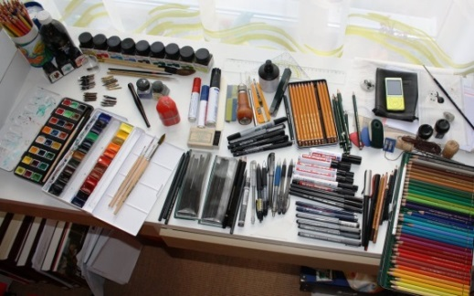
MAKER’S YARD SALE
VENDOR APPLICATION – RETURN BY SEPTEMBER 27th

Name _____________________________________________
Cell _____________________________________________
Email _____________________________________________
Types of items you may have for sale:
_______________________________________________
__________________________________________________________________________________
__________________________________________________________________________________
# Tables ____________ ($5 per table)
TOTAL DUE: $_____________
Payment Method: check cash credit card
Please return application, along with payment, no later than September 27th. Mail application and check made out to ‘CACGA’ to:
Cultural Arts Center at Glen Allen
Attn: Lauren Hall
P.O. Box 1249
Glen Allen, VA 23060

Forms can also be emailed to programs@artsglenallen.com or dropped off at the Center’s front desk. Call (804) 261-2787 or visit in person to make payment by credit card. We look forward to having you as part of this event!

