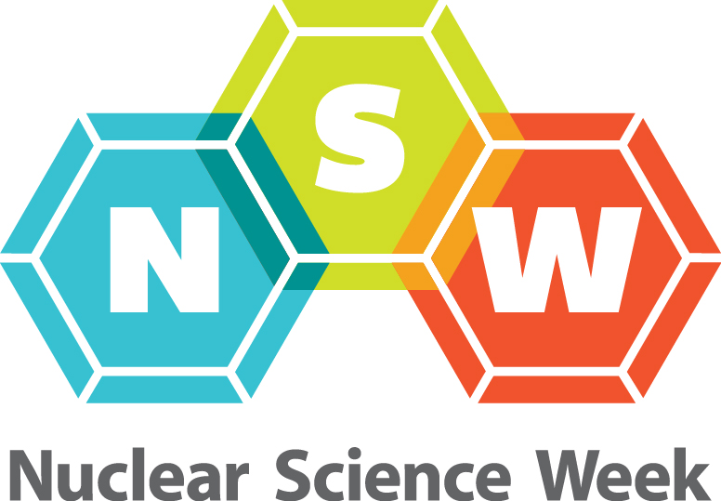

REQUEST FOR PROPOSAL
Nuclear Science Week
Hosting the National Celebration for October 16-20, 2017

Hosting the United States NATIONAL EVENT for two or more days of the observation week is an honor and privilege that can bring notoriety and visibility to organizations as partners in the region. Being the National Site host requires concentrated effort and support. By hosting, event planners also build new contacts and networks, share in recognition, reach out to the community at large, meet new people and have fun. The scale of and number of days that the events will take place are subject to the planning efforts of the Host Committee.

The Host Committee is offered a seat on The NSW National Steering Committee and will participate in the conference calls reporting on program, progress and coordination of communications and other issues.

Below are some criteria for use in proposing to host the national event at a city in the United States. Not every one of the below items is critical, many are beneficial.

REQUIRED SUPPORT FROM HOSTING GROUP
These key areas are found to be very important for a successful National Event observance.

- Sufficient supporting partnerships in place to:
  - Raise funds to defray costs is critical to success. Generally teams raise about $20K-25K for the following things
    - Travel & hospitality of speakers, Catering of events, Reception site rental, Event site rental, recognition, web streaming & video services, printing, etc.
    - Funds raised include a “seed amount” that will pass forward to assist subsequent year Host Group to begin. Suggested amount is $5,000
    - The National Museum of Nuclear Science & History may function as the financial partner with the host committee if requested. The Museum is a 501 c3 organization.
  - A solicitation Packet or materials about NSW including benefits and recognition of sponsors are available to assist Host Committee in seeking funds.
- Organizational structure sufficient to carryout tasks
  - Organizer lead person must live in, or near to the host city
  - Organizer/team has sufficient corporate or business support for time required to be spent on activities
  - Requires principal lead be a highly organized person, and a team or group effort is suggested to assist.
- Have one or more ANS, WIN, NAYGN section or representative in area
- A National Laboratory near or is partner
- University or College partner
- Corporate Sponsor for funding support
  - Presenting sponsor is at $20K generally
- Area Science Museum Partner
- Strong relationship to area public schools
  - Education component of program is vital
- Various groups represent parts of nuclear field, medicine, power, research, industry, military, etc.

DESIRED SUPPORT
These key areas will make hosting and attracting interest easier.

- The general public has an interest or curiosity in Nuclear Science
- University or Community College students in area are interested in nuclear science or have curriculum connections
- Media interest and connections
- Community interest groups
- Governmental leadership as partners

DEVELOPING SPONSORSHIP SUPPORT
Host Committee members work to secure financial support to present the program being planned. Raising funds may seem like a daunting challenge but with strong connections, it is easy to accomplish. Setting out sponsorship opportunities for consideration is key to success. Suggested parts of an event support plan might include sponsorship of the following activities.
• Sponsor a Keynote Speaker that covers travel, hotel, food for that person
• Sponsor Panel Presentation or Lecture Event
• Sponsor of Opening/Closing reception or both
• Sponsorship of Student Transport costs for a group of local schools
• Sponsor Webcast Services
• Other event components as planned
Sponsorships usually occur in levels with a “Presenting”, “Lead”, “Event” level from $20,000 to $2,000.
The National Museum of Nuclear Science & History can and will act as the Financial Partner as a non-profit.

SUBMITTING A PROPOSAL

Please submit proposal for hosting to:

Nuclear Science Week
Host Submission Review Panel
National Steering Committee
Mr. James Walther, Chair
jwalther@nuclearmuseum.org

DATE FOR SUBMISSION: By September1 of 2016

Decision will be made by National Steering Committee before 2016 event for promotional and celebration purposes.

