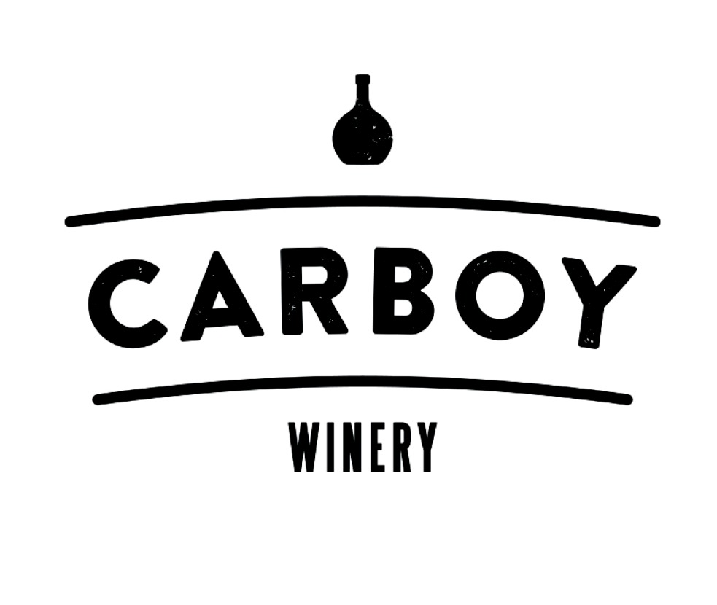
BEVERAGE PACKAGES:
Carboy Winery Denver
Guests can choose a package or can choose NO package and order per consumption.
Beer and Wine Package $28 pp
- All Beer on Tap
- All Wine on Tap
Optional add On/Experience:
- Barrel Aged Manhattan: $8 per person*
- Group Wine Tasting: $15pp*
This is our introductory tasting experience that you can include in your party. Guests will be treated to a 20 minute tasting of 3 selected Carboy wines hosted by one of our wine specialists. We’ll discuss the wine, our history, and the basics of the winemaking process. Note: Additional wine specialist fee $50. Max amount of people 50.
Alcohol Packages are for a 3-hour period of time. After the initial 3 hours, additional drinks will be rung in on a per consumption basis.
*in addition to beer & wine package
Beer and Wine selections may be subject to change

