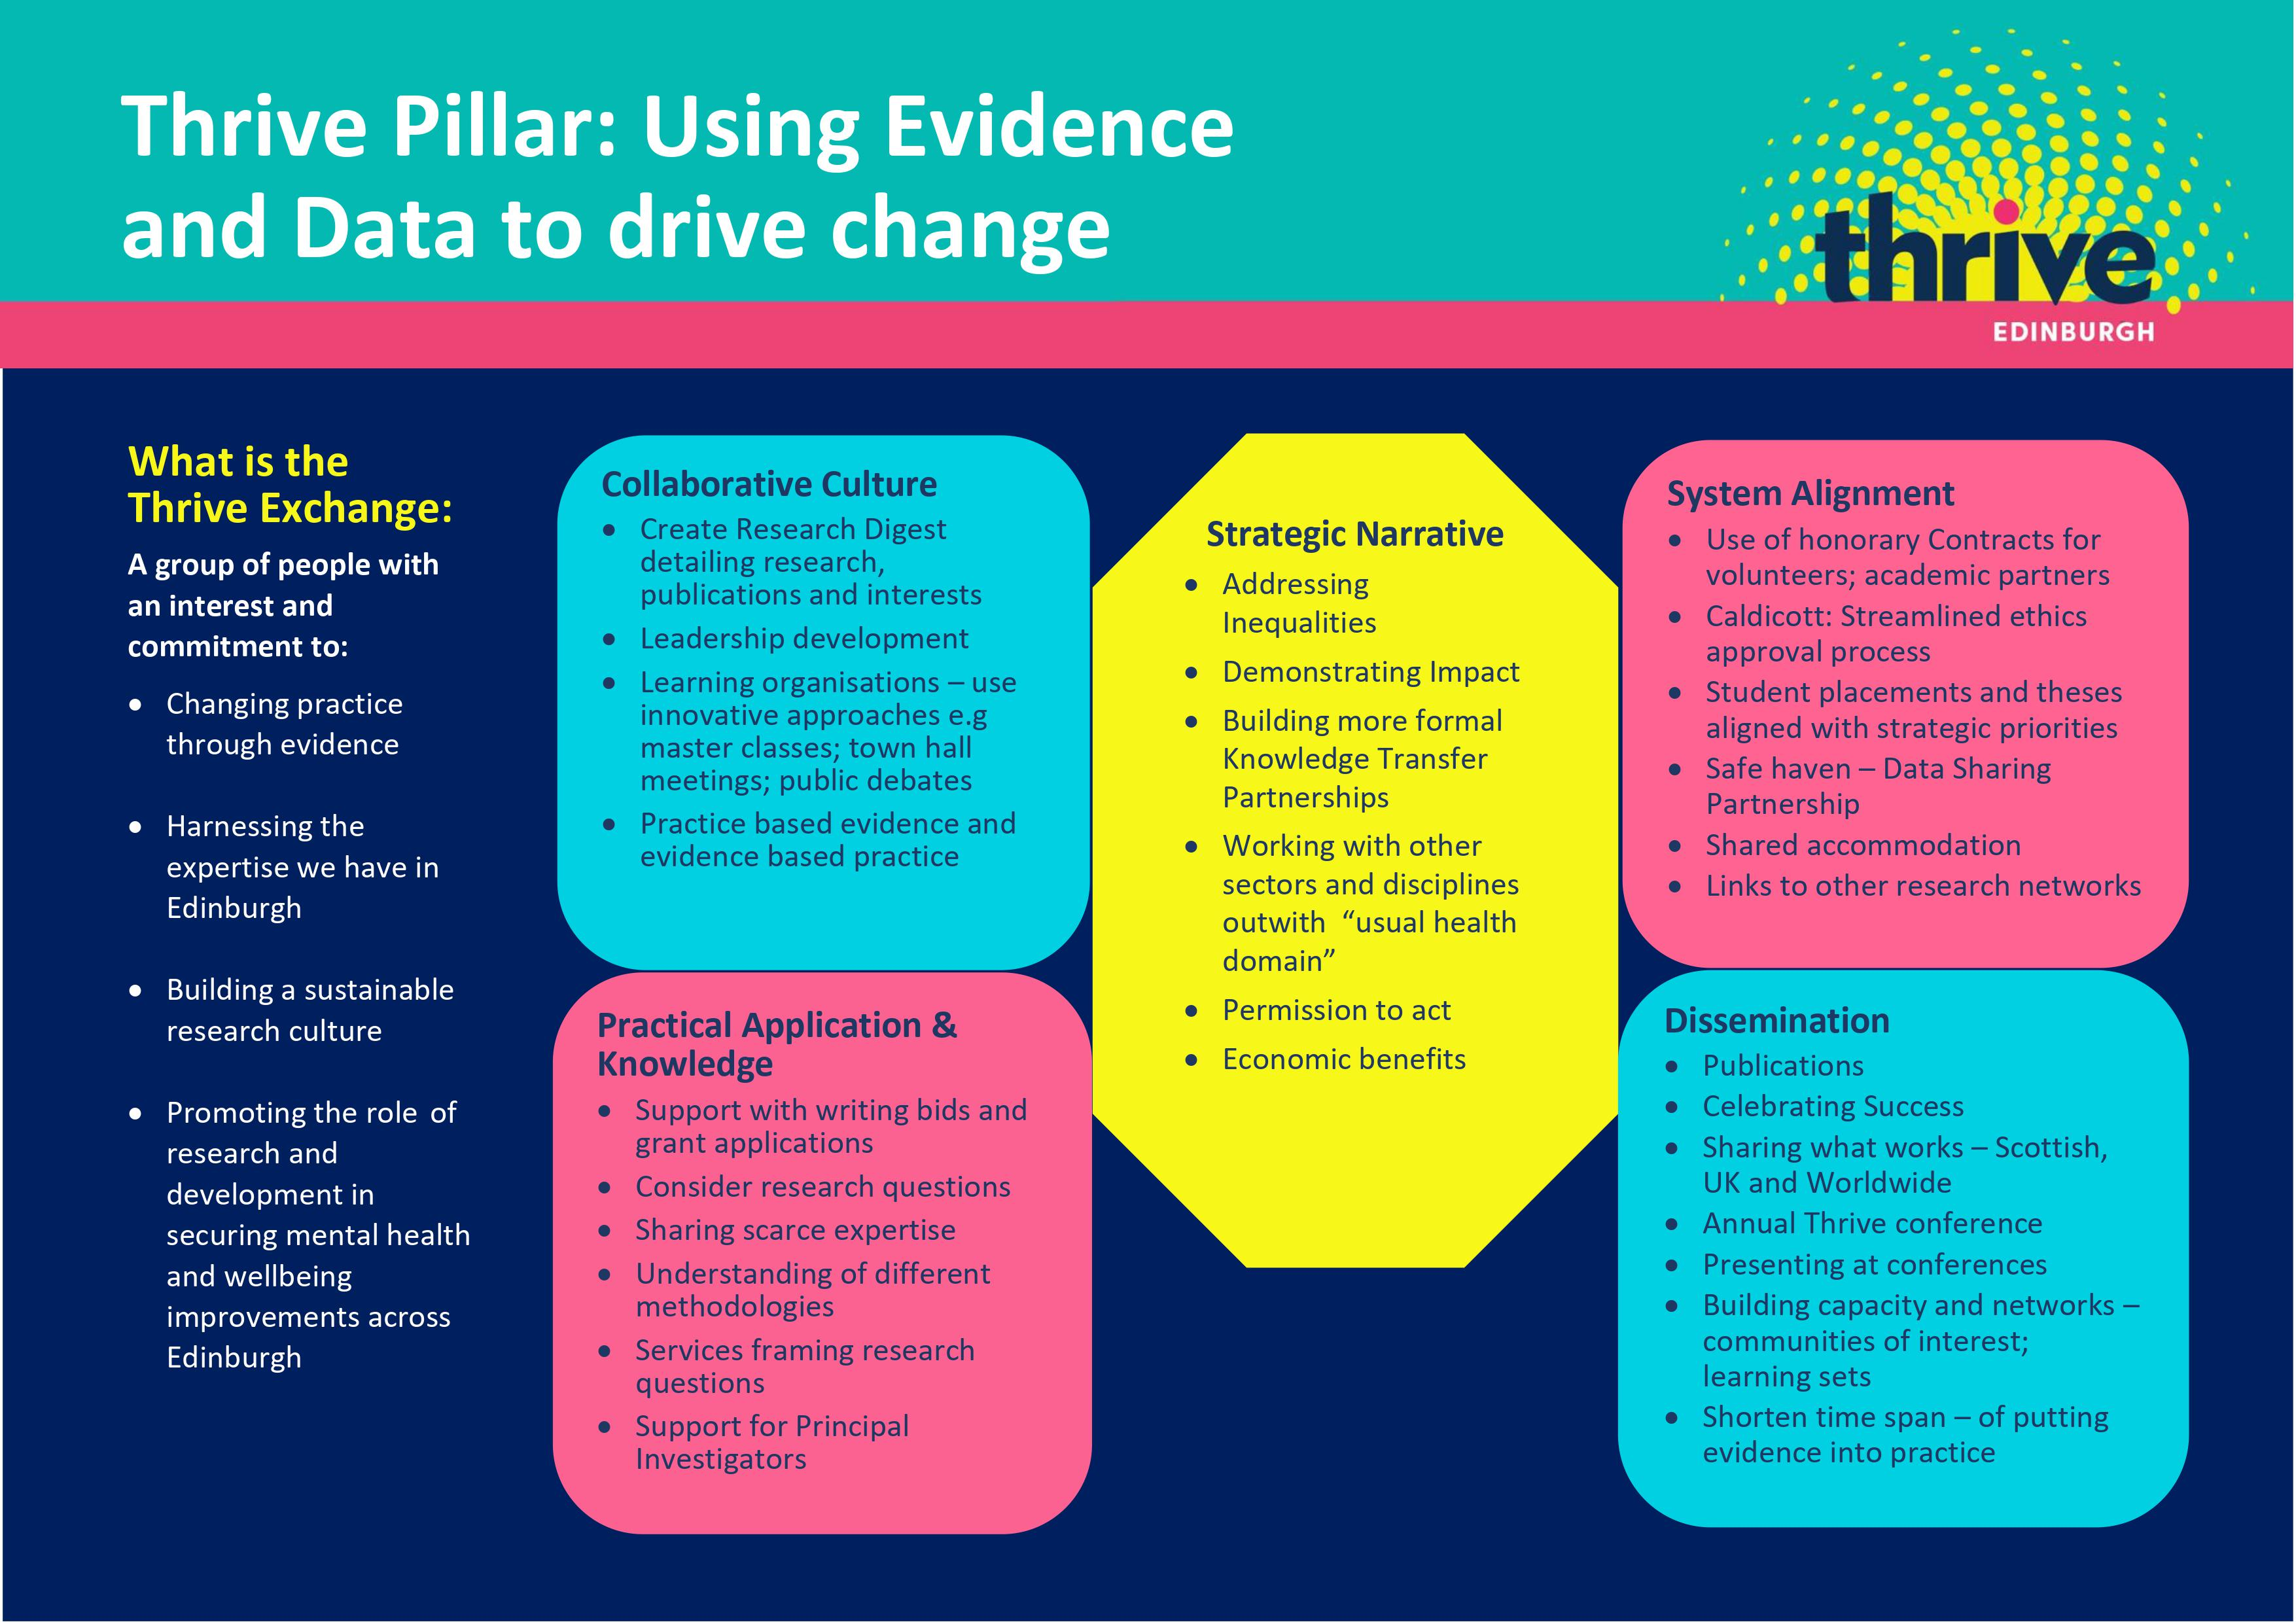

Thrive Exchange - a group of people with an interest and commitment to:
Using data and evidence to drive change - The Thrive Exchange
- Changing practice through evidence
- Harnessing the expertise we have in Edinburgh
- Building a sustainable research culture
- Promoting the role of research and development in securing mental health and wellbeing improvements across Edinburgh

You may be someone with a interest and curiosity in research, an early career researcher, a practitioner who also researches, a much published academic , a student, and so on… The Exchange is about being curious, learning together, sharing practice and ideas, discussion and debate.
Please complete this form it will help us shape the Exchange and the activities that come next…
Personal details
Name
Email
Organisation / Institution – if applicable
Mental Health and Wellbeing Research Interests - Please list your interests

Current involvement in mental health and wellbeing research/evaluation - Please provide a brief description of your work

Previous research/development work involvement - Please provide a brief description

Any Publications/ documents that you would like to share with the exchange – please send link, file or add reference

Being part of the Exchange
What can you bring to the Exchange?

What would like to receive from the Exchange?
Anything else you would like to add

Please return by 31 July 2020 to:
Linda.irvinefitzpatrick@nhslothian.scot.nhs.uk

