Women With Disabilities Australia
wwda.org.au

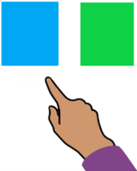
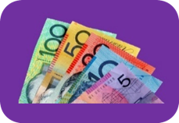
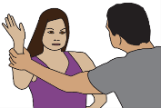

Our report to the DRC.
Big problems.

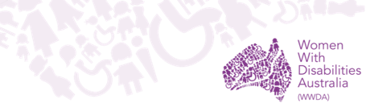

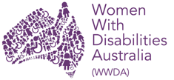
We are Women with Disabilities Australia.
We write WWDA when we talk about us.

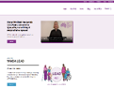
You want to know more about WWDA.
Go to www.wwda.org.au
Click the About us button.

Now.
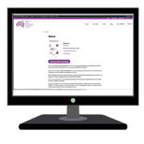

Click the About WWDA button.

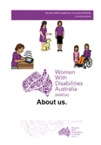

Read About us. It is in Easy English.

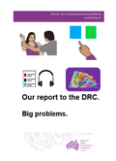
Some things are in all parts of your life.
We told the Disability Royal Commission.
We write DRC when we talk about the
Disability Royal Commission.

The big problems in all parts of your life. Like
- violence

- money
- NDIS.

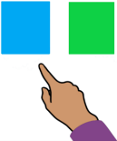
Other big problems in all parts of your life are
- how you see yourself
- the right to choose
- access to information.
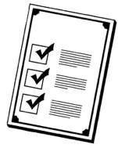
Rules

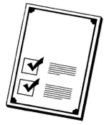
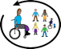
There are laws about people with disability.
They say we have the right to
- be in lots of communities
- be safe
- have money.

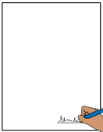
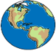
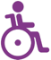
Like The United Nations Convention on the Rights of Persons with Disabilities.
We write CRPD to talk about it.

The CRPD are rules for the whole world.
It tells us about the rights of
all people with disability.

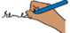
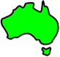
The Australian Government signed the CRPD.
They agree to follow these rules.

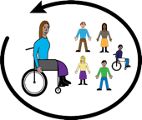
Australia agrees people with disability must be part of their community.

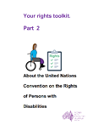

Learn more about the CRPD. Go to page 25.

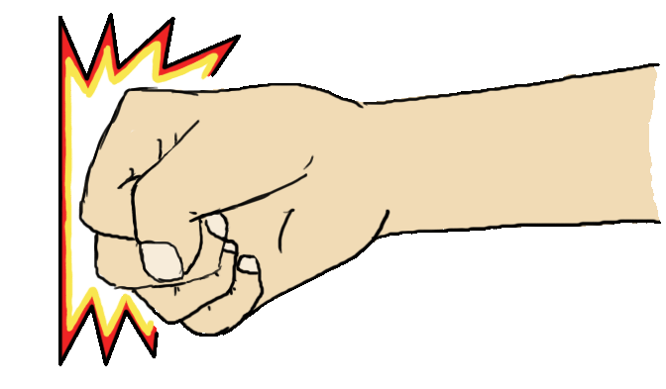
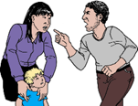
Violence. Abuse
People with disability say there are lots of bad things in your lives.
It is called violence. It is abuse.
It may be different for each person.

Like
- you get hit all the time. It may be
- an adult hits you
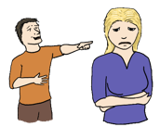
or
- your child hits you
- people say bad things about you.

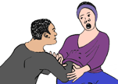

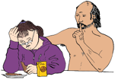
It may be abuse about sex.

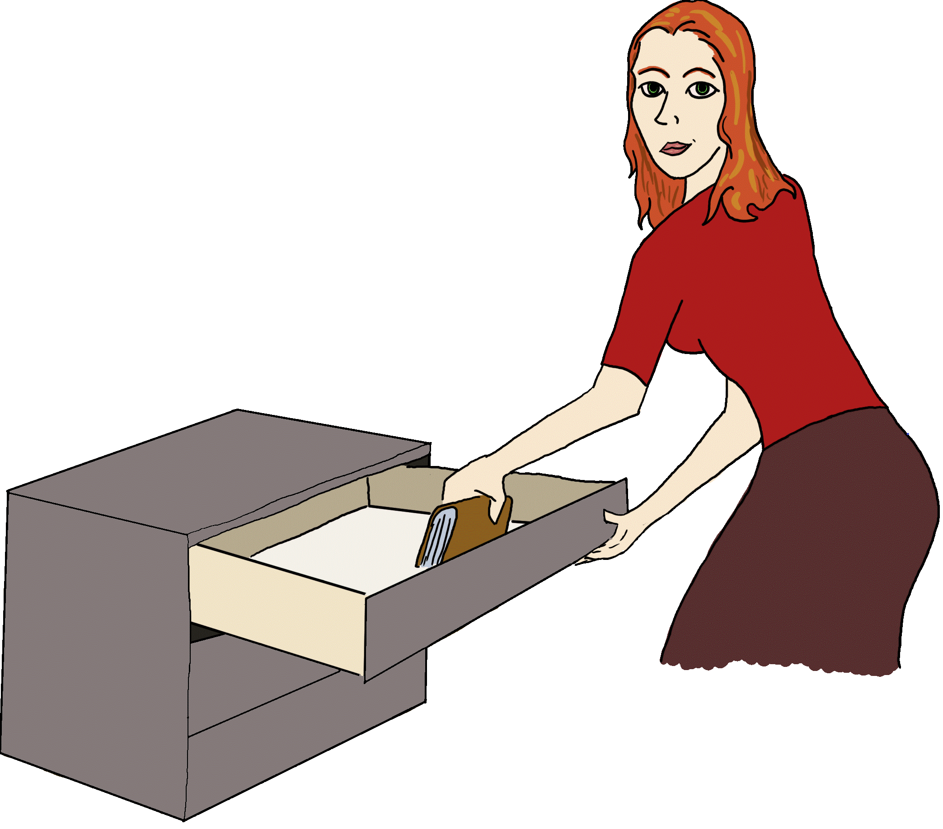
Other things may be they
- break your things. They mean to do it.
- they take your things

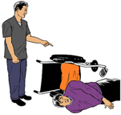

- break the things you need.

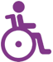
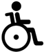

Violence happens to many people with disability.

But

It happens more to women and girls
with disability.

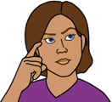
We know why there is more violence to women and girls with disability. We told the DRC.

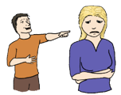
Like some people think you
- are not as good as people with no disability
- do not have feelings
- can not make your own choices
- do not have the same rights as people with
no disability.

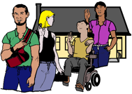
Some people say you can only do things with other people with disability. Like
- where you go to school
- where you live.

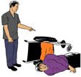
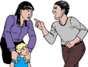
Learn more about
- violence
- abuse.

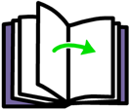

Go to page 26

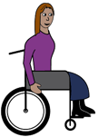
How you see yourself

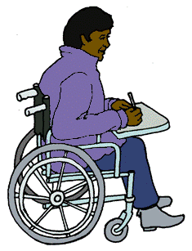
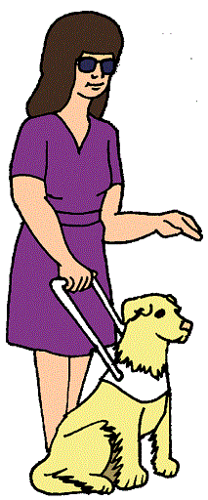
You are a
- woman
or
- girl

and

- you have a disability.

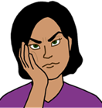
It makes it hard to do lots of things. Like

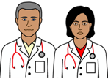

- see the doctor you want to see

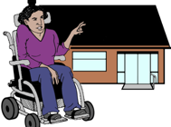

- live in a place you choose

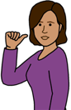
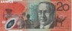
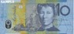

- use your own money

and
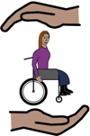

- be safe.

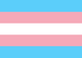
Other things make it hard too.
Like you may be
- LGBTQI+

and
- are a woman or girl
and
- you have a disability.

Or
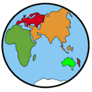

- you are from another country

and

- are a woman or girl
and
- you have a disability.
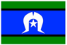
Other things make it hard too.
Like you may
- be Aboriginal or Torres Strait Islander

and

- are a woman or girl
and
- you have a disability.

Or

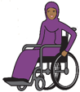
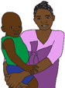
- you speak a different language

and

- you are a woman or girl
and
- you have a disability.

Information the way you need it

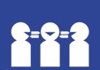
People with disability have the right to
get information
- when you need it
- in a way you can understand.

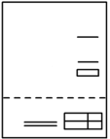
There is information you need to know.
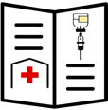
Like you
- have a bill
- have health information to read.

But

There is no information
- in Easy English
- you can listen to
- in large print
- in a different language.

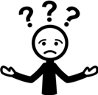
You can not understand the information.
You do not know what to do.

Right to choose

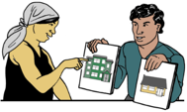
Some women and girls with disability
- do not get to choose where you live
- do not get to choose where you go to school
- do not get to choose what help you want.

Some people say we can not make our
own choice.

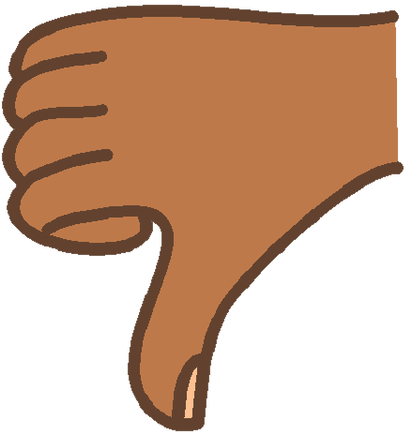
This is all wrong.
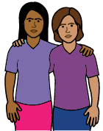
Some women and girls with disability can not choose things in your day. Like
- your friends
- where you go
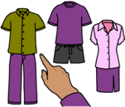

- what you wear.

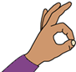
This is not OK.

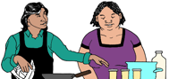
Other things may be
- you do not get the help you need
or
- people do not understand what help you need.
Money

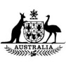
You have the right to money.
It is money from the government.
It helps pay for the things you need.

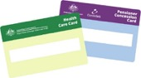
Some people with disability can get a pension. Like
- Disability Support Pension
- Sickness Allowance.

But

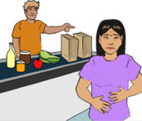
It is only a little bit of money.
It does not pay for all the things you need.

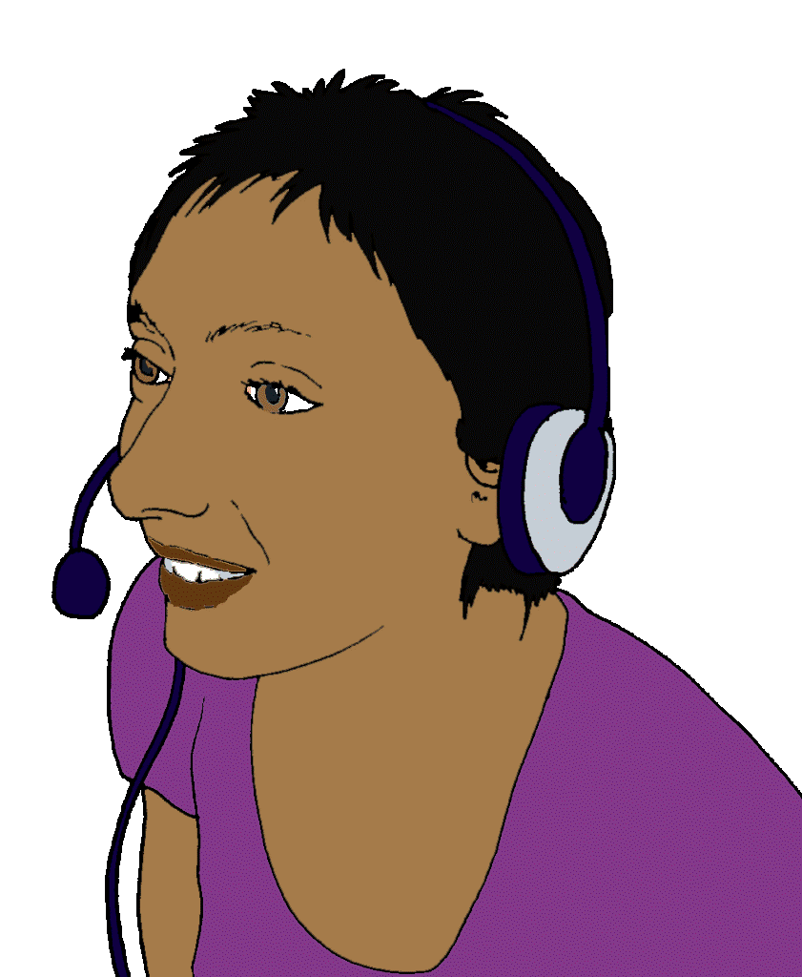
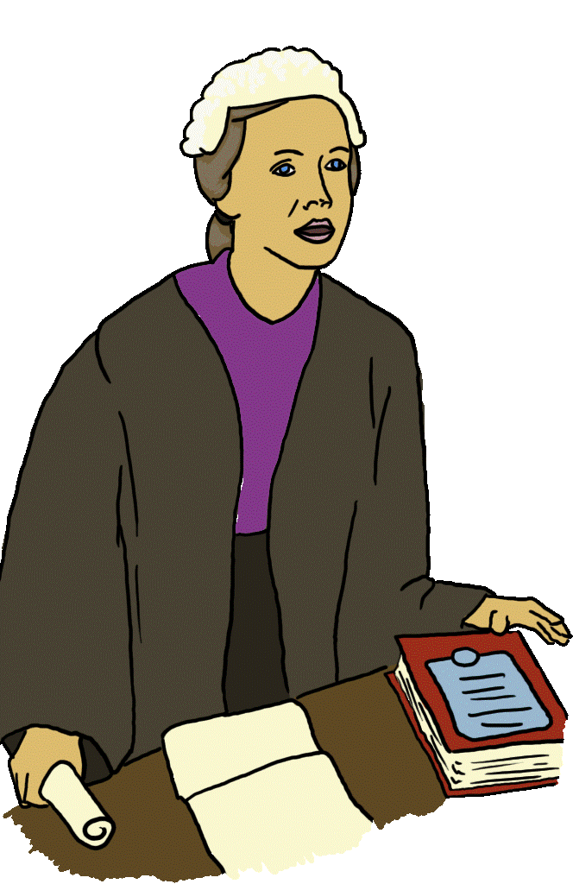
Many women and girls with disability
can not work. Like you
- can not find work you can do
- can not find a work place who lets you work.

Or

The job only pays a little bit of money.
You can not live on that money.

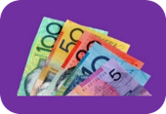
NDIS help

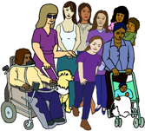

The NDIS helps some people with disability.

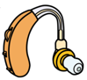
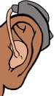
It can pay for the cost of your disability.
Like you are deaf.
You need new hearing aids.
NDIS can pay for your new hearing aids.

Many people with disability do not get NDIS help.

But

All people with disability need help some times.

Only 1 in every 10 people with disability get NDIS help. It is only a few people.
NDIS must help more people with disability.

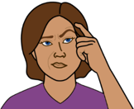
A lot of people say the NDIS is too hard to get. Like
- you do not understand what you need to do
- they do not listen to your doctor.

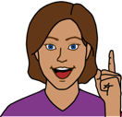
We have lost of ideas to make big changes.

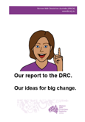
Read
Our report to the DRC.
Our ideas for big change.

Learn more about the CRPD
It is in Easy English.

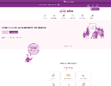
Go to www.oursitewwda.org.au
Click on Easy English at the top.

Now.

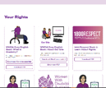
Go to the Your Rights part.
Click the Your Rights Toolkit button.

Here is our CRPD fact sheet.
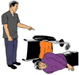
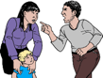
Learn more about
- violence
- abuse

Go to www.oursitewwda.org.au
Click on Easy English at the top.

Now.

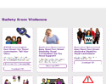

Look for the Safety from Violence part.

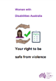
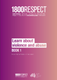
There is lots of information here. Like
- Your right to be safe from violence
- 1800 Respect. Book 1. Learn about violence.
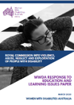
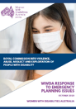
This report is based on information in all the Women With Disabilities Australia reports to the Disability Royal Commission. 2020.

Images
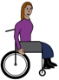
We can use these images. They are from
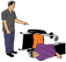
- ChangePeople
- EasyontheI
- InspiredServices
- Picto-Selector
- Spectronics
- TheNounProject
- Tobii-Dynavox.

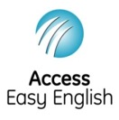
Access Easy English wrote the Easy English.
September 2021.

