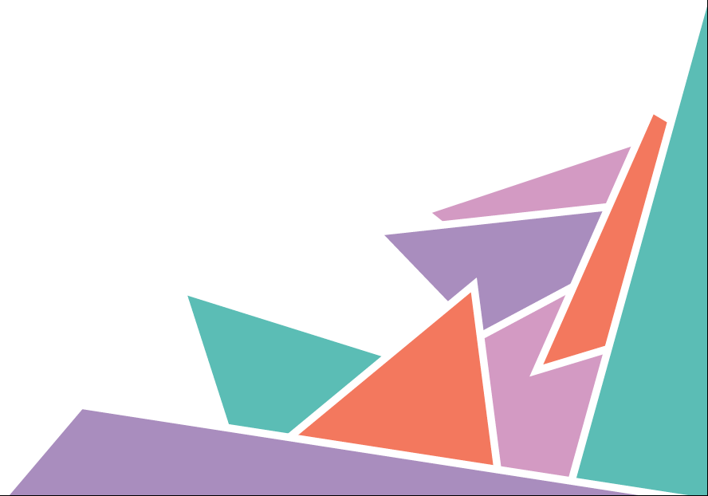
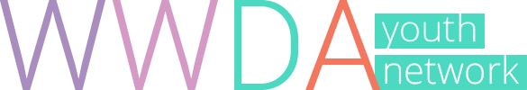

Position Statement 5

Work & Education

WWDA Youth Believe
- Education is important for advancing the human rights of girls and young women with disability.

- Schools and workplaces should be inclusive of young women and girls with disability.

- The right to an education and to meaningful, fully paid work, are basic human rights.

- When people cannot work, they are entitled to receive support from Government and the community.

- Young women and girls with disability have a right to be educated in a mainstream setting.

The Facts
- Because of discrimination and inequality, women with a disability are half as likely to find full-time employment as men with a disability

- Sexual health education programs in schools often exclude young people with disability

- Women with a disability are likely to be in lower paid jobs than men with a disability

- Limited access to education, discrimination and experiences of violence, can make it hard for young women and girls with disability to do well at school

- Access to Education and fairly paid work are human rights

What It Means

Inclusion
Having the opportunity to access and participate in the same activities and settings as people without a disability. Full inclusion means that people will feel they belong and will be treated equally as their friends.

Mainstream Settings
Mainstreaming means young women and girls with disability are supported to attend the same schools and classes as children and young people without disability.

Violence
Using force or power against another person, group or community, which results in them being hurt, feeling pain or fear. Violence can be physical, emotional, sexual, and psychological, among others. Violence can be committed by an individual, a group, or by the State (a country).

Discrimination
Being treated unfairly or differently because of who you are, where you live, what you believe, or because you have a disability.

Human Rights
Rights to freedom, dignity and fairness that all people have, no matter their race, ethnicity, nationality, age, sex, gender, sexuality, disability or political beliefs. Human rights are protected by international law.

Learn More

Human Rights
Human rights are protected under international law. These rights are described in documents called conventions or treaties. Countries such as Australia can agree to be bound by these laws.

WWDA Youth Human Rights Workbook
The WWDA Youth Human Rights Workbook explores and explains the Convention on the Right of Persons with Disabilities (CRPD) and the Convention on the Elimination of All Forms of Violence Against Women (CEDAW).
http://youth.wwda.org.au/workbook/

Convention on the Rights of the Child (CRC)
The CRC describes and protects the human rights of children and young people. Check out the “For Youth” page to learn more about your rights:
www.unicef.org/rightsite/433.htm

Convention on the Rights of Persons with Disabilities (CRPD)
The CRPD describes and protects the rights of all people with disability. You can find an easy to understand version of the convention at:
www.unicef.org/publications/index_43893.html

Australian Human Rights Commission
The Commission has put together some great ideas about how to get involved in human rights and make a difference. Visit:
www.humanrights.gov.au/education/students/get-involved-students

Help & Support

In an Emergency
If you or another person is in immediate danger, Call 000 (Triple Zero)

eheadspace
The eheadspace online and telephone service supports young people and their families going through a tough time. Visit: https://www.eheadspace.org.au/

Kids Helpline
If you need to talk about anything, you can call, email, or have an online chat
with Kids Helpline. Visit www.kidshelpline.com.au or call 1800 55 1800

1800 RESPECT
Support if you have or are currently experiencing sexual, domestic or family violence. Visit www.1800respect.org.au or call 1800 737 732

Disability Advocacy Services
A disability advocate can help you to access support around your human rights. To find an advocate near you, visit: http://finder.dss.gov.au/disability/ndap/

Get Involved

United Nations Youth Association Australia (UNYA)
UN Youth Australia is a national youth-led organisation that aims to educate and empower young Australians on global issues. Visit: www.unyouth.org.au

Women with Disabilities Australia (WWDA)
WWDA represents more than 2 million disabled women and girls in Australia. We are run by and for women with disabilities. We operate as a transnational human rights and systemic advocacy organisation. www.wwda.org.au

WWDA Youth Network

WWDA Youth Network aims to empower young women and girls with disabilities to become strong, confident, proud and educated on their rights and options. Follow us and get involved at:

Web http://youth.wwda.org.au
Facebook http://www.facebook.com/WWDAYouth
Twitter http://www.twitter.com/WWDA_Youth
YouTube http://goo.gl/BqDQ47
Instagram http://www.instagram.com/WWDA_Youth

WWDA Youth Network, Position Statement 5: Work and Education, Women With Disabilities Australia (WWDA): Hobart, Tasmania, 1st Edition, June 2017.
ISBN: 978-0-9876035-1-7
The development of this position statement was made possible through project funding from the Australian Government, Office for Women. WWDA thanks the women and girls with disability who contributed to the development of this statement.
Prepared by Cashelle Dunn and Chris Brophy.
For further information and citations, please access:
- WWDA Human Rights Toolkit and comprehensive WWDA Position Statements available at, http://www.wwda.org.au/papers/toolkit
- WWDA Youth Human Rights Workbook and WWDA Youth Position Statements available at, http://youth.wwda.org.au/workbook/
© Women with Disabilities Australia (WWDA) 2017.

