Fact Sheet:

Talking to the Police

May 2015

Introduction
Have you been the victim of a crime? Being the victim means someone hurt you, scared you, made you feel unsafe, or tried to control you. It can be scary talking to the police. But when you feel brave enough, you should talk to the police if a crime has happened to you.
Why Are Some Women And Girls Scared To Report Crime?
- You might think nobody will believe your story.
- You might be afraid the police will not understand your disability.
- You might be afraid the police will think something is not a crime – when it was a crime.
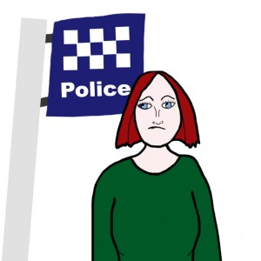
- You might be embarrassed about what happened.
- You might think something bad will happen to them if they tell.
- You might not want your friends or family to find out a crime happened to you.
- You might not be sure that what happened was a crime.
- You might have had a bad experience with the police in the past.
How to Report a Crime
If you think a crime has happened, you can tell the police
- on the phone when you call 000
- on the phone when you call your local police station
- at the police station
- at the place the crime happened
Talking To The Police
The police must make you feel safe.
You can say if you want to talk to a Policeman or Policewoman.
If you are reporting a sex crime you might want to talk to a policewoman.
The police must support you in the right way.
You might want a person to be with you when you talk to the police. You can ask the police to call someone to be with you. This means you have the right to have a support person, an Independent Third Person, and an advocate with you when you report a crime.
Having a support person can be a great emotional comfort. They can also provide you with assistance. Support people can include,

Victim & Her Support Person
- a friend
- someone from your family
- a counsellor
- a support worker
You also have the right to have a communication support person. A communication support person helps you gets your message across. For example,
- Auslan interpreter
- Foreign language interpreter (Vietnamese to English)
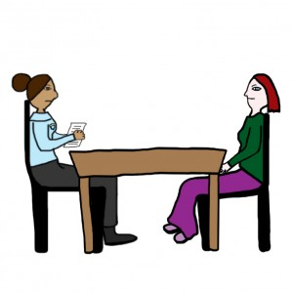
You can also have an Independent Third Person (ITP) who can be a friend, a relative or a volunteer from the Office of the Public Advocate. An ITP can not give you legal advice. This means they cannot tell you what you should do. But an ITP can help you:
- Call a lawyer
- Call a support person
- Get your message across
- Understand police questions
- Understand what is going to happen.
You can have an advocate. An advocate can be a friend, a relative, or a volunteer. An advocate can:
- Give you advice
- Help you decide what to do.
Victim talking to a female police officer
The police must make sure you feel comfortable
The place where you talk to the police should:
- be quiet
- have enough space
- not have people walking past or looking in.
The police should make sure you feel in control. They should:
- talk to you, not your support person
- treat you with respect – not like a little girl
- use words you understand
- tell you what hard words mean
- tell you all the information
- ask you “Do you want to take a break?”
- ask you “Do you want to keep going?”
The police must let you tell your story.
The police should:
- listen
- give you time to tell your story
- let you take a break
- let you communicate in a way that is good for you. For example, if you use a talking machine, they should not take it away.
They should NOT:
- interrupt you
- rush you
- ask too many questions at one time
- ask questions that confuse you.

Reference
Victorian Equal Opportunity & Human Rights Commission. Beyond doubt: Telling the police about crime; 2014 July [cited May 2015]. Available from: www.scopevic.org.au

