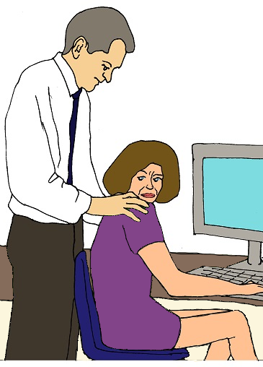

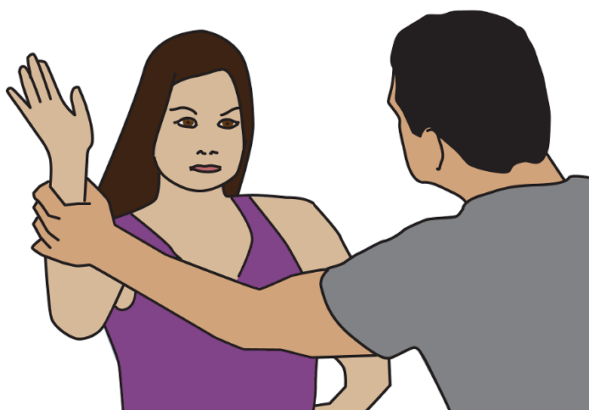

What is violence?
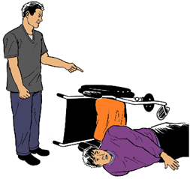
Book 2
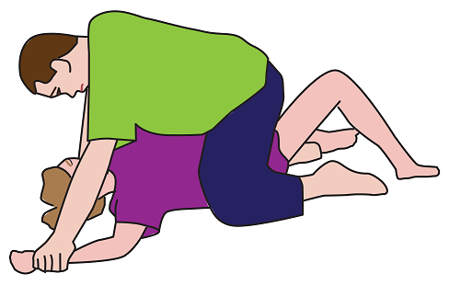

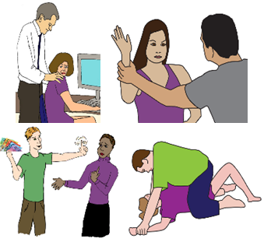
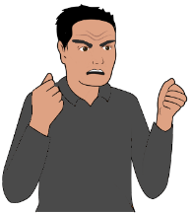
Violence
A person hurts you.
There are many different types of violence.
A person may use more than 1 sort of
violence on you.
We will tell you about different violence here.

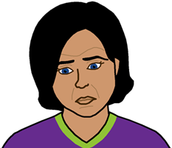

It may make you upset. You can get help.

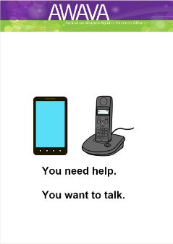

Read You need help. You want to talk.

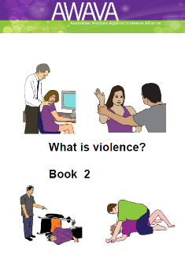
This book. Book 2

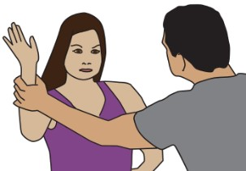

Physical page 8

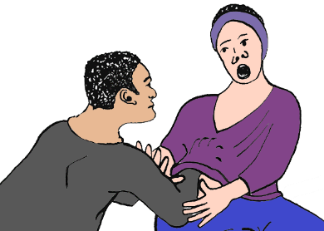

About sex page 11

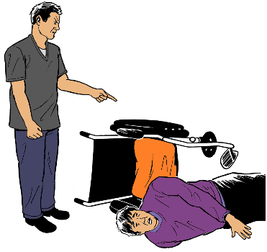

Use your disability page 18

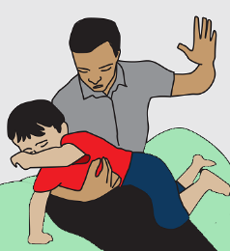
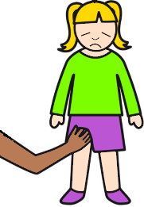
They hurt your child page 22

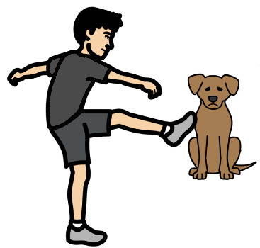

They hurt your pet page 24

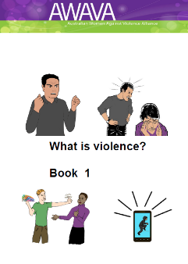
Book 1

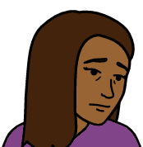
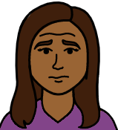
About how someone makes you feel Book 1

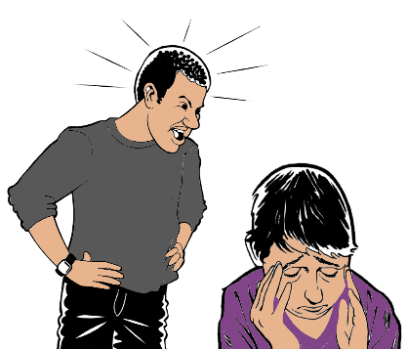

How a person talks to you Book 1

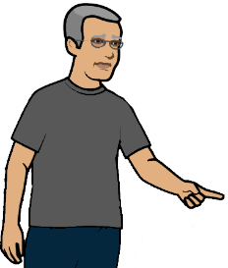
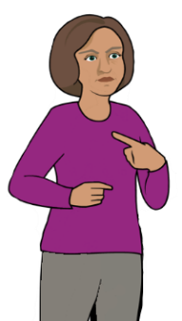

About your time alone Book 1

About money Book 1

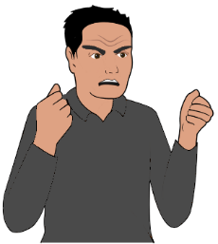

Control Book 1

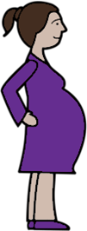

Your choice to have children Book 1

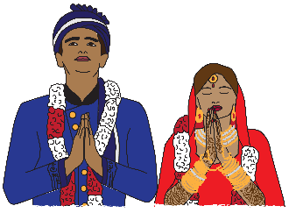

About gifts for your wedding Book 1

Physical

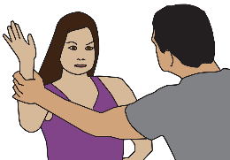

A person tries to hurt your body in some way.

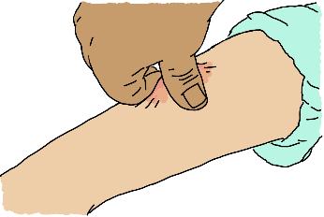
It can be they
- pinch you
- slap you

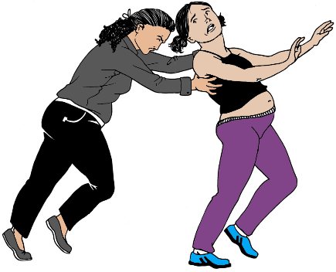
- pull your hair
- push you around.

They may hit you. They do it over and over.
They break your arm.

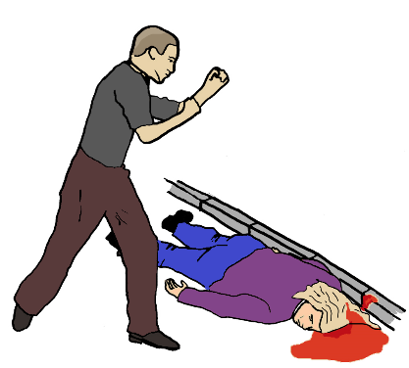
They may hit your head.
They do it over and over.

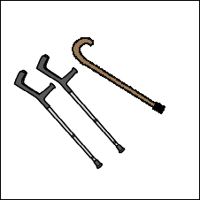
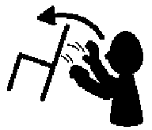
The person may use things you need.
They use it on you. Like
- your walking stick
- something from your wheel chair
- things from around your home.
Like throw a chair.

They may use their gun.

You may be in danger.
You may die.

It is called physical abuse.

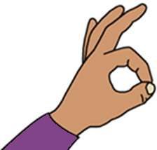

This is never OK.

About sex

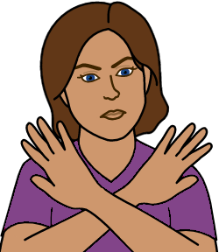
A person makes you do things about sex.
You do not want to.
You try to say no.
They do not stop.

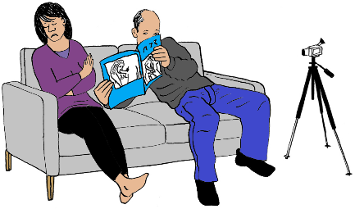
Like they make you
- look at rude pictures
- on the computer
- in a book.
You do not want to do this.

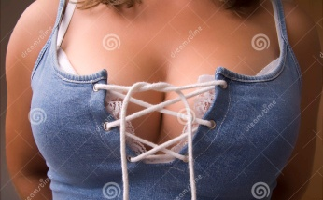
They make you dress in clothes that show your
- breasts
- private parts.
You do not want to do this.

It is also when the person touches you
- on your breast
- on your private parts
or
- in other places of your body.

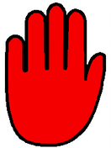
It does not feel OK.
You want the person to stop.

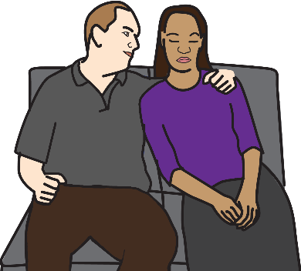
It can be when a person may touch you.

But

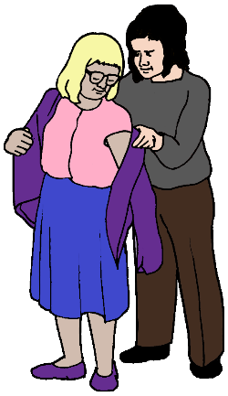
they are only there to help you. Like
- get dressed
- in the toilet
or
- in the shower.

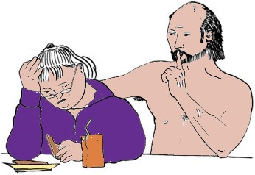
They may be staff.
But
They may be family.

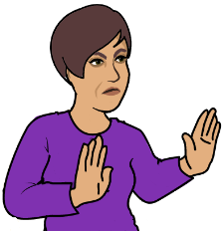
It can be the person makes you touch them.
You do not want to do that.
It does not feel OK.

Like a man makes you touch his penis.
He wants you to do it with your
- hand
or
- mouth.

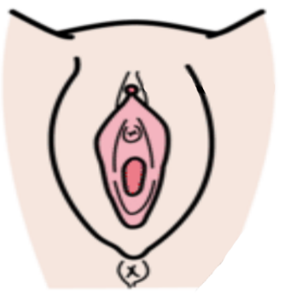
A person wants to put some thing inside you.
Like inside your
- vagina
- anus.

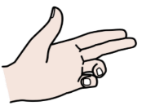
They might use their
- fingers
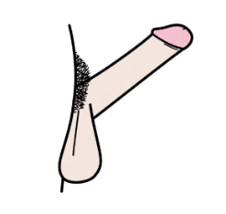
- penis.

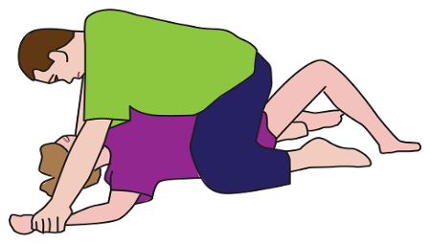
You do not want to do that.
It does not feel OK.
It is called rape.

These are all called
- sexual abuse
or
- sexual assault.

This is never OK.

Use your disability
- to control you
or
- treat you in a bad way

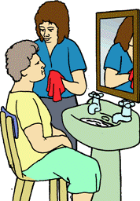
This may be the person
- will not help you in the bathroom

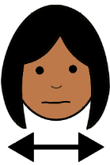
- does not give you the right pills
or
- gives you the wrong number of pills.

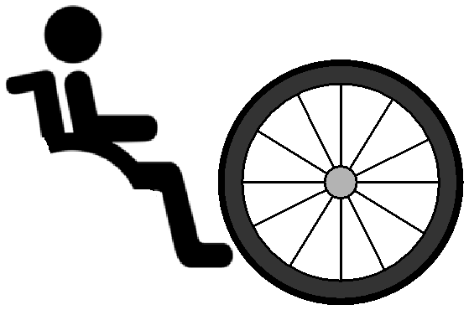
They may do things to your equipment. Like
- take a wheel off your wheelchair.
You are stuck. You can not move.

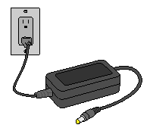
- do not put your wheel chair battery on charge for the next day

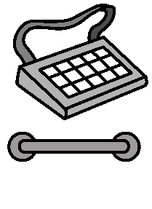
- take away your communication aid

- takes away things you need.
Like a grab rail.

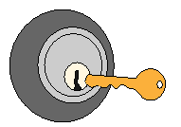
They may stop you. Like
- lock the door
- to your bed room
- to your home.
You are stuck in there. You can not get out.

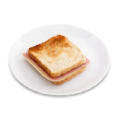
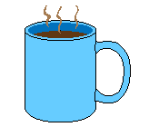
You need help to eat. They may
- not give you food.
- give you help in the wrong way.
You may choke. You do not feel safe.

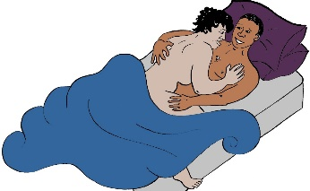
The other person makes you have sex.
They say you must have sex

or
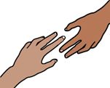
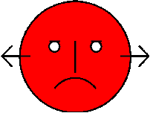

They will not help you.

This is called disability abuse.

This is never OK.

They hurt your child

A person says you must do as they say.
You do not do what they say.
They say they will hurt your child.

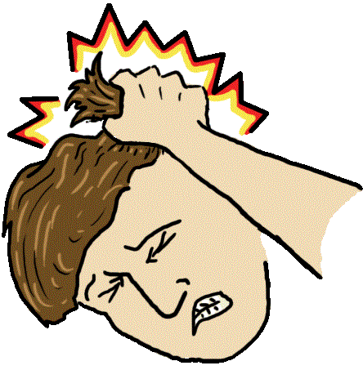
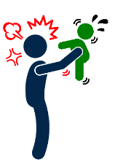
They may hurt your child with
- punches
- shakes
- kicks.

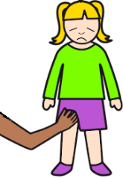
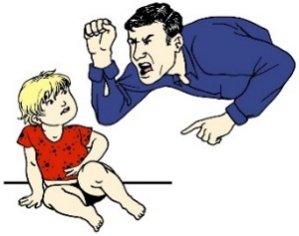
The person may
- shout at your child.
- touch your child in their private area.

This is child abuse.

This is never OK.

They hurt your pet

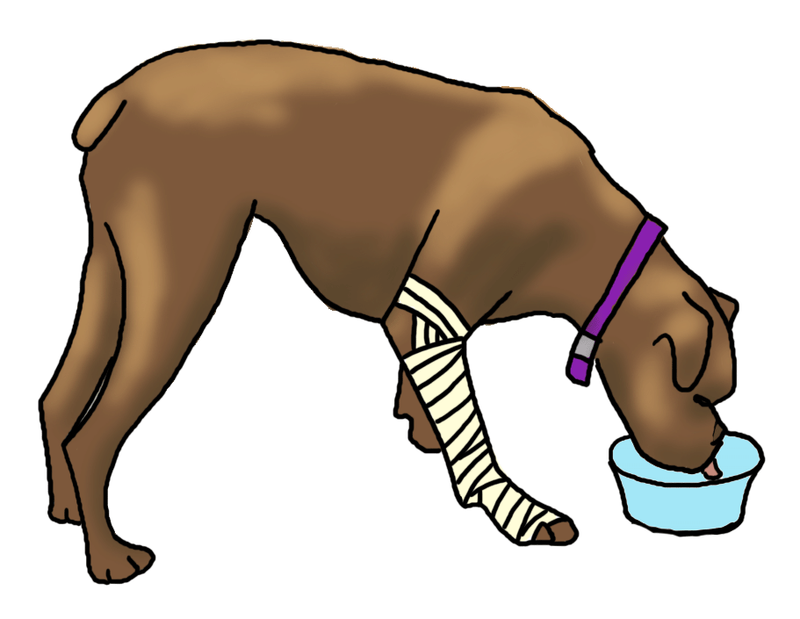
A person says you must do as they say.
You do not do what they want.
They say they will hurt your pet.

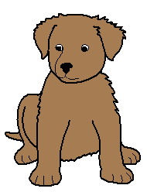
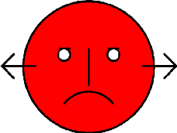
Like they
- will give away your pet

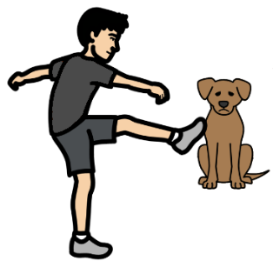
- kick your pet
- not feed your pet.

This is animal abuse.

This is never OK.

Images
We have used images from
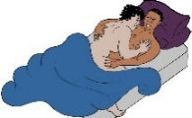
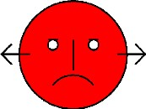
- ChangePeople
- COMPIC
- EasyOnTheI
- InspiredServices
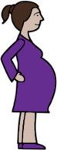
- Picto-Selector
- Spectonics
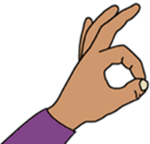
- TheNounProject
- Tobii-Dynavox.

This fact sheet is based on information

from AWAVA.

Access Easy English wrote the Easy English.
April 2021.

