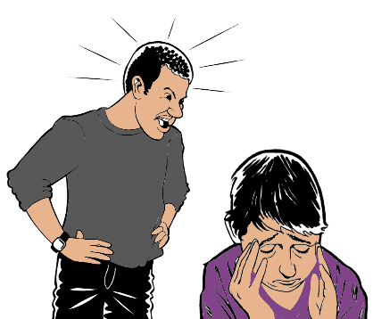
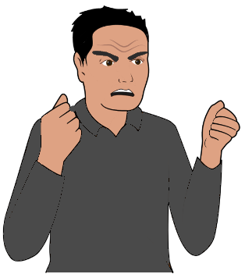

What is violence?
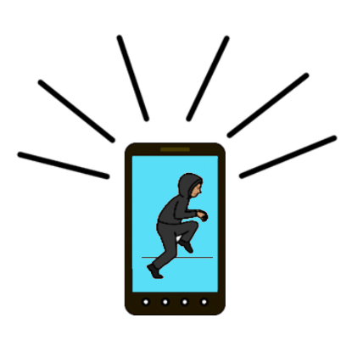
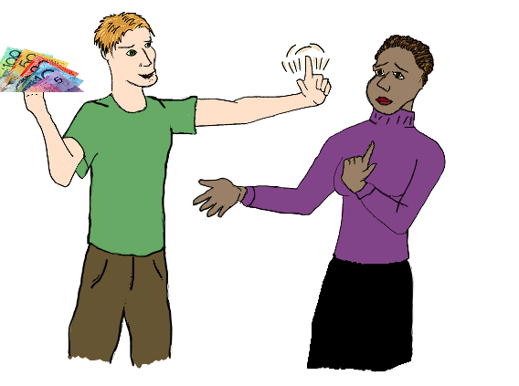
Book 1

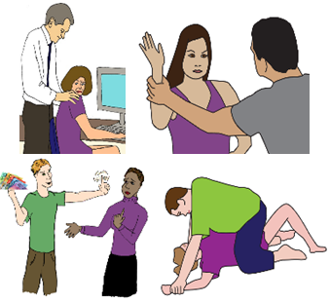
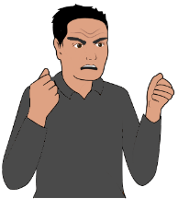
Violence
A person hurts you.
There are many different types of violence.
A person may use more than 1 sort of
violence on you.
We will tell you about different violence here.

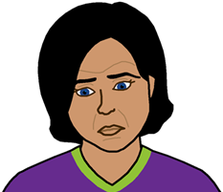

It may make you upset. You can get help.

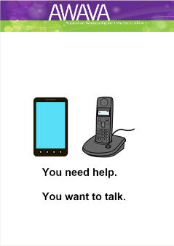

Read You need help. You want to talk.

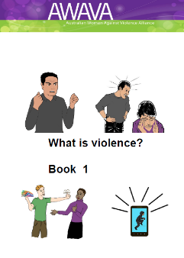
This book. Book 1

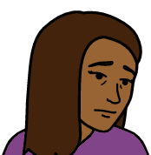
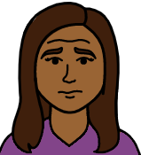
About how a person makes you feel page 8

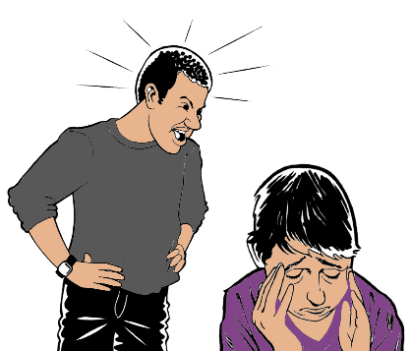

How a person talks to you page 10

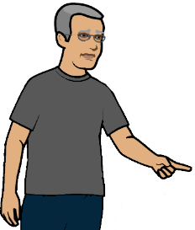
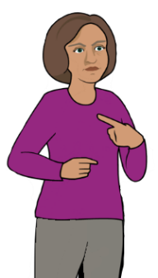

About your time alone page 12

About money page 14

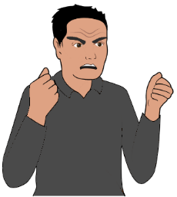

Control page 17

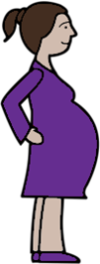

Your choice to have children page 20

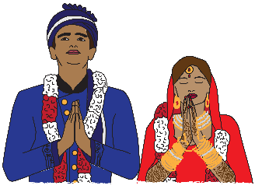

About gifts for your wedding page 22

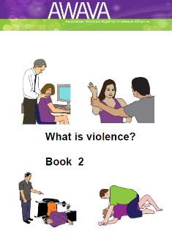
Book 2

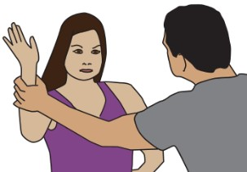

Physical Book 2

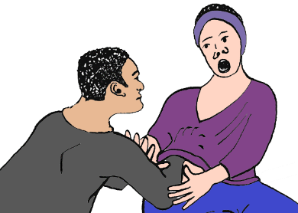

About sex Book 2

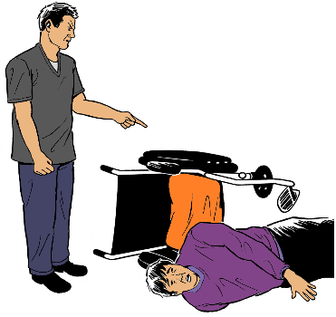

Use your disability Book 2

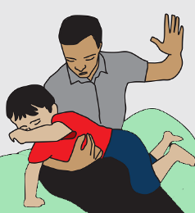
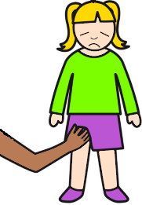
They hurt your child Book 2

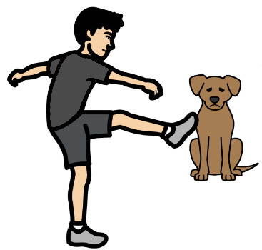

They hurt your pet Book 2

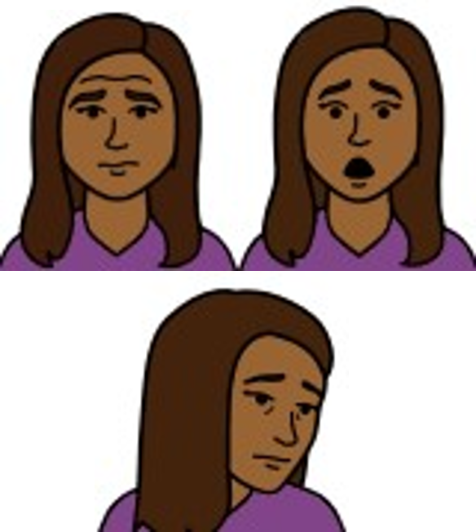
About how a person makes
you feel

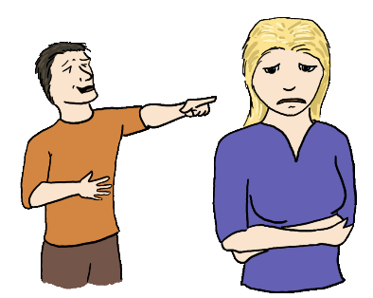
There are lots of ways a person can
hurt your feelings.

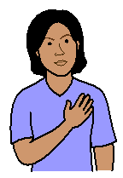
Like they
- make you feel bad about your self
- make you feel you do not trust your self.

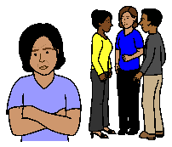
They may
- not let you be part of a group.
- ignore you
- make you feel you are alone.

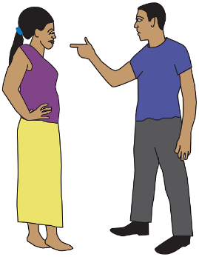
They may treat you like a child.

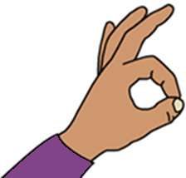
It is called emotional abuse.
This is never OK.

How a person talks to you

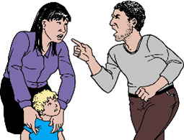
They may
- swear at you all the time
- shout at you
- say things that put you down.

Like they call you mean names.
You do not like the names.
You feel very sad.

It is called verbal abuse.
This is never OK.

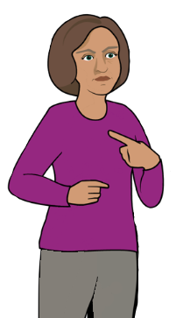
About your time alone

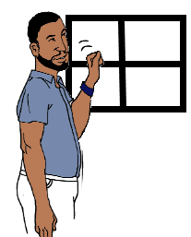
A person
- watches you at your house
- checks where you are

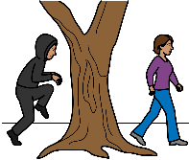
- follows you.

They may call you on the phone.
They do this all the time.
You do not want them to call you.

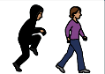
There are other things a person may do.
Like they may follow you on
- your phone
- your computer.

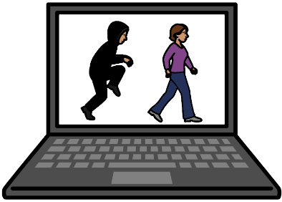
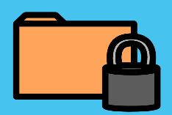
They want your pass words.
They log in to your social media. Like Facebook.
They read your private messages.

This is called stalking.
This is never OK.

About money

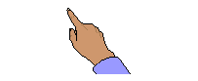
A person does not let you use your own money.

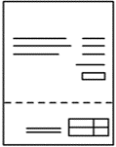
They choose how to use your money.
Like
- you pay all the bills with your money
- you pay for the other persons holiday

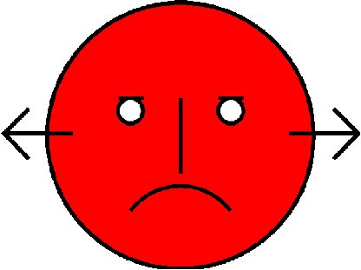
- you can only buy clothes and shoes they like.
You do not want to use your money on that thing.

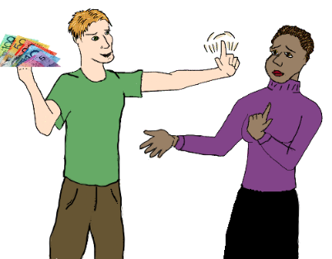
The person may not let you
- have your own money. Like
your money is with their money in the bank.
But
only they can get the money out of the bank.

Or

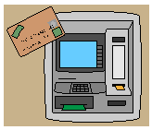
- they will not let you have your own money.
Like you do not have your own ATM card.

It is called financial abuse.
This is never OK.

Control

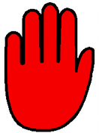
A person does not let you do things
- you want to do
- in the way you want to do them.

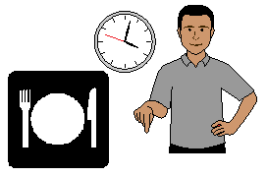
Like the other person says
- what time you can eat
- what to cook for meals

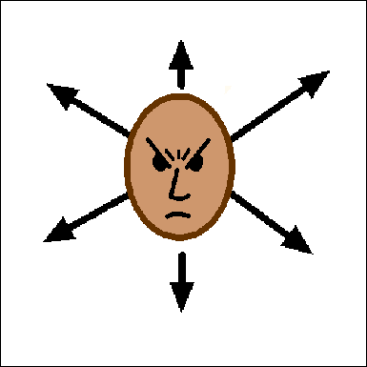
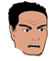
- you can only go to
- work
or
- school.
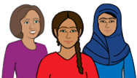
You can not do other things.
The other person says who your friends are.
Like you can only see their friends.

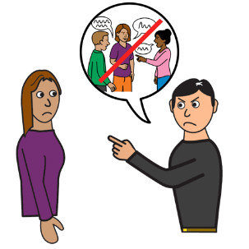
The other person says
- who you can talk to
- what you can talk about.
They are always with you.

They may
- stop you from doing things in your religion
or
- make you follow their religion.

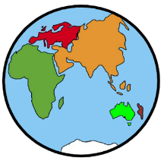
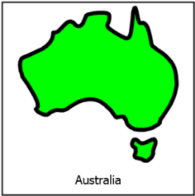
You came to Australia. Like you are a
- migrant
- refugee.

A person says you must do as they say.
You do not do as they say.
They say they will send you back to your country.

This is called coercive control.
This is never OK.

Your choice to have children

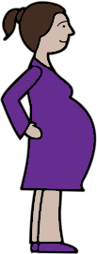
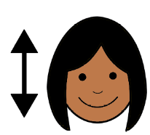
You can not choose to have children.
Like you are pregnant.

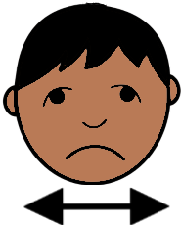
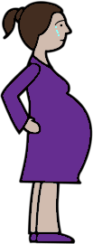
You want to keep the baby.
But
they make you stop the baby.

Or

You do not want to have a baby.

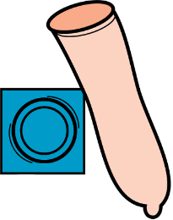
They will not have safe sex.
Like they will not use a condom.

This is called
reproductive abuse.
This is never OK.

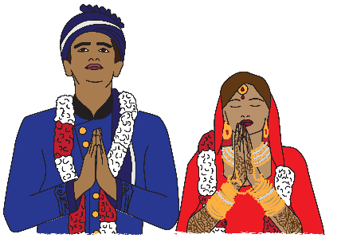
About gifts for your wedding

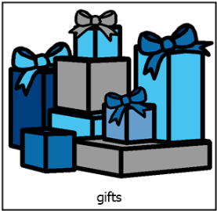
A person says what happens to the gifts from your family. The gifts are your dowry.
You have no say about the gifts.

This is all called dowry abuse.
This is never OK.

Images
We have used images from
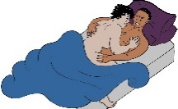
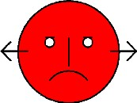
- ChangePeople
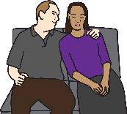
- COMPIC
- EasyOnTheI
- InspiredServices
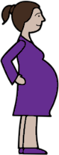
- Picto-Selector
- Spectonics
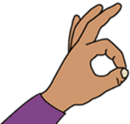
- TheNounProject
- Tobii-Dynavox.

This fact sheet is based on information

from AWAVA.

Access Easy English wrote the Easy English.
April 2021.

