Recognising and responding to sexual harassment in the workplace: Information for employees

What is sexual harassment?
Sexual harassment is any unwelcome conduct of a sexual nature. If a reasonable person would anticipate this behaviour might make you feel offended, humiliated or intimidated, it may be sexual harassment. Sexual harassment is unlawful under the Sex Discrimination Act 1984 (Cth).

Some examples of behaviour that may be sexual harassment include:
- Sexually suggestive comments or jokes
- Intrusive questions about your private life or physical appearance
- Inappropriate staring or leering
- Unwelcome hugging, kissing or cornering or other types of inappropriate physical contact

Sexually explicit text messages, images, phone calls or emails

CASE STUDY: The female complainant alleged that at a workplace function a partner from the company sexually harassed her by asking her how far up her body her tights went and by telling her she was beautiful. The complaint was resolved with an agreement that the company would pay the complainant $4,650 which represented compensation for loss of wages and reimbursement of costs for counselling sessions the complainant had undertaken.

CASE STUDY: The male complainant had recently started to work for the respondent and was to be trained by a long serving employee of the company. He alleged that the male trainer sexually harassed him from his first day at work including by asking him inappropriate questions and making comments of a sexual nature. The complainant alleged the trainer tried to flirt with him, made excuses to try to touch him, often placed his hand on the complainant's knee, would try to brush past him and would press his crotch into the complainant's back. The company said it investigated the complaint and terminated the co-worker on the grounds of inappropriate conduct. The complaint was resolved with an agreement that the company would pay the complainant $20,000 and provide him with an apology.
How common is sexual harassment in the workplace?
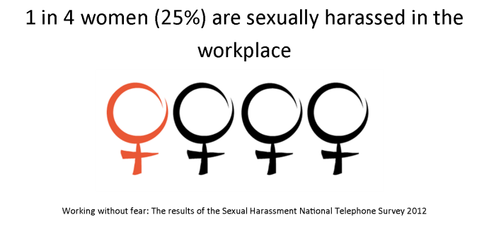
We are also seeing increasing rates of men being sexually harassed, by other men, in the workplace.
Where does workplace sexual harassment take place?
Under the Sex Discrimination Act 1984, a ‘workplace’ is:
- Where the harasser works
- Where the person being harassed works
- Where they both work
The Sex Discrimination Act also covers ‘work related’ sexual harassment, which can take place:
- At the location of someone working remotely who is harassed by email, on a social networking site, or by mobile phone.
- On work-related trips (such as training and, conferences or in hotels, cars or on trains etc).
- At work-related social events (such as work lunches, office parties, at bars and restaurants).
- In classroom or training facilities or in the workplaces of interns, trainees and apprentices.
- In educational institutions and inter-school activities (sexual harassment can be perpetrated by students over the age of 16 or by staff)
- In shops, restaurants, or anywhere that goods and services are provided (sexual harassment can be perpetrated by customers towards staff or by staff towards customers).

Which workplace relationships are covered?
The relationship between the alleged harasser and the person allegedly harassed is the key to understanding when the Sex Discrimination Act applies in the area of employment.
Under the Act, it is unlawful to sexually harass:
- an employee, a commission agent or a contract worker
- a prospective employee, commission agent or contract worker
- a colleague, partner, fellow commission agent or fellow contract worker
- a prospective colleague, partner, fellow commission agent or fellow contract worker
- another workplace participant (includes employers (eg sole trader), employees, commission agents, contract workers and partners in a partnership).

What can I do about sexual harassment in my workplace?
What can I do if I’m experiencing sexual harassment at work?

- Raise the issue directly with the harasser and tell them that their behaviour is unwelcome
- Talk to a colleague for support
- Talk to a union delegate or contact a union office for advice
- Contact a community legal centre or working women’s centre for legal advice
- Contact 1800 RESPECT for telephone and online counselling, information and referral
- Make a complaint to your manager/employer
- Contact the Australian Human Rights Commission or state and federal anti-discrimination agencies for information or to make a complaint.

How do I make a complaint to the Australian Human Rights Commission?
A person who believes he or she has been sexually harassed in the workplace can make a complaint to the Australian Human Rights Commission alleging sexual harassment under the Sex Discrimination Act 1984 (Cth). Or they can contact a solicitor advocate or trade union to make a complaint to the Commission on their behalf.
Australian Human Rights Commission’s National Information Service
Call us
Infoline: 1300 656 419 or (02) 9284 9888
TTY: 1800 620 241
If you need an interpreter you can call the Translating and Interpreting Service (TIS) on 131 450 and ask to be connected to the Australian Human Rights Commission.
If you are deaf or have a hearing or speech impairment you can contact the National Relay Service (NRS) on 133 677 (TTY/Voice) or 1300 555 727 (Speak & Listen) and ask to be connected to the Australian Human Rights Commission.
Write to us
Postal Address: GPO Box 5218, Sydney NSW 2001
Email: infoservice@humanrights.gov.au
Fax: (02) 9284 9611
Go online
Website: www.humanrights.gov.au
Make a complaint: www.humanrights.gov.au/complaints/lodging-your-complaint

Why take action?

Evidence shows that reporting is an effective way to make the sexual harassment stop.

45% of workplace sexual harassment
stops after a complaint or report is made.

I’m worried about what will happen if I make a complaint…

Many people are worried they will make things worse if they report their experience of sexual harassment to their employer. Under federal legislation it is unlawful for an employee to be disadvantaged because they’ve reported sexual harassment. For example, it may be unlawful for your employer to move you to a position with fewer responsibilities or give you a critical reference just because you’ve reported sexual harassment.
How can I take action as a bystander?
People who see or hear about harassment in their workplace are called bystanders.
Active bystanders play a role to reduce the harm of sexual harassment and ensure there is no tolerance for sexual harassment in their workplace.
You can talk to the person experiencing harassment:
- Listen to them
- Assist them in finding information or on how to make a complaint

There are also other things you can do:

- Talk to your manager or supervisor about displaying the workplace sexual harassment policy prominently in your workplace
- Organise sexual harassment training for your workplace
- Talk to Human Resources about implementing any sexual harassment policies
- Talk to a union delegate or union about raising awareness of sexual harassment in the workplace
- If you have the person experiencing the harassment’s permission you can also report it to your employer.
What bystander action is possible will differ in different workplace contexts, so it may be necessary to adapt what action you take to the context of your workplace.

The best thing you can do is to listen to the person who has been harassed
and ask them what support they would like.

Know where the line is

For information on sexual harassment, how to take bystander action or make a complaint to the Australian Human Rights Commission see our website at: www.knowtheline.com.au

Australian Human Rights Commission, Working without Fear: Results of the 2012 Sexual Harassment National Telephone Survey (2012), p5. At: http://www.humanrights.gov.au/working-without-fear-results-sexual-harassment-national-telephone-survey-2012 (viewed 14 May 2014).
An employee includes full-time, part-time and casual workers as well as independent contractors.
A commission agent is a person who does work for another person as the agent of that other person and who is remunerated, whether in whole or in part, by commission.
Sex Discrimination Act 1984 (Cth), ss 28B(1)-28B(6).
Community Legal Centres: http://www.naclc.org.au/need_legal_help.php Women’s Legal Services: http://www.wlsa.org.au/members Working Women’s Centres: http://www.wwc.org.au/ Victoria Legal Aid: http://www.legalaid.vic.gov.au/ Job Watch (Victoria): http://www.jobwatch.org.au/ Employment Law Centre of WA: http://elcwa.org.au/

