Better Healthcare for People with Disability

Your Healthcare Rights
In healthcare you have the right to:
- be treated with respect
- have an interpreter

Your Healthcare rights are stated in the Australian Charter for Healthcare Rights.
Learn about the Charter on the Australian Commission for Safety and Quality in Healthcare website:
https://www.safetyandquality.gov.au/consumers/understanding-your-rights.
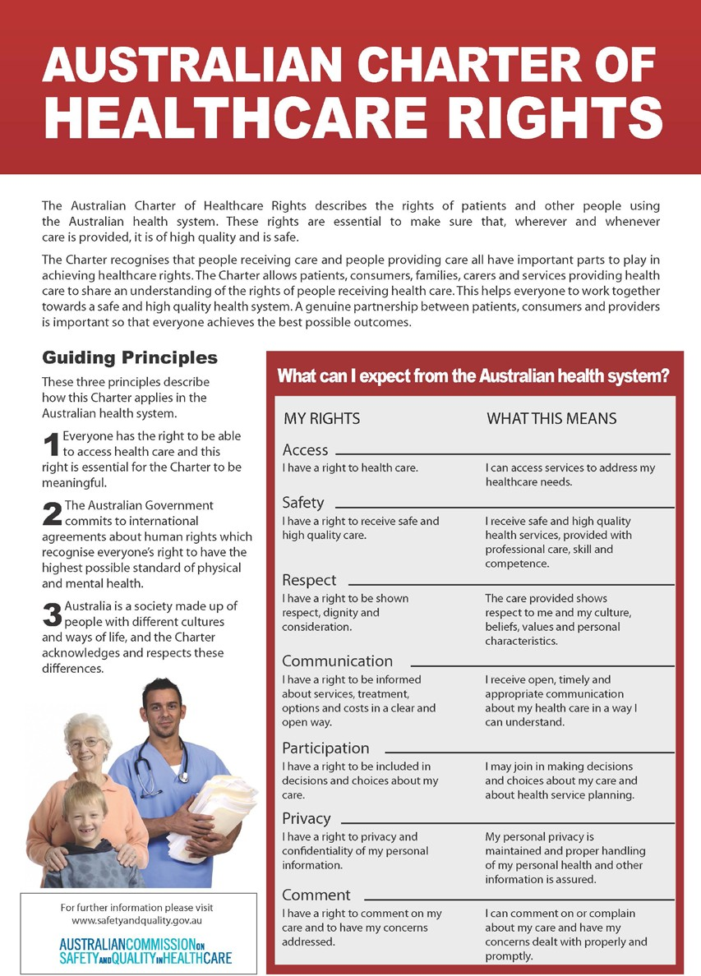

- feel safe and be safe
- have privacy
  - of your body
  - of your information
- have time to think and talk about things
- be able to ask questions
- use a communication device
- have information given to you in a way you prefer
- receive the same level of care as any other person
- get a second opinion from another doctor
- have an advocate or other support person with you.
- be able to ask questions.
- be listened to
- say no to a treatment
- have your disability taken into account if needed, this might look like:
  - having someone stay with you
  - receiving a special diet
  - having a quiet area to wait in.
Responsibilities

Your Responsibilities
You have the responsibility to:
- answer the doctor’s questions honestly
- cancel appointments if you can’t attend
- let the doctor know if something is wrong.

Responsibilities of staff
All staff have the responsibility to:
- speak to YOU.
- respect YOU.
- listen to YOU.
- be honest with YOU.
Staff should get to know you by asking you and your carer questions. They should also take time to understand and watch your reactions to what they are doing. Tell the staff if you feel they aren’t listening to you.

Do I have to have this treatment?
Your treatment is your choice!
Before a doctor can do anything to you, they have to explain what the risks are.

Informed Consent can only be given if you know about your condition, what treatments can help you, and what is the safest treatment for you.

Here are some questions to ask:
- What is my condition called?
- What are the treatments called?
- What do I need to get better?
- What do I need to do?
- What is good about this treatment?
- What is bad about this treatment?
- How safe is this treatment for ME? Has the Doctor done this before?
- What happens if I do nothing? How much will it cost?
- How long will it take to recover?

If you have other questions about your health or treatment, you can use this online tool to help work out what you’d like to ask.

Question Builder
This tool has been developed by the Australian Government to help people prepare for medical and healthcare appointments. It is free to use. You can use it to prepare for a medical appointment https://www.healthdirect.gov.au/question-builder

Where to go for help?

Talking with staff.

If the staff are not explaining things clearly you have the right to:

- ask them to repeat it

- ask them to slow down

- tell them if it is too much information at once

- ask them if you can talk in a different room or be in a quieter place

- ask them to explain it another way

  - ask the doctor to explain with dot-points or with pictures or drawings

  - ask for a factsheet, brochure or website link

- ask for a translators or interpreter.

- get support from a social worker or somebody else.

National Relay Service
The National Relay Service is a government initiative that allows people who are deaf, hard of hearing and/or have a speech impairment to make and receive phone calls. More information about the National Relay Service is available at: https://www.communications.gov.au/what-we-do/ phone/services-people-disability/accesshub/national-relay-service.
For help with making relay calls, contact the National Relay Service via SMS or Phone between 8am and 6pm Eastern Standard time.
- Phone: 1800 555 660

- Fax: 1800 555 690

- SMS: 0416 001 350

- Email: helpdesk@relayservice.com.au

If things go wrong.

Every hospital and health service have a way for you to talk about any concerns you have regarding your care.
If something has gone wrong, you can put in an incident or complaint form.

You can talk to:

- the hospital complaints team

- a nurse unit manager

- a patient liaison officer

- a social worker.

If your care was good you can let them know that too! Ask one of the staff for a feedback form.

Australian Health Practitioner Regulation Agency (AHPRA)

If you haven’t been able to sort out your complaint with the healthcare service, you can make a complaint to your state’s Health Ombudsman the Australian Health Practitioner Regulation Agency (AHPRA).

Learn more on the AHPRA website: https://www.ahpra.gov.au/Notifications/Raise-a-concern.aspx.

Speaking up if you feel unwell.
Nobody knows your health like you do. You are the best person to notice any changes in your health.

If you are in hospital, press the call bell and ask to speak to:

- a nurse

- a nurse unit manager

- your doctor.

If you still feel unwell after you have spoken to the doctor you can ask them for a second opinion or medical review.
If you are at home, you can speak to:

- Health Direct – phone: 1800 022 222

- after-hours doctors

- if it is an emergency, always call 000

Taking Medicines.
Medicine is anything you take for your health and wellness. This includes over-the-counter medicine, prescribed vitamins, home remedies, recreational drugs and bush medicines. Make sure you don’t take any new medicine without letting the doctor or pharmacist know what you are currently taking. Sometimes you can have a bad reaction to mixing medicines.
Talk to your doctor, nurse or pharmacist about your medicines. You should tell them:
- if you allergic to anything (e.g. medicine, food, wound dressings, gloves)
- if your medicine makes you feel worse or sick
- if you have difficulty swallowing your tablets.

Keep a note or take a photo of the medicines you take at home. If you go to hospital, or to see another healthcare professional take this with you. Include:
- the name of the medicine
- the strength of the medicine (e.g. 500mg)
- how much do you take? (e.g. 1 tablet)
- when do you take it? (e.g. in the morning)
- why do you take it?

- what does it do for you?

- when did you start taking it?

Family and carer involvement
Family and friends who look after you can sometimes be called your Carer. They may talk to health staff on your behalf if you are too sick and not able to talk for yourself.
There are things available to support your family if you are in hospital.
Ask the hospital team!

Keep your mind well
Medical appointments, going to hospital and being sick can sometimes be stressful.
You might feel:
- sad

- lost

- worried

- anxious

It is important you find someone to talk with about how you are feeling. You could talk to family, friends or your GP or specialist about your feelings. You could talk to a member of staff. Or if you’d rather talk to someone else, you can call Beyond Blue who are available 24 hours a day. You can also use the National Relay Service to make the call.
Beyond Blue Support Service Phone: 1300 22 4636
Website: https://www.beyondblue.org.au/get-support/get-immediate-support.

