# **Women with Disabilities Australia**

# 

# **About us**

****This book is about us.

We wrote this book for women and girls

with **disability.**

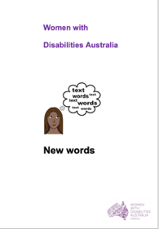

Read more about **disability** in our book

**New Words.**

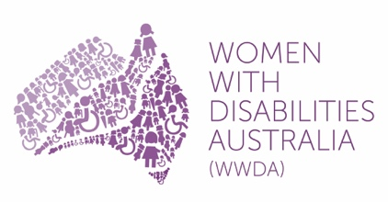We are Women with Disabilities Australia.

We will write **WWDA** when we talk about us.

## **About WWDA**

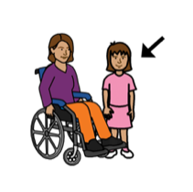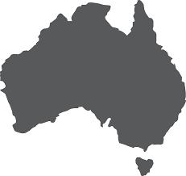

WWDA isfor

* all women and girls who have a disability
* who live in Australia.

WWDA is anational organisation.

WWDA is

* run by women with disability.

**and**

* for women with disability.



WWDA help all women and girls with disability have good lives.

***Our work is based on **rights.**

**

All women and girls with disability have rights. Like the right to

* + - * 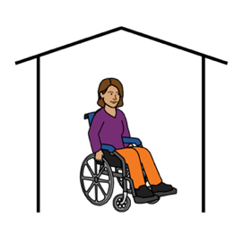be safe from violence

**and**

* + - * have a place to live

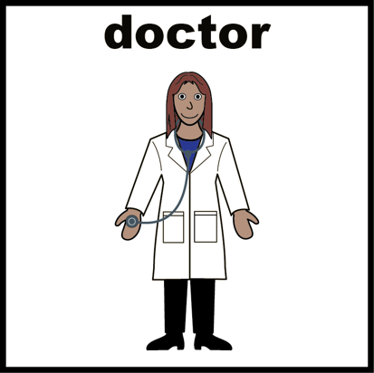have good health.

Women and girls with disability have the right to

* + - * make choices.

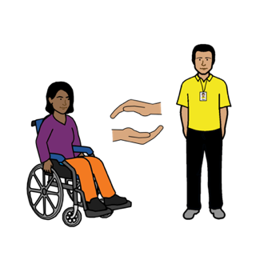

* + - * have the support they need
      * A close up of a logo

        Description automatically generatedA close up of a logo

        Description automatically generatedA close up of a logo

        Description automatically generatedbe listened to

**and**

* + - * be believed.

## **Disabled Peoples**

## **Organisations Australia**

**WWDA** is a member of Disabled Peoples Organisations Australia.

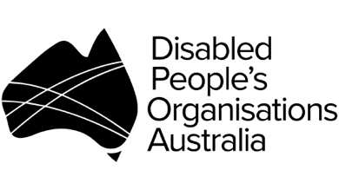Disabled Peoples Organisations Australia has a long name. We will write **PDOA** when we talk about this group.

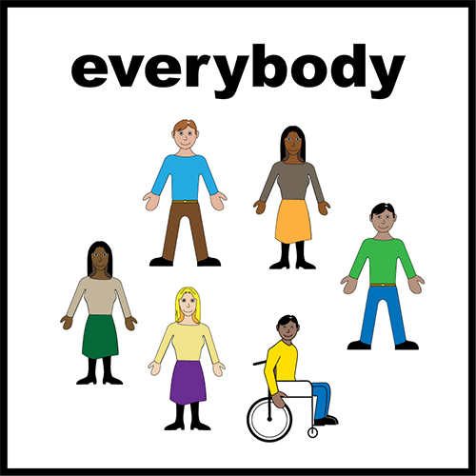

There are 4 groups in DPOA.

These groups are all run by people with disability.

### **The groups in the DPOA are**

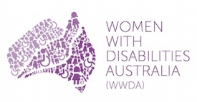

* + - * Women with Disabilities Australia.

We are also called WWDA

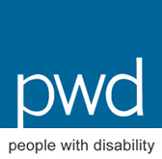

* People with Disability Australia.

They are also called PWDA

* 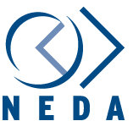National Ethnic Disability Alliance

They are also called NEDA

* 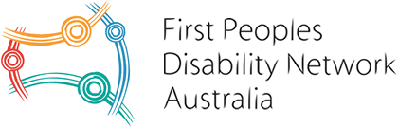First People’s Disability Network

They are also called FPDN.

### For more about WWDA go to our website www.wwda.org.au

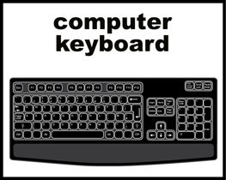



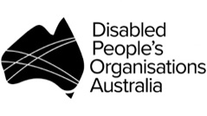For more about DPOA go to their website www.[dpoa.org.au](http://www.dpoa.org.au/)

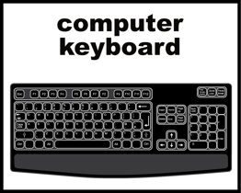

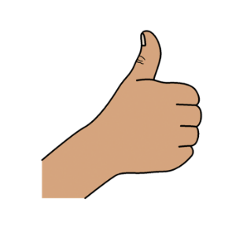**Thank you**

**Who wrote this book?**

Women with Disabilities Australia wrote this book in 2019-2020.

This book is for general education and information only.

**Copyright**

© Copyright

Women with Disabilities Australia (WWDA) Inc. 2020.

All intellectual property rights, including copyright and patents, in this book is owned and licensed by Women with Disabilities Australia Inc.

**Thank you for the money to write this book.**

The National Disability Insurance Scheme gave Women with Disabilities Australia some money to help build this website.

**The images used in this fact sheet**

Easy on the I Images © 2019 Leeds and York Partnership NHS Foundation Trust. Used with permission. [www.easyonthei.nhs.uk](http://www.easyonthei.nhs.uk)

The Picture Communication Symbols © 2019 by Mayer Johnson LLC a Tobii Dynavox company. Used with permission. [www.tobiidynavox.com](http://www.tobiidynavox.com)

Logos. Used with permission.