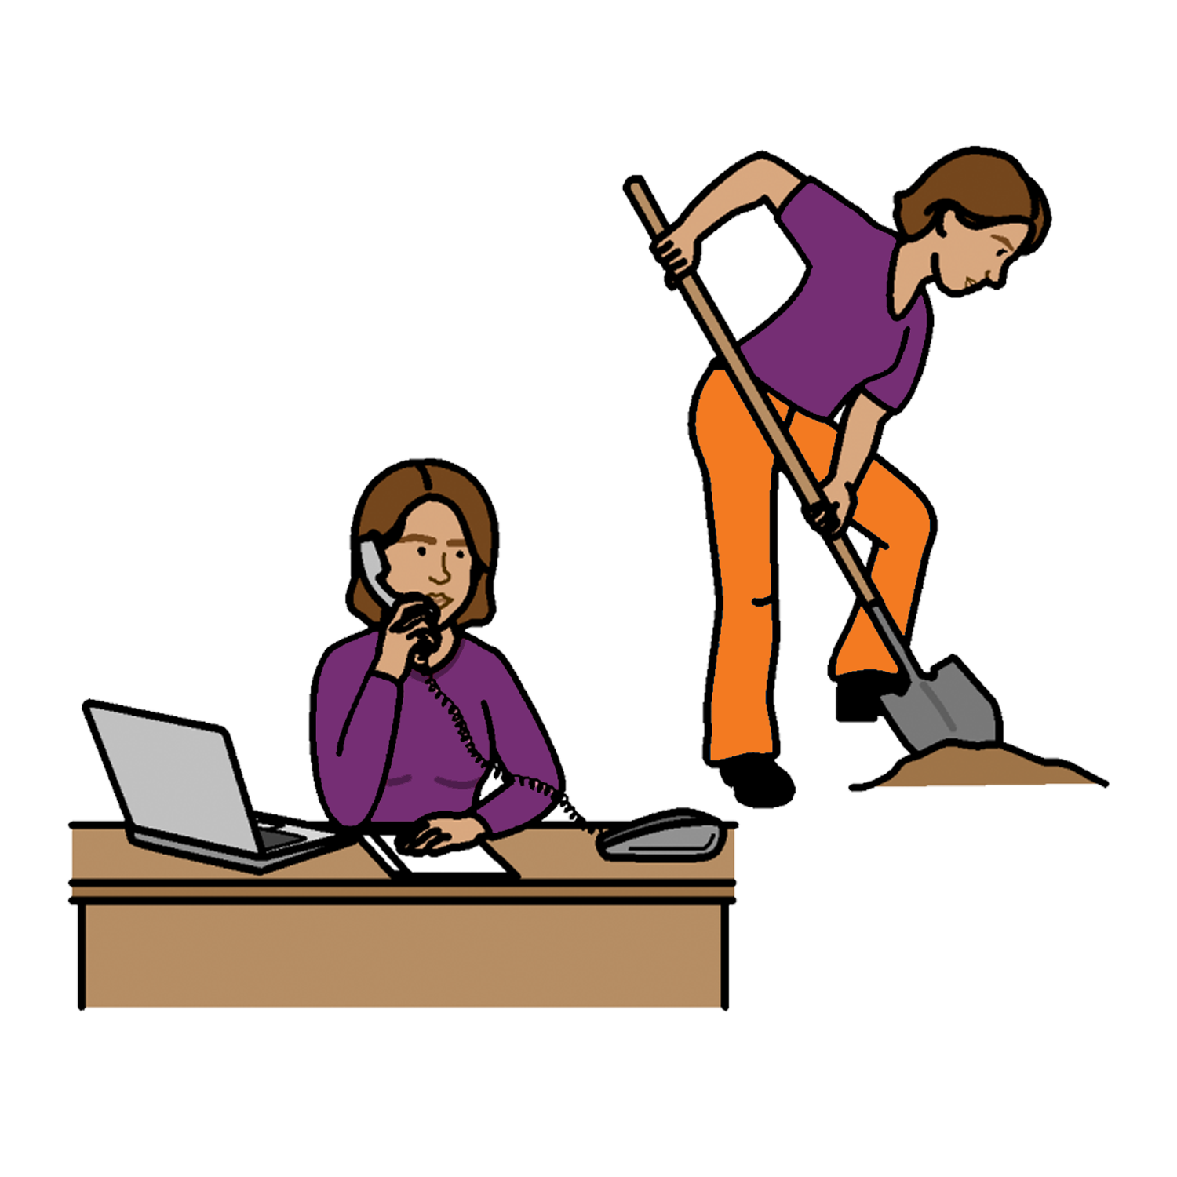
Women with
Disabilities Australia

Your rights at work

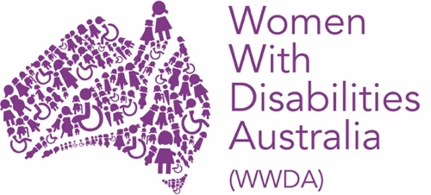

This book is about your rights at work.

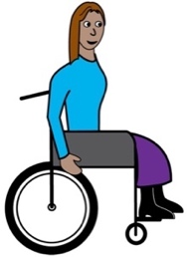
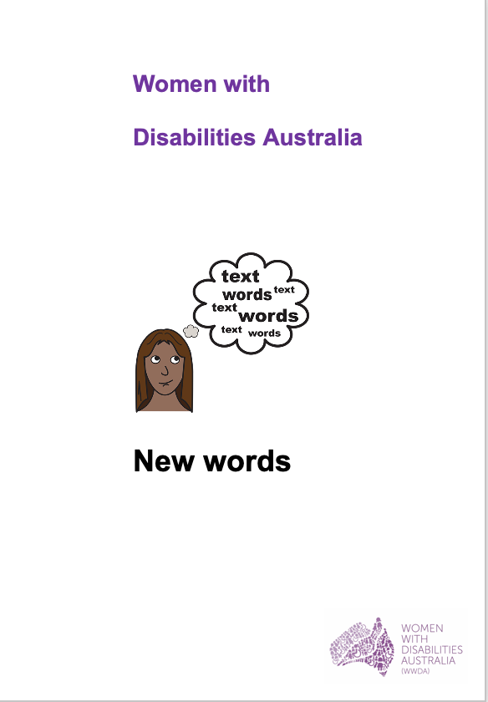
We wrote this book for women and girls
with disability. Read more about disability
in our book New Words.

We are Women with Disabilities Australia .

Your rights at work
Women with disability have a right to work.

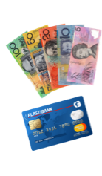
We have a right
- to be paid for the work they do

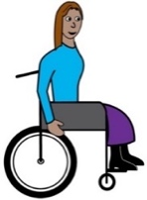
- to be paid the same as other people for
the same work.

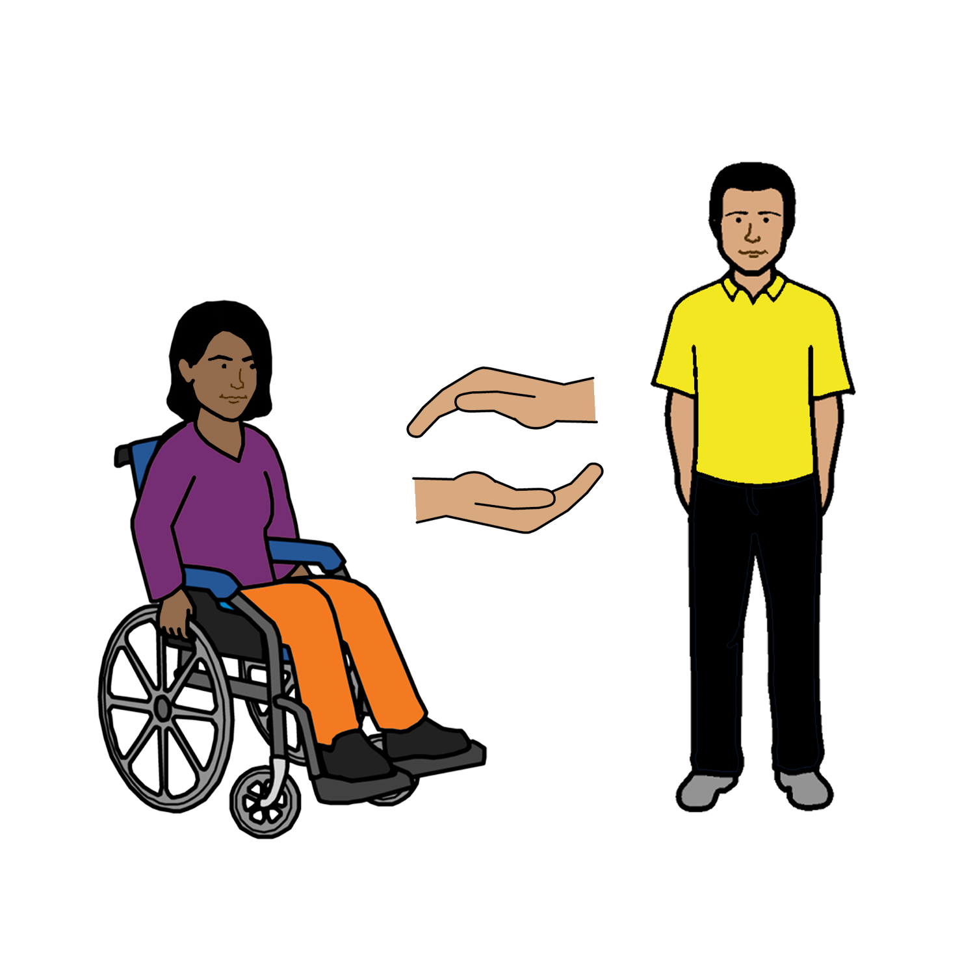
Help at work
Women with disability have a right to more help
at work. Like

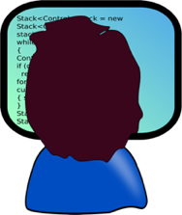
- a desk that moves up and down
- a screen reader for your computer

and

- a support person to help you understand things
- information written in an easy to read way.

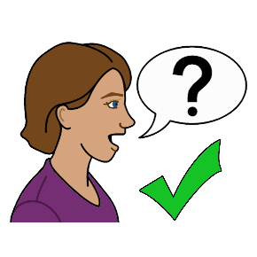

You can ask for the things you need!

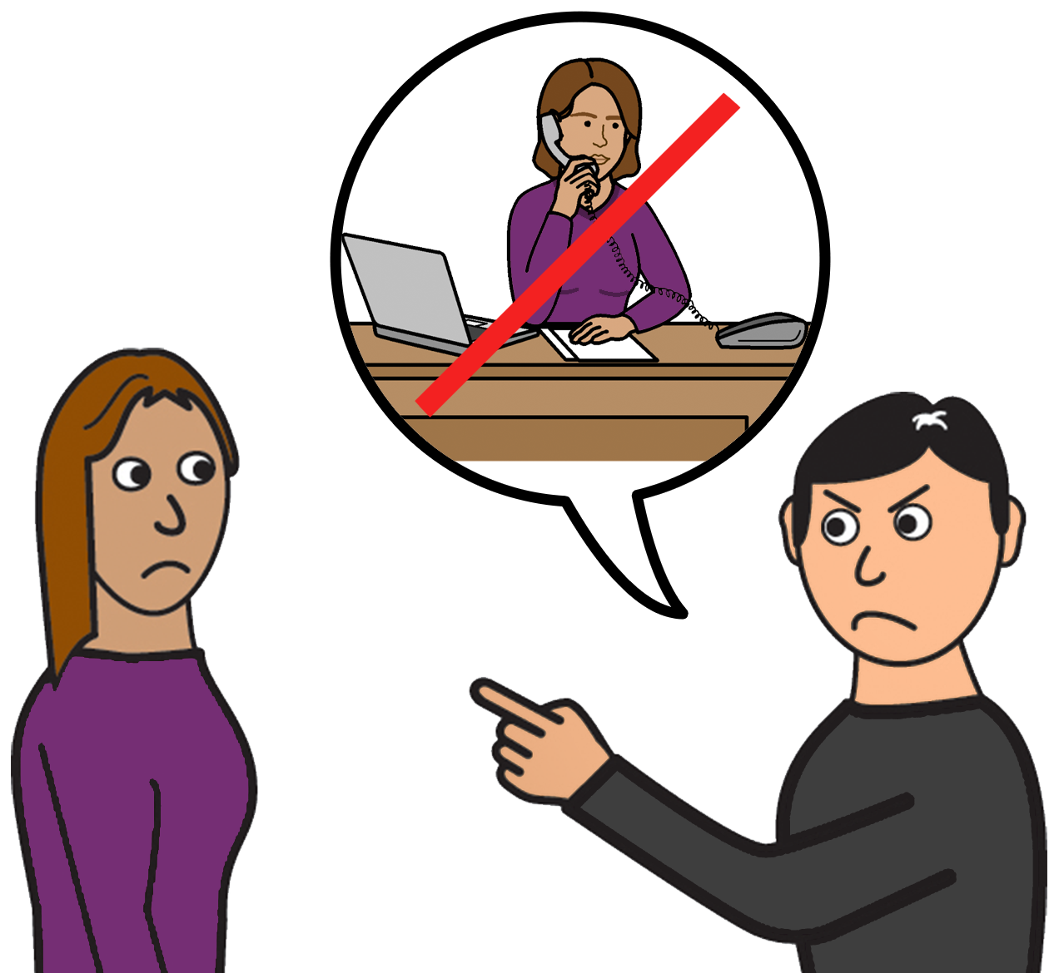
Women and girls with disability must be treated
in a fair way. Like

You must not be made to do work for no money

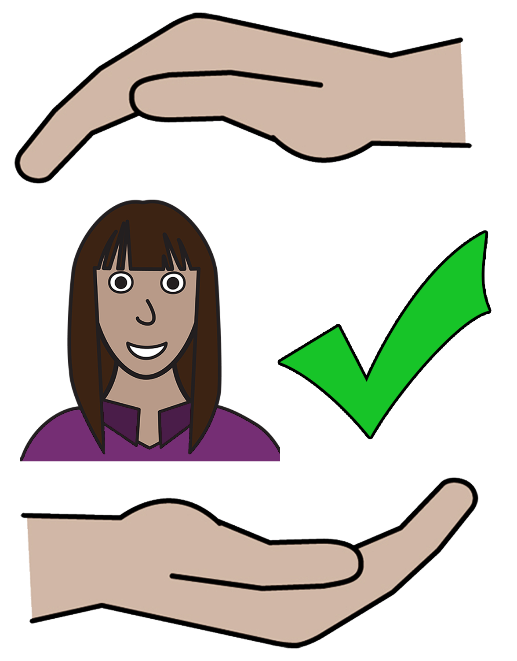
Safety at work
Women and girls with disability must be
safe at work. Violence at work is never ok.

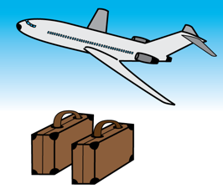
Women and girls with disabilities must not be
- made to move
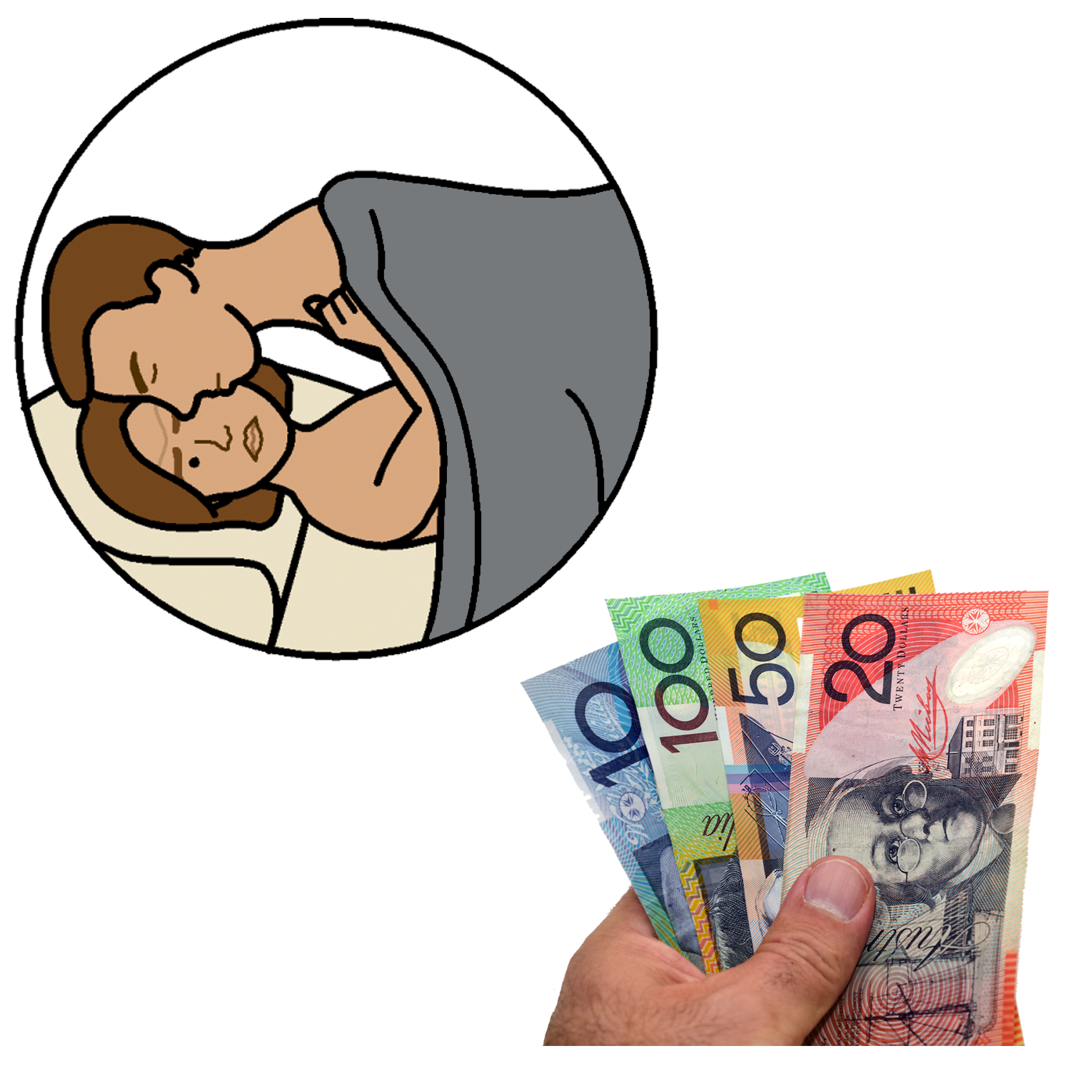
and
- do work
and
- give all their pay to someone else.

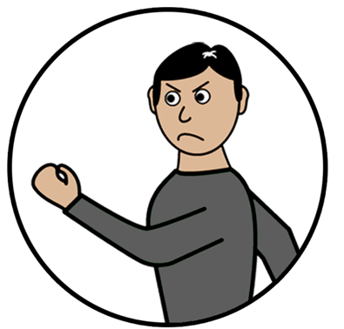
This is called trafficking.
Trafficking is violence.
Read more about violence in our book
New Words.

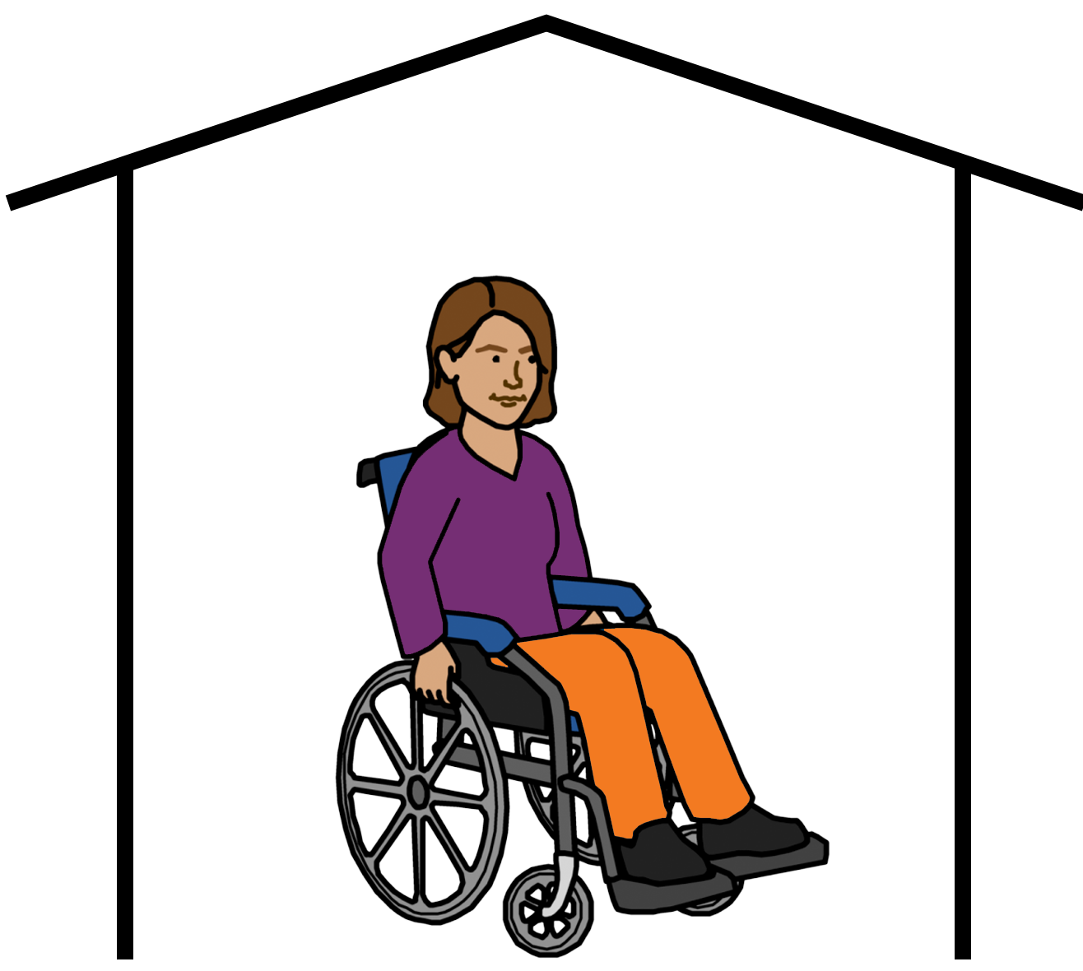
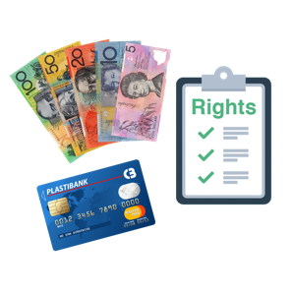
Time away from work
Women and girls with disability have a right to stay home from work. Like

- to have a baby

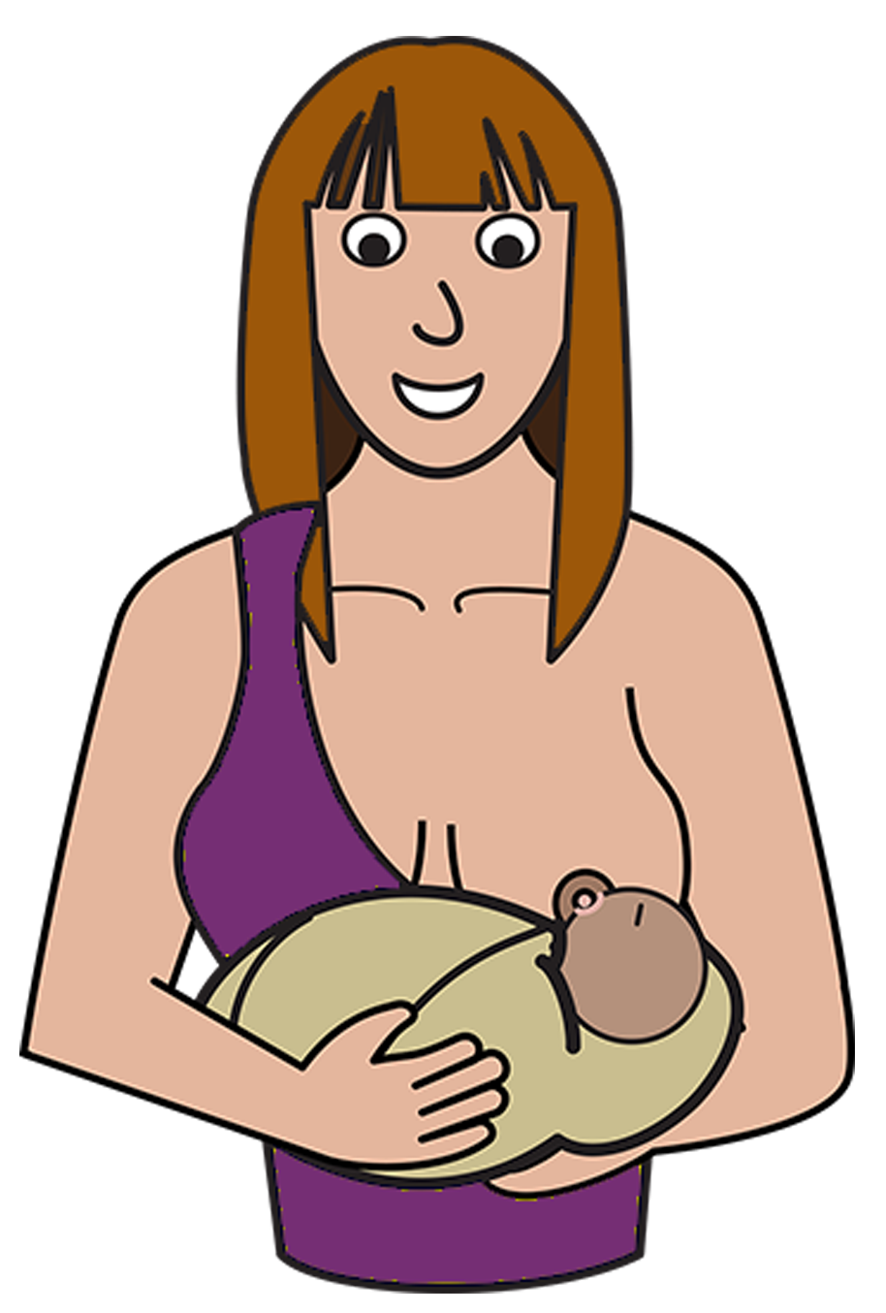

- to look after children

- go to appointments
- look after their health.

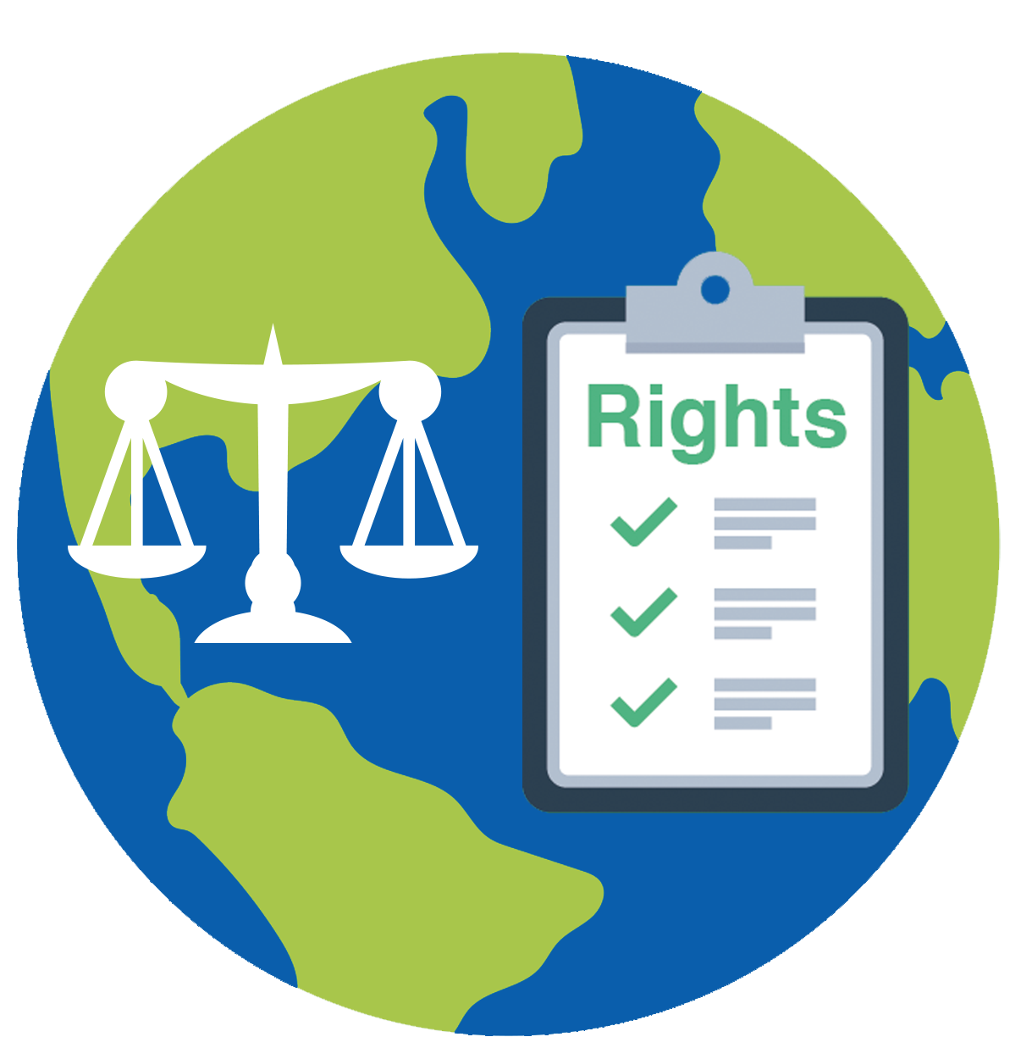
UN Conventions and Work
There are United Nations Conventions about the right of women and girls with disabilities and work.

Read more about what is a United Nations Convention in our book New Words.

There are UN Conventions to make sure we have the right to work. They are

- The Convention on the Rights of People
with Disabilities

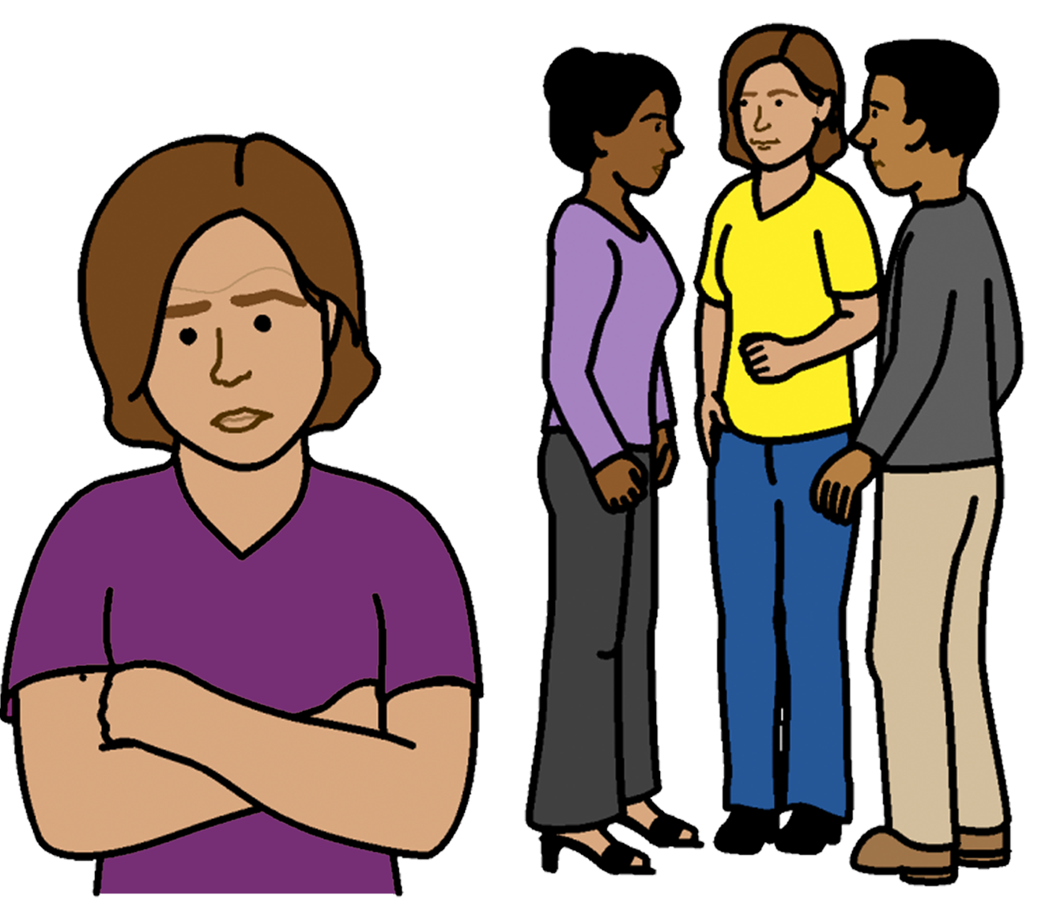
- The Convention on the Elimination of all forms of Discrimination against women

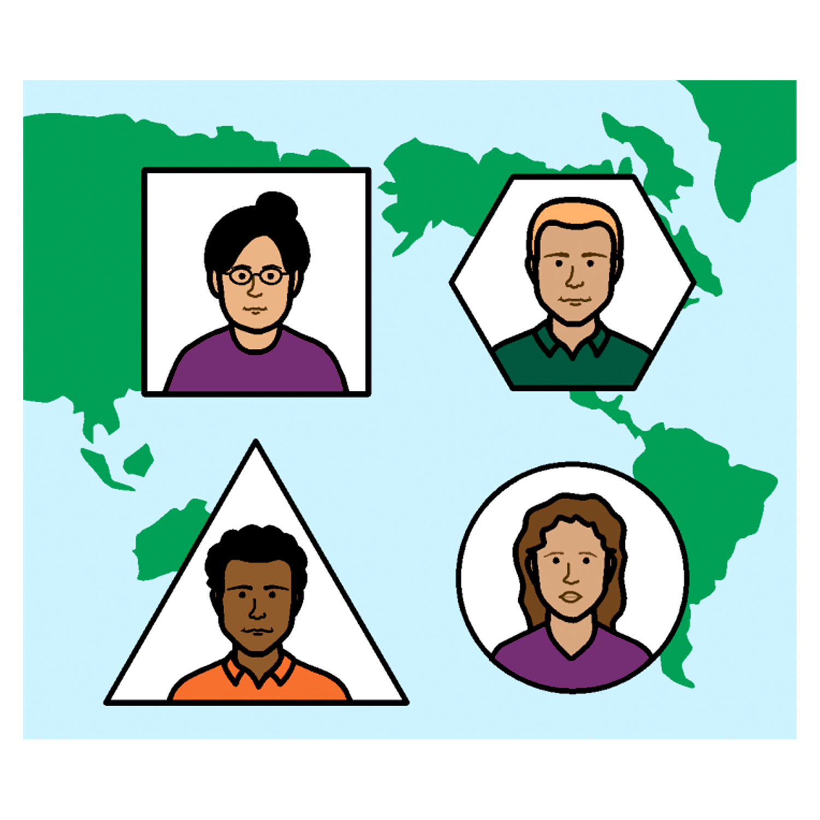
- The International Covenant on Economic Social and Cultural Rights.

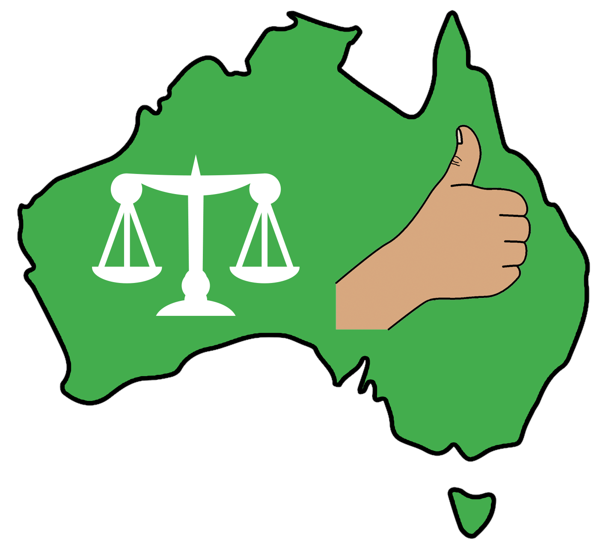
These rules say the Australian Government must do things to help women and girls with disabilities to work. It is the law. Like

- help find work you can do

- help pay for more help you need at work

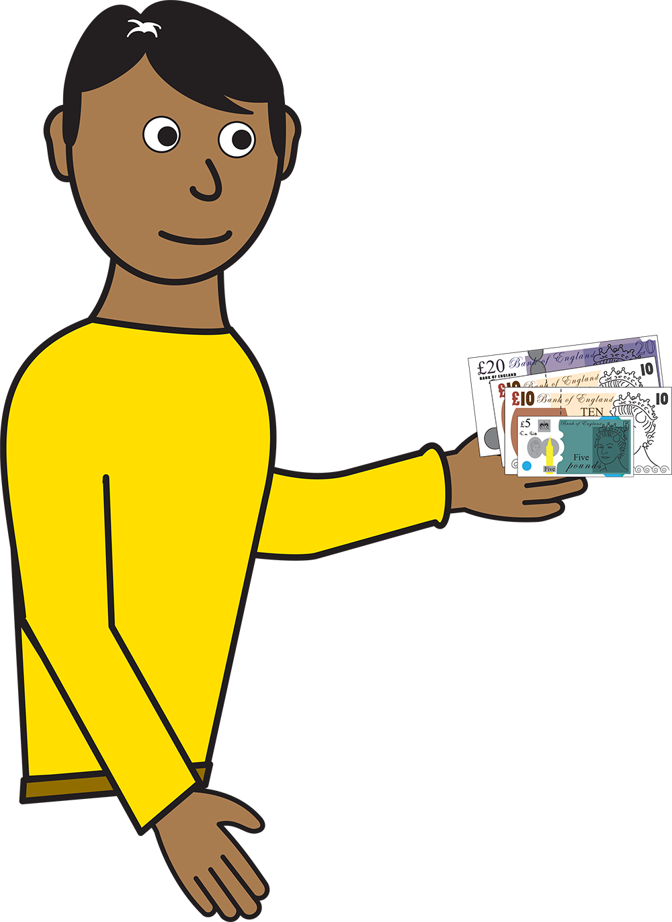
- give you money to live when you can not work

and

- have laws that say we must be respected.
It is not ok to treat us in a bad way at work

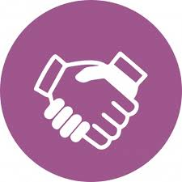

have laws to help us join work unions.

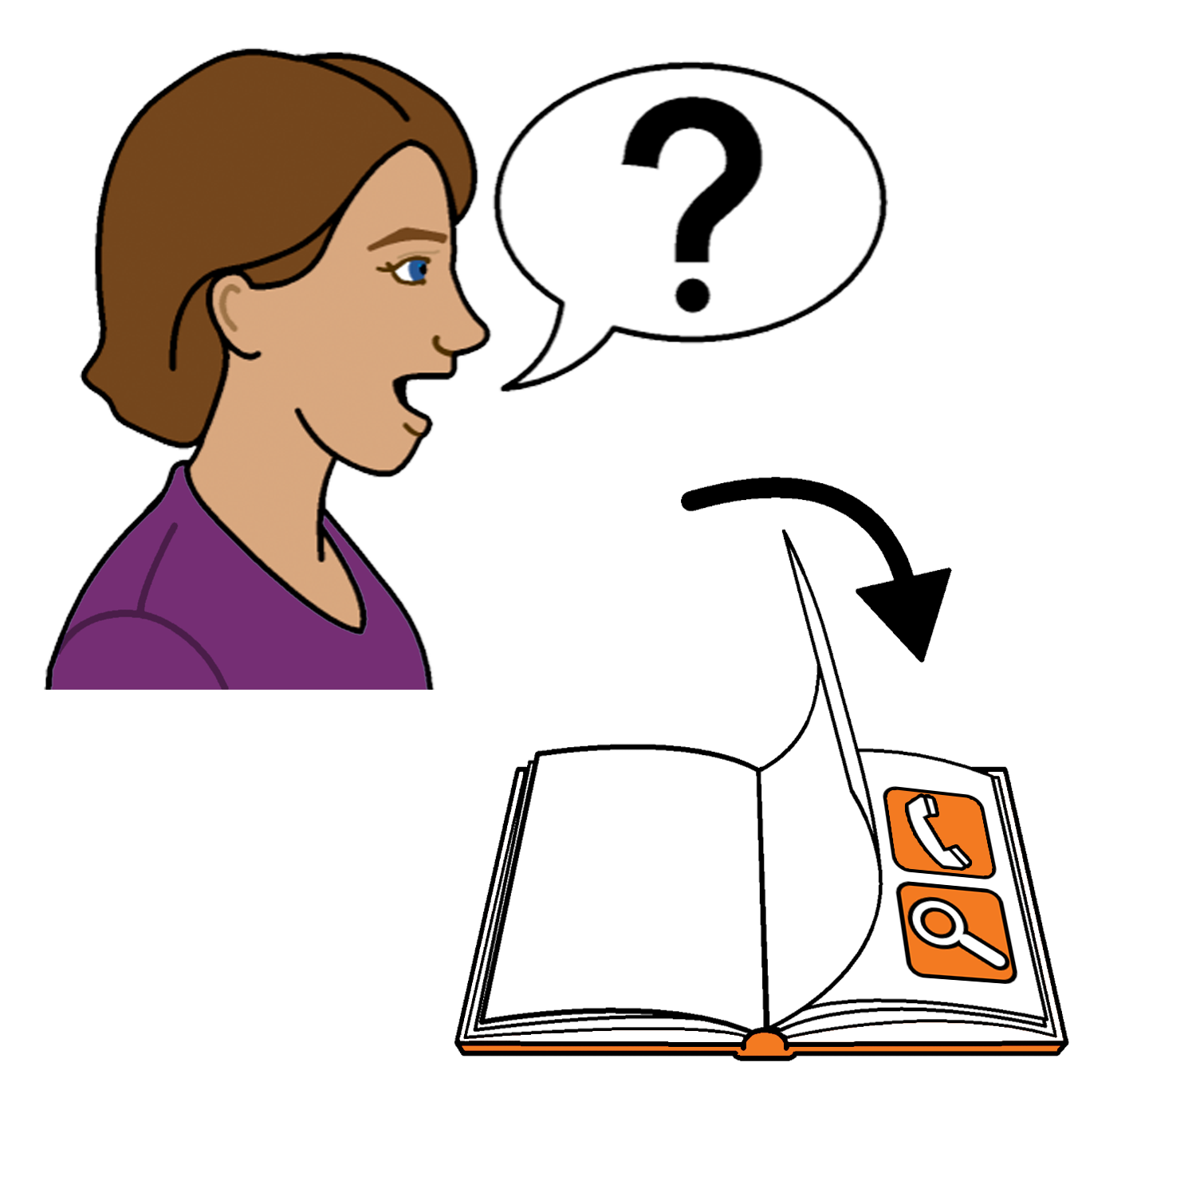

Read more about work unions on the next page.

Work Unions
A work union helps you get things you need at work. Like

- be paid the right money for your work

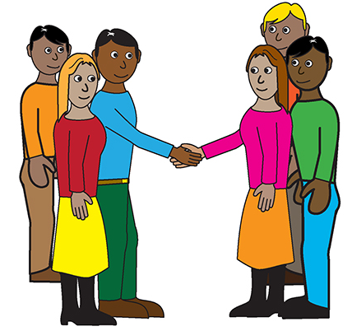

- meet other workers

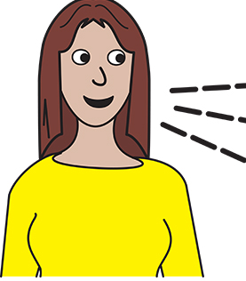
- tell them when you are not treated in a fair way.
They can talk to your bosses for you.

To learn more about your work union

- ask the Australian Council of Trade Unions

- call …… 1300 486 466

or

- go to their website www.changetherules.org.au/begin-join
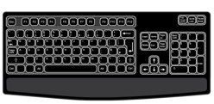

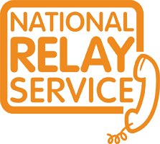
Use the National Relay service
Call ………. 1800 555 677
TTY ……… 133 677

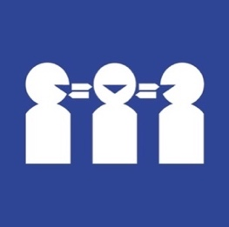
Need a translator
Call ……… 131 450

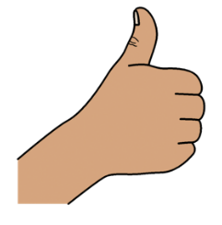
Thank you
Who wrote this book?
Women with Disabilities Australia wrote this book in 2019-2020.
This book is for general education and information only.

Copyright
© Copyright
Women with Disabilities Australia (WWDA) Inc. 2020.

All intellectual property rights, including copyright and patents, in this book is owned and licensed by Women with Disabilities Australia Inc.

Thank you for the money to write this book.
The National Disability Insurance Scheme gave Women with Disabilities Australia some money to help build this website.

The images used in this fact sheet
Easy on the I Images © 2019 Leeds and York Partnership NHS Foundation Trust. Used with permission. www.easyonthei.nhs.uk
The Picture Communication Symbols © 2019 by Mayer Johnson LLC a Tobii Dynavox company. Used with permission. www.tobiidynavox.com

Logos. Used with permission.

