Women with
Disabilities Australia
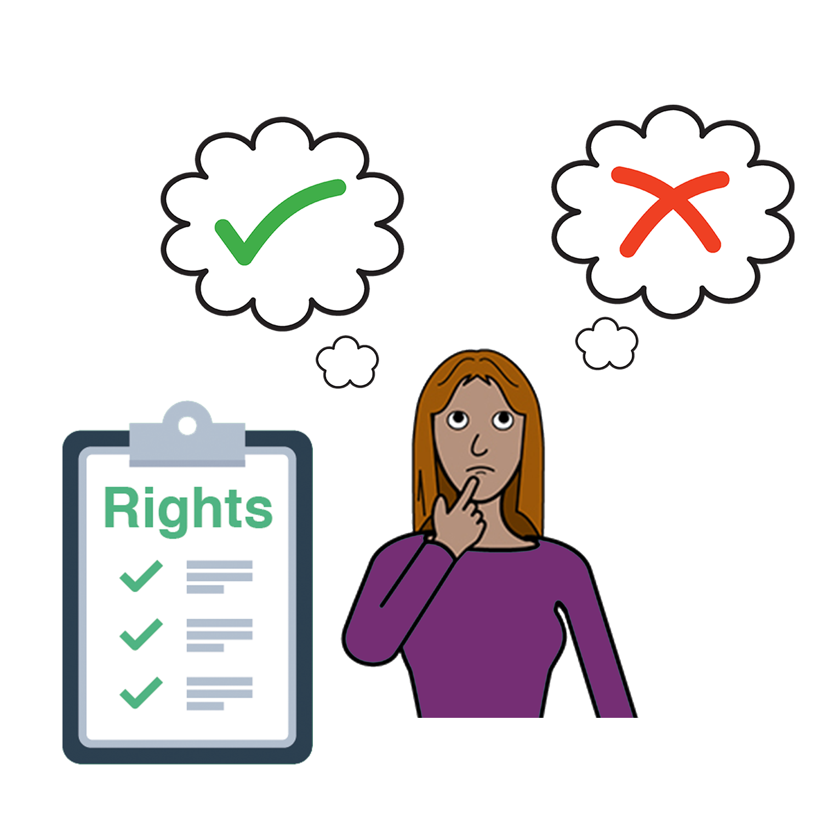

Your right to
make choices
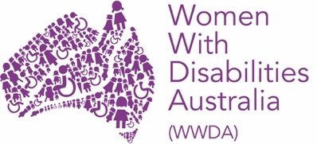

We are Women with Disabilities Australia.
We will write WWDA when we talk about us.

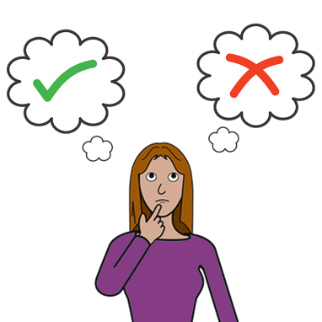

This book is about choices.

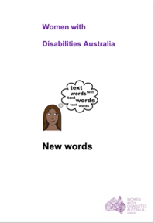
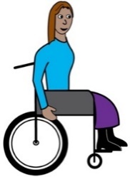
We wrote this book for women and girls
with disability. Read more about disability
in our book New Words.

What is a Choice?
A choice is when you make your mind up
about some thing.

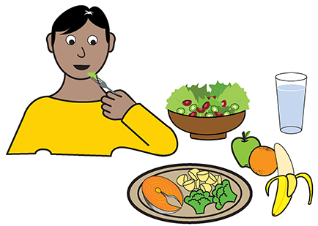
Like
- what to eat

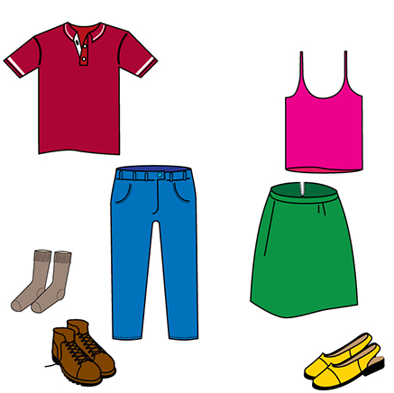
- what to wear

and
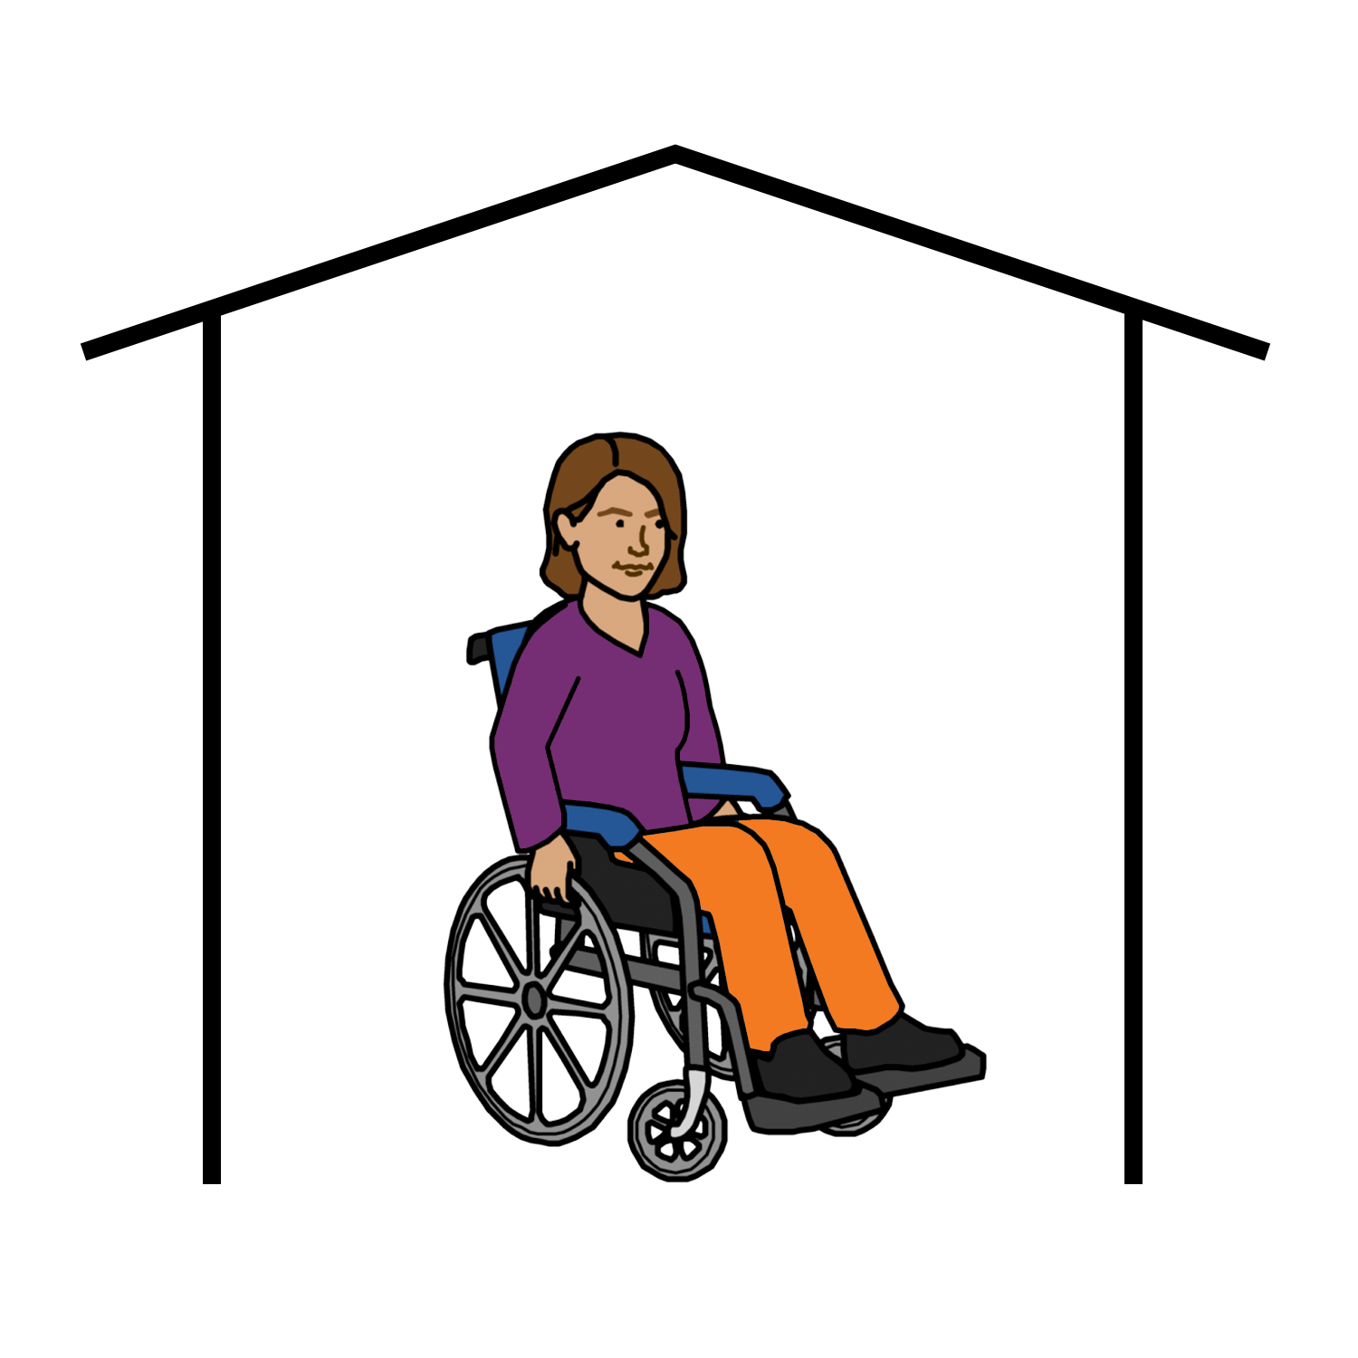

- where to live.

Some people think women with disability can not make choices about things.

Like
- about our money

- about our health

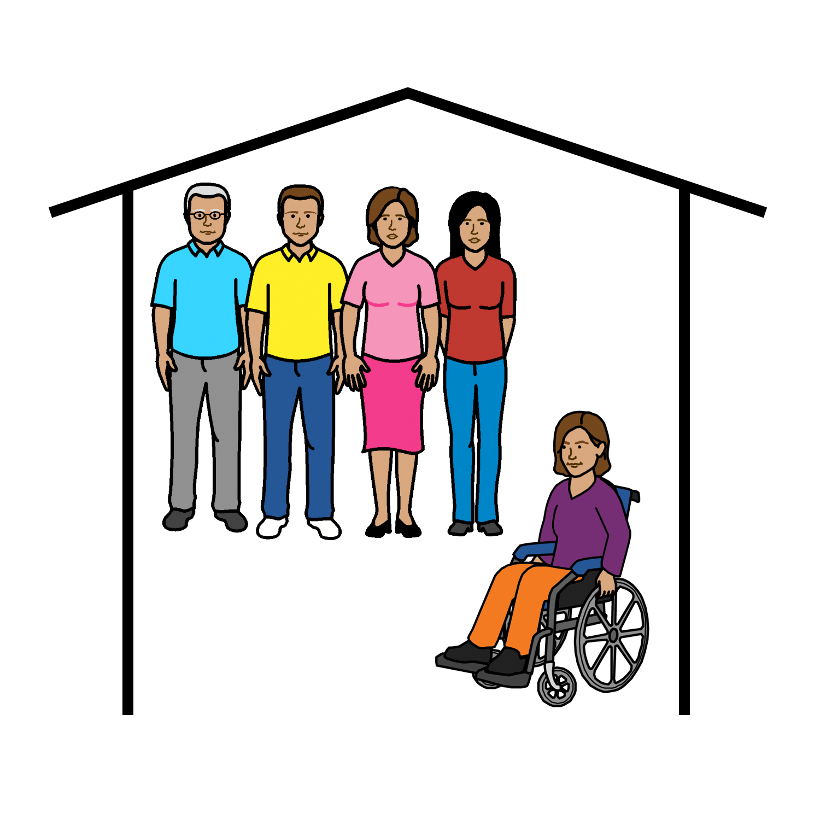

- who to live with.

Rights
Women and girls with disability can make
our own choices.

You have a right to make your own choices.

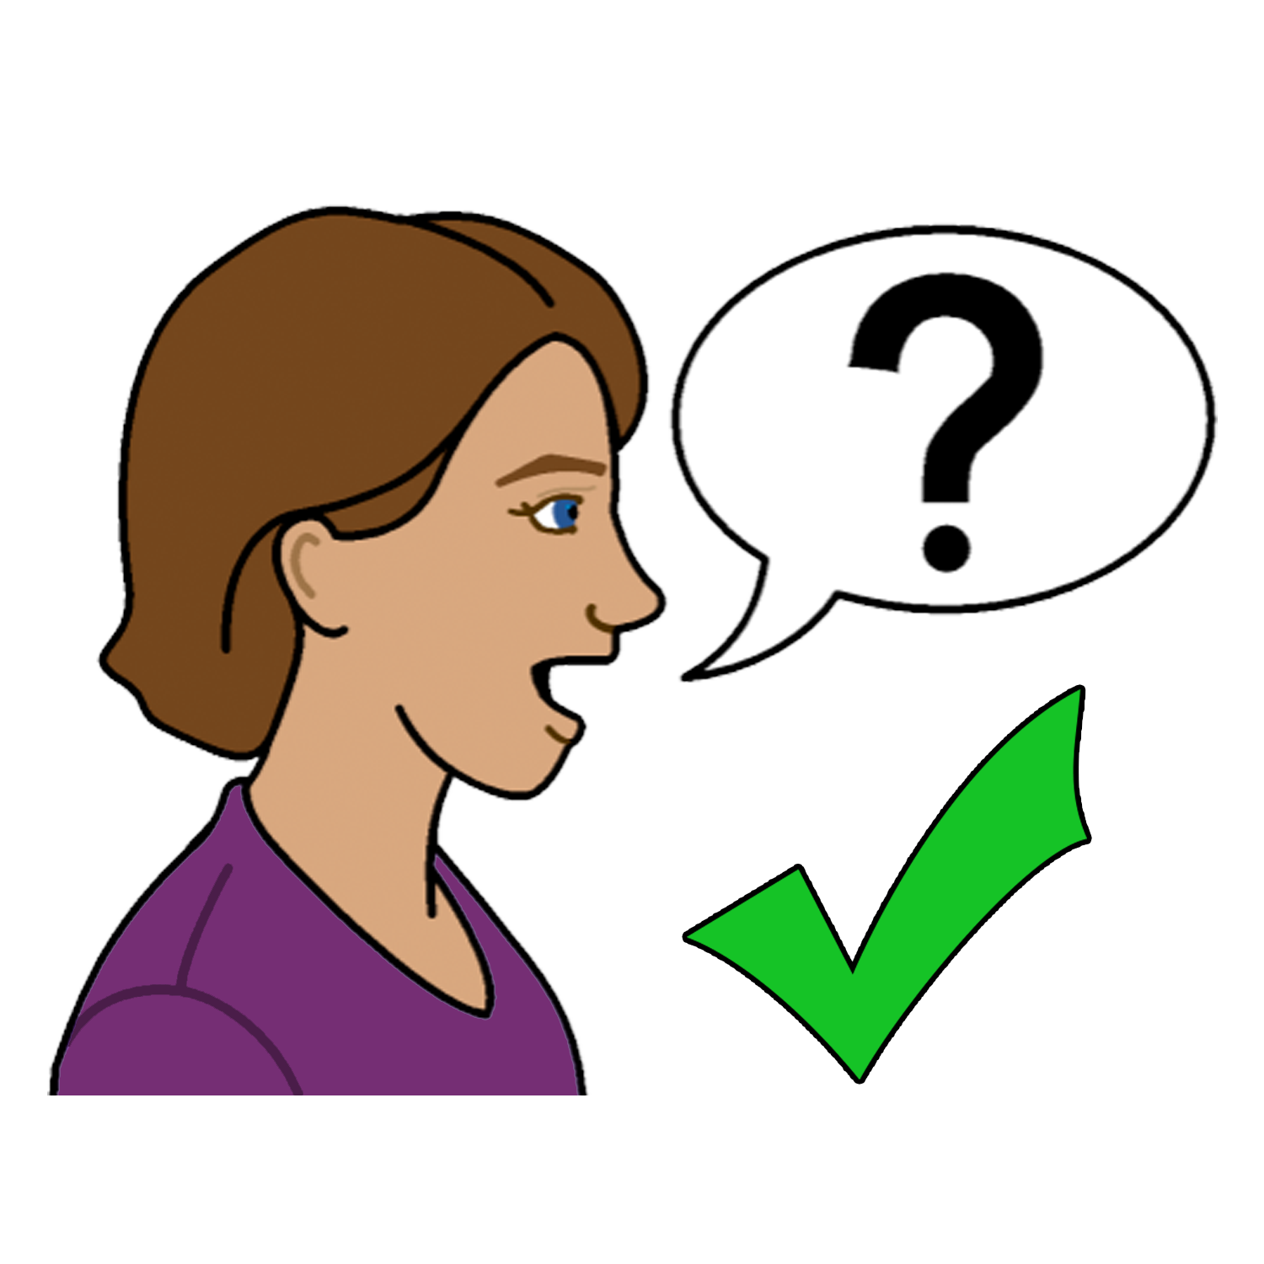
Some women and girls with disability may need help to make choices.

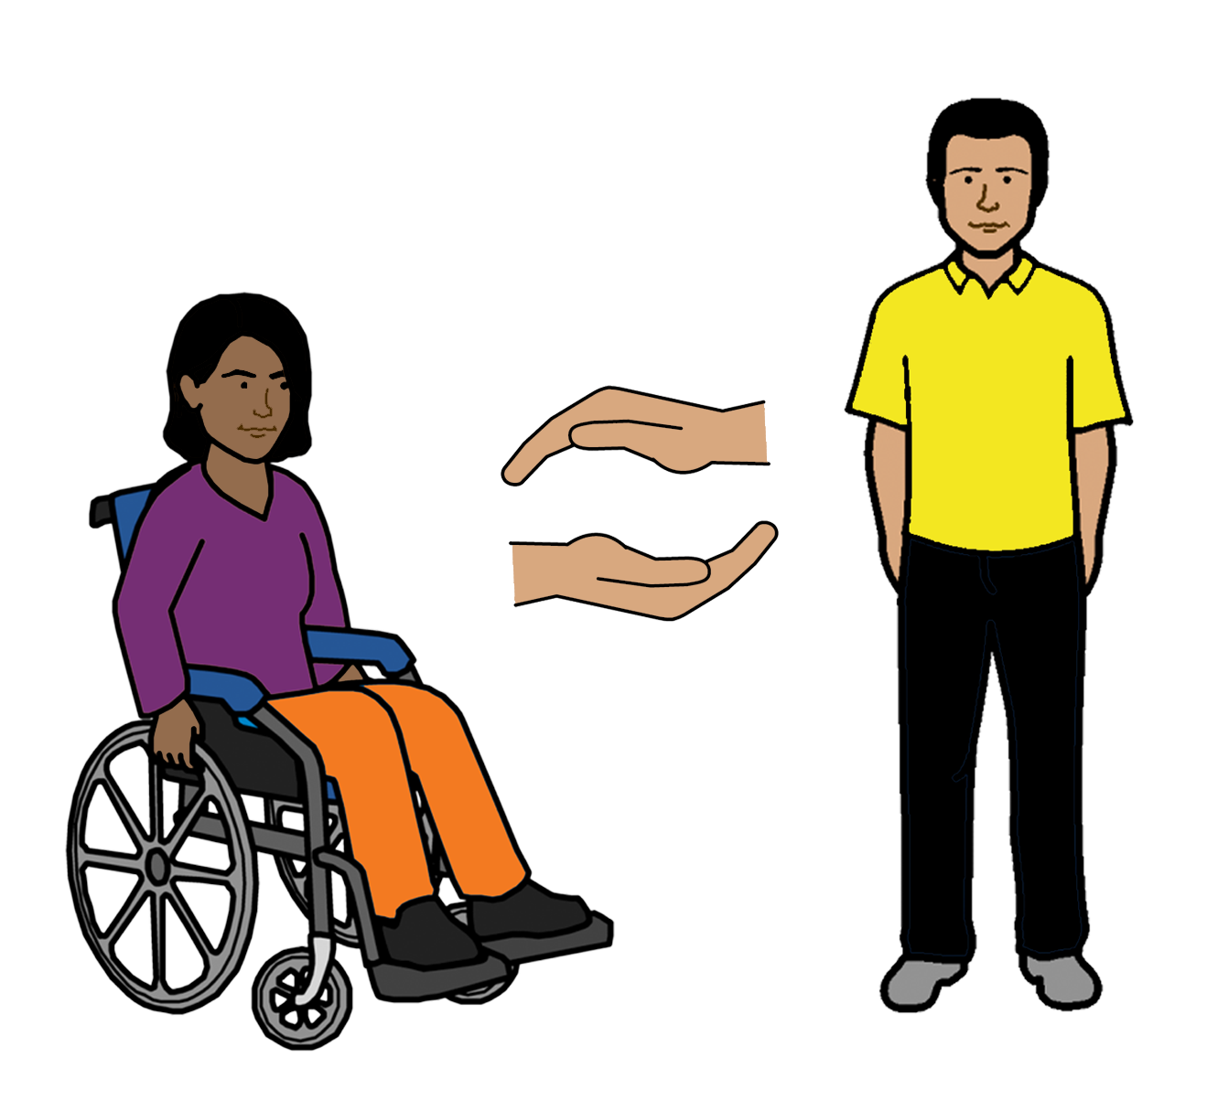

You have a right to get any help you need.

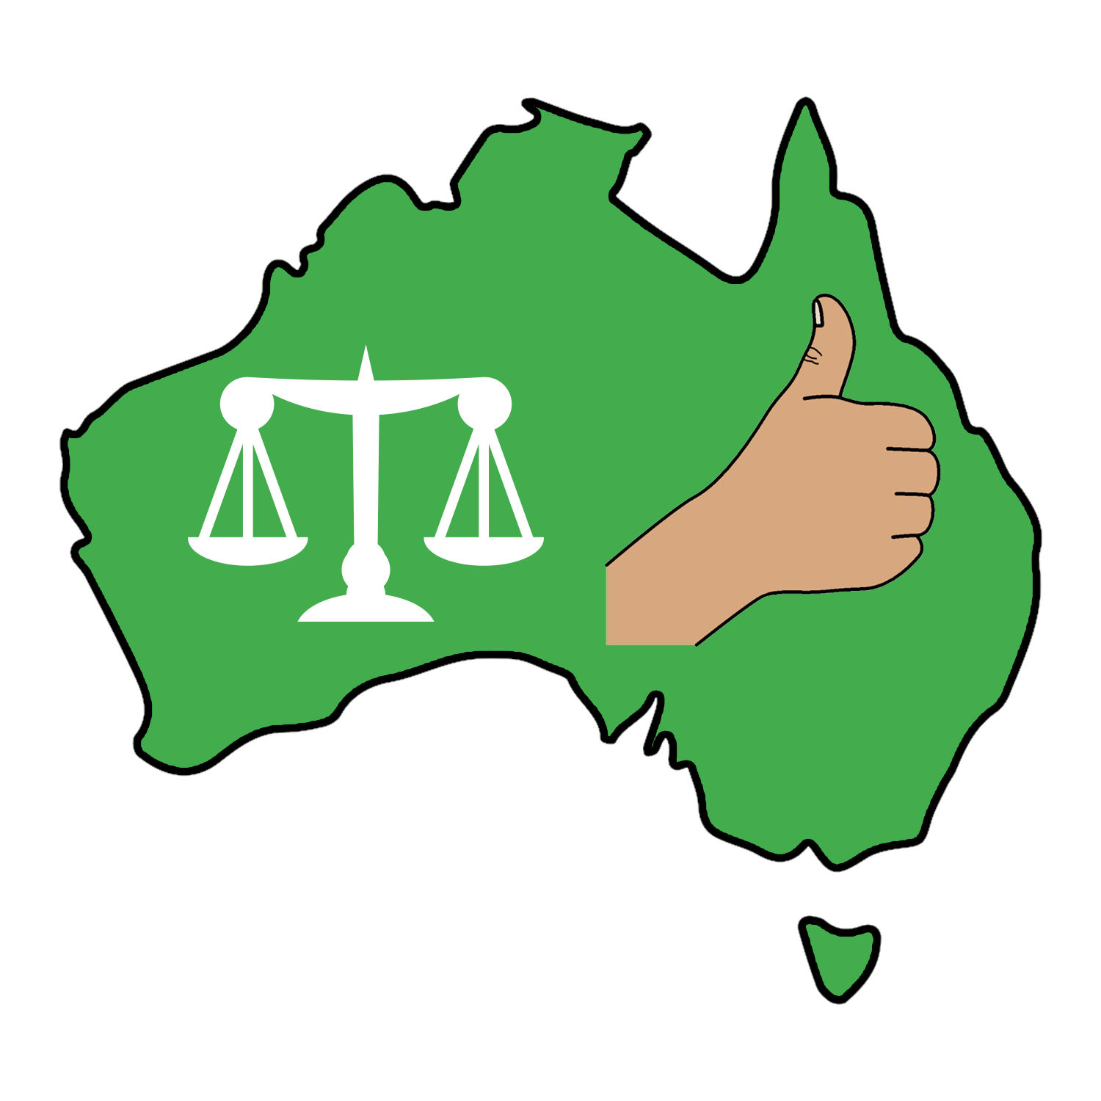
The Australian Government

The Australian Government must

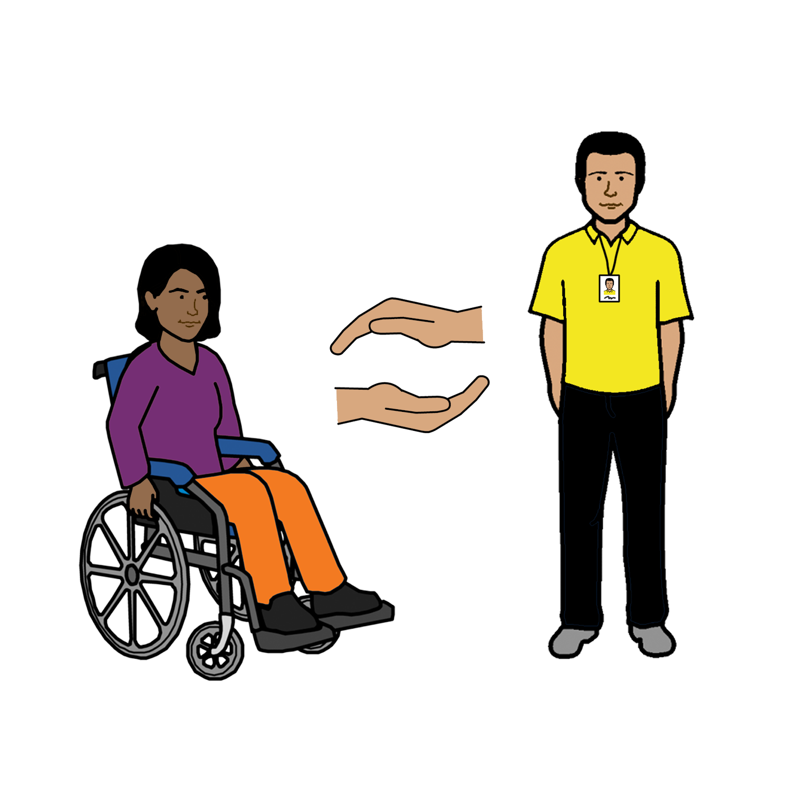
- support women with disability to make their own choices

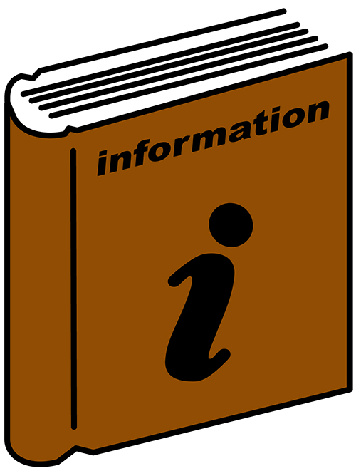
- give women and girls with disability
information they can understand

- follow the UN Convention on the Rights of Peoples with Disabilities.

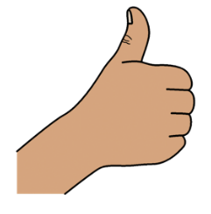
Thank you
Who wrote this book?
Women with Disabilities Australia wrote this book in 2019-2020.
This book is for general education and information only.

Copyright
© Copyright
Women with Disabilities Australia (WWDA) Inc. 2020.

All intellectual property rights, including copyright and patents, in this book is owned and licensed by Women with Disabilities Australia Inc.

Thank you for the money to write this book.
The National Disability Insurance Scheme gave Women with Disabilities Australia some money to help build this website.

The images used in this fact sheet
Easy on the I Images © 2019 Leeds and York Partnership NHS Foundation Trust. Used with permission. www.easyonthei.nhs.uk
The Picture Communication Symbols © 2019 by Mayer Johnson LLC a Tobii Dynavox company. Used with permission. www.tobiidynavox.com

Logos. Used with permission.

