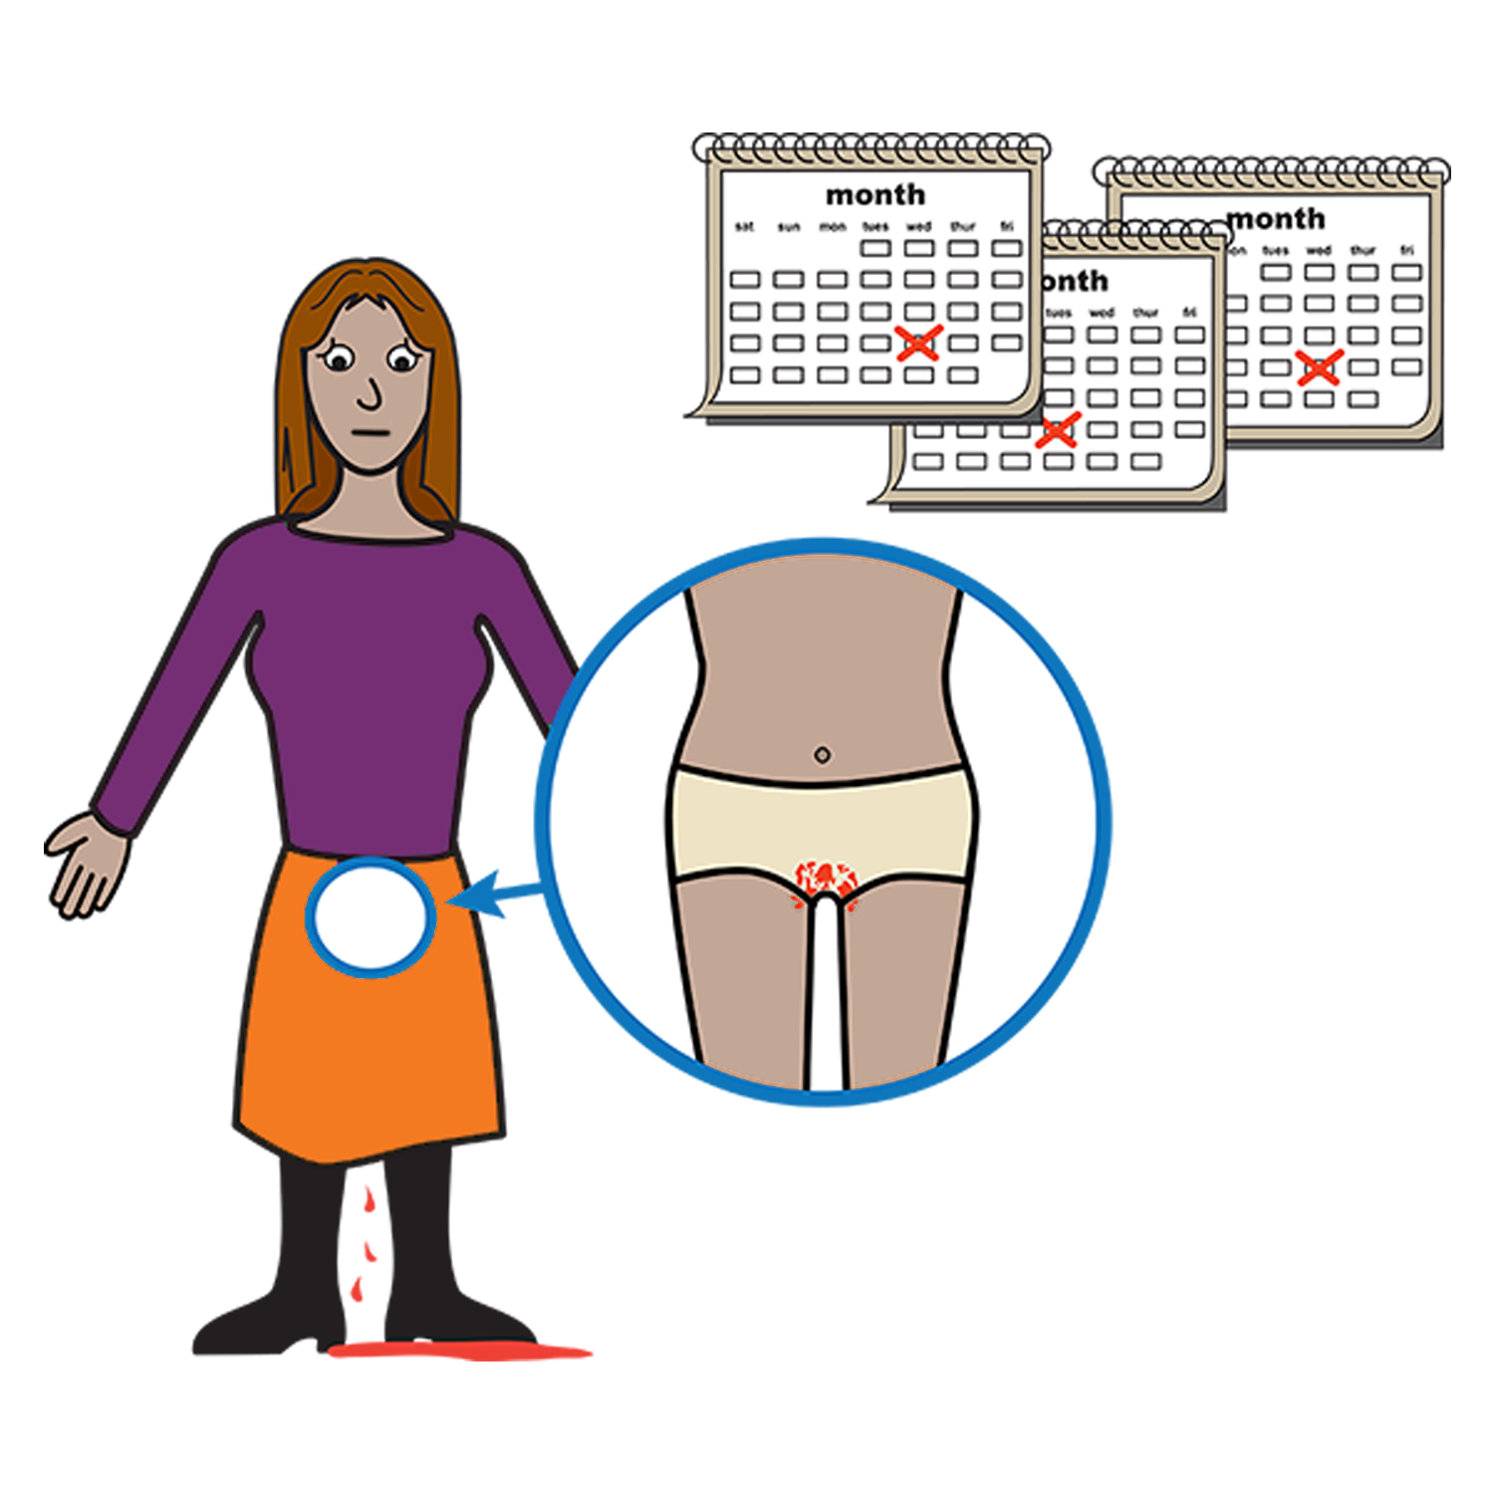
Women with
Disabilities Australia

Your period. It is
called Menstruation.

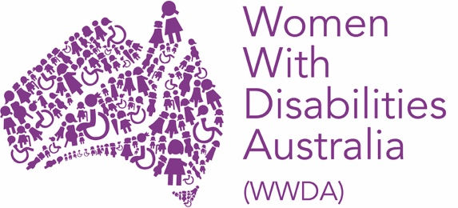

This book is about your period.
Your period is also called menstruation.

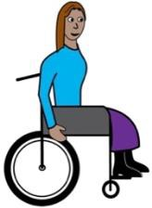

We wrote this book for women and girls with disability.

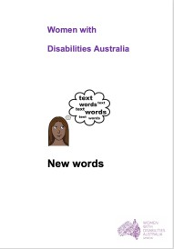

Read more about disability in our book New Words.

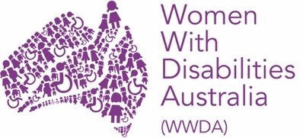
We are Women with Disabilities Australia.

What is my period?
It is also called Menstruation.

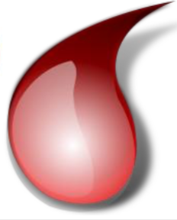
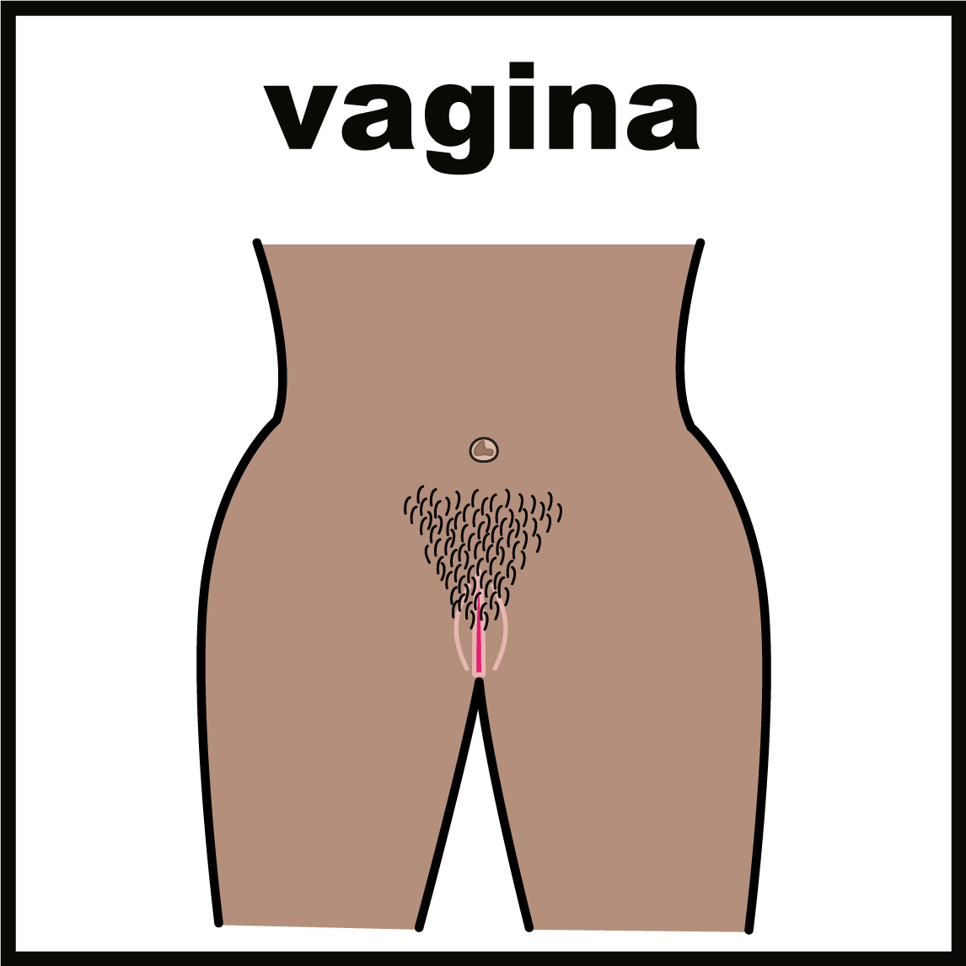
Your period is when you bleed from your vagina

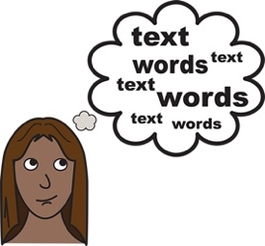

Some people call their period other things.

Like:

- time of the month

When will I get my period?

Most girls get their first period when they go
through puberty.

This is any time from 10 years old
to 15 years old.

You will get your period:
- about once a month
- for 4 to 7 days.

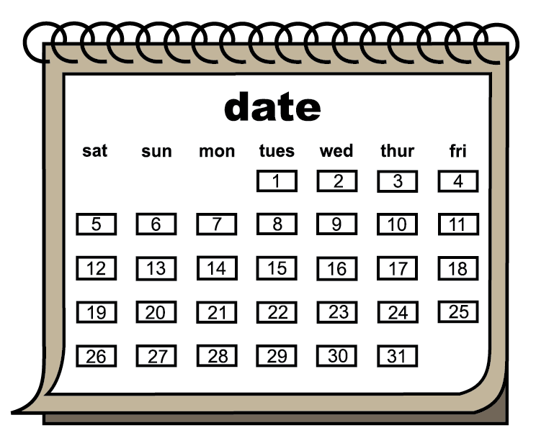

Some people have periods for a different time.
Like:
- every 6 weeks
- for 5 days.

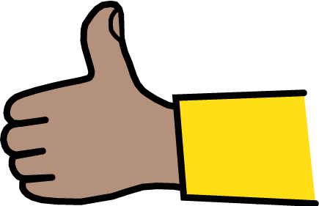

This is OK.

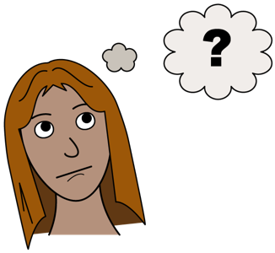
Why do I get a period?

Girls are born with 2 ovaries. They are inside your body. You cannot see them.

Your ovaries have eggs in them. They are for when you start a baby.

Each month your body lets an egg go.

When you do not want to get pregnant the egg:
- must come out of your body
- comes out in some blood

This is when you have your period.

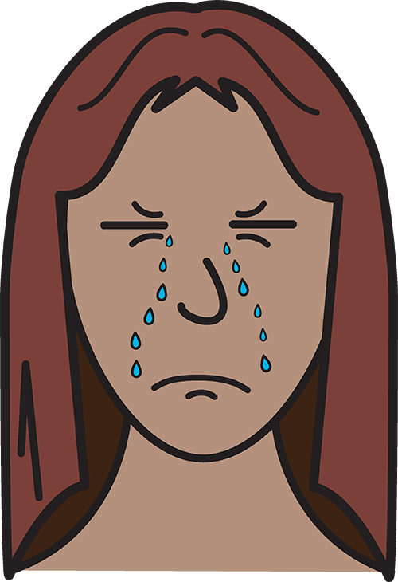
How will you feel when
you have your period?

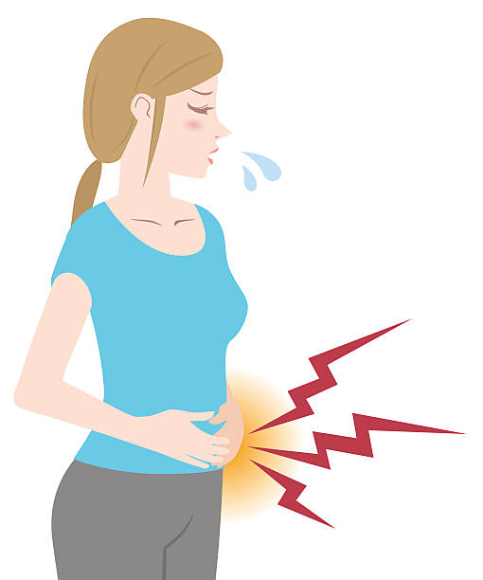

Your stomach may hurt.

You may feel:
- grumpy
- sad.

You do not need to worry.
This is OK.

What to do when your

period starts

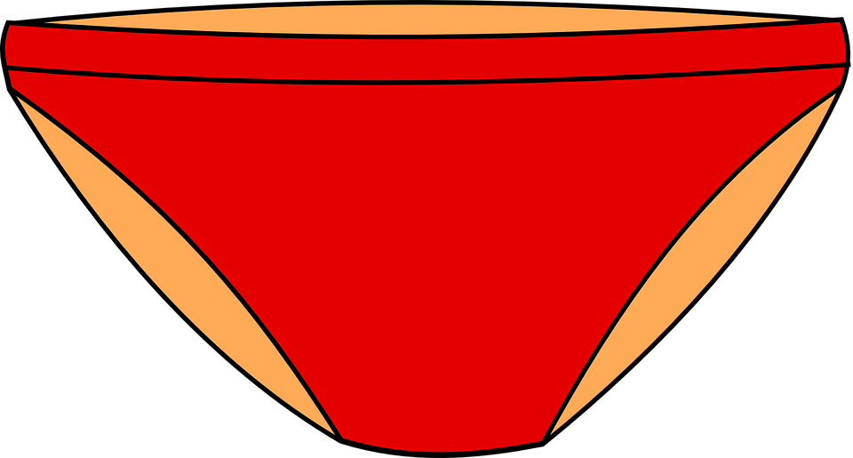

You need to wear something to catch the blood.

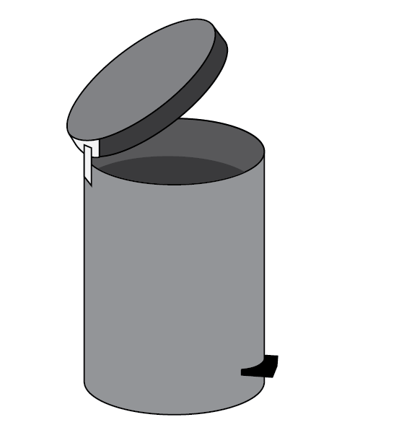

You can use something you throw away

after it is used.

or

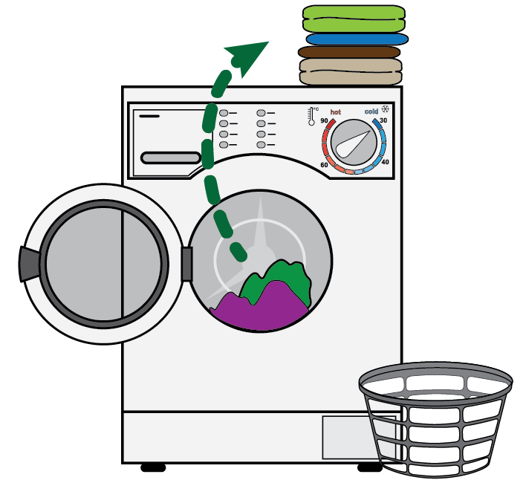

You can use things that you wash.

You can then use them again.

Things to use. Then throw away.

Like:

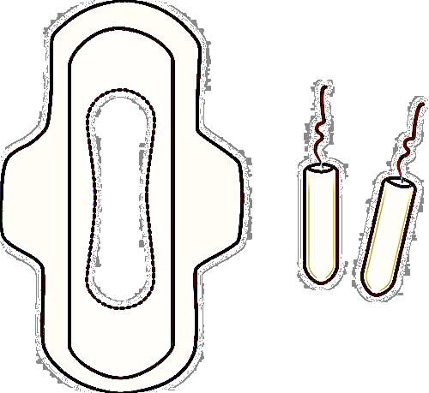
- sanitary pads.

You wear them in your underpants.

or

- tampons. You put them in your vagina.

You can buy these from most shops.

Like:
- supermarkets
- chemists.

Things to use. Then wash and use again. Like:

- period proof underwear

- menstrual cups

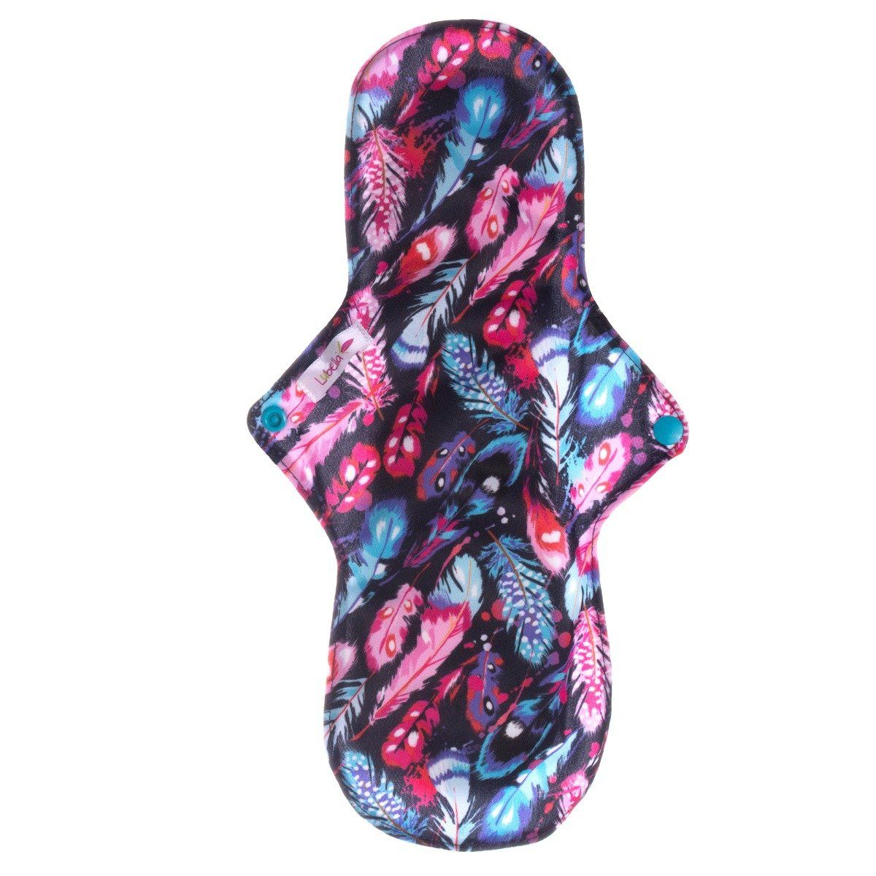

- cloth pads.

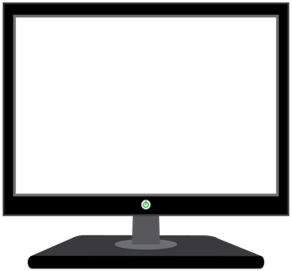

Learn more about the things you can re-use:

www.lunette.com.au/blogs/news/green-your-teens-period
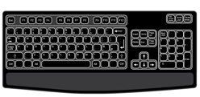

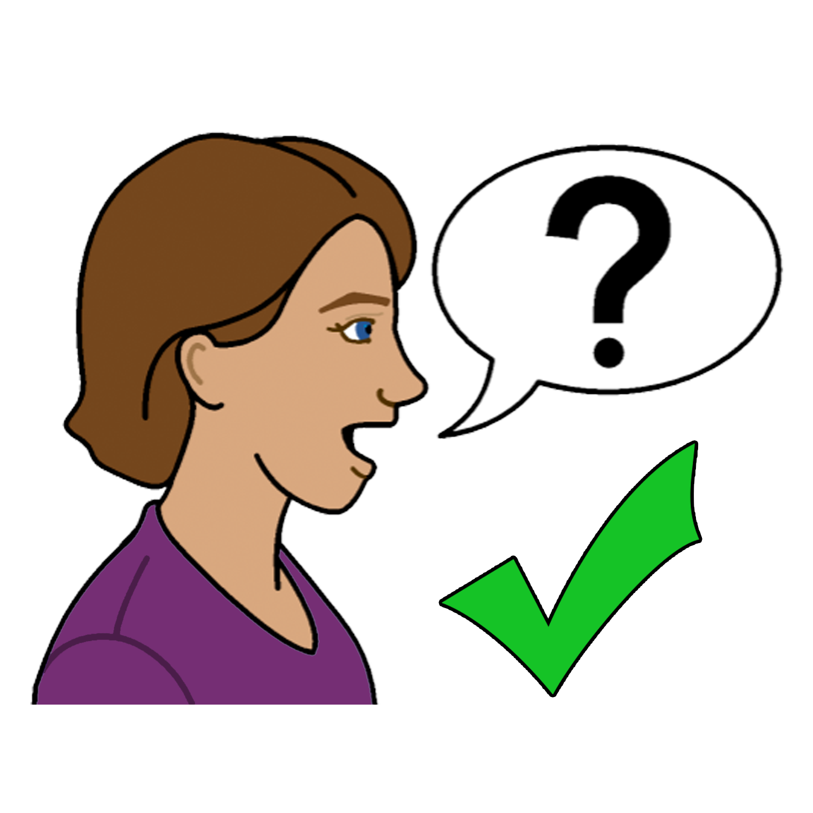
To find out more
You can talk to:

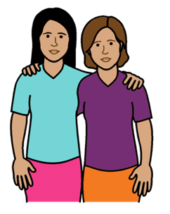
- a friend
- a family member

- your doctor

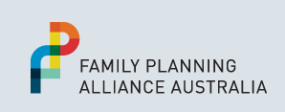
- your local Family Planning Service.
Go to: www.familyplanningallianceaustralia.org.au/services

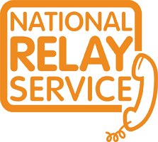
You can use the National Relay Service
when you call a service
Call: ………….. 1800 555 677
TTY: …………. 133 677

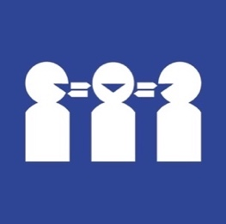

Need a translator
Call ………….. 131 450

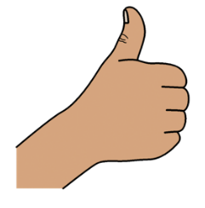
Thank you
Who wrote this book?
Women with Disabilities Australia wrote this book in 2019-2020.
This book is for general education and information only.

Copyright
© Copyright
Women with Disabilities Australia (WWDA) Inc. 2020.

All intellectual property rights, including copyright and patents, in this book is owned and licensed by Women with Disabilities Australia Inc.

Thank you for the money to write this book.
The National Disability Insurance Scheme gave Women with Disabilities Australia some money to help build this website.

The images used in this book
Easy on the I Images © 2019 Leeds and York Partnership NHS Foundation Trust. Used with permission. www.easyonthei.nhs.uk
The Picture Communication Symbols © 2019 by Mayer Johnson LLC a Tobii Dynavox company. Used with permission. www.tobiidynavox.com

Logos. Used with permission.

