Aboriginal and
Torres Strait Islanders
Know Your Rights
This brochure explains what racial discrimination is and what you can do it you experience it, as well as the work of the Australian Human Rights Commission and the Aboriginal and Torres Strait Islander Social Justice Commissioner in relation to Aboriginal and Torres Strait Islander people.

What is racial discrimination?
Racial discrimination is when a person is treated less favourably than another person in a similar situation because of their race, colour, descent, national or ethnic origin or immigrant status.
For example, it would be ‘direct discrimination’ if a real estate agent refuses to rent a house to a person because they are an Aboriginal or a Torres Strait Islander.
It is also racial discrimination when there is a rule or policy that is the same for everyone but has an unfair effect on people of a particular race, colour, descent, national or ethnic origin or immigrant status.
This is called ‘indirect discrimination’.

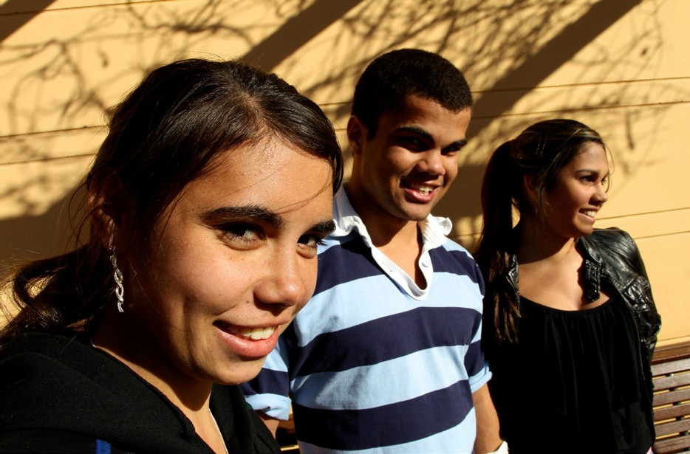

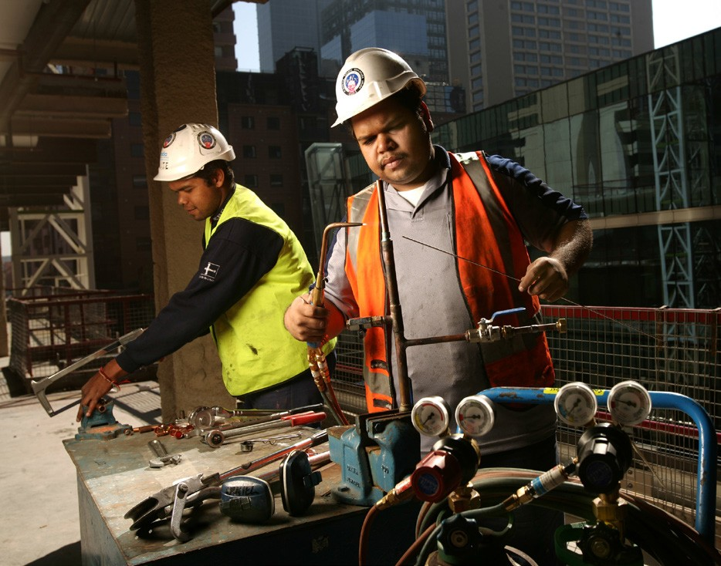

What is racial hatred or racial vilification?
Racial hatred (sometimes referred to as vilification) is doing something in public based on the race, colour, national or ethnic origin of a person or group of people which is likely to offend, insult, humiliate or intimidate.
Examples of racial hatred may include:
- racially offensive material on the internet, including eforums, blogs, social networking sites and video sharing sites
- racially offensive comments or images in a newspaper, magazine or other publication such as a leaflet or flyer
- racially offensive speeches at a public rally
- racially abusive comments in a public place, such as a shop, workplace, park, on public transport or at school
- racially abusive comments at sporting events by players, spectators, coaches or officials.

How am
I protected from
racial discrimination
and racial hatred?
The Racial Discrimination Act aims to ensure that Australians of all backgrounds are treated equally and have the same opportunities.
This Act makes it against the law to treat you unfairly, or to discriminate against you, on the grounds of race, colour, descent, national or ethnic origin.
The Act also makes racial hatred against the law.
The Act gives effect to Australia’s obligations under the International Convention on the Elimination of All Forms of Racial Discrimination, to which Australia is committed.

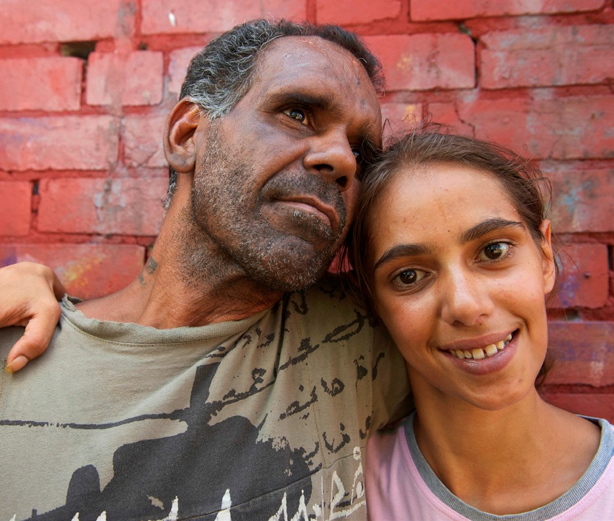

What does the Racial Discrimination Act do?
The Act protects you against discrimination in many areas of public life, including:
- employment – getting a job, terms and conditions of a job, training, promotion, being dismissed
- education – enrolling or studying in a course at a private
or public school, college or university
- accommodation – renting or buying a house or unit
- getting or using services – such as banking and insurance services, services provided by government departments, transport or telecommunication services, professional services like those provided by lawyers, doctors or tradespeople, services provided by restaurants, shops or entertainment venues
- accessing public places – such as parks, government offices, restaurants, hotels or shopping centres.
The Act also protects you if you ate harassed because of your race.

What about discrimination and harassment at work?
The Racial Discrimination Act covers situations where you feel that, because of your race, you have been:
- refused employment
- dismissed
- denied a promotion, transfer or other employment-related benefits
- given less favourable terms or conditions of employment
- denied equal access to training opportunities
- selected for redundancy
- harassed.
It doesn’t matter if you are applying for a job, are an apprentice or trainee, on probation, work part-time or full-time, or if you are a casual or permanent employee – you are protected by the Act.
The law covers all types of employers, including: the Commonwealth and state governments; the private sector; as well as contract and commission-based work; and recruitment and employment agencies.
Employers have a legal responsibility to take all reasonable steps to prevent racial discrimination and should have policies and programs in place to prevent racial discrimination in the workplace.

When is racial hatred
not against the law?
The Racial Discrimination Act aims to strike a balance between the right to communicate freely (‘freedom of speech’) and the right to live free from racial hatred or vilification.
To strike this balance, the Act outlines some things that are not against the law, provided they are ‘done reasonably and in good faith’ - even if they are done in public.
Under the Act, the things that are not against the law if they are “done reasonably and in good faith” are:
- an artistic work or performance – for example, a play in which racially offensive attitudes are expressed by a character.
- a statement, publication, discussion or debate made for genuine academic or scientific purposes – for example, discussing and debating public policy such as multiculturalism or special measures for particular groups, like Aboriginal and Torres Strait Islander people.
- making a fair and accurate report on a matter of public interest – for example, a fair report in a newspaper about racially offensive conduct.
- making a fair comment, if the comment is an expression
of a person’s genuine belief.
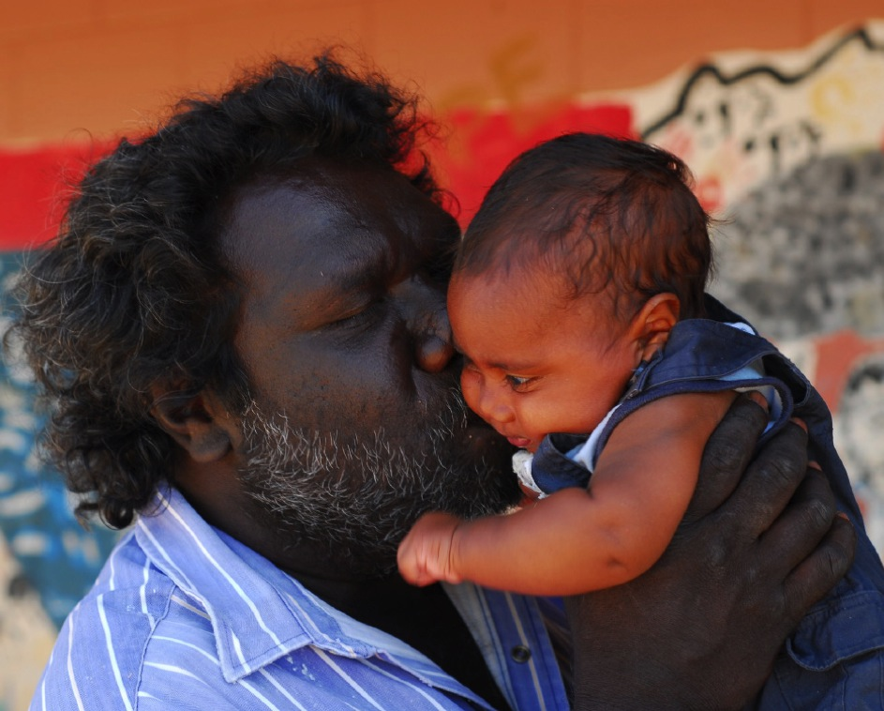

Early signature image of the Close the Gap campaign: Clarence Paul with his son.

What can I do if
I experience discrimination or
racial hatred?
You may want to deal with the situation yourself by raising it directly with the person or people involved or with a supervisor, manager or discrimination/harassment contact officer.

Making a complaint to the Commission
If this does not resolve the situation, or you do not feel comfortable doing this, you can make a complaint to the Australian Human Rights Commission. You can also have someone such as a solicitor, advocate or trade union make a complaint on your behalf.
It does not cost anything to make a complaint to the Commission.

Your complaint needs to be put in writing. The Commission has a complaint form that you can fill in and post or fax to us or you can lodge a complaint online at our website. If you are not able to put your complaint in writing, we can help you with this.
The complaint should say what happened, when and where it happened and who was involved. A complaint can be made in any language. If you need a translator or interpreter, we can arrange this for you.

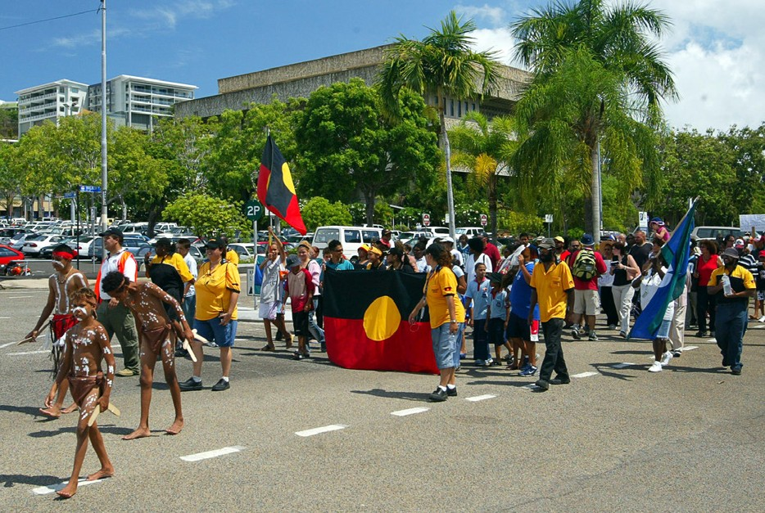

What will happen with my complaint?
When the Commission receives a complaint about something that is covered by the Racial Discrimination Act, the President of the Commission can investigate the complaint and try to resolve it by conciliation.
The Commission is not a court and cannot determine that discrimination has happened. The Commission’s role is to get both sides of the story and help those involved resolve the complaint. Commission staff may contact you to get further information about your complaint.
Generally, the Commission will tell the person or organisation the complaint is against (the respondent) about your complaint and give them a copy of the complaint. The Commission may ask the respondent for specific information or a detailed response to your complaint.
Where appropriate, the Commission will invite you to participate in conciliation. Conciliation is an informal process that allows you and the respondent to talk about the issues and try to find a way to resolve the complaint.
If your complaint is not resolved or it is discontinued for another reason, you can take your complaint to the Federal Court of Australia or the Federal Magistrates Court.

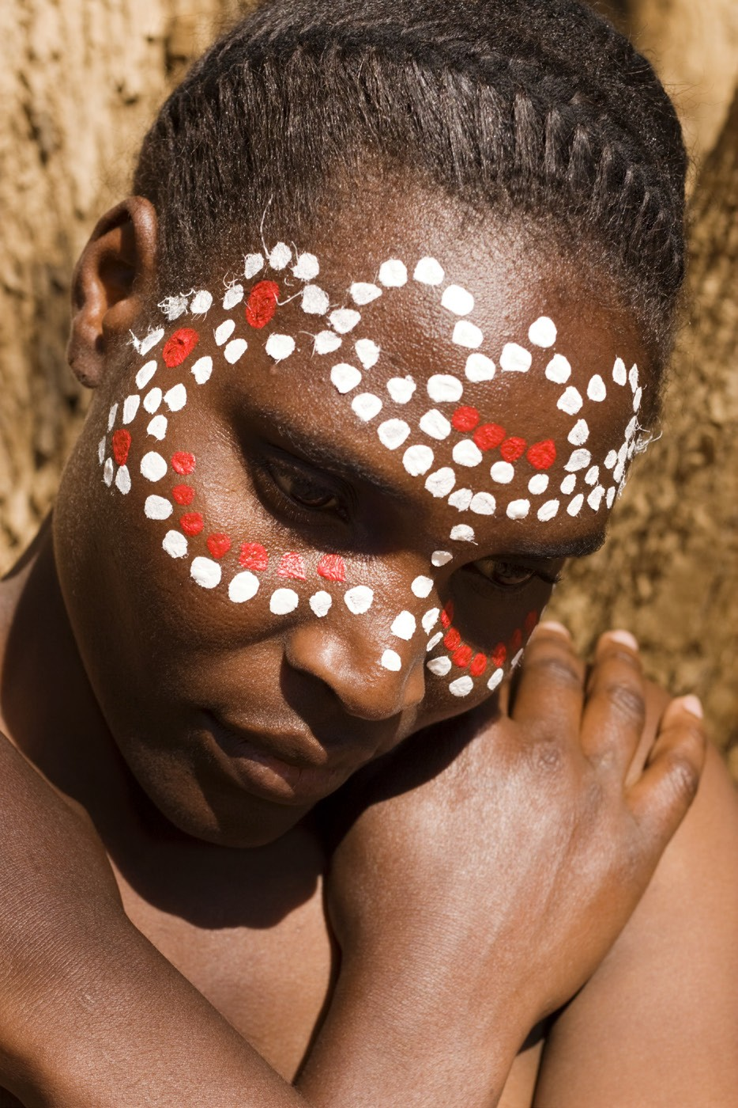

What can I do to prevent discrimination?
Everyone has a role to play to help ensure that people from diverse cultures and backgrounds have the same opportunities as other Australians to participate in the political, economic and social life of our communities by letting us know what is happening.
The Commission undertakes a wide range of activities to build awareness about the rights and responsibilities that individuals and organisations have under the Racial Discrimination Act.
There is also a major focus on undertaking research and education projects to tackle racism and promote greater understanding between people of different cultures and backgrounds.
Projects have included national consultations, conferences, community forums and online forums.
The Commission has developed resources to assist sporting organisations and employers respond to and benefit from cultural diversity. Education resources have also been developed for schools and communities.

National Anti-Racism Partnership and Strategy
In 2011, the Australian Government committed to develop and implement the National Anti-Racism Strategy for Australia, to be implemented between July 2012 and June 2015.
The aim of the National Anti-Racism Strategy is to promote
a clear understanding in the Australian community of what racism is, and how it can be prevented and reduced, through:
- creating awareness of racism and how it affects individuals and the broader community (primarily through is the RACISM. IT STOPS WITH ME campaign
- identifying, promoting and building on good practice initiatives to prevent and reduce racism, and
- empowering communities and individuals to take action to prevent and reduce racism and to seek redress when it occurs.
You can find out more about what we’re doing by visiting: www.humanrights.gov.au/our-work/race-discrimination

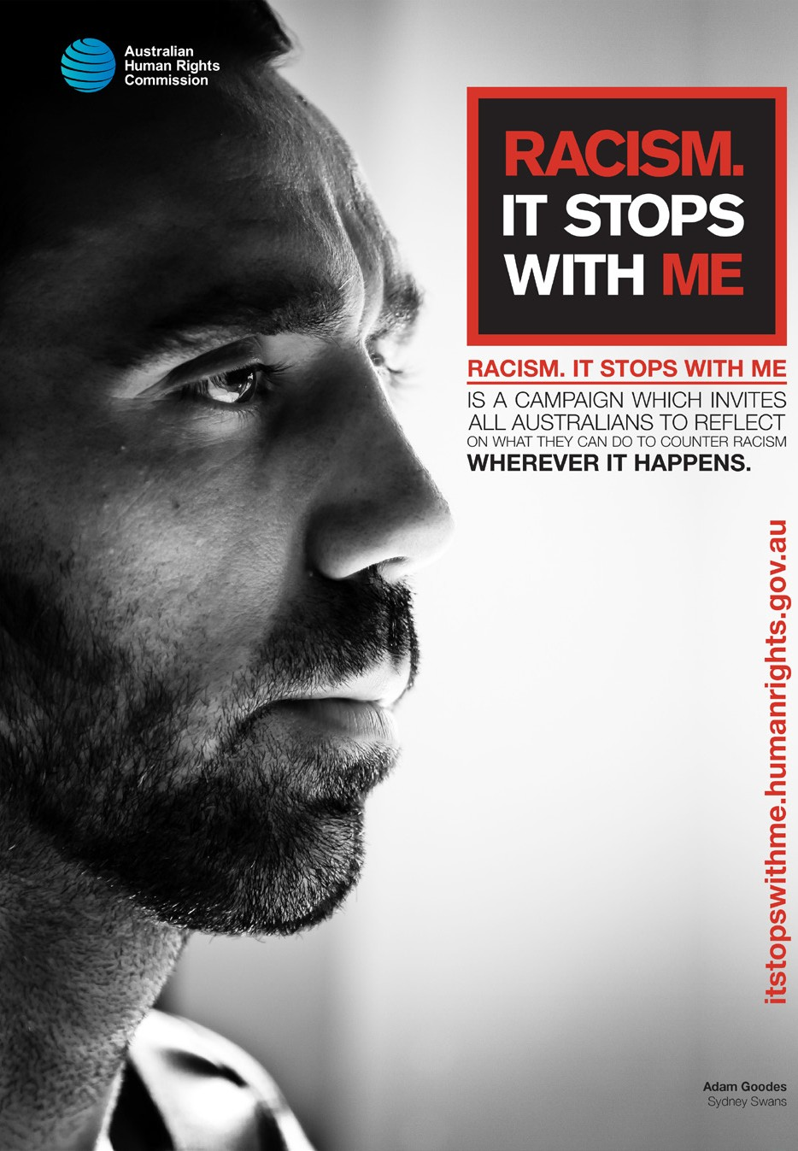

The Aboriginal and Torres Strait Islander Social Justice Commissioner
As a member of the Australian Human Rights Commission, the Social Justice Commissioner works, both in Australia and internationally, in the interests of Aboriginal and Torres Strait Islander peoples to:
- advocate for the rights of Indigenous peoples
- promote an Indigenous perspective on different issues
- build support and understanding for an Indigenous perspective, and
- empower Indigenous peoples.
This involves the Commissioner joining with other organisations to develop educational initiatives, such as seminars and training programs, and targeted educational resources.

What is Native Title?
Native title is a property right that reflects a relationship to land – land being the very foundation of Indigenous religion, culture and well-being. The non-discriminatory protection of native title is a recognised human right.

The Social Justice and Native Title Report
The Social Justice Commissioner is required to report annually to federal Parliament on significant social justice and native title issues facing Indigenous Australians.
The Social Justice and Native Title Report looks at the key human rights issues facing Indigenous Australians and makes recommendations about changes to government policies, programs and laws that will help Indigenous Australians more fully enjoy their rights.

It covers issues ranging from self-determination, addressing violence and governance reform through to criminal justice issues and issues relating to land tenure, native title and heritage protection.
You can find these reports online at: www.humanrights. gov.au/publications/aboriginal-and-torres-strait-islander- social-justice?source=our-work

What is the Close the Gap: Indigenous Health campaign?
Since 2006, and with the leadership of the Social Justice Commissioner, Australia’s peak Indigenous and non-Indigenous health bodies, NGOs and human rights organisations have been working as a coalition to achieve health and life expectation equality for Australia’s Aboriginal and Torres Strait Islander peoples.
This is known as the Close the Gap campaign.

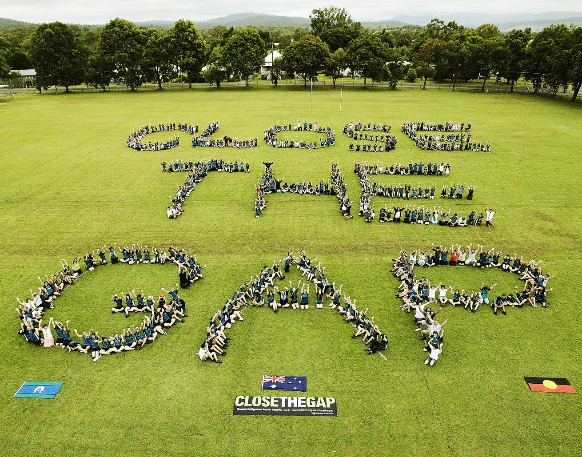

Currently, Indigenous Australians can expect to live 9-11 years less than other Australians. Babies born to Aboriginal mothers die at more than twice the rate of other Australian babies (Australian Bureau of Statistics).
Aboriginal and Torres Strait Islander people also experience higher rates of preventable illness, such as heart disease, kidney disease and diabetes.

The Close the Gap campaign’s goal is to close the health and life expectancy gap between Aboriginal and Torres Strait Islander peoples and non-Indigenous Australians within a generation.
It is built on evidence that shows that significant improvements in the health status of Aboriginal and Torres Strait Islander peoples can be achieved within short time frames.
With this in mind, the campaign’s aim is motivate and empower governments to take real, measurable human rights based action to achieve Indigenous health equality by 2030.
This includes the creation of a generational Aboriginal and Torres Strait Islander health equality plan with ambitious yet realistic targets supported by a partnership between Aboriginal and Torres Strait Islander peoples, their representatives and Australian governments.
By joining our efforts we can make sure that by 2030 any Aboriginal or Torres Strait Islander child born in this country has the same opportunity as other Australian children to live a long, healthy and happy life.
Find out more at the Close the Gap website: www.oxfam. org.au/explore/indigenous-australia/close-the-gap/

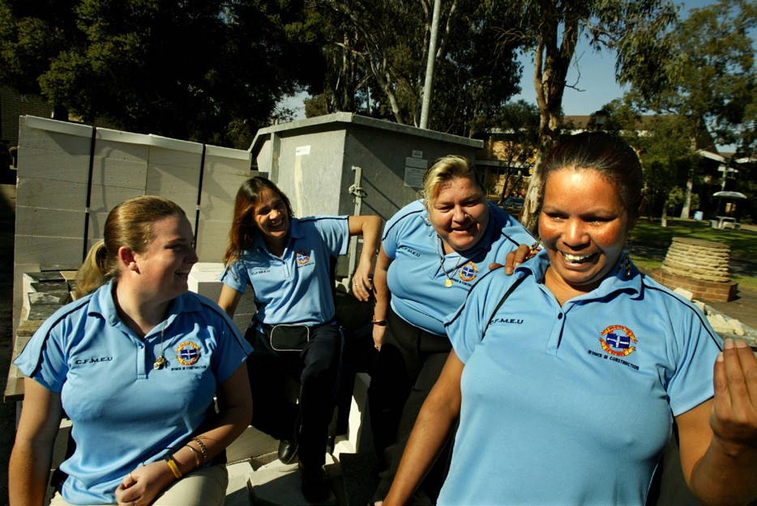

What is justice reinvestment?
Justice reinvestment is a criminal justice policy approach that diverts a portion of the funds for imprisonment to local communities where there is a high concentration of offenders.
The money that would have been spent on imprisonment is reinvested into services that address the underlying causes of crime in these communities - and therefore helps prevent the cycle that results in people being imprisoned.
Most importantly, justice reinvestment is an opportunity to create safer communities – which means less offending, which in turn mean less people going to prison.

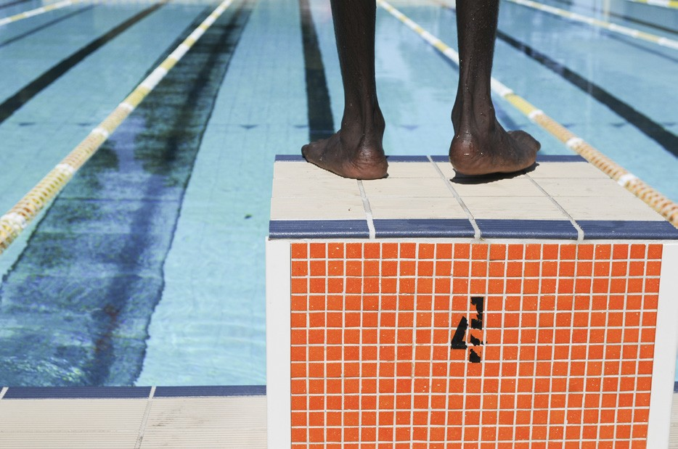

In comparison to the rest of the Australian population, the rate of imprisonment of Aboriginal and Torres Strait Islander people in Australia’s prison system is 14 times higher.
Aboriginal and Torres Strait Islander young people are 35 times more likely to be in detention, with almost three out of five young people in detention being Indigenous.

For Indigenous women, the rate of imprisonment increased by over 58% between 2000 and 2010, and more than 51% for men.
Prevention, early intervention and diversionary measures are features of justice reinvestment approaches.
The Social Justice Commissioner, and the Commission itself, are committed to advocating for implementation of justice reinvestment in Aboriginal and Torres Strait Islander communities and to bringing federal governments together with state and territory governments to embrace these approaches.
You can find out more about justice reinvestment by reading the Senate Report at: www.aph.gov.au/Parliamentary_Business/Committees/Senate/Legal_and_ Constitutional_Affairs/Completed_inquiries/2010-13/ justicereinvestment/report/index

What is Constitutional Recognition?
The Australian Constitution does not recognise Aboriginal and Torres Strait Islander peoples.
In recent years, there has been a growing feeling in the Australian community that the Constitution needs to be brought up to date to reflect the reality of Australia in the 21st century.
The Constitution underpins our federal laws and institutions and can only be changed by the people.
There is broad support among members of Parliament, across all political parties, to recognise Aboriginal and Torres Strait Islander Australians in the Constitution.
The passing of the Aboriginal and Torres Strait Islander Peoples Recognition Act 2013 (Cth) has been an important step towards this goal.

Another important step has been the establishment of the Joint Select Committee on Constitutional Recognition of Aboriginal and Torres Strait Islander Peoples in November 2012.
This Committee is working to build Parliamentary consensus around the timing, specific content and wording of referendum proposals for Indigenous constitutional recognition.
The Commission continues to advocate strongly for constitutional recognition, including the continued engagement of Aboriginal and Torres Strait Islander peoples, which is crucial to ensure any proposal is meaningful and supported by First Peoples.
You can find more information at the website set up by the Expert Panel: www.recognise.org.au

What is the
UN Declaration on the Rights of Indigenous Peoples?
The UN Declaration on the Rights of Indigenous Peoples is an international instrument that provides a blueprint for Indigenous peoples and governments around the world to respect the rights and roles of Indigenous peoples within society.
It is based on the principles of self-determination and participation.
The Declaration is the instrument that contains the minimum standards for the survival, dignity and well-being of Indigenous peoples all over the world.
Aboriginal and Torres Strait Islanders were involved in drafting the Declaration, which was adopted by the UN in September 2007. Australia formally supported it in April 2009.

The Declaration is clear that action should be taken to make sure that Indigenous peoples can realise the rights in the Declaration.
The rights in the Declaration are based on justice, democracy, respect for human rights, equality and non- discrimination, good governance and good faith.

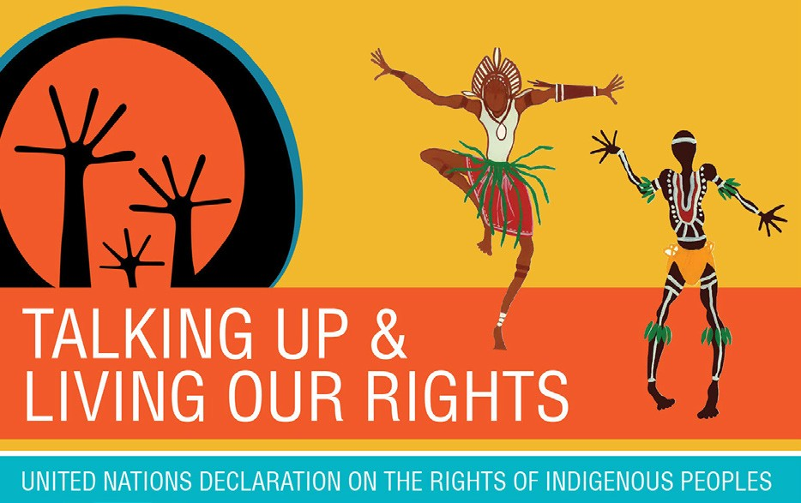

Not all the rights in the Declaration are protected under Australian law and when a right in the Declaration is violated, there is not always a remedy available.
The Commission is committed to working to see these rights protected. So if you feel you have been discriminated against, or your human rights have been violated, contact the Commission.
To find out more about the Declaration, visit: http://www. humanrights.gov.au/publications/community-guide-un- declaration-rights-indigenous-peoples

Where can I get more information?
The Australian Human Rights Commission’s contact details are:
Postal Address
Australian Human Rights Commission
GPO Box 5218
Sydney NSW 2001
Street address
Level 3, 175 Pitt Street
Sydney NSW 2000
Phone: 1300 656 419 (local call cost) or (02) 9284 9888
TTY: 1800 620 241 (toll free)
Fax: (02) 9284 9611
Email: infoservice@humanrights.gov.au
Website: www.humanrights.gov.au

Complaints
Complaint Info line: 1300 656 419 (local call)
Email: complaintsinfo@humanrights.gov.au
Online: You can make a complaint online by going to https://forms.business.gov.au/smartforms/ahrc/ahrc- enquirycomplaint-form.
If you need an Auslan interpreter, the Commission can arrange this for you.
If you are blind or have a vision impairment, the Commission can provide information in alternative formats on request.

Other contact points for racial hatred complaints
If you are concerned about offensive media stories, broadcasts or online content, you can complain to the Australian Communications and Media Authority (ACMA); the Advertising Standards Board for advertisements; or the Australian Press Council for newspaper stories.
You can also complain to the Editor or Manager of the particular media organisation involved.
If you are concerned about offensive behaviour by neighbours, you can approach a Community Justice Centre to help resolve the problem, or the Department of Housing if you live in public housing.
If you are threatened with violence or violently attacked you should go to the police.

General legal advice
If you are thinking about making a complaint, you might also want to consider obtaining legal advice or contacting your trade union.
There are community legal services that can provide free advice about discrimination and harassment. Contact details for your closest community legal centre can be found at www.naclc.org.au/directory

Know Your Rights brochures on other forms of discrimination
You might find these other KNOW YOUR RIGHTS brochures useful:
- Age Discrimination
- Disability Discrimination
- Race Discrimination
- Sex Discrimination

The Australian Human Rights Commission encourages the dissemination and exchange of information provided in this publication.
All material presented in this publication is provided under Creative Commons Attribution 3.0 Australia, with the exception of:
- the Australian Human Rights Commission Logo
- photographs and images
- any content or material provided by third parties.
The details of the relevant licence conditions are available on the Creative Commons website, as is the full legal code for the
CC BY 3.0 AU licence.

Attribution
Material obtained from this publication is to be attributed to the
Australian Human Rights Commission with the following copyright notice:
© Australian Human Rights Commission 2014.

Photography | All Rights reserved by:
Wayne Quilliam: Cover photograph
Fairfax Syndication: page 2 – Ben Rushton; page 3 –
Simon Schluter; page 5 – Justin McManus; page 9 – Andy Zakeli;
page 17 – Tamara Dean
Thinkstock: pages 4, 11, 15, 18
Close the Gap/Oxfam: page 8 – Photo of Clarence Paul and his son taken by Wayne Quilliam; page 16 – Jason Malouin
Riki Salam, Gilimbaa Pty Ltd: page 21

Disclaimer
The information in this brochure is only intended as a guide.
It is not a substitute for legal advice.

Australian Human Rights Commission
www.humanrights.gov.au

24

