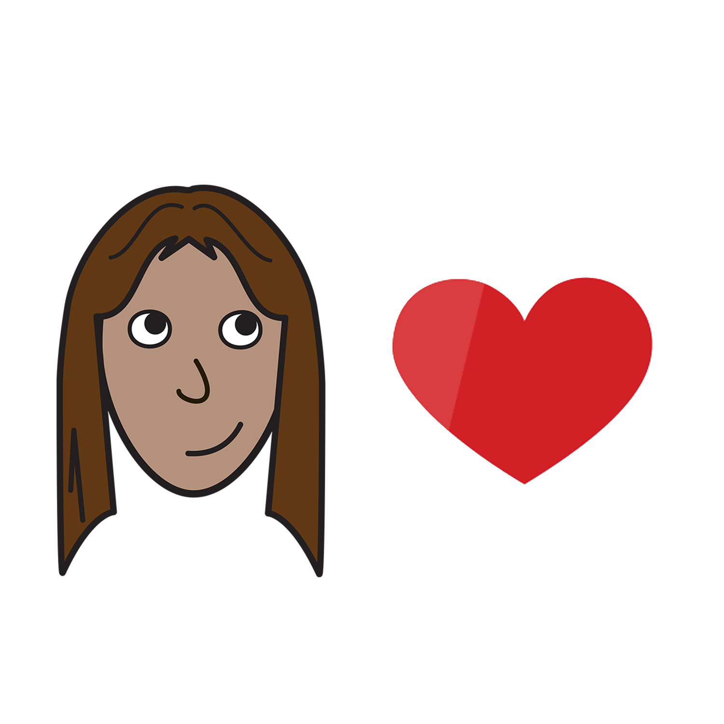
Women with
Disabilities Australia

Sex and your body

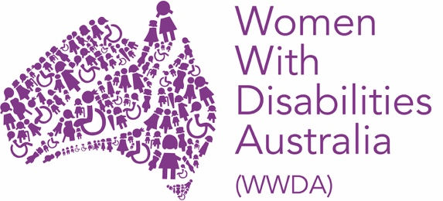

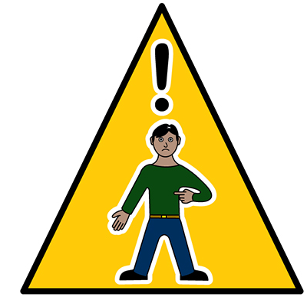
In danger now

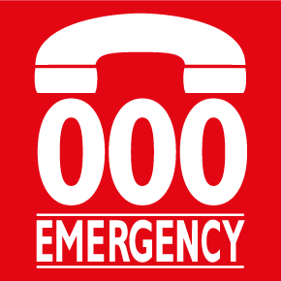
Call 000

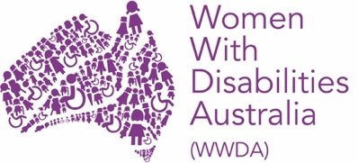
We are Women with Disabilities Australia. We will write WWDA when we talk about us.

This book is about sex and your body.

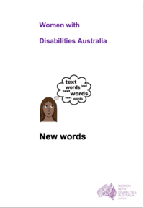
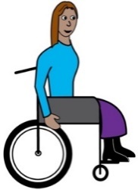
We wrote this book for women and girls
with disability. Read more about disability
in our book New Words.

Your health rights
You have the right to

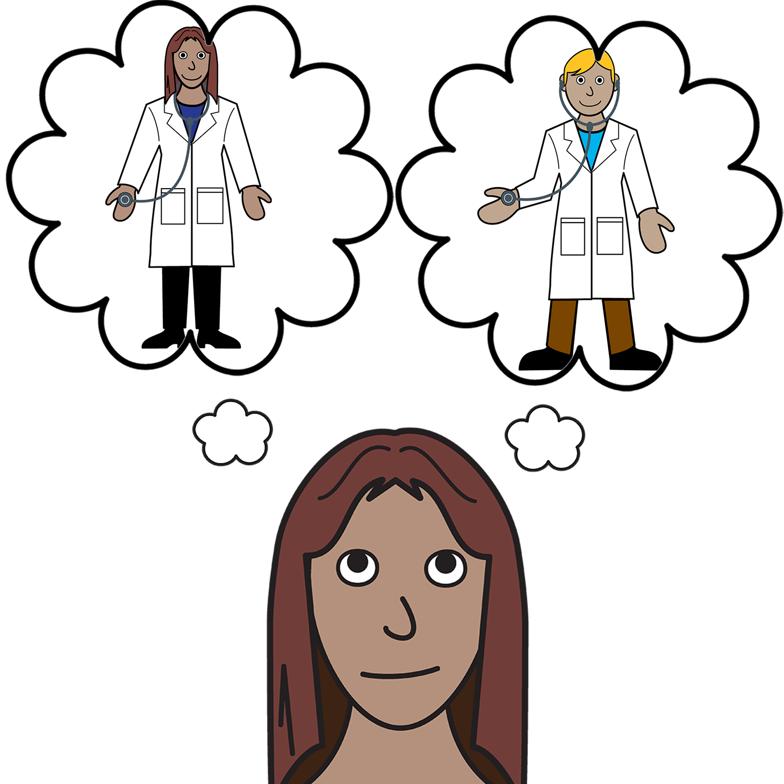
- choose your doctor.

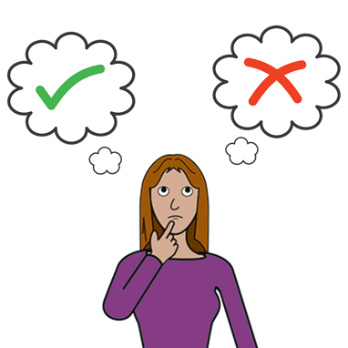

- make choices about your body.

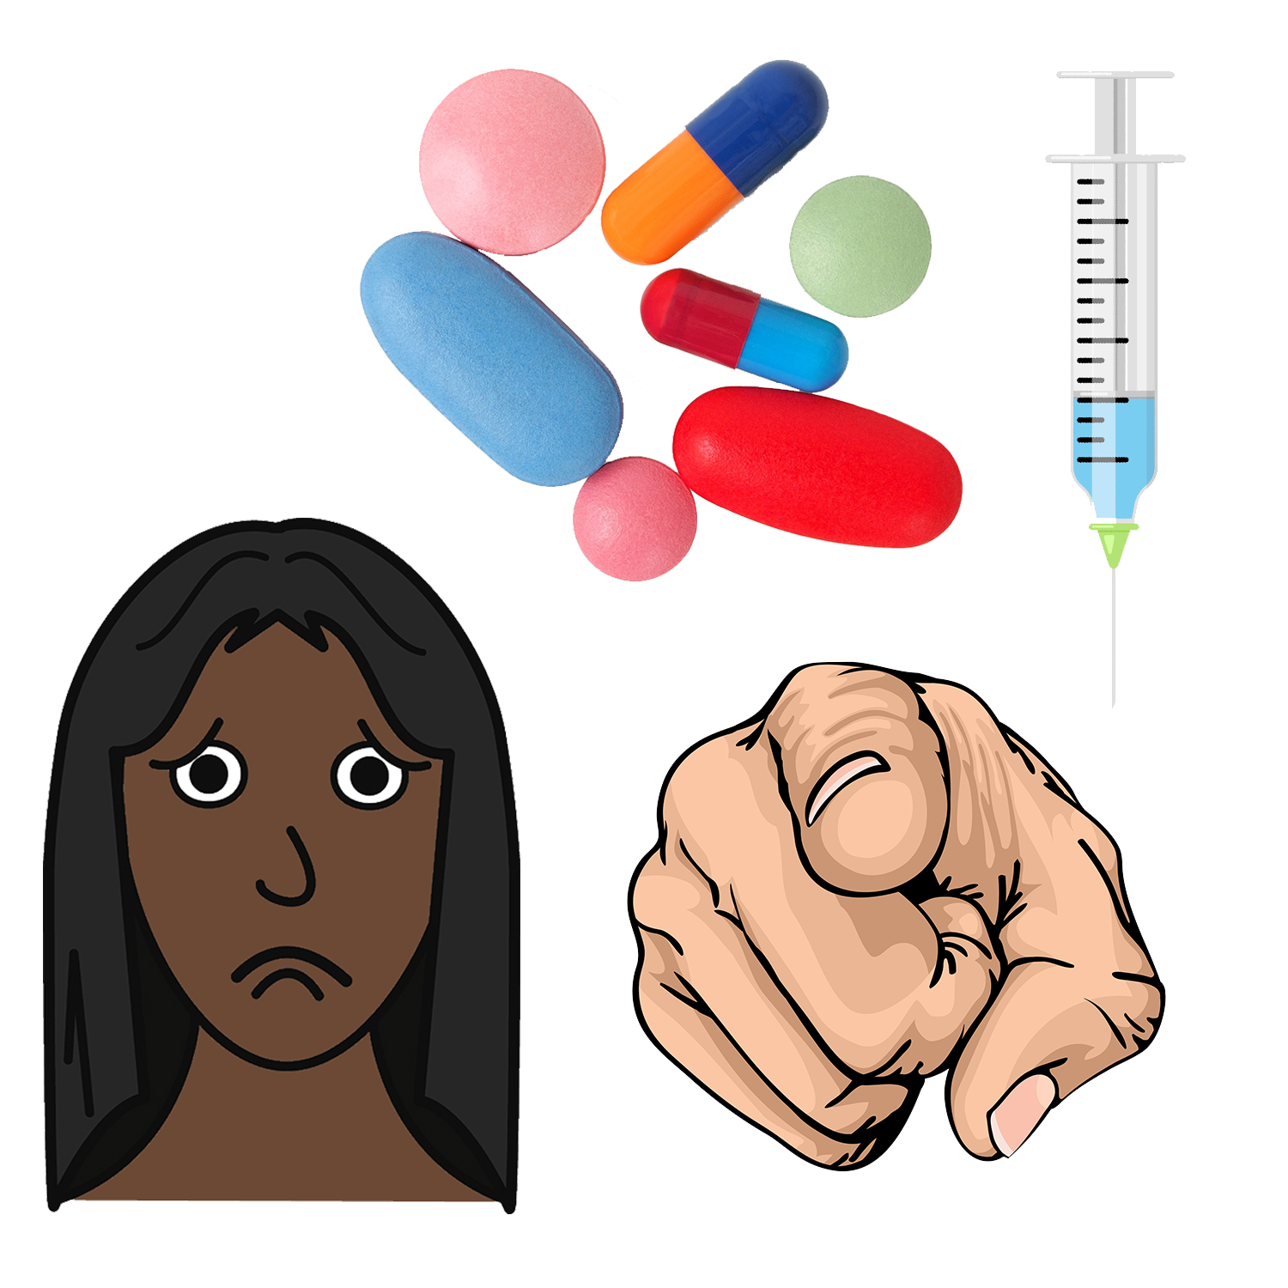
- say no to medication you do not want.

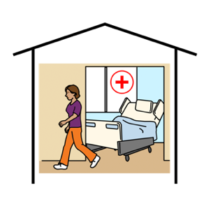
Health services
You have a right to access the healthcare you need. Like

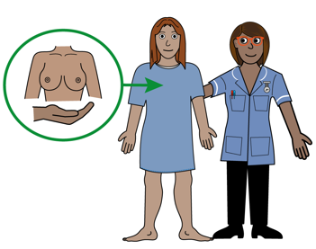

- breast screens and checks

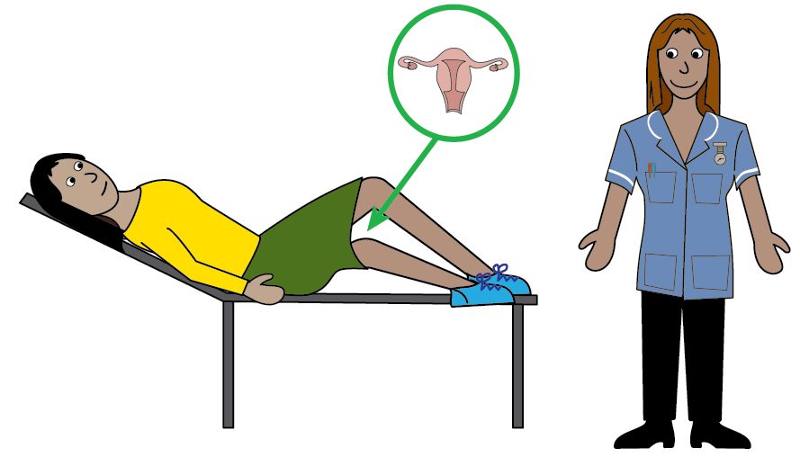

- doctors appointments and pap smears

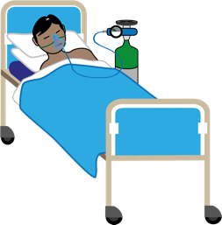
- hospital stays and surgery.

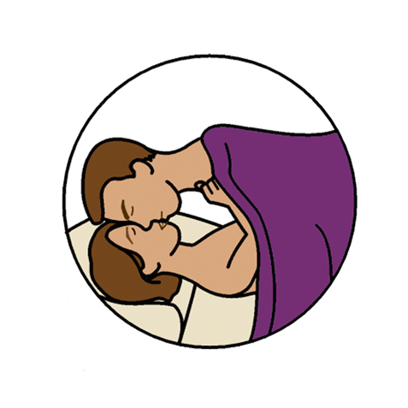
Right to sex

You have a right to choose who you love.

You have a right to have sex.

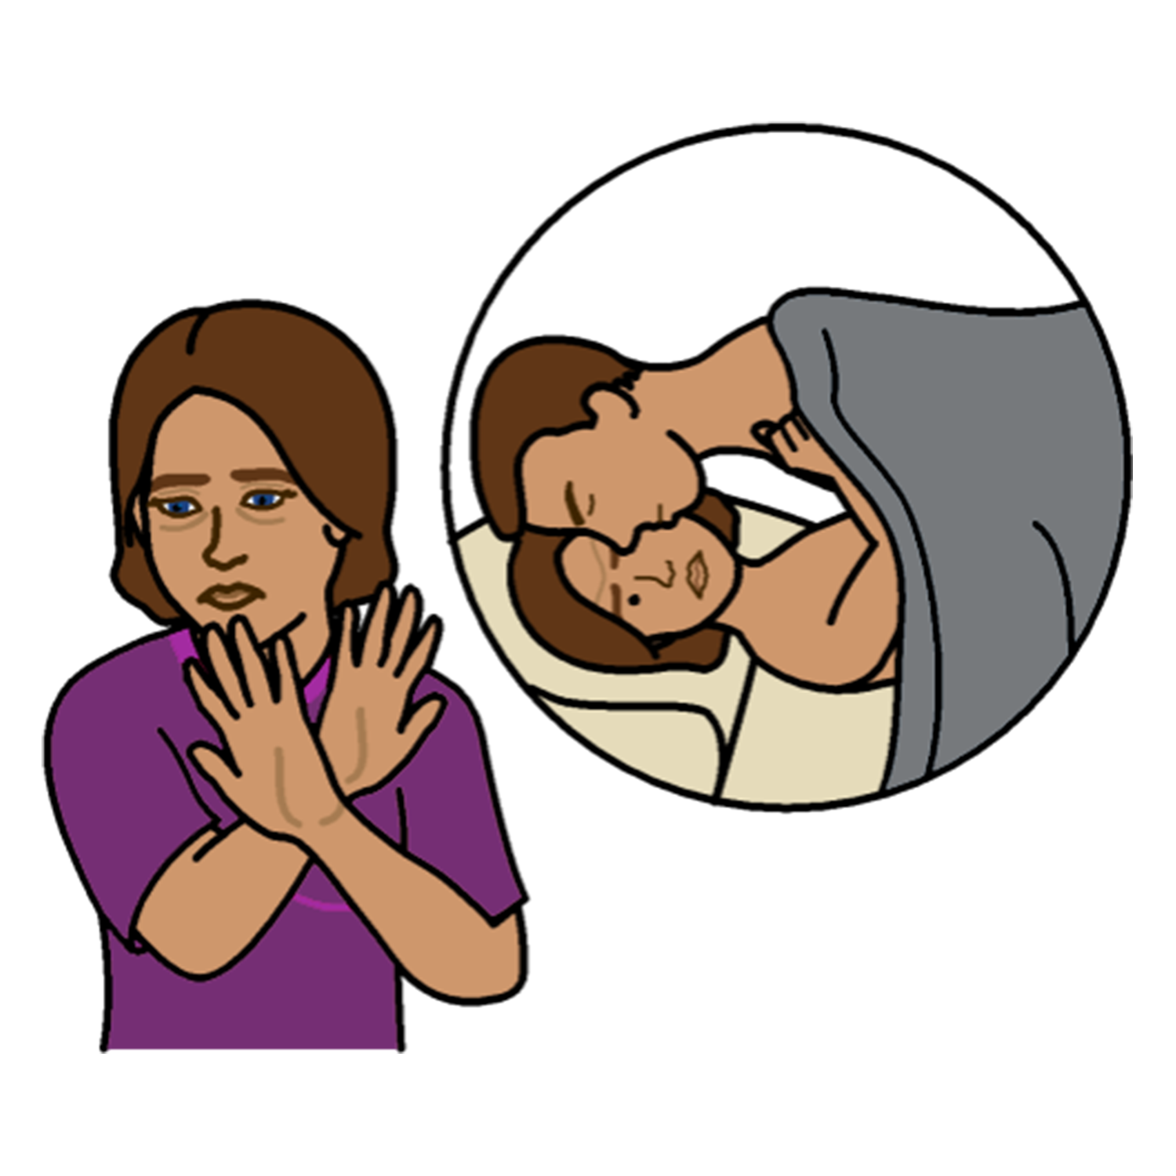

You have a right to say no to sex.

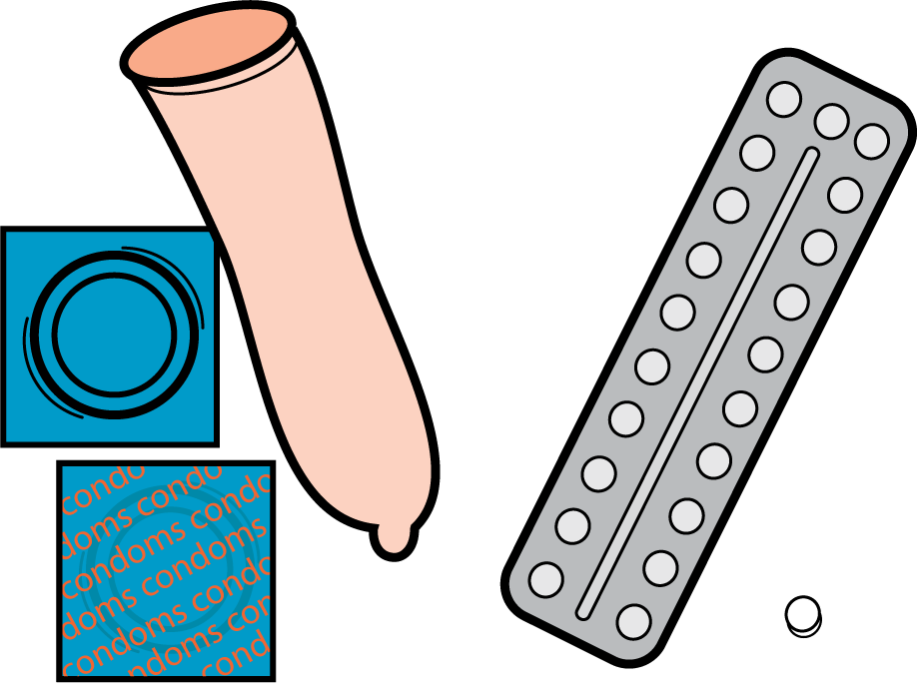
Contraception
Contraception is things you use or do to stop you getting sick or pregnant when you have sex.

You have a righ to choose contraception. Like

- condoms

- pills

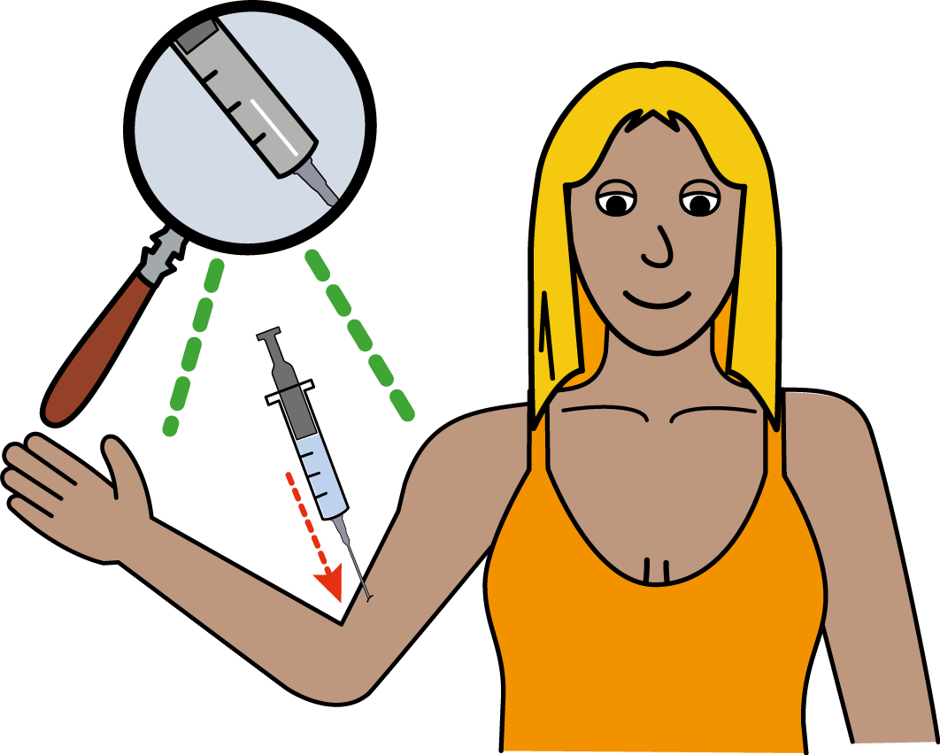
- an implant with a needle.

You can talk to your doctor about contraception options.

It is your choice!

Pregnancy and Choices
If you get pregnant you have a right to make a choice about what to do.

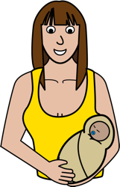
You can have the baby and become a parent.

You can have an abortion. This means you stop being pregnant.

You can have the baby and give it up for adoption. This means you give the baby to another family to look after.

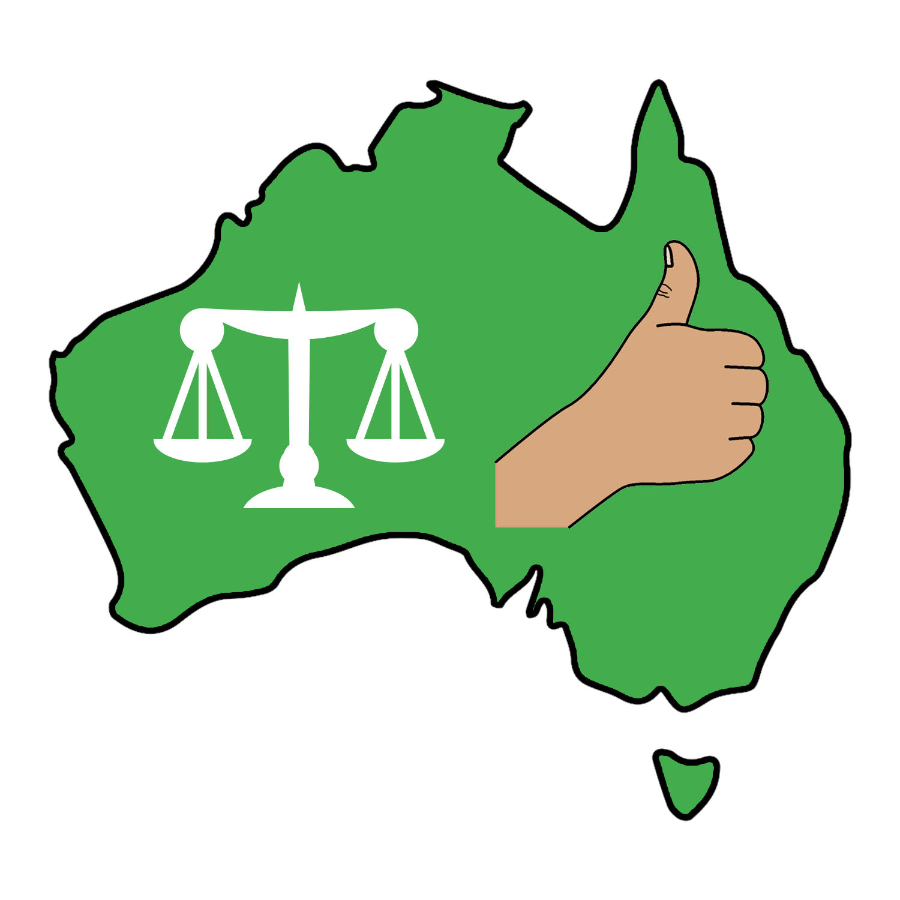
The Australian government must:

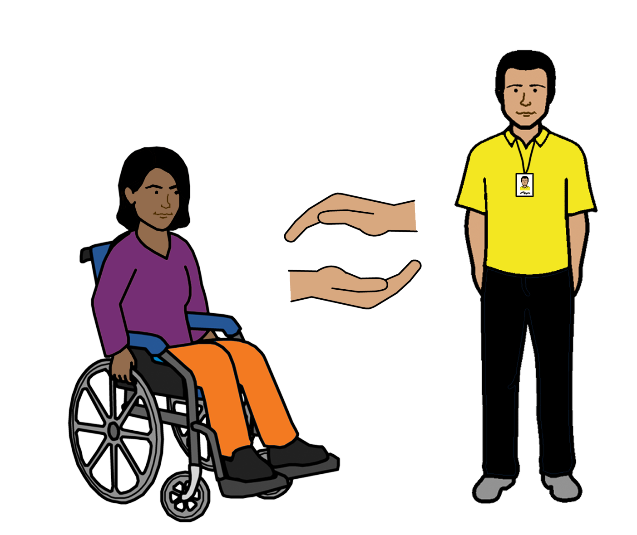
- support you to make their own choices about health and sex

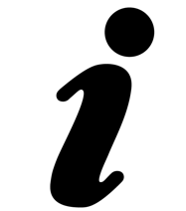
- give you information about sex and health.

- make sure you can access the health services you need.

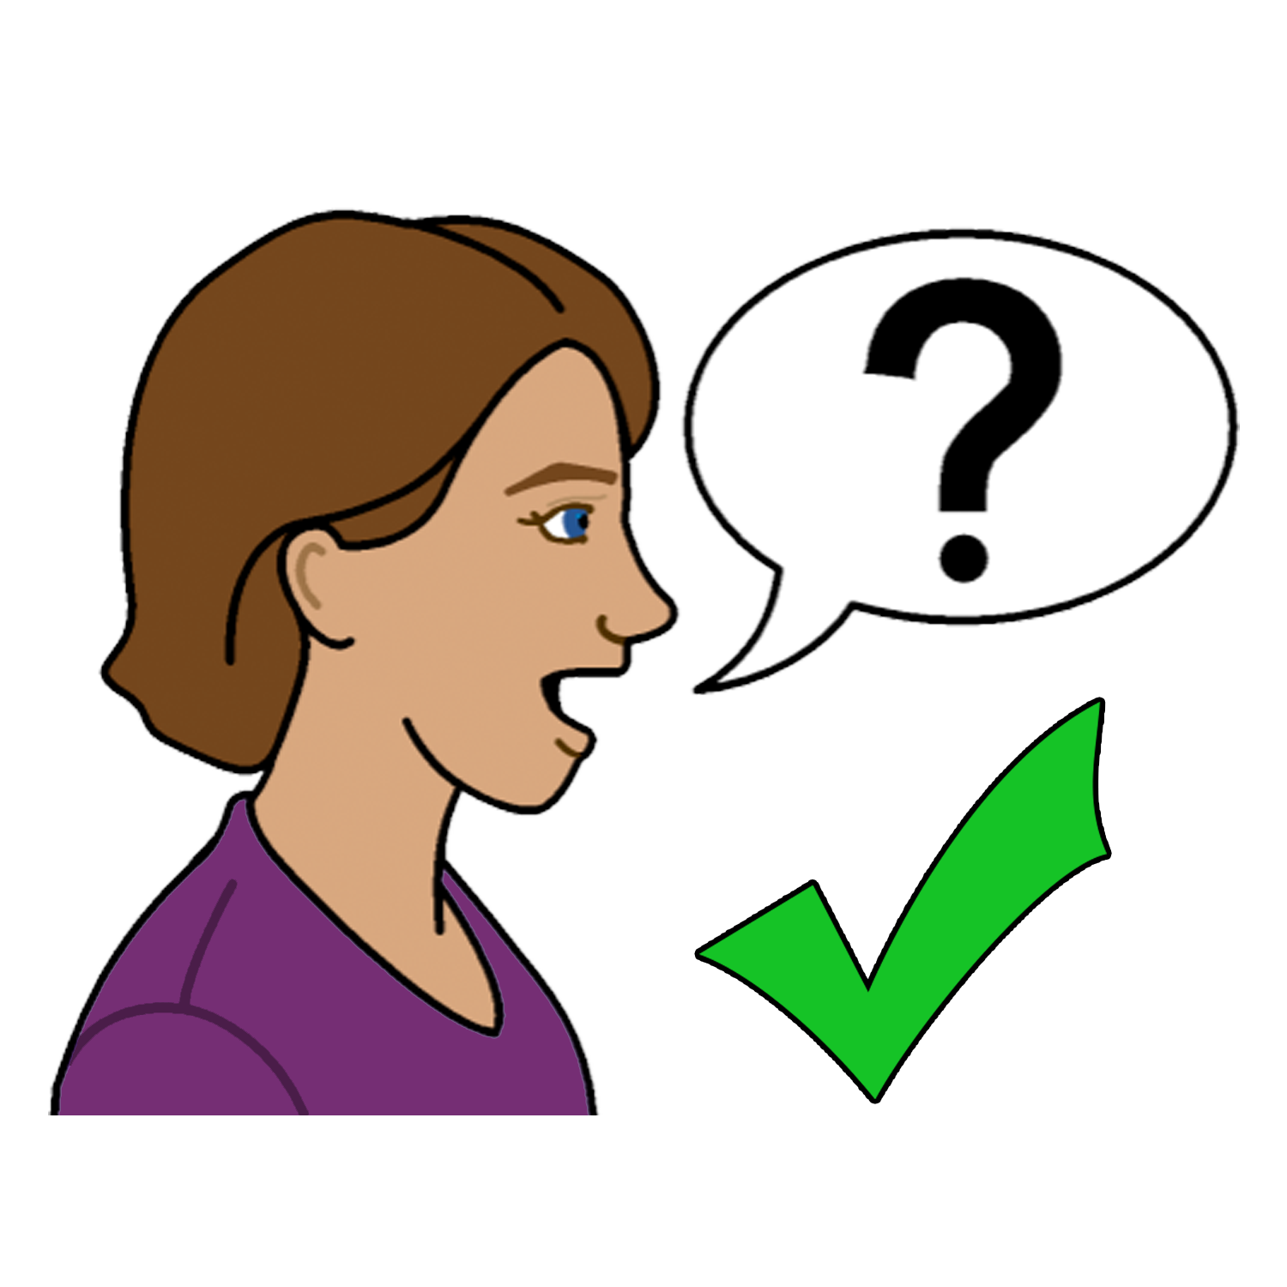
To find out more
You can talk to

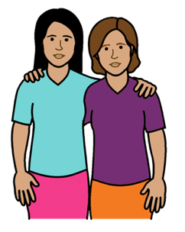
- a friend
- a family member

- a doctor

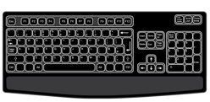
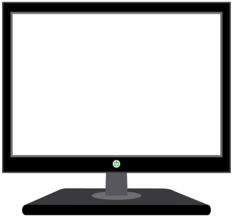
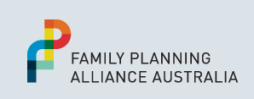
- your local Family Planning service.
Go to www.familyplanningallianceaustralia.org.au/services

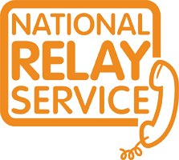
You can use the National Relay service
when you call a service
call 1800 555 677
TTY 133 677

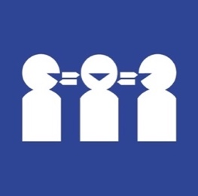
Need a translator
Call 131 450

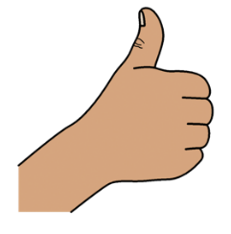
Thank you
Who wrote this book?
Women with Disabilities Australia wrote this book in 2019-2020.
This book is for general education and information only.

Copyright
© Copyright
Women with Disabilities Australia (WWDA) Inc. 2020.

All intellectual property rights, including copyright and patents, in this book is owned and licensed by Women with Disabilities Australia Inc.

Thank you for the money to write this book.
The National Disability Insurance Scheme gave Women with Disabilities Australia some money to help build this website.

The images used in this fact sheet
Easy on the I Images © 2019 Leeds and York Partnership NHS Foundation Trust. Used with permission. www.easyonthei.nhs.uk
The Picture Communication Symbols © 2019 by Mayer Johnson LLC a Tobii Dynavox company. Used with permission. www.tobiidynavox.com

Logos. Used with permission.

