Women with
Disabilities Australia
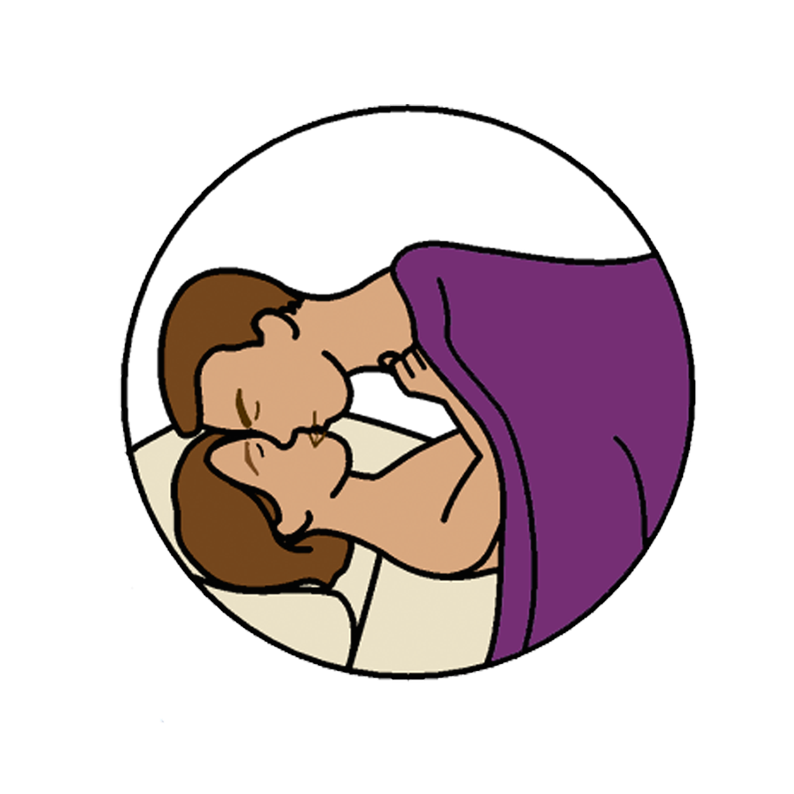
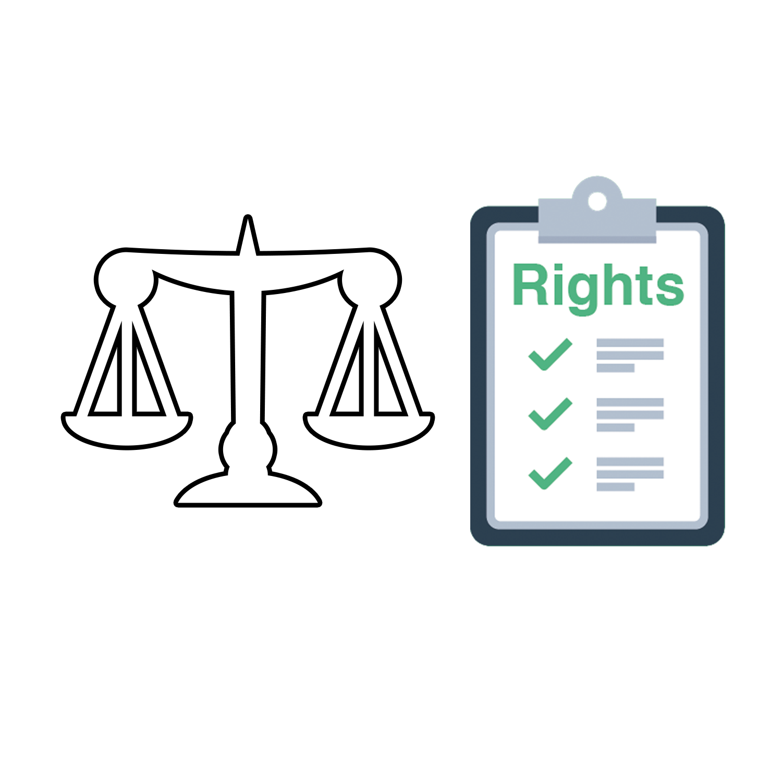

Sex and Laws

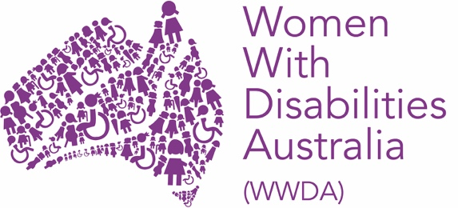

This book is about sex and the law.

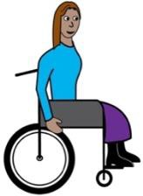

We wrote this book for women and girls with disability.

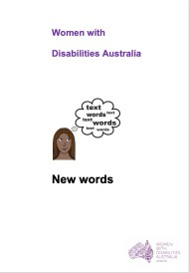

Read more about disability in our book New Words.

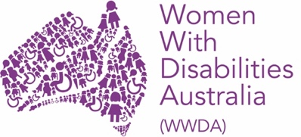
We are Women with Disabilities Australia.

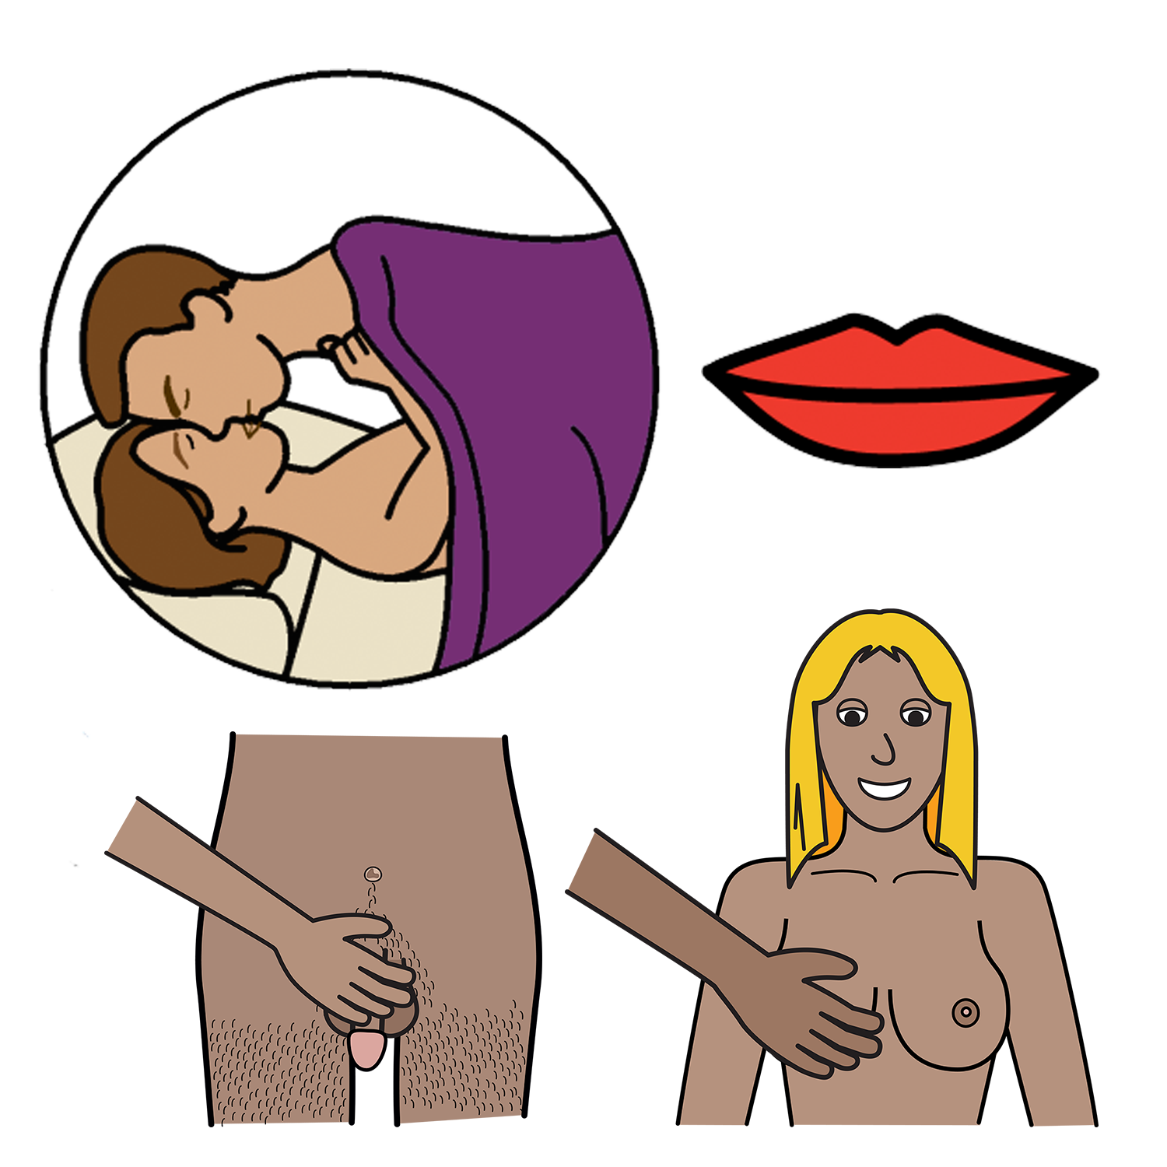
What is sex?
There are lots of different ways to have sex.

Sex can be:

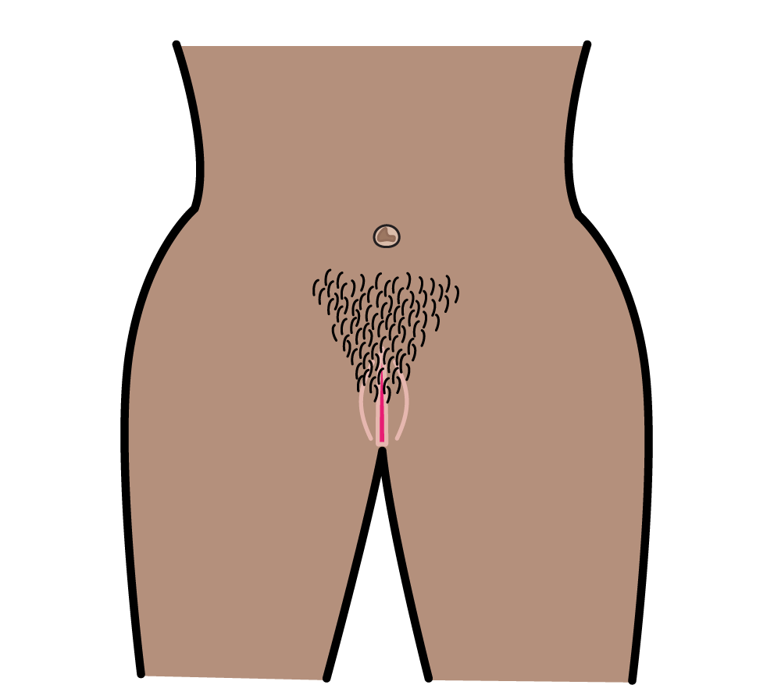
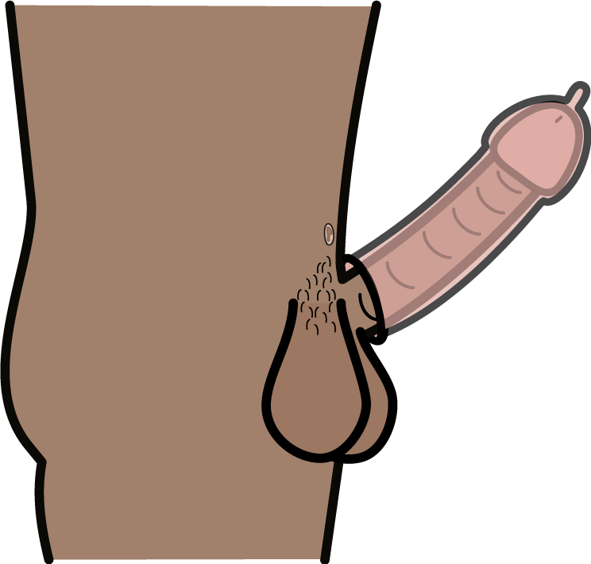

- a penis in a vagina

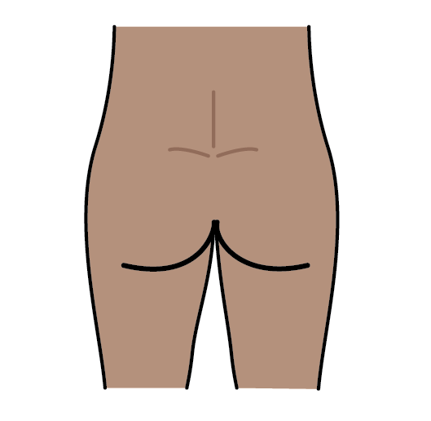

- a penis in a bottom

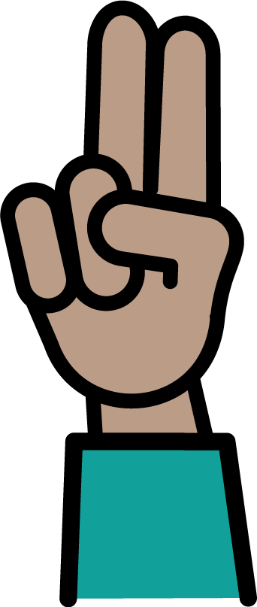
- fingers in a vagina

Sex can also be other things.

Like:

- a penis in a mouth
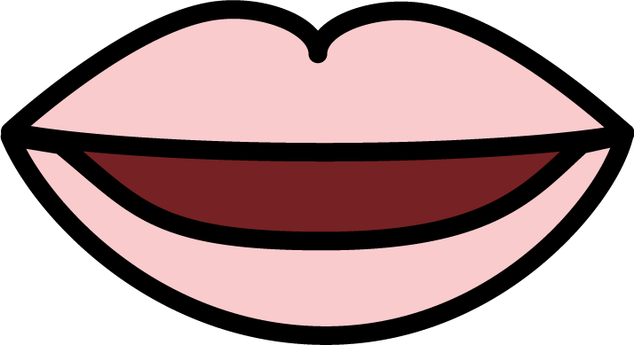

- a mouth on a vagina

Sex is not:

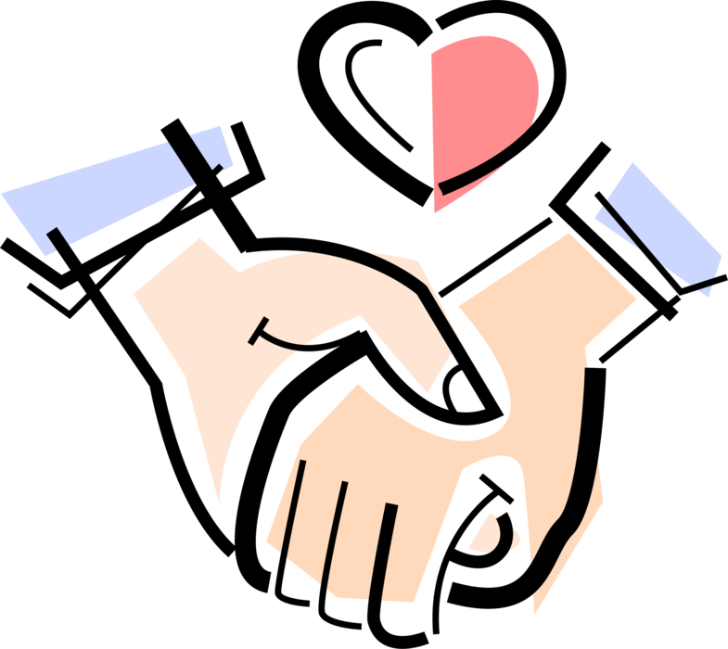

- when you hold hands



- when you hug

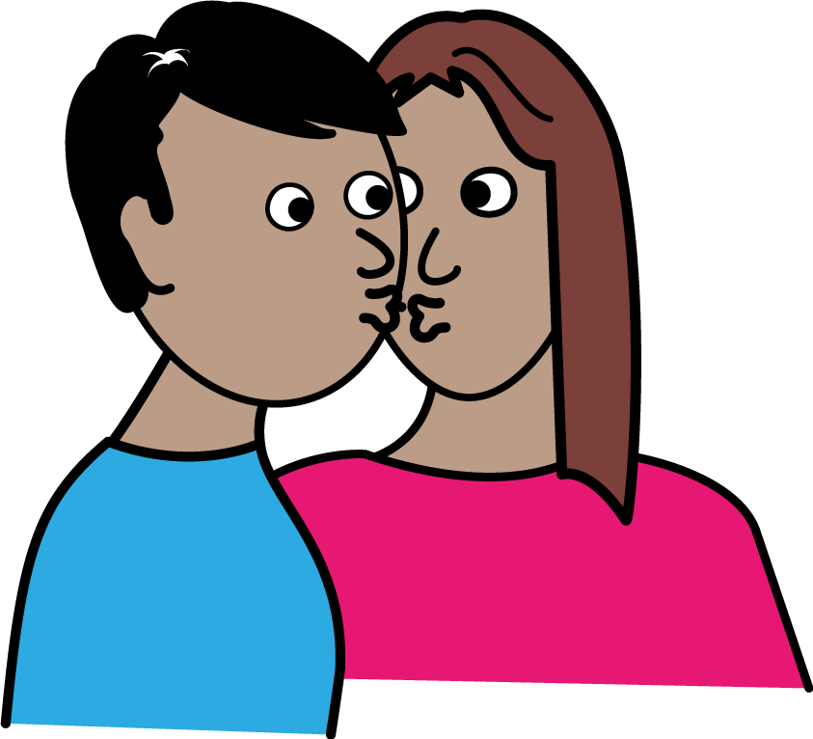

- when you kiss.

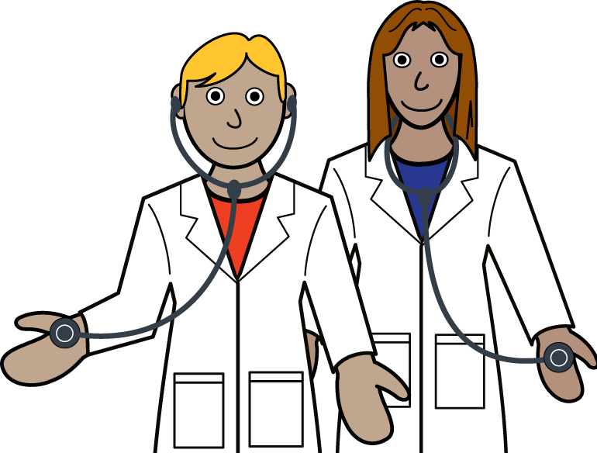
Sex is also not a test or check at the doctors.

Like:

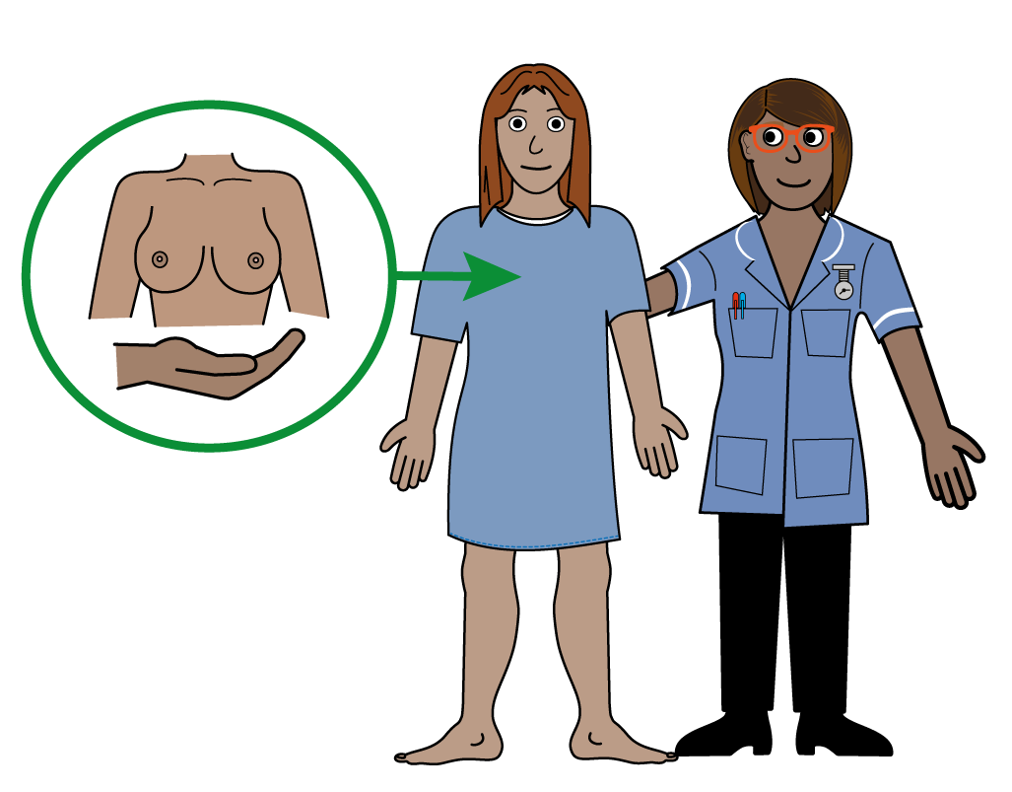

- a check of your breasts

or

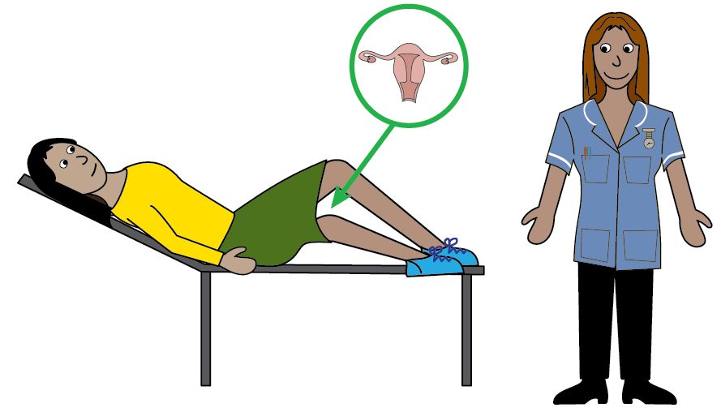

- a cervical screen test.

Sex and the Law
There are laws about sex.

They help you to:
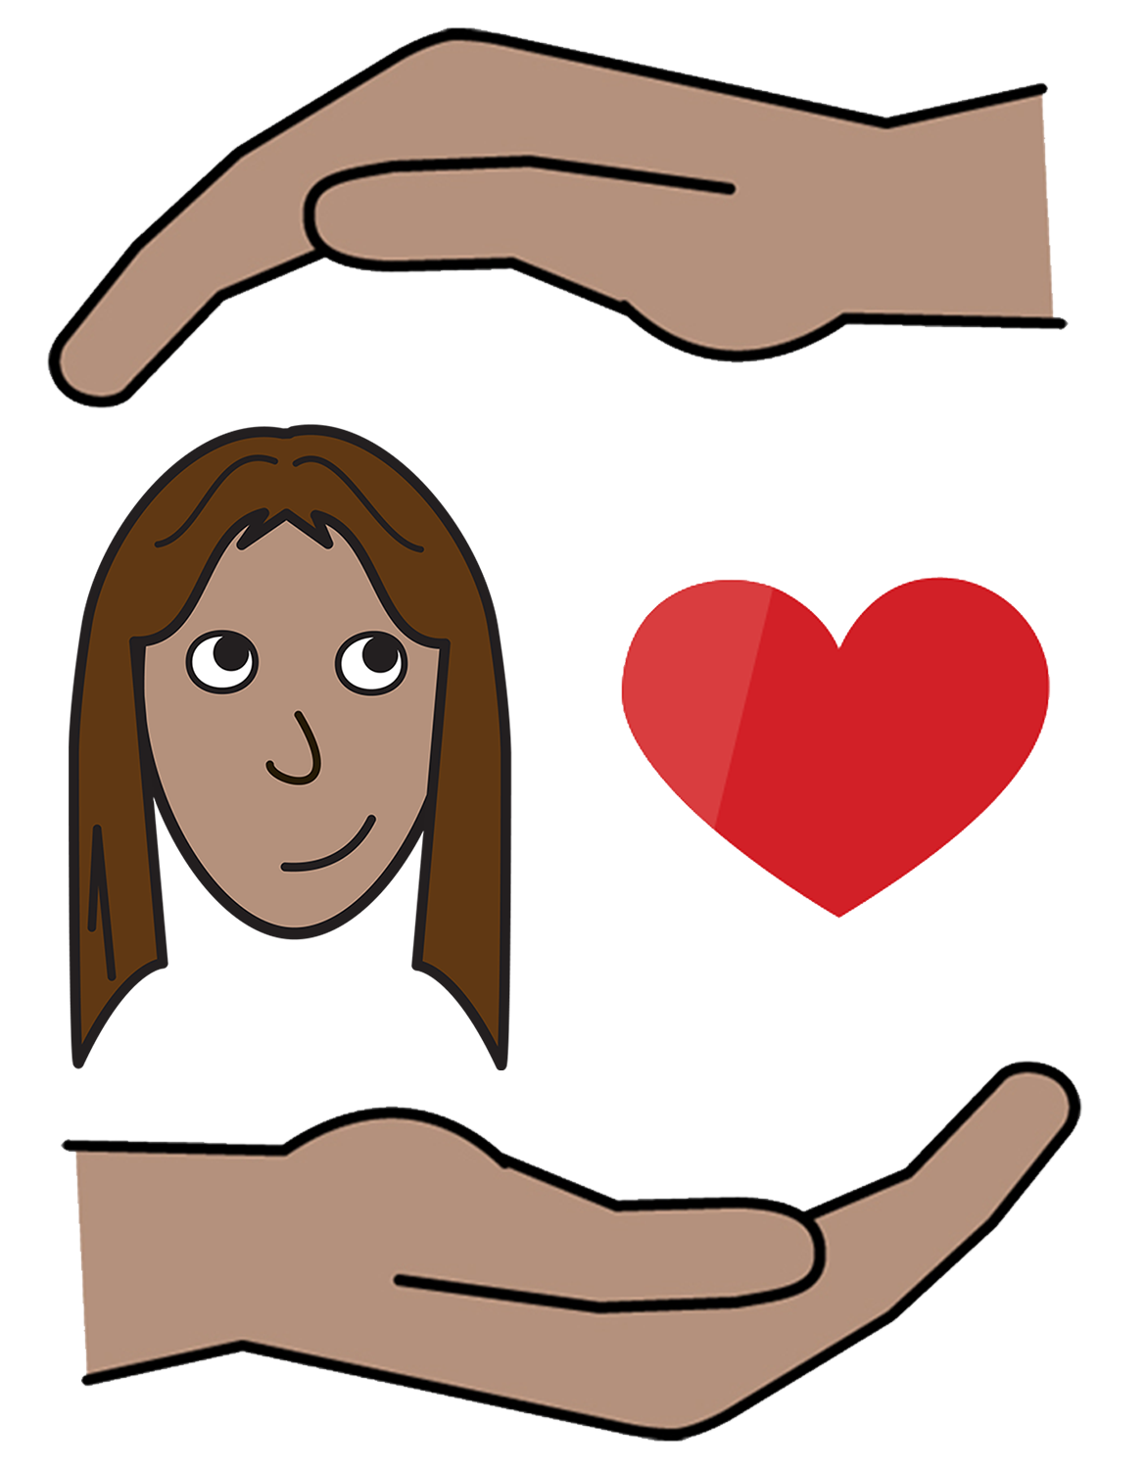

- stay safe

and

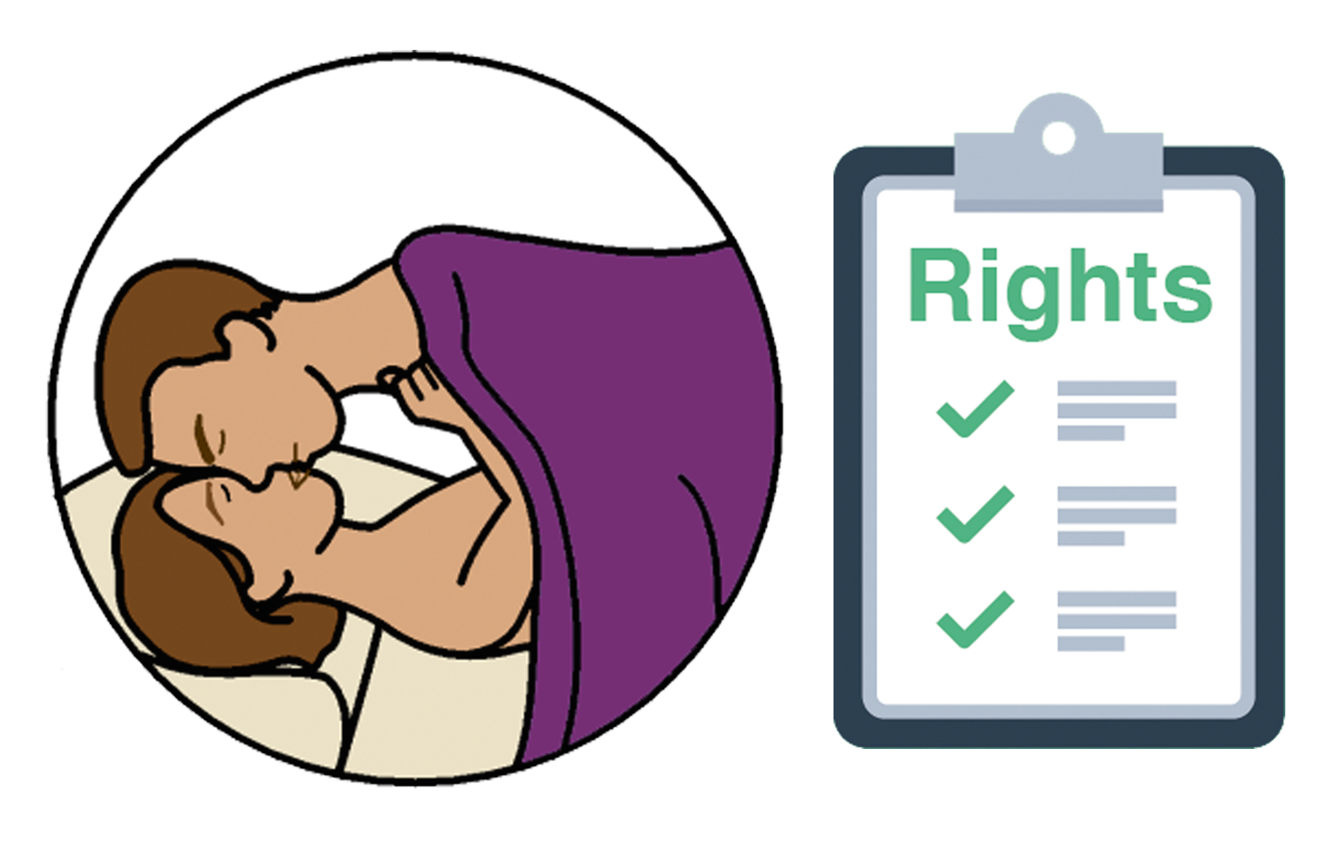

- know your rights about sex

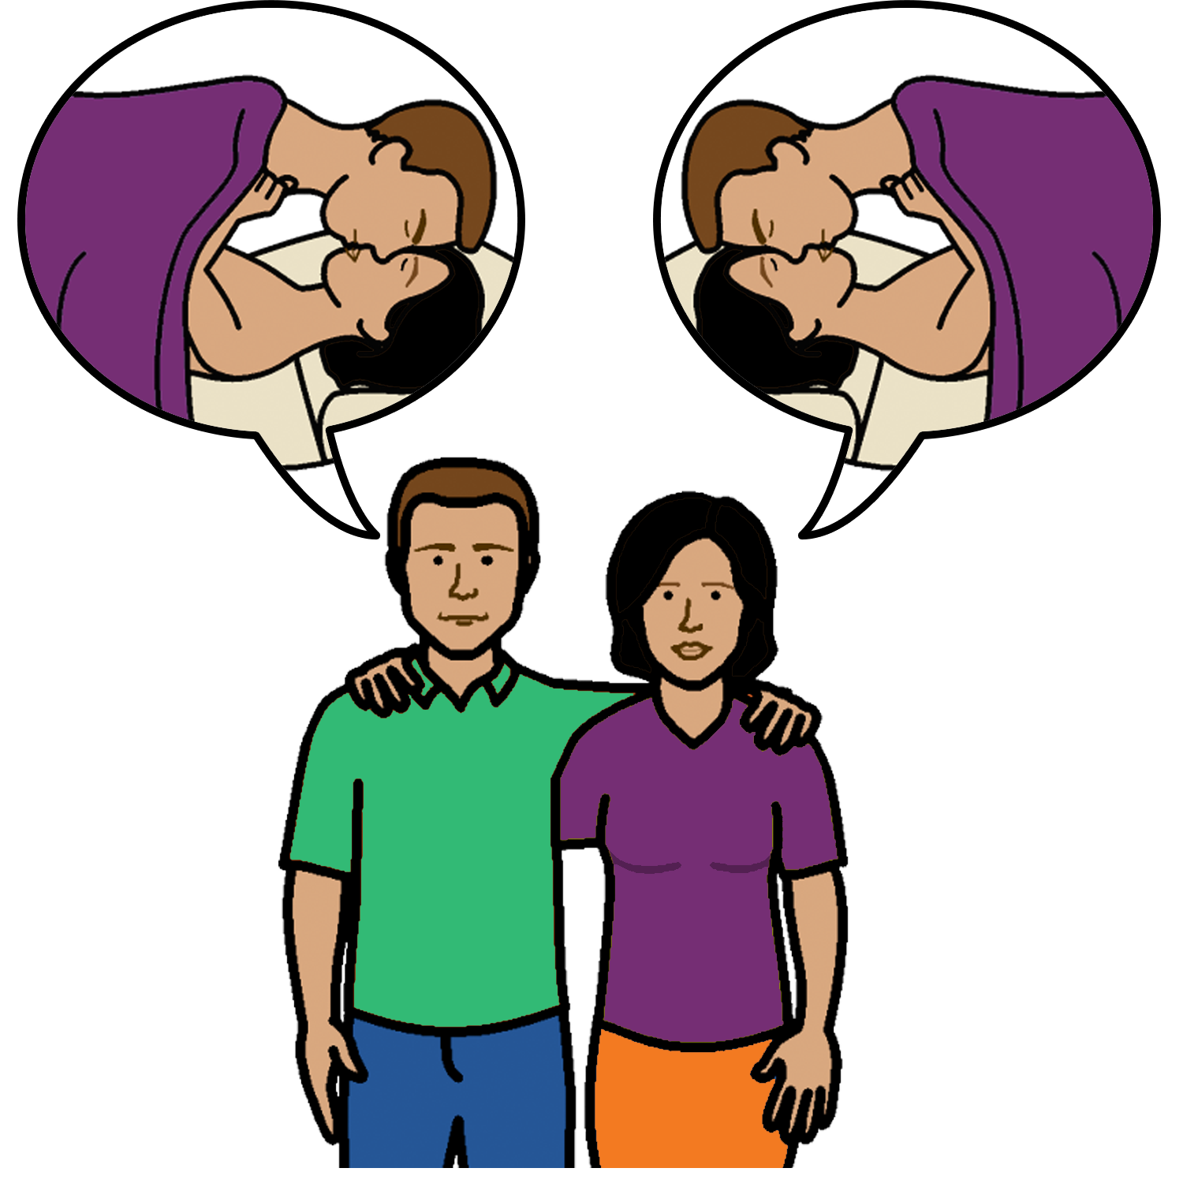

This is called consent.

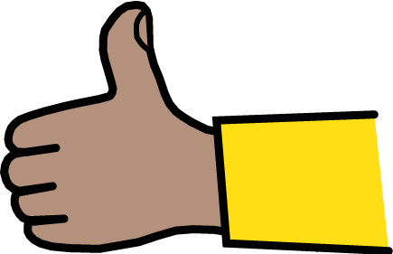
Consent
Before you have sex with someone you say:

- yes

or



- no.

When you say yes this is called consent.
It means you agree to have sex
- at that time
- with that person.


Remember

The law is the same when you are:
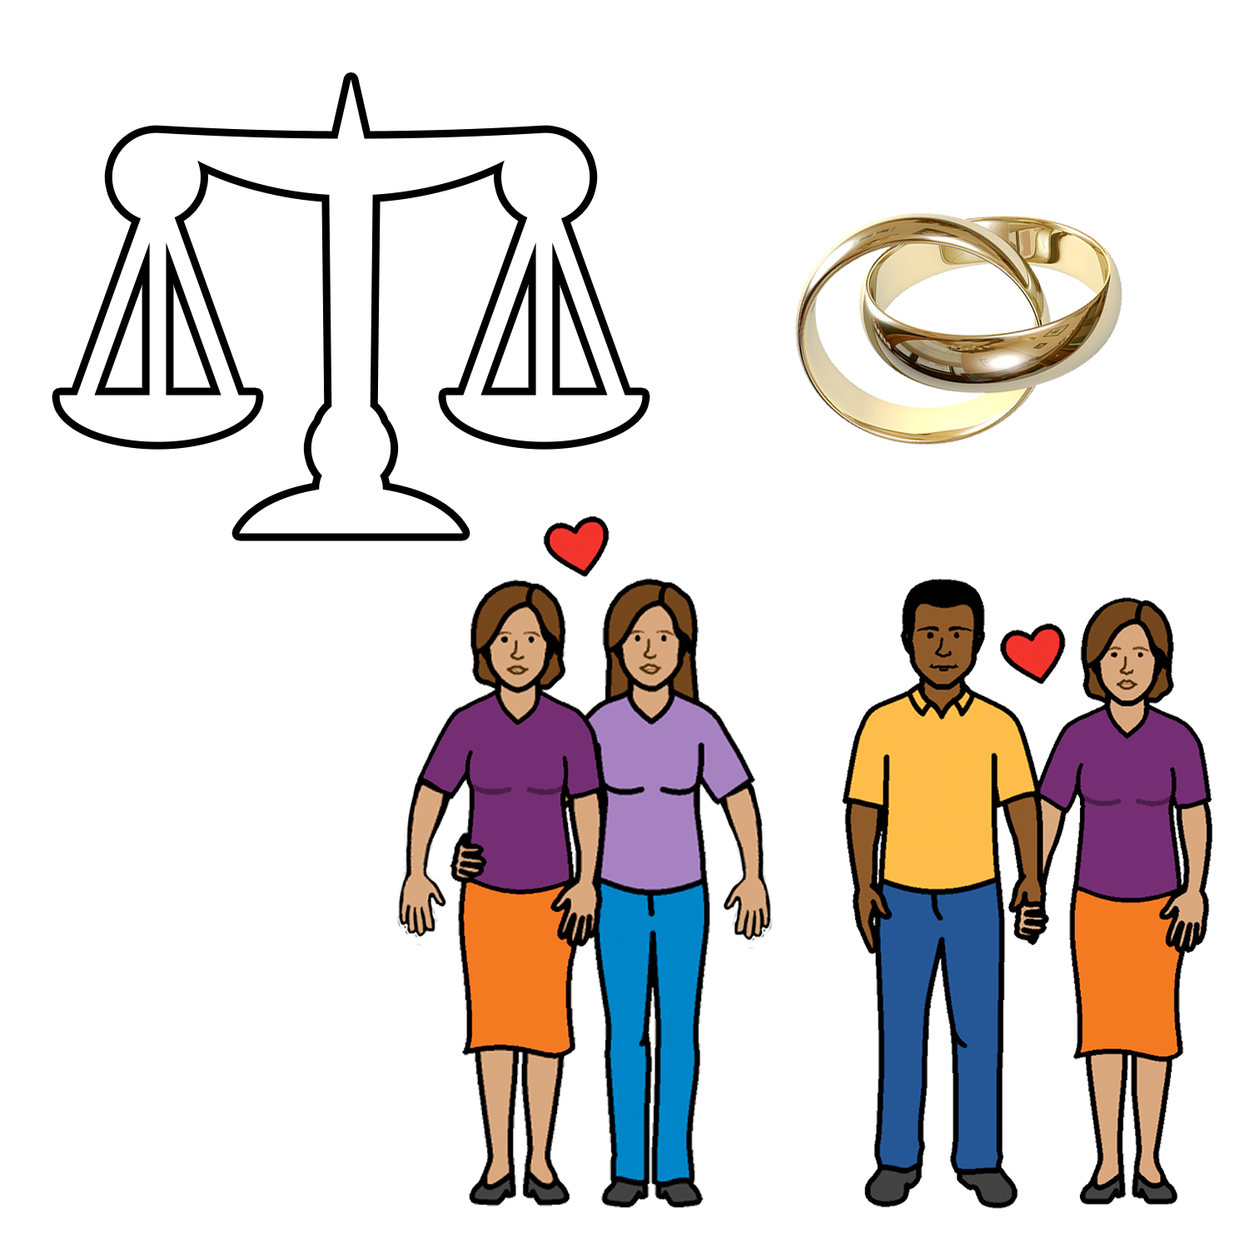
- married

or

- the person is your
- boyfriend
- girlfriend

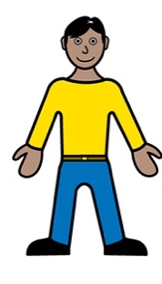
or

- you have just met the person.

You must give consent every time you have sex.
You must get consent every time you have sex.

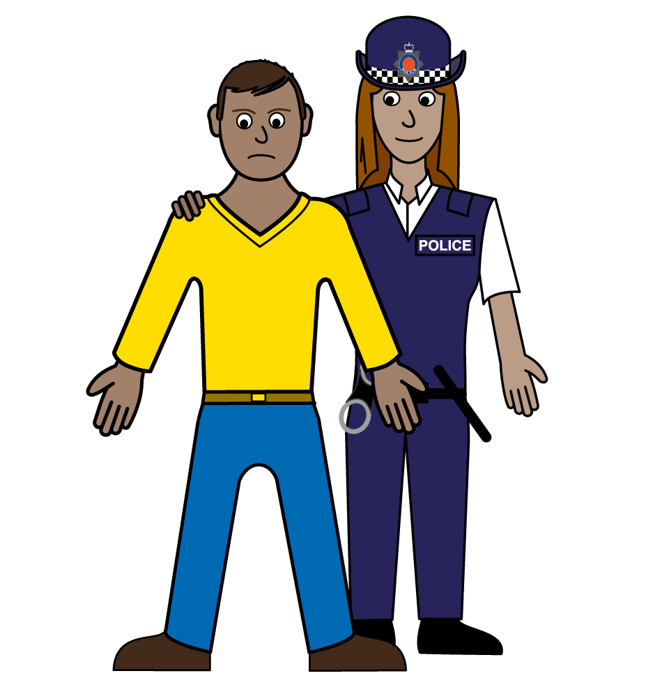

The other person has broken the law:

- when you do not agree

but

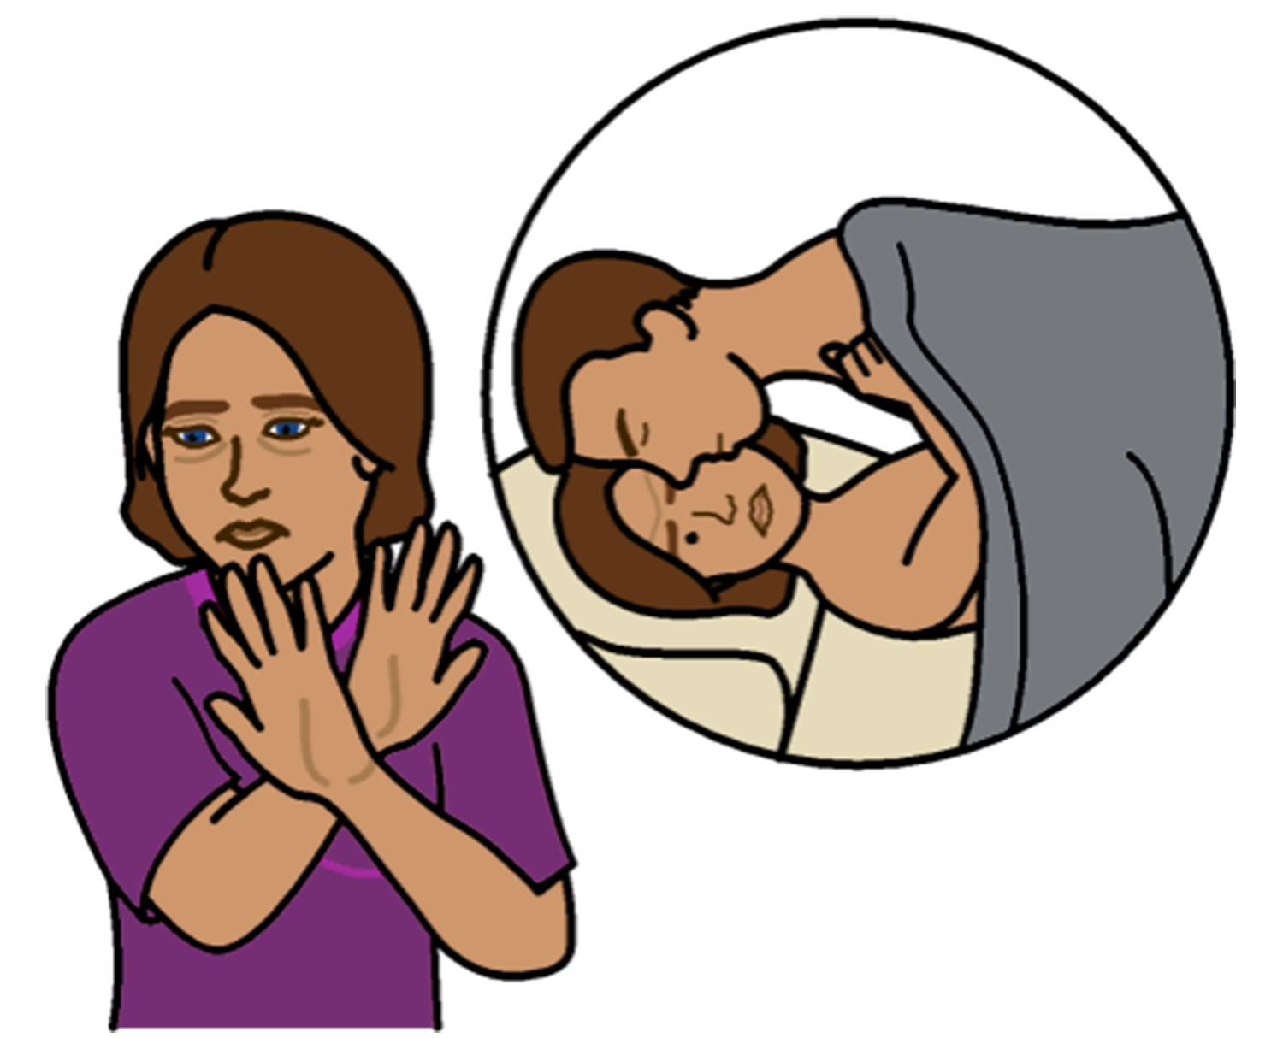

- they still make you have sex.

You cannot give consent to sex when:

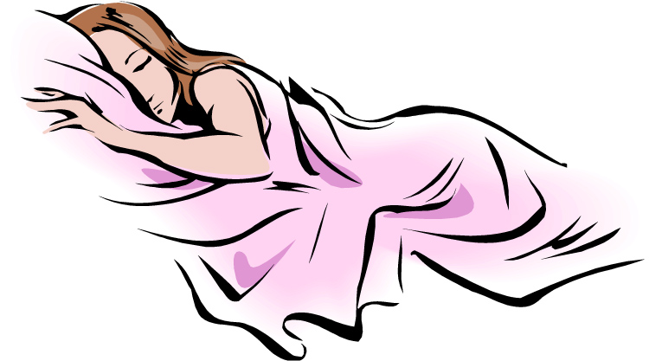

- you are asleep

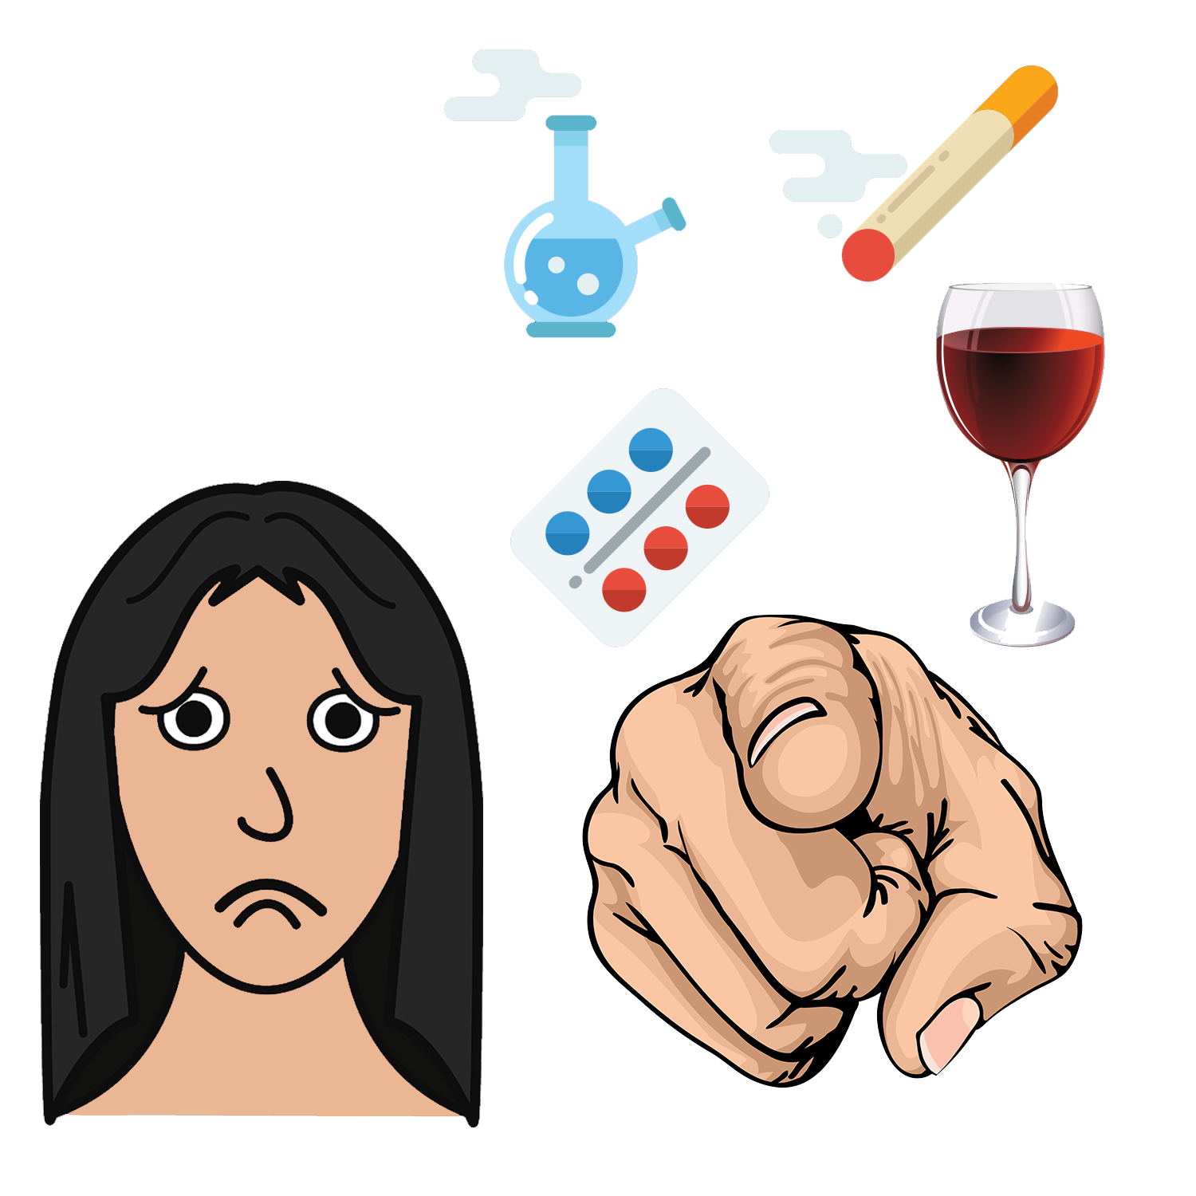

- you have had too much
- alcohol
- drugs

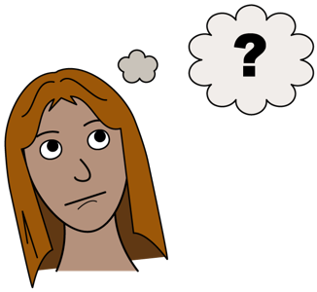

- you do not understand.

You cannot have sex with some people.
It is against the law.
Like:

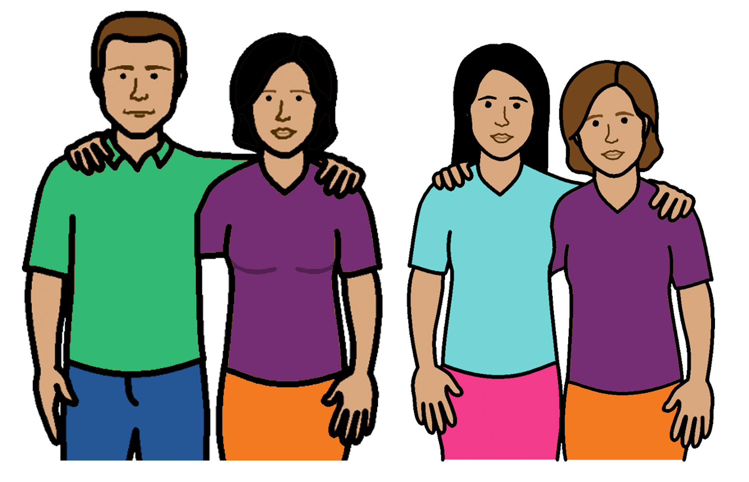
- no sex with someone in your family.
This is people like your:
- parent
- brother
- sister
- uncle
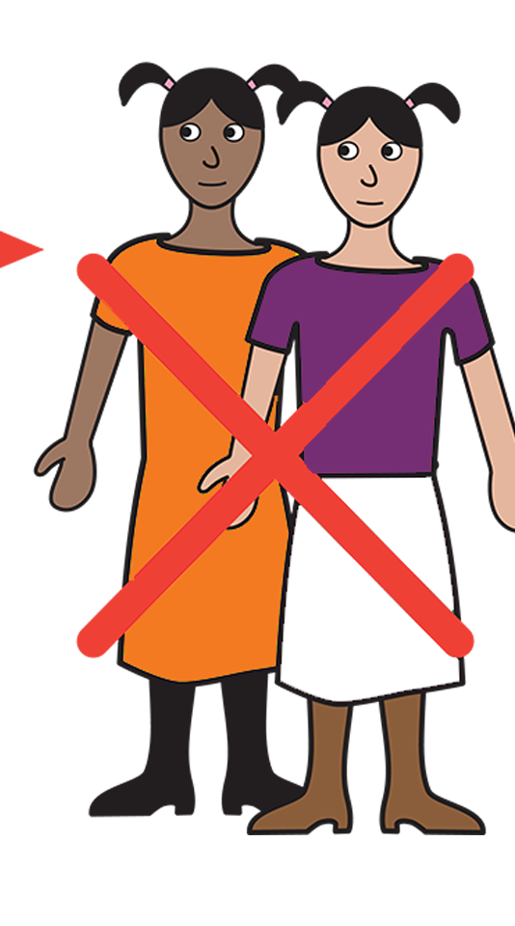

- no sex with someone under 16 years old

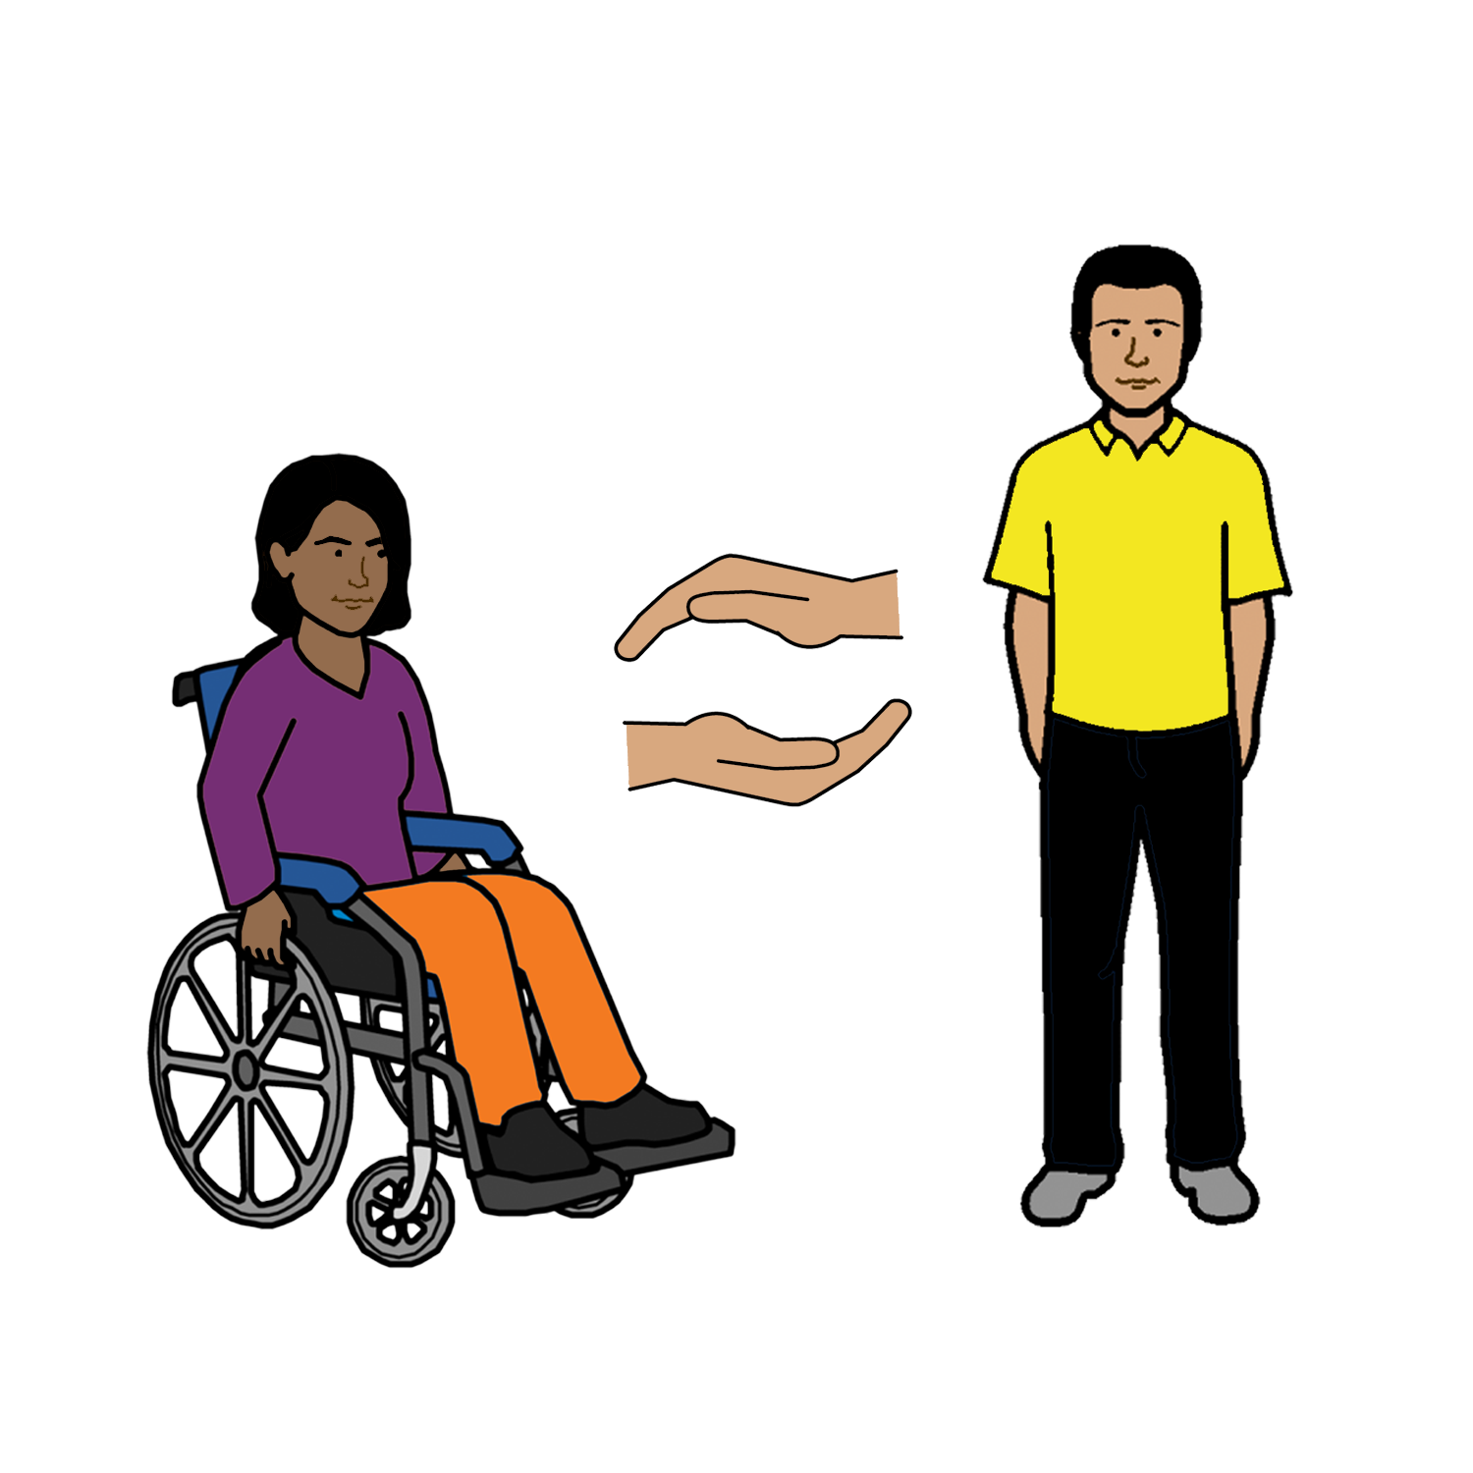
- no sex with someone who helps you. Like:
- your teacher
- your support worker
- your doctor.

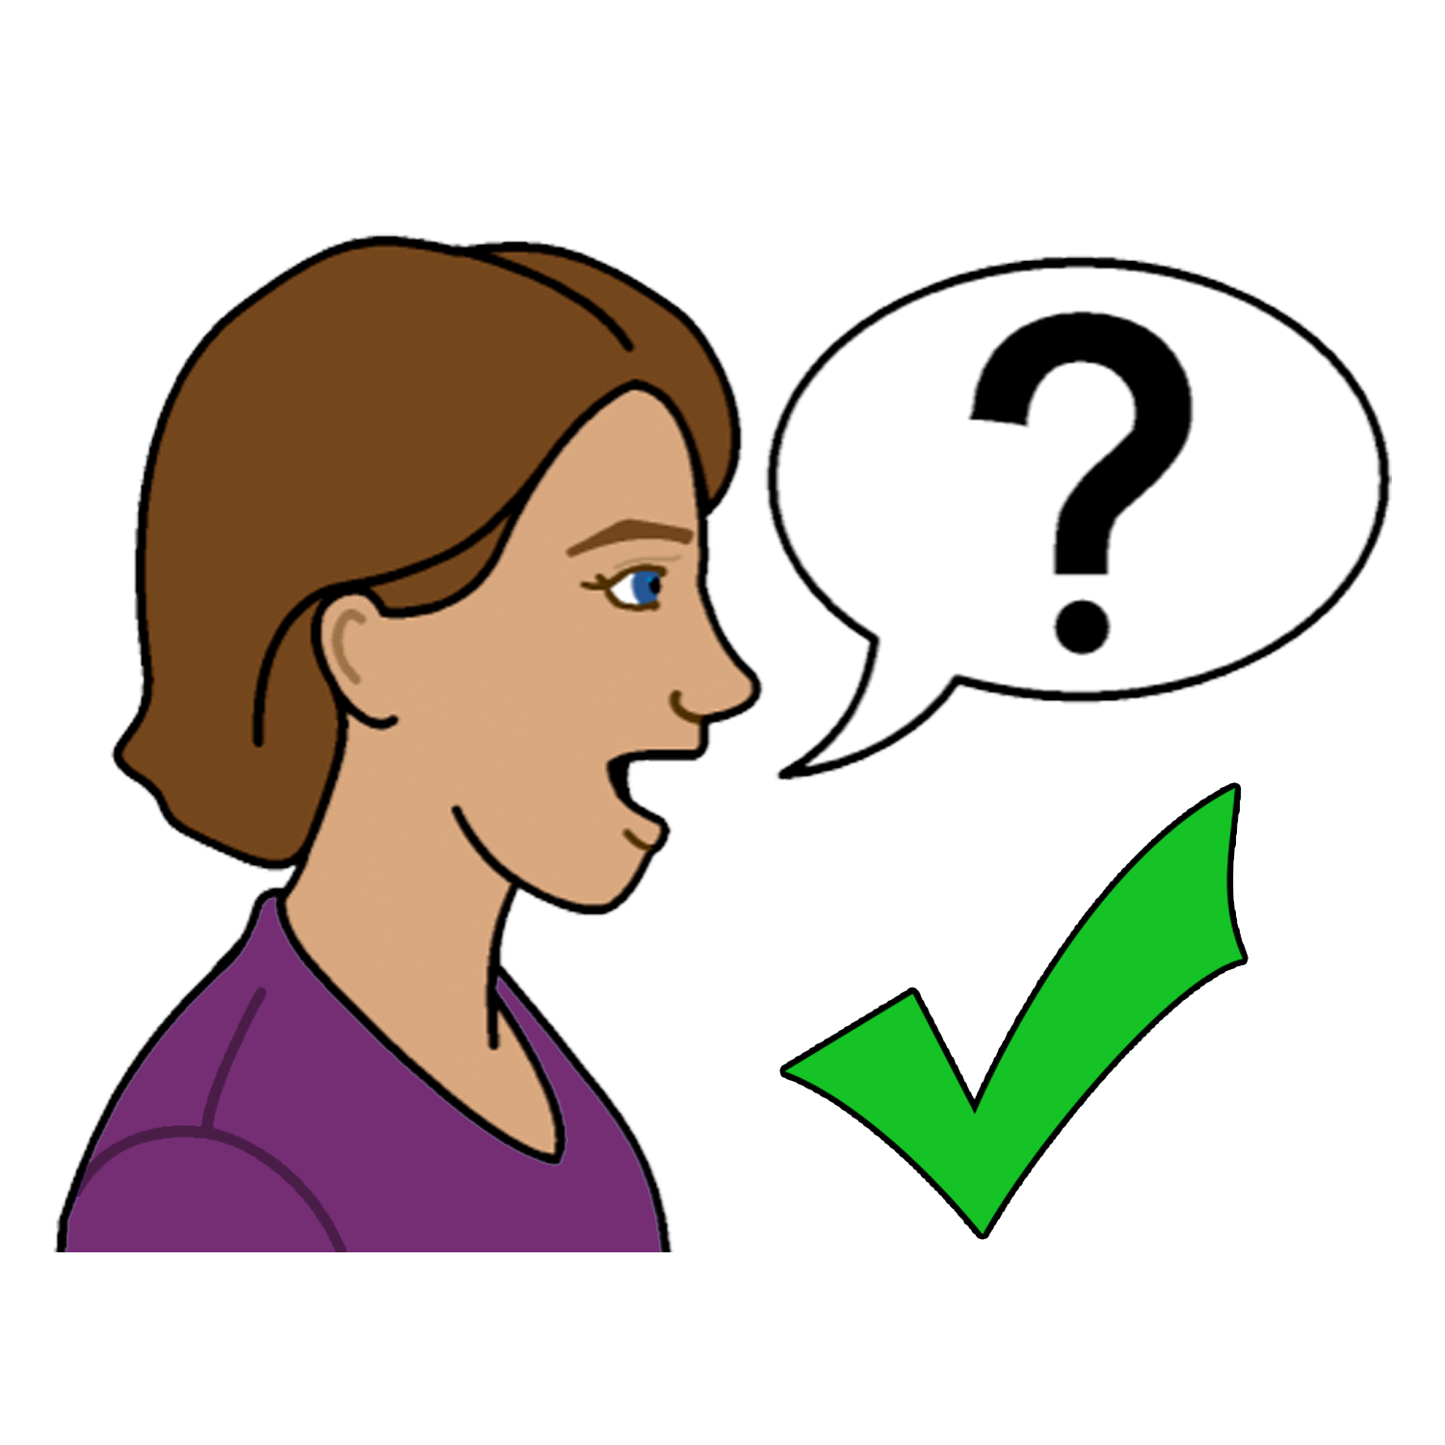
To find out more
Talk to someone you trust.
Like:

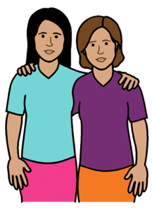

- a friend
- a family member

- a support worker

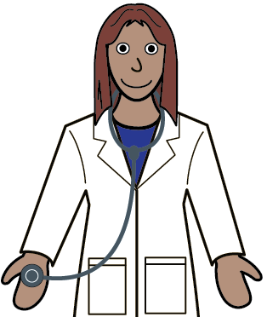

- your doctor.

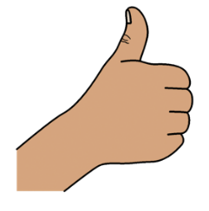
Thank you
Who wrote this book?
Women with Disabilities Australia wrote this book in 2019-2020.
This book is for general education and information only.

Copyright
© Copyright
Women with Disabilities Australia (WWDA) Inc. 2020.

All intellectual property rights, including copyright and patents, in this book is owned and licensed by Women with Disabilities Australia Inc.

Thank you for the money to write this book.
The National Disability Insurance Scheme gave Women with Disabilities Australia some money to help build this website.

The images used in this book
Easy on the I Images © 2019 Leeds and York Partnership NHS Foundation Trust. Used with permission. www.easyonthei.nhs.uk
The Picture Communication Symbols © 2019 by Mayer Johnson LLC a Tobii Dynavox company. Used with permission. www.tobiidynavox.com

Logos. Used with permission.

