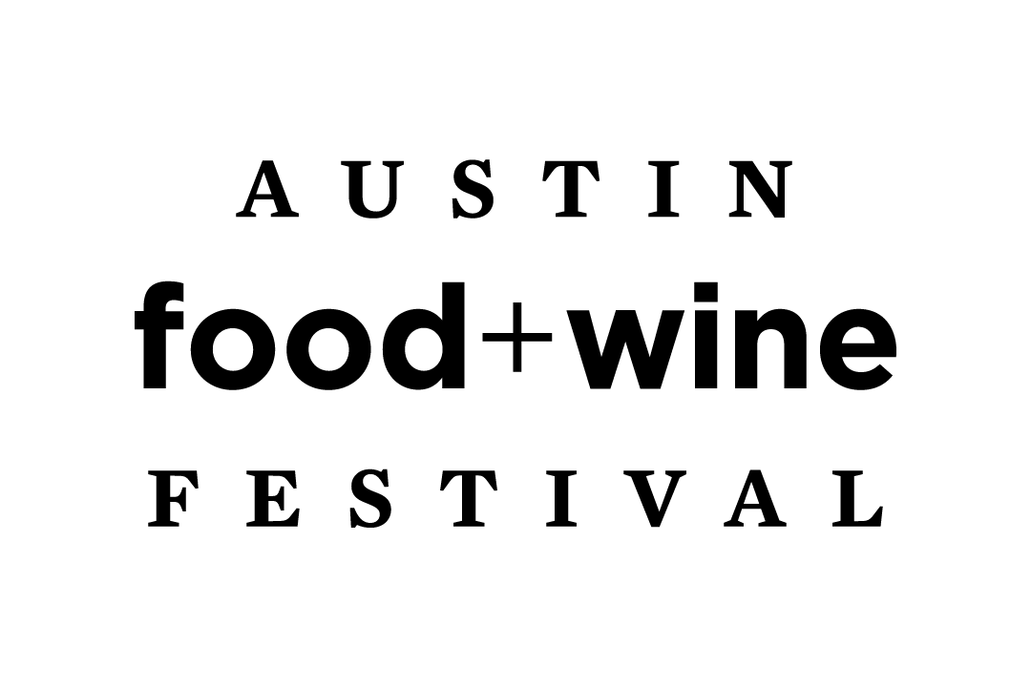

For Immediate Release Contact: Baltz & Company

Sarah Abell, 917.584.8567

sabell@baltzco.com

Austin Food + Wine Festival Returns November 5-7, 2021
Tenth Annual Festival Announces Schedule & Programming

Austin, TX (September 1, 2021) – Tickets are on sale now for the tenth annual Austin Food + Wine, November 5-7, 2021; www.austinfoodandwinefestival.com/tickets. Presented by FOOD & WINE Magazine and C3 Presents, Austin Food + Wine Festival is proud to be the benefactor of the Austin Food & Wine Alliance, a non-profit dedicated to fostering awareness and innovation in the Central Texas food and wine community through grants, educational programming and events. To date, Austin Food + Wine Festival has contributed over $1.1 million to the Alliance.

The tenth annual Festival will feature chefs, restaurants and wine & spirits experts over three days at Auditorium Shores and the newly refurbished Republic Square Park. Festival highlights include the return of Friday night’s Grillin’ and Chillin’ hands-on, interactive dinner party hosted by chef Tim Love; fan favorite Rock Your Taco competition on Saturday night featuring several first-time competitors and James Beard Foundation Award nominees and winners; engaging cooking demonstrations + conversations; pitmasters and chefs cooking over interactive Fire Pits; samples of signature dishes from local chefs and restaurants; dynamic wine, beer & cocktail tastings; live music; book signings; and much more.

“The Austin Food + Wine Festival has always been such an incredibly fun and delicious experience,” says Uchi chef/owner Tyson Cole. “We are thrilled to be back and ready to Rock your Taco again!”

Grillin’ and Chillin’, Tim Love’s ultimate hands-on grilling dinner party hosted at Auditorium Shores, kicks off the Festival on Friday, November 5. This interactive party offers All-In ticket holders the opportunity to sharpen their skills as they join chef Love for a fun and informative evening of hands-on grilling, drinks and dinner, all underneath the Austin skyline. Grillin’ and Chillin’ attendees will share a charcoal grill with a partner and prepare their own dinner as chef Love guides them through the menu while offering tips for how to become a grilling expert. Grillin' and Chillin' is exclusively included with the All-In ticket and will be the only time that the hands-on grilling demo will be offered throughout the weekend.

On Saturday, November 6 and Sunday, November 7, the Festival grounds will come alive with cooking demonstrations, book signings and an interactive area where chefs and pitmasters will cook over live Fire Pits and offer tastes to attendees throughout the weekend. The Fire Pits will showcase live fire cooking expertise from John Bates (InterStellar BBQ); Sonya Coté (Hillside Farmacy, Store House Market + Eatery); Lance Kirkpatrick (Stiles Switch BBQ); Tom Micklethwait & Ren Garcia (Micklethwait Craft Meats); Marco Oglesby (The Switch); and more pitmasters and chefs to be announced.

Showcasing a dynamic roster of chefs and restaurants throughout the weekend, attendees can sample signature dishes from some of Austin’s most beloved spots, including: Christopher Andrews (TLC); Jeff Balfour (Southerleigh Fine Food & Brewery); Daniel Brooks (Licha’s Cantina); Jeff Brown (Old Thousand); Jo Chan (Eberly); Krystal Craig & Ian Thurwachter (Intero); Nick Ervan (Wax Myrtle); Jacob Euler (Le Vacher); Reed Faitak (Austin Daily Press); James Flowers (1417); Rachelle Fox (Wicky's Walkup); John Gocong (Salty Cargo); Mark Grimes (CreekHouse); Wade Guice (Juliet Italian Kitchen); Victor Ibarra (Andiamo); CJ Jacobson (Aba); Andrea Juarez (Walton's Fancy & Staple); Andy Knudson (Tillies); Geronimo Lopez (BOTIKA); Jason McVearry (Poke-Poke); Margarita & Nestor Mendez (Pueblo Viejo); Josh Neises (Lonesome Dove Austin); Daniel Olivella (Barlata Tapas Bar); Matthew Perez (The Beer Plant); Chris Rios (The Vegan Nom); Ryan Samson (Vespaio & Enoteca); Jam Sanitchat (Thai Fresh); Carmen Valera (Tamale House East); Ling Wu (Lin Asian Bar + Dim Sum) and more chefs and restaurants to be announced.

Festival attendees keen on learning from the pros can listen in as a host of chefs and authors, including Dawn Burrell (Late August, Houston); Helene Henderson (Malibu Farm); Fermín Núñez (Suerte); Yoshi Okai (Otoko); and Jam Sanitchat share their tricks, tips and favorite recipes during Cooking Demos and conversations. A roster of sommeliers, wine, beer & spirits experts to be announced will help round out the Austin Food + Wine Festival line-up.

Rock Your Taco, Saturday evening’s signature tasting event, returns to a newly renovated Republic Square Park. Chefs will square off against one another to create the ultimate taco, as deemed by a People’s Choice award. Rock Your Taco competitors include: Tatsu Aikawa (Ramen Tatsu-Ya); Nicola Blaque (Mi Roti, The Jerk Shack, San Antonio); Dawn Burrell; Tyson Cole (Uchi); Diego Galicia & Rico Torres (Mixtli, San Antonio); Sarah Heard & Nathan Lemley (Foreign & Domestic); Helene Henderson; LeAnn Mueller (la Barbecue); Ryan Pera (Eight Row Flint, Houston); Jam Sanitchat; Charles Schlienger (Sway); and more chefs and restaurants to be announced.

Additional programming announcements will be made over the course of the fall; please visit www.austinfoodandwinefestival.com for more information and updates.

Detailed health and entry policies will be released closer to the event. Please visit www.vaccinefinder.org for questions about the COVID-19 vaccines or resources to find a vaccination location.

Tickets for the 2021 Austin Food + Wine Festival go on sale Wednesday, September 1, 2021, at 10:00 a.m. CT at www.austinfoodandwinefestival.com/tickets.

All-In ($625/per person)
The All-In ticket includes Saturday and Sunday Festival access; interactive cooking demos & book signings; hands-on beer, wine and cocktail tasting sessions; wood-fired culinary creations from the Fire Pits; tastes from Austin’s best chefs & restaurants; Friday night’s Grillin’ and Chillin’ with Tim Love; Saturday night’s signature Rock Your Taco competition; and more.

Weekender ($250/per person)
The Weekender ticket includes Saturday and Sunday Festival access; interactive cooking demos & book signings; hands-on beer, wine and cocktail tasting sessions; wood-fired culinary creations from the Fire Pits; tastes from Austin’s best chefs & restaurants; and more.

Tickets can be purchased at www.austinfoodandwinefestival.com/tickets. All attendees must be 21 years of age or older. For more information, please visit www.austinfoodandwinefestival.com, or follow us on Instagram @austinfoodwine, Twitter @austinfoodwine and Facebook.com/austinfoodwine.

For press credentials, please find the online application here: https://www.austinfoodandwinefestival.com/contact

The Austin Food + Wine Festival is generously sponsored by Toyota, HEB, Republic National Distributing Company, Angry Orchard Hard Cider and FOOD & WINE.

About FOOD & WINE
For more than 40 years, from classic to cutting-edge, FOOD & WINE has defined the American epicurean experience. With the confidence of undisputed global authority among consumers and the culinary trade, we inspire and empower our wine and food obsessed community to discover, create, and devour the best in food, drink, travel, and home. For the latest in restaurant intel, cooking advice, wine picks, and travel, find us at: FoodandWine.com, @foodandwine across social, and on newsstands everywhere. FOOD & WINE is part of Meredith Corp.’s (NYSE: MDP: Meredith.com) portfolio of best-in-class brands.

