**This book belongs to**

…………………………………………………………………………………………

**This book is about my journey to secondary**

**school, who is involved, and what to expect.**

**My**

**to high school \***

**(a social story)**



Insert

a photo

of the

secondary

school

My transition from primary school to high school is a big deal!

Everyone tells me it’s ok to be nervous about the move to high school because most kids my age feel anxious about going also.

**The name of my high school is** ………………………...…………………………………

My school’s address is …………………………………………………..…...…………….

………….………………………………………..…………………

My high school’s telephone number is ……………………………………………….

My school’s email address is …………….………………………………………..



Many things will be unfamiliar, I will meet other new students and teachers,

new buildings and different subjects.

I won’t let this worry me, because other new students will be feeling the same

way.

When I arrive and learn what high school is really like, I know I won’t be

nervous anymore.

At high school I will be going to many different classrooms and buildings.

Most high schools are much bigger than primary schools, and it may take me

some time to find my way around the school grounds.

I will be given a map of the school grounds, it shows where all the different

rooms and buildings are located. My teacher will show me how to use my

school map to navigate my way around and become familiar with the

grounds.

If I ever get lost I can ask a teacher for help.

Being familiar with the school grounds will help me arrive on time to classes.

Here is a map of my high school:

Insert a map

of the

school

grounds



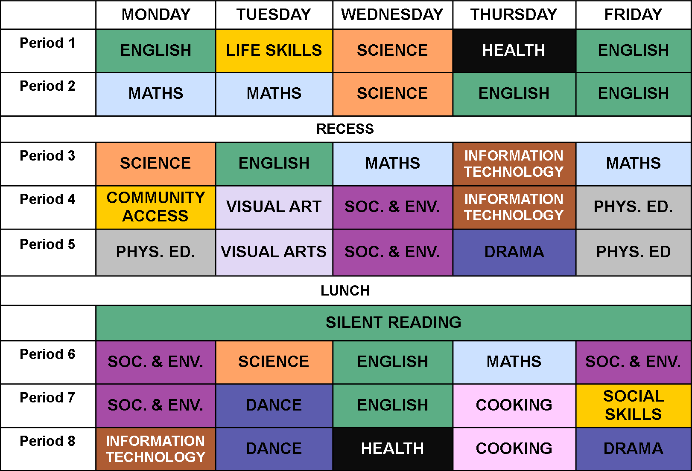

At high school I will have many subjects to take part in. I will

have a timetable to follow. It tells me which subjects I have for

that day, the time it begins, who my teacher is, and where I

need to go.

I can organise my timetable using different colours, by

matching each of my subjects with a colour using a *“Colour*

*Key”.*

I’duse a different coloured pen for each subject.

Here is an example of a colour coded timetable.



At high school, I will be expected to wear a uniform. I will have two

uniforms in the summertime; my every day school uniform and a sports

uniform.

I wear my sports uniform for my P.E. lessons, or on special days like sports

carnival or swimming carnivals.

On every other day, I wear the regular ‘everyday’ school uniform.

At high school, I will be expected to have my own equipment and carry it with

me in my bag to each class. I might need equipment such as pencils,

calculator, text books, rulers, aprons, gloves etc.

Here is my list of some items I will need for high school:

Insert photo

of the

sports

uniform

Insert photo

of the

school

uniform

|  |  |  |
| --- | --- | --- |
|  |  |  |
|  |  |  |
|  |  |  |
|  |  |  |
|  |  |  |





Insert photo of head

/ education

support teacher

**In high school, I will have a head teacher.**

The name of my head teacher is

………….……………………………………

He/she will be my head teacher, and in charge of making sure my journey at high school runs smoothly. I may see them often if they also teach me important subjects like life skills and community access.

**I will have a year coordinator.**

The name of my year coordinator is

………….……………………………………

The year coordinator looks after all students in a year level.

I can talk to the year coordinator about any worries or problems that I might be experiencing in the classroom or at school.

Insert

photo of

the year

coordinator

Insert

photo

of the principal

**I will have a new school principal.**

The name of the principal is

………….……………………………………

The principal is in charge of an entire school, they are considered the ‘big boss’ and works hard to make sure the entire school runs as planned.

Sometimes I will see the principal walking around the school grounds saying hello.

During a typical day at high school I may work with several different

education assistants. The education assistants will guide me and

support me with my work during some periods.

If there are things I do not understand, like when I may get lost, the

school rules, classroom work and the Education Assistants will help me.

Insert photo of education assistant

Insert photo of education assistant

Insert photo of education assistant

Insert photo of education assistant

Insert photo of education assistant

Insert photo of education assistant



This is ……………………………..…

they will be my ……...…………..…… teacher.

This is ……………………………..…

they will be my ……...……………… teacher.

This is ……………………………..…

they will be my ……...……………… teacher.

This is ……………………………..…

they will be my ……...……………… teacher.

**Insert**

**photo of**

**staff**

**member**

**Insert**

**photo of**

**staff**

**member**

**Insert**

**photo of**

**staff**

**member**

**Insert**

**photo of**

**staff**

**member**



You will have different teachers for different

subjects. After the first few weeks you will come

to know and remember what teacher teaches you

in each subject.

**Insert**

**photo of**

**staff**

**member**

This is ……………………………..…

they will be my ……...……………… teacher.

**Insert**

**photo of**

**staff**

**member**

This is ……………………………..…

they will be my ……...……………… teacher.

**Insert**

**photo of**

**staff**

**member**

**Insert**

**photo of**

**staff**

**member**

**Insert**

**photo of**

**staff**

**member**

This is ……………………………..…

they will be my ……...……………… teacher.

This is ……………………………..…

they will be my ……...……………… teacher.

This is ……………………………..…

they will be my ……...……………… teacher.



Insert

photo of the

front office



This is the front office.

This is the main classroom I

will be working in.

Insert

photo of

my classroom

Insert

photo of the

bus bay

This is the bus bay.

This is the canteen.

Insert

photo of

canteen

Insert

photo of the

student toilets



These are the toilets

I will be using.

This is the school library.

Insert

photo of

library

Insert

photo of the

oval

This is the school oval.

This is where I hang my school bag, or keep my books and equipment.

Insert

photo of

where I hang

my bag

Insert

photo of the

school gym



This is the school gym.

This is the staff room where the staff eat their lunch.

Only teachers and

education assistants can

enter that building.

Insert

photo of

library

Insert

photo

Insert

photo

Insert

photo



Insert

photo

Insert

photo

Insert

photo

**What if I have nothing to do during recess or lunch?**

• I could go to the library

• I could buy a snack and eat it in the canteen

• I could find my buddy

**What if I forget how to find my way to the classroom?**

• I use my map and try to find my way

• I can ask a passing teacher or education assistants

**What if I have difficulty ordering at the canteen?**

• Ask the teacher on duty to help me

• I could ask to go to lunch or recess early

• I could tell my teacher who will show me how to properly order food or drinks.

**What if I forget my lunch money?**

• I see my head teacher or education assistant and explain I have no money for lunch

• If I am lucky, the head teacher or education assistant may lend me some money to buy some lunch

• Sometimes my Mum may be informed with a phone call or a reminder note in my diary

**What if I forget to bring my homework to school?**

• I explain to the teacher why I do not have my homework with me

**\* Schools may insert secondary school or college depending on their local context**

**What if I am called a rude name or teased by another student?**

• I do my best to walk away and not say anything back

• I will explain what happened to my teacher or education assistant

• The teacher or education assistant will deal with the matter



**? ? ?**

**Finally, some questions answered:**