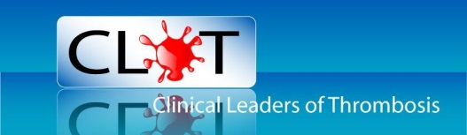
CLOT News Letter Autumn Winter 2014

CLOT Conference 2014

This year’s annual conference was held in Birmingham on Friday 10th October. The CLOT committee are always very happy to welcome all members of CLOT to the annual conference and this year was no exception noting the meeting to be very well attended as always.
Topics covered this year included the perspective of Anticoagulation in the primary care setting, management of patients presenting with active bleeding on Anticoagulation, including the non- vitamin k oral anticoagulants, and how to manage this in the emergency room setting. Lessons learnt from route cause analysis and pulmonary embolism and pulmonary hypertension. Two of our CLOT committee members also kindly stood in for a speaker who was unable to attend and gave talks on the future of anticoagulation and Community acquired VTE.
Instead of the advanced practice workshops that normally take place in the afternoon, this year, CLOT held a quiz to test the knowledge of all members on anything relating to Anticoagulation. Everyone appeared to demonstrate very good general knowledge in this area as well as having some fun in the process so congratulations to all those that took part.
CLOT would like to thank the delegates for attending and completing the evaluation forms. The forms assist CLOT in planning the annual conferences as well as help in ensuring CLOT is able to provide the on-going support its members require. CLOT also continues to be very proud to be able to offer considerable subsidised rates to members in order for them to attend.
CLOT would like to say a big thank you to all the speakers for sharing their expertise with the delegates. The presentations are available for members via the CLOT website in the library section.
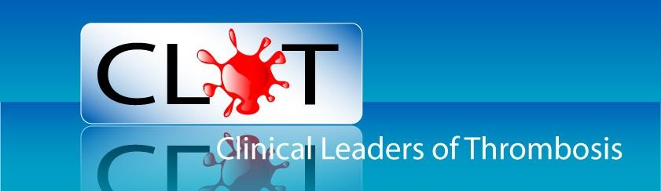

CLOT Committee News

Caroline Baglin stepped down at this year’s conference as Chairperson. The Committee welcome Betty Brough as the new Chairperson. Betty will continue in this role for the next two years. CLOT would like to take this opportunity to wish Betty all the best in her new position. The Committee would also like to thank Caroline for her valued time and dedication to CLOT while in post and wish her the very best for the future and hope to see her at the annual conference next year.

Dates for the Diary 2015

ISTH 2015

Next year’s ISTH Meeting will be held in Toronto, Canada on June 20th -25th 2015. CLOT encourages as many members as possible to attend if they have an opportunity to do so. Our very own Huw Rowswell attended ISTH in Amsterdam in 2013 where by he gave a presentation about risk assessment and lower limb immobilisation and a poster presentation looking at the incidence and mortality and morbidity around incidental VTE findings. He thoroughly enjoyed the experience expressing that he recommended anybody able to attend should try to do so as it is an inspiring and educational event.
The ISTH will be welcoming abstract submissions, either orally or a poster for consideration at the conference from the 1st December 2014. Closing date for abstract submission is 4th February 2015. For more information about the whole event go to www.isth.org

BSH 2015

The British Society for haematology will be holding their conference in Edinburgh, April 20th-22nd 2015. The society wish to encourage as many nurses as possible to attend and share their views and best practice in the specialist area of Anticoagulation and thrombosis, so if Toronto is a little too far too travel then perhaps consider this event instead. You can find out more information by visiting their web site at www.bshconferences.co.uk/edinburgh2015

World Thrombosis Day

This global event took place 13th October, Rudolf Virchow’s Birthday. It is set to be repeated annually to continue to maintain heightened awareness of all aspects of thrombosis to alert the general public and other health care professionals who are not fully aware of this massive subject. ISTH spearheaded the launch with the involvement of national and international Thrombosis organisations who arranged educational activities and stands. Click on our website to find out what members have been doing around the UK. CLOT would love to hear from anybody who was able to organise something on the day to bring attention to this very important issue, or perhaps anyone that may have attended an event. Perhaps you baked cakes or set up a stand in the corridor, whatever you may have done or attended, contact us at our website and share your experience. For more in-depth information and educational resources about World Thrombosis Day go to the ISTH website. CLOT website also has a link to all the information.

NICE Work Continues for CLOT and Its Members

All CLOT members will now be aware as an organisation we are often formally invited to relevant drug appraisals under development as a consultee. This means we as a group have the opportunity to provide NICE with a professional organisational submission giving our opinion with information we consider relevant to the appraisal. It comes as no surprise that we have attended several work shop’s in recent times focusing on the Non Vitamin-K Oral Anticoagulant’s (NOAC’s). CLOT cannot emphasise enough the importance of your opinion in these appraisals and fully encourages all members to submit their opinions via the CLOT website. As health care professionals working within the field of Anticoagulation and ultimately working with the NOACS that are now steadily beginning to flood the market, it is our responsibility to ensure we have a voice and that our opinions are heard. We as a group are very fortunate to be in a position where by our views and opinions matter, so we call upon all our members to ensure that they submit their opinion to make it count. CLOT would like to take this opportunity to thank all those members that have submitted opinions in previous appraisals.

The next single technology appraisal that NICE has approached CLOT for is Edoxaban Tosylate, for preventing stroke and systemic embolism in people with non-valvular atrial fibrillation. CLOT is invited to make a submission with information relevant to this appraisal. All members wishing to submit an opinion regarding the use Edoxaban Tosylate need to do this by 5pm 20th January 2015. Please send any comments to our Educational Secretary, helengray.clot@yahoo.co.uk

CLOT Conference 2015

Next year’s conference will be held at the Holiday Inn, Birmingham on the 16th October 2015. Look out for further details which will be available in due course on the CLOT website.

Sponsors
The committee would like to thank Bristol Myers Squibb Pharmaceuticals Ltd/ Pfizer Alliance, Hart Biologicals, Roche, Sullivan Cuff Software/ INR Star and Leo-Pharma who supported the conference with table top stands.

Many thanks to our Gold Sponsors Boehringer- Ingelheim and Bayer for their continued support of CLOT.
We would like to wish all our Members a
very Merry Christmas And a Happy New Year
from Betty, Lesley, Helen, Rebecca, Dawn, Huw
and Mandy

