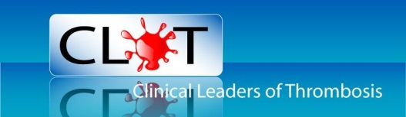
CLOT News Letter Spring/Summer 2015

CLOT Conference 2015

This year’s annual conference will once again be held in Birmingham on Friday 16th October at the very popular and easily accessible Holiday Inn.
As always CLOT aims to plan a both educational, interesting and motivational day of talks, with topics on this year’s agenda looking to include management of cancer associated Thrombosis, thrombolysis as an alternative solution, how to differentiate between the non-vitamin K oral anticoagulants ( NOAC’s) and communicate risks and benefits, mechanism of vitamin K antagonist’s and NOAC’s, bridging procedures for vitamin K antagonist’s and NOAC’s, VTE post CQUIN and a report from the successful applicants on attending ISTH conference in Canada.
As if we haven’t packed enough in to the day already we will also be including a slot titled “ask the experts.” This will give our delegates an opportunity to ask any questions they may have to a panel of experts in the field of anticoagulation and haemostasis. Cards will be available on all tables from the beginning of the conference. Write your question down on the card and our experts will respond, sharing their knowledge and information with the audience in this part of the day.
In addition to all of the above, CLOT will also be offering a £100 prize for the best poster presentation on the day. So do bring along your research to share with other members as well as having the added bonus of potentially winning a prize.
CLOT continues to maintain its considerable subsidised rates in order for members to attend. We are proud that the fees for attendance have not increased for several years due to the continued support of our sponsors. Conference attendance is only £30 for the day including lunch or you could opt for an evening meal, overnight accommodation and conference attendance at just £80. Look out for further information later in the year on the CLOT web site to book your place.

ISTH 2015 and CLOT

This year’s ISTH Meeting will be held in Toronto, Canada on June 20th -25th 2015. Earlier in the year CLOT offered a fantastic opportunity for two members to travel to this prestigious conference with all expenses paid. In return for this amazing experience we asked for a one page summary of how a visit to ISTH would help advance service delivery. We were inundated with replies and it was very difficult to choose from the excellent responses we received. There were only two places however and the two successful CLOT members chosen for this remarkable scholarship are Sarah Bond and Kay Sumner.
Sarah is a specialist Anticoagulant pharmacist and joint Anticoagulant lead at Great Western Hospital, Swindon and has worked within the field of anticoagulation for over seventeen years. Sarah works with a team of specialist nurses within her hospital. She is also a member of the editorial board of Thrombus Magazine.
Kay is a VTE Nurse Manager at United Lincolnshire Hospitals NHS Trust. She has been in post for the past 5 years. Her role involves advising, training and supporting VTE risk assessment. Kay is also a member on the Trust Thrombosis committee.
Congratulations to both ladies and we look forward to being updated with their experience of ISTH in Toronto when they both return.
Remember that CLOT can offer a Travel/Educational scholarship to any member for up to £2,000. We want to encourage all members to apply who are aiming to promote new and innovative approaches to their area of work, presentations/submissions to conferences or attendance at events that will improve best practice.
To apply or to find out more about the scholarship use the ‘CONTACT US’ form on the CLOT website.
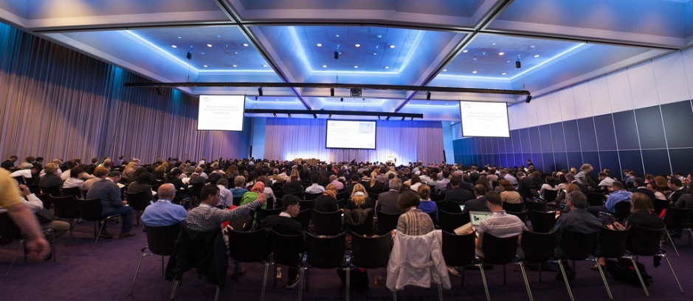
CLOT Committee News

The CLOT executive committee have been seeking new members to join the existing team to continue providing the service to our members that we have been delivering since 1996. We are delighted to announce that the committee has added three new executive members to the team. We are proud to welcome Lesley Magee, Jodie Williams and Sue Rhodes.
Lesley works as an Anticoagulation Nurse Specialist at North Manchester General Hospital and helped to establish the nurse led anticoagulant community clinics. She is part of a very busy team, monitoring approximately 5000 patients.
Jodie is an Atrial Fibrillation Nurse Specialist and has worked within her field for twelve years. She shares her time in both primary and secondary care, based at University Hospital of the North Midlands. The service Jodie provides supports a huge population and her focus is stroke prevention.
Sue works as a VTE Clinical Nurse Specialist and Joint Anticoagulant Lead at Great Western Hospital, Swindon. Sue is a member of a very busy anticoagulation service that provides monitoring for over 4000 patients.
We would like to congratulate all three ladies in joining the CLOT executive committee and wish them all a very happy and successful time in their new roles.

World Thrombosis Day

This global event took place for the first time on 13th October 2014 on Rudolf Virchow’s Birthday. It is now set to be repeated annually to maintain heightened awareness of all aspects of thrombosis to alert the general public and other health care professionals who are not fully aware of this massive subject. ISTH spearheaded the launch with the involvement of national and international Thrombosis organisations who arranged educational activities and stands. CLOT would love to hear from anybody who is organising something on the day this year to bring attention to this very important issue. Or perhaps you be may be planning to attend an event. Let us know. For more in-depth information and educational resources about World Thrombosis Day go to the ISTH website.

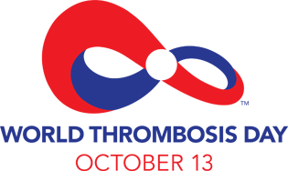

Sponsors

The committee would like to give a big thank you too Bristol Myers Squibb Pharmaceuticals Ltd/ Pfizer Alliance, Boehringer Ingelheim and Bayer for their continued support of CLOT

