Enjin Joins United Nations Global Compact to Promote Sustainability and Equality
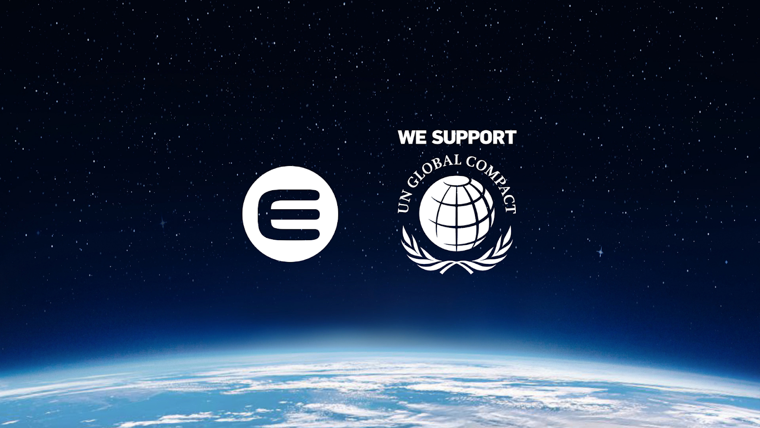
Enjin is committed to the UN Global Compact corporate responsibility initiative and its principles in the areas of human rights, labor, the environment and anti-corruption.

SINGAPORE, 20 July 2021 — Enjin, the pioneering blockchain platform for non-fungible tokens (NFTs), has become the first NFT company accepted into the United Nations Global Compact. The company joins the Global Compact as a Participant, the highest membership rank.

Membership in the UN Global Compact requires a rigorous commitment to sustainability and equality according to the ten principles of the Global Compact, which offer guidance in the areas of human rights, environment and labor. More broadly, the Global Compact aims to support businesses in working towards the UN’s Sustainable Development Goals (SDGs).

“We are excited to work with Enjin to explore how blockchain and NFTs can contribute to the fulfillment of the United Nations Sustainable Development Goals,” said Irakli Beridze, Head, Centre for AI and Robotics, UNICRI, United Nations. “While we are struggling to recover from the global pandemic and its impacts, we are experiencing exponential growth of technologies like AI and blockchain. More than ever, we need to take advantage and harness the potential of these new technologies to ensure that we are better equipped and more united in the future, in order to make our planet a more livable, equitable place for all.”

By launching the eco-friendly JumpNet blockchain and joining the Crypto Climate Accord, Enjin has made significant strides in decarbonizing NFTs on Ethereum. These efforts directly support Principle 9 of the Global Compact, which focuses on “the development and diffusion of environmentally friendly technologies.” JumpNet already consumes 99.99% less energy than Ethereum, the most commonly used network for NFTs. Furthering its commitment to sustainable NFTs, Enjin recently took JumpNet carbon-negative and is building Efinity, a sharded Proof of Stake parachain on Polkadot.

Enjin will explore novel ways of utilizing NFTs to carry out the UN’s missions of sustainability and equality. For example, the technology could become the financial and monetization backbone of carbon capture companies, helping fight climate change. Permissionless access to NFT markets can also help eliminate the inequality of opportunity between different nations, empowering worldwide creators and NFT users to compete on equal footing and reduce the global wealth gap.

“With less than ten years left to meet the UN's 2030 Agenda on sustainable development, technology plays an important role that can help us reach the SDGs faster and contribute to a more prosperous and sustainable world,” said Esther Chang, Executive Director of Global Compact Network Singapore. “We warmly welcome Enjin to the United Nations Global Compact and look forward to working alongside them to take decisive action for the SDGs.”

Enjin’s membership in the Global Compact comes amid a growing realization that sustainability, both social and environmental, are the key to unlocking trillions of dollars in value in the next decade. Conversely, many prominent figures have levied criticism against NFTs due to their perceived carbon footprint, which Enjin has directly addressed through the release of JumpNet alongside a 5-step plan to enable carbon-neutral NFTs.

“At Enjin, we’re developing a sustainable ecosystem to create a better future using NFTs,” said Maxim Blagov, CEO of Enjin. “Joining the UN Global Compact reaffirms our commitment to improving people’s lives through blockchain technology, and will ensure these efforts are sustainable, focused, and optimized while holding us accountable to the public along the way.”

About Enjin
Enjin is the all-in-one platform for developing scalable, interoperable blockchain ecosystems, making it simple for anyone to adopt NFTs. NFTs are central to the Enjin ecosystem, which offers a comprehensive product stack for creating, integrating, trading, and distributing NFTs on a scalable and almost-zero fee platform. Enjin’s products see wide application in blockchain games, applications, enterprise programs, and innovative marketing campaigns.

