Enjin Partners with Health Hero to Launch NFT-powered Wellness Program
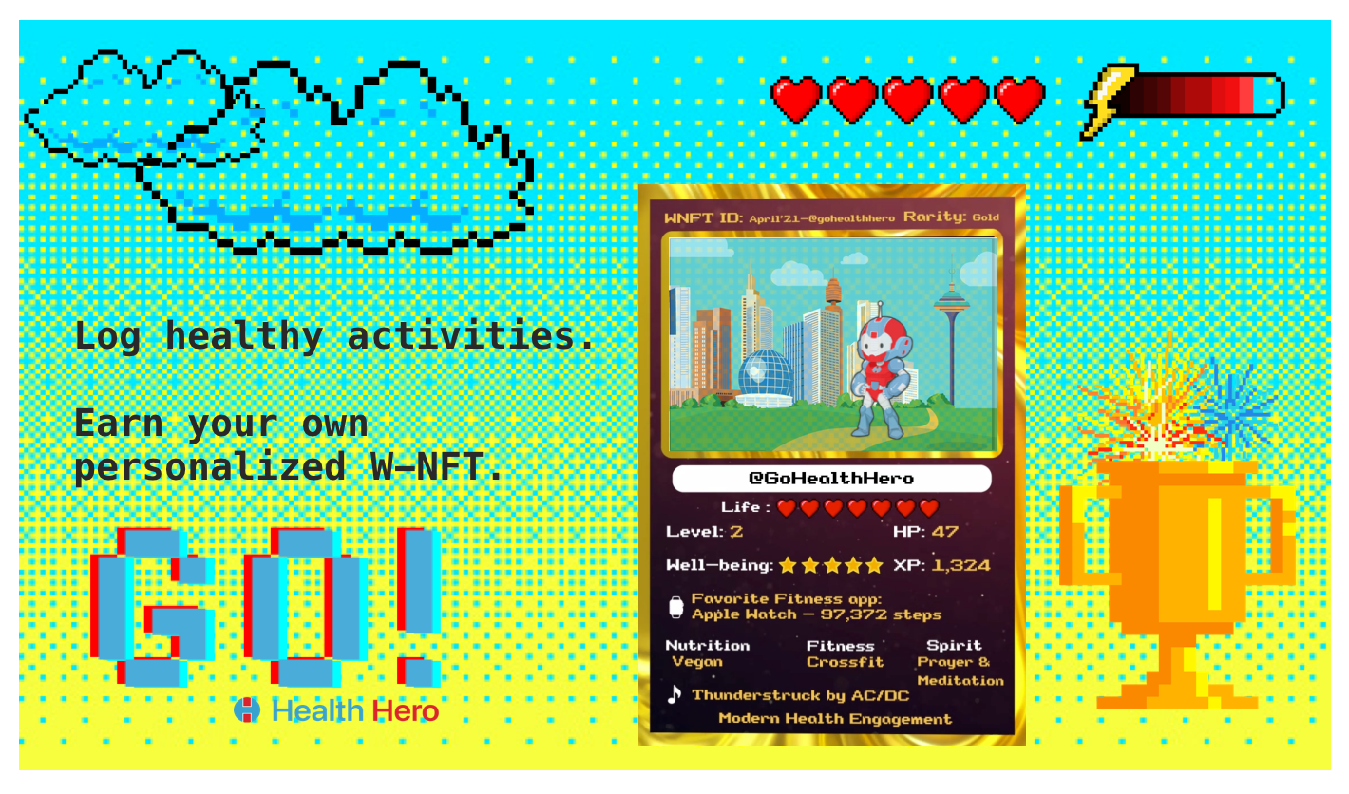
SINGAPORE / SAN FRANCISCO, June 9, 2021 — Enjin, the full-stack blockchain engine for virtual worlds and non-fungible tokens (NFTs), is announcing a partnership with Health Hero, a digital health engagement company partnered with Microsoft, Slack, and Salesforce, to develop an NFT-powered wellness app.

The result of the collaboration will be Go! By Health Hero, a new health monitoring and engagement app that introduces the concept of Well-being Non-Fungible Tokens, or W-NFTs. The Go! app collects activity and wellness data through an integration with health tracking devices and apps like Apple Health, Google Fit and Fitbit. Based on this data, the app generates unique W-NFTs with a set of features designed to imbue scarcity into the token.

Each user is able to create a token unique to their health and activity characteristics. As they input more activity statistics and well-being parameters, the corresponding W-NFT acquires new traits and features, making it ever more unique and rare. The NFTs can then potentially be traded and exchanged for Enjin Coin (ENJ) on the Enjin Marketplace.

The Go! App will build on an existing pilot of W-NFTs spearheaded by Health Hero for its Global Challenges app. Global Challenges fosters a worldwide wellness community where users can become part of a unified leaderboard defined by their commitment to wellness. Global Challenges offers a dashboard experience to gamify fitness and health, enabling a novel kind of digital community. Health Hero is introducing W-NFTs to Global Challenges through a Telegram-centric campaign, allowing users to create custom W-NFTs based on their wellness parameters. These NFTs are earned for free, with the purpose of engaging users to be part of a community.

“Health Hero’s app highlights how NFTs can be adopted in entirely new and innovative ways by businesses across industries,” said Maxim Blagov, CEO of Enjin. “We are excited to support the first project bringing NFTs to health and fitness, pairing the security of blockchain with new gamification mechanics.”

“With well-being and activity data, we are creating a new blockchain layer where we are driving health engagement and placing that on the blockchain, allowing us to have more secure and personal activity data for our users,” said Anthony Diaz, CEO and Founder of Health Hero, Inc.

The Go! App will use Enjin’s gas-free JumpNet blockchain, ensuring that W-NFTs remain cheap to use while being far more environmentally friendly than other platforms, consuming 99.99% less electricity than networks like Ethereum. Scalability is key for the partnership with Health Hero, whose products are used internally by over 38,000 companies worldwide through integrations with Microsoft Teams, Slack and Salesforce.

About Enjin
Enjin is the platform of choice for building products that integrate NFTs in their stack, offering the Enjin Wallet, Platform,Marketplace, and Beam to create and interact with custom NFTs. By using the JumpNet blockchain platform, developers can cut gas costs almost entirely, making NFTs viable for mass adoption while remaining connected to the Ethereum blockchain. Enjin’s products can be used by businesses, individuals, and developers to build innovative NFT use cases, campaigns, games, and applications. For more information, visit https://enjin.io.

About Health Hero
Health Hero is a modern health engagement and telehealth company that rewards people for their health. Health Hero allows users to log healthy activities, participate in global challenges, and compete in fun and engaging leaderboards across multiple chat platforms, web, mobile, and SMS. Health Hero's W-NFT is an innovative approach to digital well-being assets where users get rewarded with NFTs that they can sell, trade, or buy. For more information, visit https:// gohealthhero.com/.

