Enjin & GameTalkTalk Bring Eco-Friendly NFTs to 3 Million Users on Korea’s Largest Social Gaming Platform
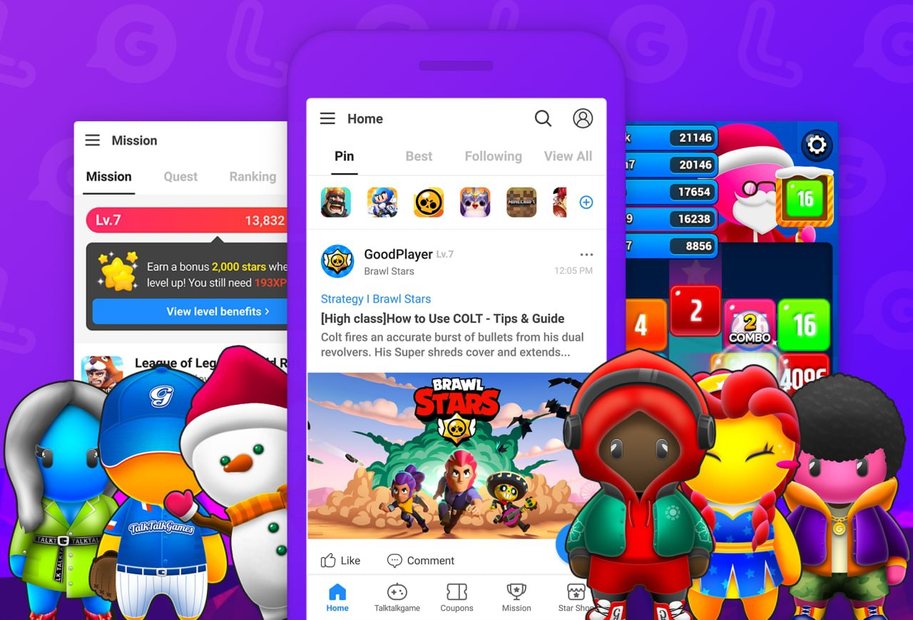

Singapore - 24 March 2021 — South Korea’s top gaming social media company, Ludena Protocol, and leading non-fungible token (NFT) ecosystem developer, Enjin will bring sustainable NFTs to the fourth-largest gaming market in the world, beginning with its largest social gaming platform, GameTalkTalk.

The news follows the release of Enjin's 5-step plan to enable carbon-neutral NFTs by 2030.

“We’re thrilled to work with GameTalkTalk to bring carbon-neutral NFTs to their 3 million users,” said Maxim Blagov, CEO of Enjin. “This is also a unique opportunity to show some of the legendary companies they’ve worked with how NFTs are creating highly-engaged communities that drive new users to games, in a sustainable way.”

As the booming NFT market continues to grow in volume and value, Enjin is bringing an environmentally-sustainable multi-chain approach to the GameTalkTalk app via its upcoming NFT highway, Efinity, and gas-free scaling solution, JumpNet.

When JumpNet launches on April 6, GameTalkTalk will use the Proof of Authority (POA) solution to provide a seamless user experience with free and instant NFT transactions to its clients, which include prestigious brands such as Blizzard, SEGA and Nexon.

“We are so excited to be collaborating with the Enjin team, who are global leaders in the NFT phenomenon, particularly in their proactiveness in tackling the many associated environmental concerns through their innovative JumpNet blockchain,” said Joshua Kim, CEO of Ludena Protocol. “We are looking forward to introducing Enjin's unique NFT technology to our upcoming blockchain gaming metaverse, Ludena World, where we aim to create an exciting and value-creating ecosystem where global users can easily opt in.”

GameTalkTalk’s 200,000 monthly active users will be able to build a fun, engaging digital life for their in-app avatars by minting digital fashion and real estate NFTs, and personalize their avatars’ homes with tokenized pets and furniture.

South Korea is the world’s fourth largest gaming market, with more than 29 million active gamers. Valued at $5.9 billion, the country’s market for games, consoles and related content is expected to exceed $9 billion by 2026.

About Enjin
Enjin is the leading ecosystem of blockchain software products that make it simple for anyone to develop, trade, monetize, incentivize, and market with blockchain and NFTs. The Enjin Platform powers the creation of unique digital assets and marketplaces that underpin the next generation of the digital economy. Many of the world’s pioneering blockchain games, applications, and projects created by talented developers and forward-thinking companies are built on the Enjin ecosystem. For more information, visit https://enjin.io.

About Ludena Protocol
Ludena Protocol is a decentralized ecosystem dedicated to gamers worldwide. The platform encompasses a gaming social media app, hyper casual P2P gaming platform, and fee-less virtual item exchange. The company’s first dapp, GameTalkTalk, is a reverse ICO project that has grown to become South Korea’s largest gaming social media app with 3 million users. For more information, visit https://ludenaprotocol.io/eng/

Media Contacts
Dylan Tucker
dylan@yapglobal.com

Bryana Kortendick
bryana@enjin.io

