Axana Games Joins Blockchain Game Alliance and Signs with Enjin

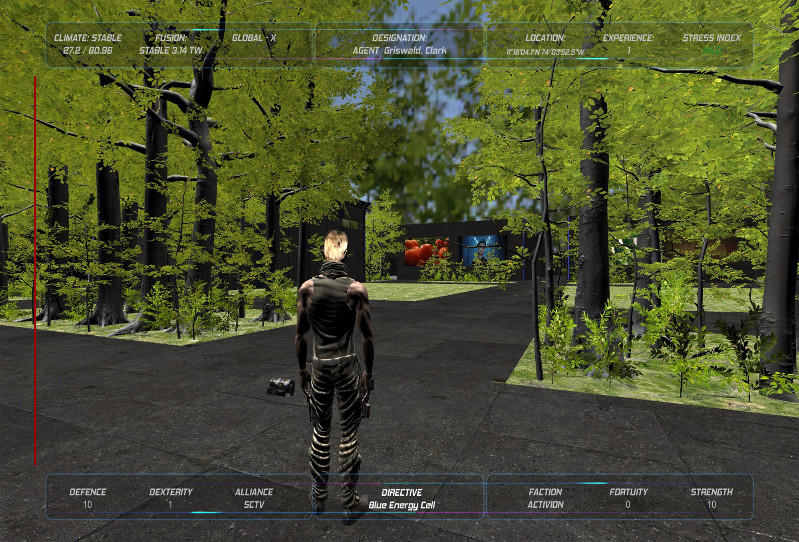
29 October 2020, SINGAPORE — Axana Games has announced their adoption of the Enjin Platform one week after joining the Blockchain Game Alliance. The team is developing a full-scale sci-fi MMO called Wavelings that explores a blockchain-powered future free from hunger, disease, and climate change.
<link to trailer: https://youtu.be/vplX9mLOkEA>
Set to launch in 2021, Wavelings is designed to serve as an interactive instruction manual for new cryptocurrency and blockchain users. An AI companion will guide players through the process of connecting their blockchain wallet and using it to earn in-game assets and money. Each AI will have a unique identity stored on the Ethereum blockchain in the form of a non-fungible token (NFT), enabling players to upgrade and trade it freely.
“After researching the tech and establishing the top priorities for our model and clients, Enjin became the easy choice,” said Leah Munro, CEO of Axana Games. “The Enjin ecosystem is at the forefront of modern blockchain technology and provides a suite of tools that remove potential barriers to adoption. This is invaluable and will allow us to remain focused on the business of gaming.”
Players will have the opportunity to own blockchain-based land in Wavelings, where they can build their faction and farm resources. The land will also feature advertising space where they can rent out promotional billboards and holograms that can promote real-world products, and even distribute branded NFTs with the click of a button.
Axana Games will be showcasing Wavelings at the Blockchain Game Alliance Demo Day on November 4. The demo will feature a gameplay walkthrough in the brave new world of Wavelings and showcase some of the game’s most innovative mechanics.
About Enjin
In 2009, Enjin launched the Enjin Network, a gaming community platform that boasts over 20 million users. In 2017 following a successful ICO that raised $18.9 million, Enjin began building a suite of blockchain products that enable anyone to easily create, manage, trade, store, explore, distribute, and integrate blockchain assets.
Comprised of the Enjin Platform, Explorer, Wallet, Beam, and other tools and services, Enjin’s tools enable game developers and studios to utilize tokenized digital assets as part of their acquisition, retention, engagement, and monetization strategies. The Enjin ecosystem is fueled by Enjin Coin (ENJ), an Ethereum-based cryptocurrency used to directly back the value of Enjin-powered blockchain assets. For more information, visit https://enjin.io.
Media Contact:
Bryana Kortendick
Enjin VP of Communications
bryana@enjin.io

###

