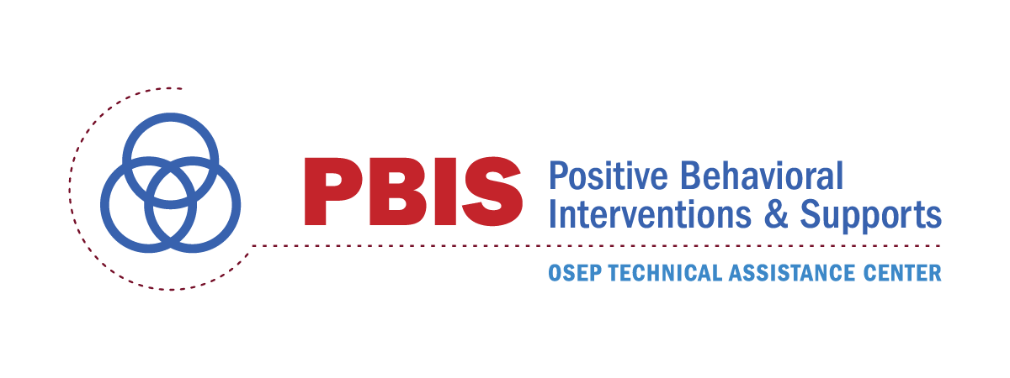 | School Climate Transformation Grants  Technical Assistance Worksheet

Purpose: The purpose of this worksheet is to describe the technical assistance (TA) supports available through the National TA PBIS Center so that (a) SCTG grantee may develop action steps for securing TA support and (b) PBIS personnel can organize the provision of TA resources.
Date________________________
SEA________________________ LEA_________________________________________________
Name(s) Completing Checklist__________________________________________________________
Contact Name and Email_______________________________________________________________
For each TA support resource, indicate (a) level of need or interest (High, Medium, Low) and (b) next action step.
Technical Assistance Support  What may I request from the PBIS Center? | Need  H, M, L | Next Action  What will I do next?
- Access website (www.pbis.org) materials
- Facilitate conference calls with LEA &/or SEA Leadership Team
- Meet with SEA Leadership Team
- Assist in conducting an audit of related behavioral practices, programs, resources, grants, and initiatives
- Assist in development of MTBF policy and procedural guides
- Assist in development of 1-3 year implementation action plan (see PBIS Implementation Blueprint)
- Assist in developing plan for enhancing capacity for PBIS Trainer/Coach Training
- Assist in selection and use of implementation PBIS fidelity measures
- Assist in use of SWIS suite and identification of local SWIS facilitators
- Assist in design and implementation of evaluation plan (questions, measures, tools, procedures)
- Assist in identifying local PBIS trainers and/or coaches
- Assist in identifying local examples and demonstrations of MTBF implementation
- Assist with SCA or DCA administration
- Provide webinars on selected PBIS and MTBF implementation topics
- Provide SCTG specific sessions and/or workshops at annual PBIS conferences (i.e., Fall PBIS Leadership Forum and Spring APBS Conference)
- Assist in identification, development and implementation of regional collaboration and training events (e.g., regional conferences and workshops)

Additional Action Steps

