FOR IMMEDIATE RELEASE
Media Contacts:
Hannah Minton
Portavoce PR for Biosero
760-814-8194 Ext. 102
Hannah.Minton@PortavocePR.com

Biosero Forms 4-Person Strategic Advisory Board

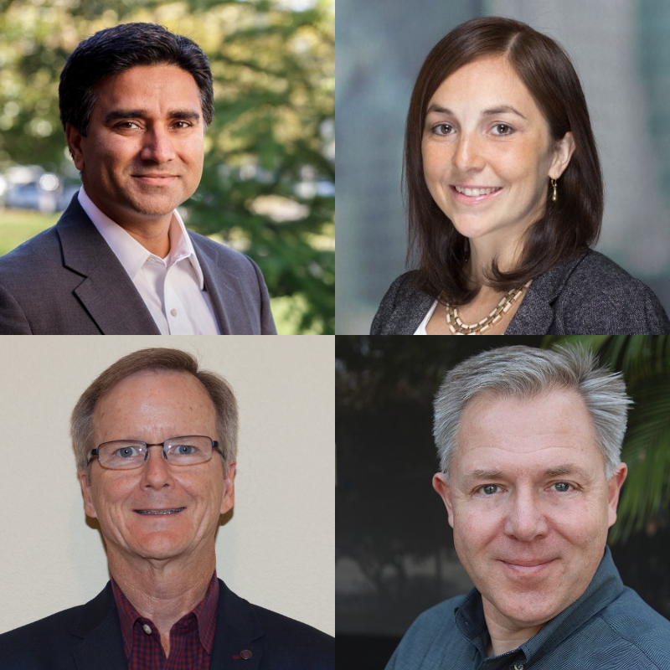
SAN DIEGO, Aug. 27, 2019 – Biosero, Inc. has formed a strategic advisory board made up of four members who will contribute to Biosero’s mission to provide automation software solutions that enable people and technology to make complex decisions in less time, using more data.

“Biosero has a 16-year track record of success,” says Tom Gilman, CEO, Biosero. “We have evolved into a software company with an exceptional opportunity for rapid growth. Input from successful, proven leaders in the software, life science, healthcare, financial and commercial industries will help guide Biosero into the future.”

The advisory board members will collaborate to expand and develop agnostic, integrated solutions for the life science and industrial markets. Strategic advisory board members include:

Mrinal Bhasker, Founding Partner at Leap Orbit
In 2015, Mrinal founded Leap Orbit, a health Information Technology (IT) product and services company. Mrinal and the company built a prescription drug monitoring product for the NIC, Inc., the industry-leading RxGov platform. Previously, Mrinal was a founder and executive at RightCare Solutions (acquired by Cardinal Health), Audacious Inquiry, HealthUnity (acquired by ZeOmega) and Commercia.com (acquired by Microsoft). At Microsoft, Mrinal worked in teams building enterprise products. Mrinal earned a bachelor’s degree in mechanical engineering from the Indian Institute of Technology, Kanpur. He holds a Master of Business Administration from the Wharton School at the University of Pennsylvania.

Jeff Ludwig, Vice President of Network Platform Services and Data at Sony Interactive Entertainment – PlayStation
During his five years at PlayStation, Jeff has led software and cloud engineering operations to drive development, quality and growth. Before joining PlayStation, Jeff served in several technology leadership roles at Intuit Inc. During his 30-year career, Jeff has helped build highly available and resilient software service platforms that serve millions of consumers. Jeff earned a bachelor’s degree in information systems from California State Polytechnic University, Pomona.

Tricia Shaw, Vice President at Evercore
In her current role at Evercore, Tricia provides strategic and tactical advice to both public and private technology companies, with a focus on software. She has advised on numerous acquisitions, mergers and sales, providing valuation analyses and transaction execution. Before joining Evercore, she worked in the Investment Bank at J.P. Morgan in the Diversified Industries coverage team, advising on debt, equity and M&A transactions. Tricia served 10 years in the U.S. Navy as a Naval Aviator flying surveillance and reconnaissance missions worldwide. Tricia earned her Bachelor of Science and Master of Business Administration from the Wharton School at the University of Pennsylvania.

Mike Sjaastad, Director of Development and Strategy at Biosero
During his three years at Biosero, Mike has developed marketing strategies and led product planning and partner relations operations. He has secured and maintained OEM relationships to expand the use and installed base for Biosero’s breakthrough software, Green Button Go™ Automation Scheduling Software, a device-agnostic software platform that integrates equipment into a cohesive lab ecosystem. Before joining Biosero, Mike worked in strategic roles at multiple biotech instrumentation companies and as an independent consultant providing corporate strategy, strategic marketing, technology prospecting and product positioning skills for small companies and startups. Mike earned a bachelor’s degree in psychobiology from Swarthmore College. He holds a doctorate in cell physiology from University of California, Berkeley and participated in post-doctoral training and research at Stanford University.

# # #

About Biosero, Inc.
Biosero, Inc. develops automation software people use to make better decisions, in less time, using more data. The company’s software enables complex, data-driven decisions to be made instantaneously, keeping workflows and operations in life science, pharmaceutical and industrial manufacturing moving. Biosero’s device-agnostic Green Button GoTM Automation Scheduling Software integrates hardware solutions from different OEMs to create cohesive technology ecosystems that accelerate operations and increase productivity. Biosero is based in San Diego, Calif., with offices in prominent biotech and pharma hub regions around the world. For more information, please visit www.biosero.com.

