F/V “CRISTINA GLACIAL”

- 50 m Longliner

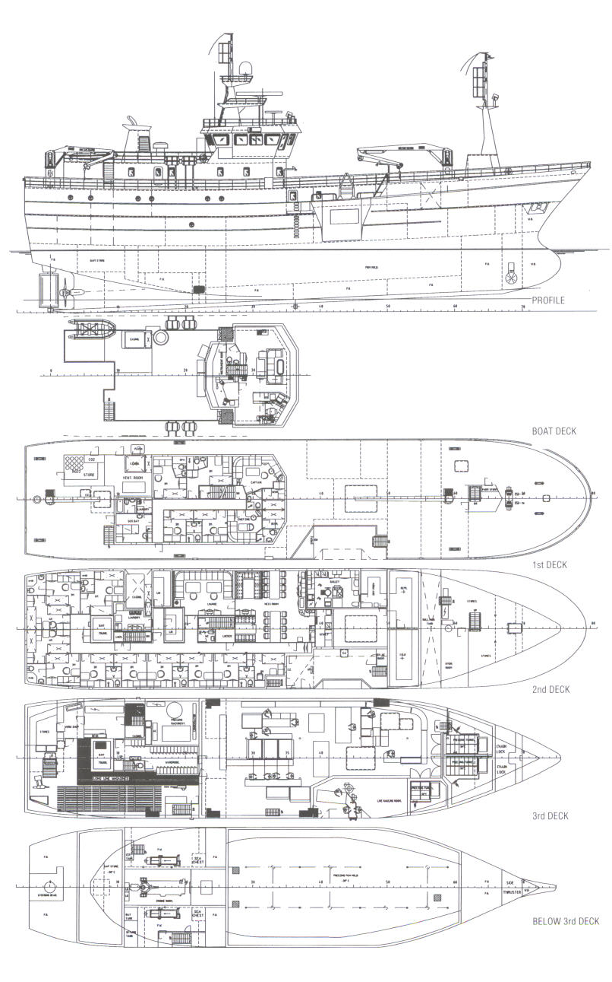

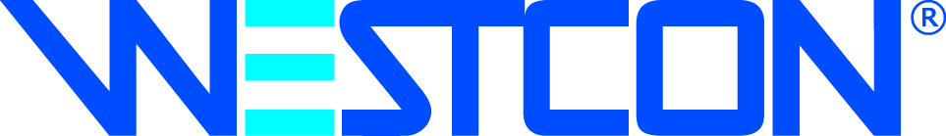

N-5582 Ølensvåg, Norway
Tel: (+47) 53 77 50 00 – Fax: (+47) 53 77 50 01

Webadress: www.westcon.no
E-mail: westcon@westcon.no

Principal particulars
Length o.a.: 49,99 m
Length p.p: 43,60 m
Breadth mid: 10,70 m
Depth to 1st deck: 9,90 m
Depth to 2nd deck: 7,50 m
Depth to 3rd deck: 5,00 m
Gross tonnage: 1139 Brt.
Accommodation: 41 men + hospital
Freezing hold capacity: 580 m³
Bait hold: 53 m³
Fuel oil capacity: 386 m³
Fresh water capacity: 24 m³
Speed: 14 knots
Class: DnV + 1A1 Fishing vessel, ICE C

Main Engine
Make: Caterpillar
Type: 3606 TA
Power: 2360 BHP/900 RPM
Gear/Propulsion line: Volda ACG 627450

Electronical equipment
Radar A: Furuno FR2110 ARPA
Radar B: Furuno FR7111
Chartplotter: Maxsea
Echosounder A: Simrad ES500
Echo sounder B: Simrad EQ50
Satcom system: 1 x Aritsu RS402A Inmacsat B
Main radio system: Furuno FS1502
Watch receiver: Sailor R 501
Gyro: Robertson RGC11
Autopilot system: Robertson AP45MKII
GPS: 2 x Furuno GP50MKII
VHF: 3 x Shipmate RS8400
Handheld VHF: 2 x ICOM
Weather fax: Navtex receiver
Monitoring system: 4 x Sony Colour
Intercom System: Vingtor Marine
Loudhailer: Rayton RAY430

Fish processing equipment
Freezing plant type: Teknotherm
Freezing capacity: 30 t / 24 h
Fish factory: P. E. Bjørdal AS
Temperature in hold: -30°C

Special equipment
Deck Cranes: Karm SWL 2 t / 12 m
Karm SWL 1,5 t / 10 m
Autoline system: Mustad 40.000 hooks
Fishing winch: Westcon SWL 1 tonnes
Anchor winch: Karm
Capstan: Karm 2 tonnes
Fresh water generator: Alfa Laval 12 t / 24 h
Fuel oil separator: Alfa Laval
Air compressors: Sperre HLF 2/77
Machine room pumps: Allweiler Norge
Ventilation: Nyborg
Air condition: Covent CVCE2
Engine room CO₂ plant: Alf Lea
MOB boat: DSB-kopas
Life rafts: DSB 4 x 20 men
Navigation Lights: Tranberg

V E S S E L I N F O R M A T I O N

50 M LONGLINER

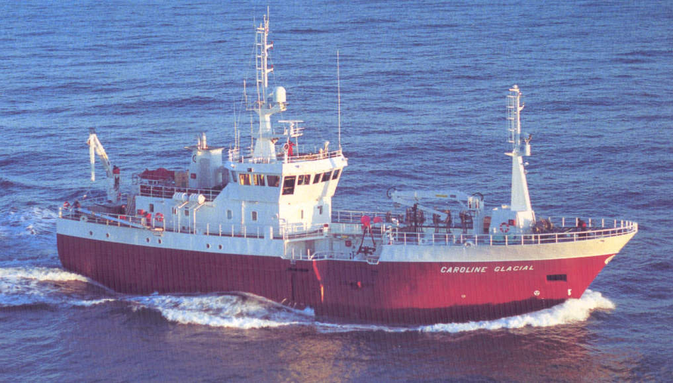

F/V CRISTINA GLACIAL

Delivered in 1997 by West Contractors AS, Ølensvåg, Norway as yard no. 13 for owner Glacial Shipping SA. The longliners are built for worldwide deep-sea fishing and are equipped with an extensive fish-processing factory.

N-5582 Ølensvåg, Norway
Tel: (+47) 53 77 50 00 – Fax: (+47) 53 77 50 01

Webadress: www.westcon.no
E-mail: westcon@westcon.no

